

MG5615 Understanding Business and Management Research Methods

Study Guide for the Academic Year 2021/22

TABLE OF CONTENTS | Page
Introduction to module & learning objectives | 1
Core Reading List and Supplementary Reading | 2
Lecture/Seminar Programme | 3-4
Assessment | 4
APPENDIX
Problems with your Study, and Extenuating Circumstances | 5
Coursework Submission - Important Details | 5
Feedback on Coursework | 5
Re-assessment Details | 5
Employability and 'Graduate Identity' | 5

Introduction TO MODULE & Learning objectives

Credits | 15
Module Leader | Dr Michael Heller
Other Staff | Dr Marcia Ferreira, Dr Liyuan Wei, Dr Sharifah Alwi
Term | Term 2
Contact and Private Study Time | Lectures 20  Workshops 2  Private Study 128  Total 150
Assessment | Coursework 100%

The learning objectives of the module are:

- Comprehensively understand different research designs and its appropriateness to study different research problems.

- Identify and combine complex research data on a given topic and identify an appropriate methodology for management issues.

- Evaluate and justify systemically the use of quantitative and qualitative research methods.

- Demonstrate a variety of skills including recording, communication, and explanation of reading research material involved.

This study guide should be read in conjunction with the College Student Handbook, the Senate Regulations, and the Appendix of this study guide. More information about your programme can be found at the ‘Programme Documentation Repository’. The School assumes that you familiarise yourself with this information, so you will need to look at these pages carefully at various times throughout your studies. These policies and procedures might change from one academic year to another and it is in your own interest to keep yourself aware about them and their possible changes. Any queries about this module should be directed to the module leader, who you can contact either by way of ‘feedback and consultation hours’ or by email.

Core reading list and supplementary reading

You will likely be directed to study aspects of the following texts in your out-of-classroom time, that is, in your private study.

- Core Reading List

Bell, E., Bryman, A., and Harley, B. (2019). Business Research Method (5th Edition. Oxford: Oxford University Press
- Supplementary Reading

- Black, K. (2003) Business Statistics for Contemporary Decision Making (4th edition). London: Wiley
- Braun, V and Clarke V, (2022) Thematic Analysis: A Practical Guide. Sage Publications.
- Blumberg, B., Copper, D.R. and Schindler, P.S. (2011) Business Research Methods. London: McGraw-Hill.
- Bowerman, B. L., O’Connell, R. T. and Murphree, E. S. (2009) Business Statistics in Practice (5th edition). London: McGraw-Hill.
- Davies, B. M. (2007) Doing a Successful Research Project: Using Qualitative or Quantitative Methods. London: Palgrave Macmillan.
- Denicolo, P. and Becker, L. (2011) Success in Research Proposals. London: Sage.
- Evans, J. (2021) Business Analytics. Global Edition. Harlow: Pearson Education. Third edition. (e-book)
- Ferreira, M. C. and Scaraboto, D. (in press) Qualitative insights for digital marketing. SAGE Handbook of Digital Marketing, Annmarie Hanlon and Tracy L. Tuten (eds). Sage Publications.
- Field, A. (2013) Discovering Statistics Using SPSS (4th edition). London: Sage.
- Gibbs, G. R. (2018), “Thematic coding and categorizing,” Analyzing qualitative data (Vol. 6). Sage Publications, 53-74.
- Hart, C. (2001) Doing Literature Review. London: Sage.
- Malhotra, N.K. (2020) Market Research: An Applied Approach. Global Edition. (7th edition) Harlow: Pearson.
- Kozinets, R. V. (2019) Netnography: The essential guide to qualitative social media research. 3rd edition. Sage.
- Myers, M. (2009) Qualitative Research in Business and Management. London: Sage Publications.
- Pallant, J. (2013) SPSS Survival Manual: A Step by step guide to Data Analysis Using IBM SPSS (5th ed). Maidenhead, England: McGraw-Hill.
- Pears, R. and Shields, G. (2008) Cite them right: the essential guide to referencing and plagiarism. Newcastle upon Tyne: Pear Tree Books.
- Perri 6 and Bellamy, C. (2012) Principles of Methodology: Research Design in Social Sciences. London: Sage.
- Pears, R. and Shields, G. (2008) Cite them right: the essential guide to referencing and plagiarism. Newcastle upon Tyne: Pear Tree Books.
- Ridley, D. (2011) The Literature Review: A step-by-Step Guide for Students. London: Sage.
- Saunders, M., Lewis, P., and Thornhill, A. (2016) Research Methods for Business Students (7th edition) Harlow: FT Prentice Hall.
- Susan R., Nigel S., and Canhoto, A. (2014) Management Research: Applying the Principles. Routledge, ISBN 1317819144, 9781317819141
- Walliman, N. (2011) Your Research Project: Designing and Planning Your Work. London: Sage.
- Yin, R. K. (2009) Case Study Research: Design and Methods (4th edition). London: Sage.

Academic Journals
Journals listed in the ABS (Associations of Business Schools) ranking list

Go to Library

- Term 2: (ALL Levels)
The teaching term starts 17 January 2021 and ends 1 April 2021. We have no Effective Learning Week.

For full details of terms, holidays, and examination periods and the full list of University weeks/week numbers and the rest, go to:
http://www.brunel.ac.uk/about/campus/term-dates

Lecture/seminar programme

TERM 2
Study Week | Week Commencing | Study Theme | Lecture | Workshop | Bryman & Bell Book Chapters
18 | 17/1/22 | Introduction to Business Research and Research Philosophy | - Module Introduction  - The Research Process  - Research Philosophy |  | - Chapter 1  - Chapter 2
19 | 24/1/22 | Research Design and Literature Review | - Research Design  - Research Questions  - Literature Review |  | - Chapter 3  - Chapter 4  - Chapter 5
20 | 31/1/22 | Introduction to Qualitative Research and Interviews & Focus Groups | - Qualitative Methods  - Introduction to qualitative research  - Interviews  - Focus Groups |  | - Chapter 17  - Chapter 20  - Chapter 21
21 | 7/2/22 | Qualitative Grounded Research | - Qualitative Research  - Qualitative Grounded Research |  | - Chapter 24
22 | 14/2/22 | Netnography | - Qualitative Research  - Digital Ethnography  - Netnography | Workshop 1: Focus Groups | - Chapter 19  - Kozinets (2019)
23 | 21/2/22 | Thematic Coding | - Qualitative Analytical Process  - Research Scenarios  - Thematic Coding |  | - Gibbs (2018)  - Braun & Clark (2022)  - Ferreira & Scaraboto (in press)
24 | 28/2/22 | Hypotheses, Surveys and Data Types | - Quantitative Research  - Hypotheses  - Designing Surveys  - Data Types |  | - Malhotra (2020) Chapter 2, 3, 10 and 13
25 | 7/3/22 | Validity, Reliability and Experimental Designs | - Quantitative Research  - Validity  - Reliability  - Experimental Designs |  | - Malhotra (2020) Chapter 11 and 12
26 | 14/3/22 | Testing Hypotheses about group differences | - Quantitative Research  - Data descriptives  - Comparing groups  (t tests, ANOVA, Chi square test) | Workshop 2: Basic skills in using Excel | - Evans (2021) Chapters 2, 7
30 | 21/3/22 | Testing Hypotheses about relationships | - Quantitative Research  - Testing Hypotheses and exploring relationships  - Correlations and regressions |  | - Evans (2021) Chapters 7, 8
31 | 28/3/22 | No Lecture

AssessmenT

Choose a research based article from a 3* or 4* ABS ranked journal related to marketing and branding and write a holistic review of the paper in an essay format based on the content taught in this module that demonstrates an understanding of the research strategy of the article. This must include an outline of its research aims and questions, a discussion of its application of research philosophy and theory, a critical examination of the article’s use of its literature review throughout the paper, a thorough discussion and analysis of its methodology, an overview of its presentation and analysis of data, an analysis of its discussion and conclusion, and a critical evaluation of its research and managerial contributions. The review should provide a coherent analysis which is grounded and evidenced in the article with each of the above sections coherently fitting together. The coursework should also draw on the material taught on the module and use the textbook and the material from the supplementary reading for the module found in the Study Guide. A demonstration of an understanding of business, management, and marketing research is fundamental for a successful grade on this paper. Students are expected to use the textbook and ten other academic sources. At least four of these must be from the supplementary reading.

The report should be 2,500 words long. Students are allowed to exceed this by 10% (either below or above) but any writing above or below this limit will be penalised by 10% per 1000 words (or a fraction thereof for the first 1000 words).

You should prepare and submit all coursework according to the School's instructions for assessments. You should be aware that you cannot later claim that you did not know the rules and regulations. See the Appendix, below, for further details about coursework submission(s).

Full details regarding the module’s coursework requirements can be found via the Coursework Brief on WISEflow, including the submission date and time.

The clear expectation is that you will submit your coursework by the submission deadline stated in the coursework brief. In line with the University’s policy on the late submission of coursework, coursework submitted up to 48 hours late will be accepted, but capped at the pass grade (D- for Undergraduate and C- for Postgraduate). Work submitted over 48 hours after the stated deadline will be graded as an NS (non-submission).

This is the end of the study guide. Below is the Appendix, which informs and supplements the above.

APPENDIX

Problems with your Study, and Extenuating Circumstances

You may feel that your ability to study is being affected by personal problems, illness or any other matter, or you miss an assessment because of extenuating circumstances (or you feel that the quality of an assessment you have taken may have been affected by extenuating circumstances). If so, you should first read the relevant sections in the College Student Handbook. If, after reading this, you have further queries, you are encouraged to get in contact with your Personal Tutor.

Coursework Submission – Important Details

As per the College Student Handbook and College Coursework Submission Procedure, formal coursework submissions must be made via WISEflow in which you must use the College’s electronic coursework coversheet. On no account will we accept any coursework (‘coursework’ includes the Final Year Project/Masters Dissertation) via any other means. So, if you attempt to, or actually submit it to, a lecturer, the Taught Programmes Office (TPO) or to anyone else, either in person or via email, we will not accept it, and we will not look at it or mark it. This is the case for those with extenuating circumstances and for those without extenuating circumstances. Any coursework not submitted via WISEflow will be deemed to have not been submitted.

Please note that we will not accept coursework submitted in any other file format than this/those prescribed on the coursework brief’s submission instructions section. Therefore, your files should be converted to the approved format. After submitting your coursework to WISEflow, please check that it is actually there. Do not rely on simply pressing the ‘submit / upload’ button hoping that it has been submitted and it is on WISEflow. Go back in, and check, that it is actually there. Because, if you discover, later, that it is not then this will be an error on your part for which the university cannot be held accountable.

Feedback on Coursework

The School is committed to providing you with feedback on all assessed coursework and will do so normally within 20 working days from the submission deadline. You will get feedback on your performance via various means, including face-to-face. If you do not receive feedback within this time, then you should first contact the module leader. If it proves necessary, you should then contact the Pathway / Programme Leader or the Director of Undergraduate / Postgraduate / MBA Studies. Submitted coursework, including your Final Year Project / Masters Dissertation, will not be returned to you. This is true for all coursework, in all modules and at all levels, and does not apply only to this module.

Re-Assessment Details

The Board of Examiners is responsible to make decisions about ‘progression’ (or not) or ‘recommendation of an award’ (or not). After the board’s meeting, students are able to see their results on eVision. The Board of Examiners meets only at the end of a Level (undergraduate) / the taught part of the programme (postgraduate). The Board of Examiners may have decided that you have been given an opportunity to be re-assessed. This might be for a capped mark/grade (so this will be counted as a ‘second attempt’) or for a full mark / grade (this will be counted as a ‘first attempt’), depending on whether or not there are / were extenuating circumstances. You will know whether you need to be (re-)assessed by looking at eVision.

Employability Skills and your ‘Graduate Identity’
Employability skills refer to “a set of attributes, skills and knowledge that [you] should possess to ensure [you] have the capability of being effective in the workplace” (CBI, 2009). A study (Hinchliffe and Jolly, 2010) asked “employers from various sectors … about their perceptions of graduates and the importance they place on almost 50 specific skills, competencies, attributes and personal qualities”. When senior executives were asked what the most important factors were when recruiting graduates “employability skills came out on top”.

The Brunel Business School Employability Framework (blow) integrates academic programme learning outcomes with employability skills and support activities. At the centre of the framework sit the five graduate attributes and skills (critical thinking, communication skills, digital and information literacy, business acumen, sustainability and ethics), that are mapped against learning outcomes across degree programmes. The attributes are surrounded by the five practices that support graduate employability (placement, internship and volunteering; curriculum development; programme accreditation; employer engagement and co-curricular learning). Finally, supporting the framework the five steps of an annual review process (discuss attributes and skills, auditing and mapping, action, review, and disseminate and promote), indicating that the objective of graduate employability is an ongoing process. 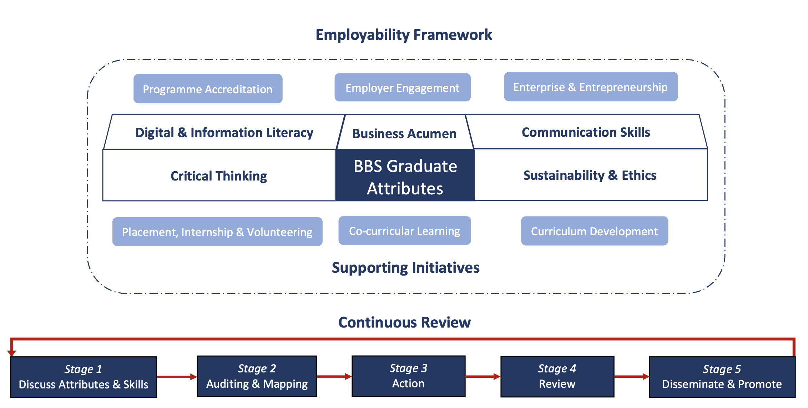

In the table below employability skills indicated as most important by industry partners are listed beneath general graduate attribute descriptions. From this, you can see what employability skills are being introduced or practiced and, naturally, how your engagement in this module helps you “to ensure [you] have the capability of being effective in the workplace”.

Employability Skills |  | This Module?
1 | Critical thinking skills: Understand how to critically analyse and question sources, facts, and situations and how to reflect and report upon them.  Application: Analysing business problems (case studies/vignettes), facts and situations and applying creative thinking to develop appropriate solutions | Yes
2 | Communication skills: Demonstrate an understanding of effective oral and written communication.  Application: Report writing, minutes taking, emails, written and oral presentations | Yes
3 | Information Literacy: Recognise the use of a variety of information and data sources relevant to business and management activities.  Application: Basic IT capacities, including familiarity with word processing, spreadsheets; interpreting graphs, charts, diagrams, statistics, estimates and percentages; file management and use of internet search engines. | Yes
4 | Business acumen: Comprehend the structure, culture and practice of business and management.  Application: Leadership, professionalism, initiative taking and teamwork, business and customer awareness and risk management. | Yes
5 | Sustainability and ethics: Demonstrate a knowledge and comprehension of socially responsible, ethical and sustainable business and management practices.  Application: Defined as the UN PRIME Sustainable Development Goals. | Yes

This is the end of the Appendix / this study guide.

Confederation of British Industry and Universities UK. (2009) Future Fit: Preparing Graduates for the World of Work. London, CBI.
Hinchliffe, G. and Jolly, A. (2010) Graduate Market Trends: Employability and Graduate Identity. HECSU.

