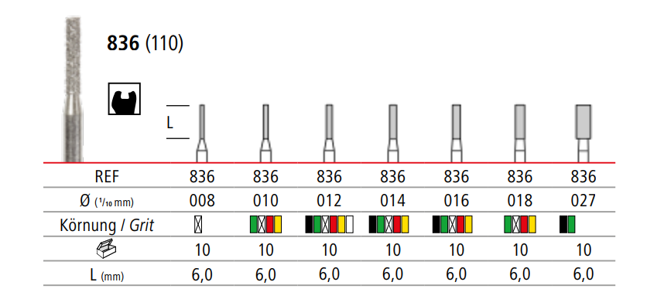

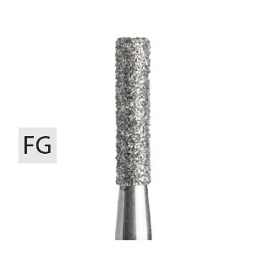

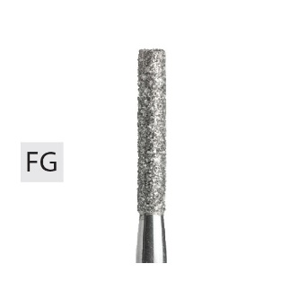

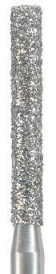 

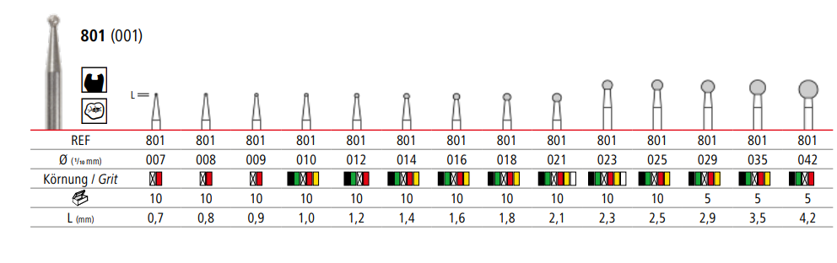

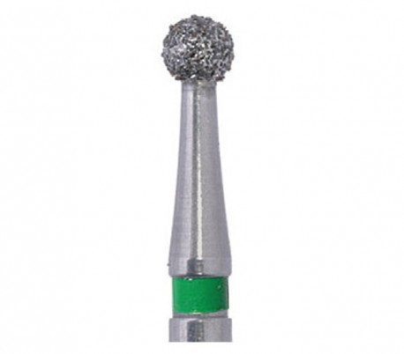

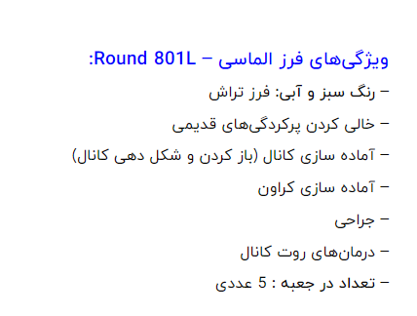

[**https://dent-smile.ir/product/dental-diamond-burs-round-801l-sani/?utm_medium=PPC&utm_source=Torob**](https://dent-smile.ir/product/dental-diamond-burs-round-801l-sani/?utm_medium=PPC&utm_source=Torob)

**فرز الماسی مدل روند توربین ۵ عددی – Round 801L:**

خرید فرز الماسی مدل روند توربین ۵ عددی برند Sani از [تجهیزات دندانپزشکی دنت اسمایل](https://dent-smile.ir/)

این فرز در خالی کردن پرکردگی‌های قدیمی مورد استفاده قرار می‌گیرد.

در آماده سازی کانال (باز کردن و شکل دهی کانال) و کراون  و درمان‌های روت کانال کاربرد دارد.

سایزهای بزرگ آن برای ایجاد حفره در تاج دندان مورد استفاده است.

این محصول در بسته بندی ۵ عددی عرضه می‌گردد.

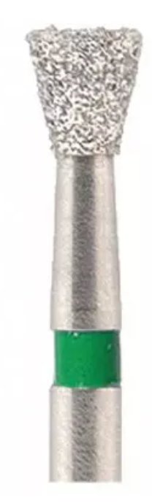

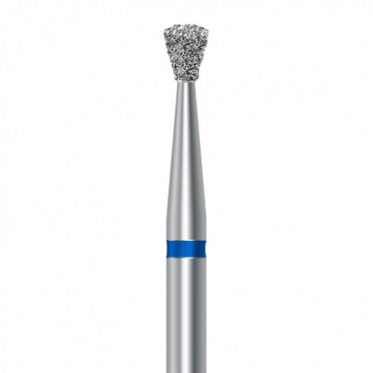

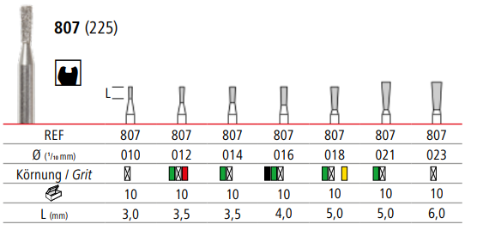 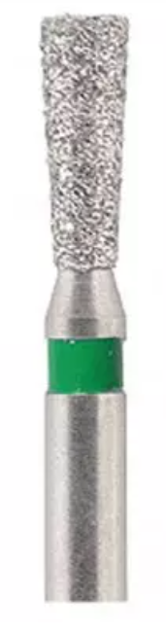

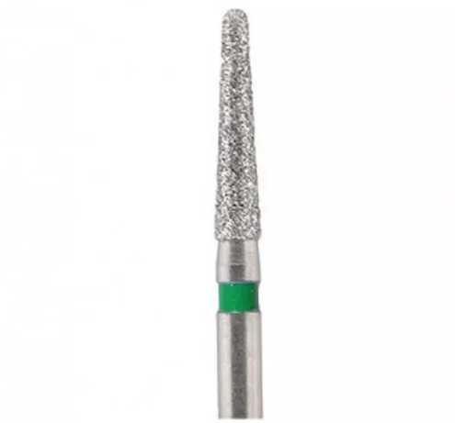 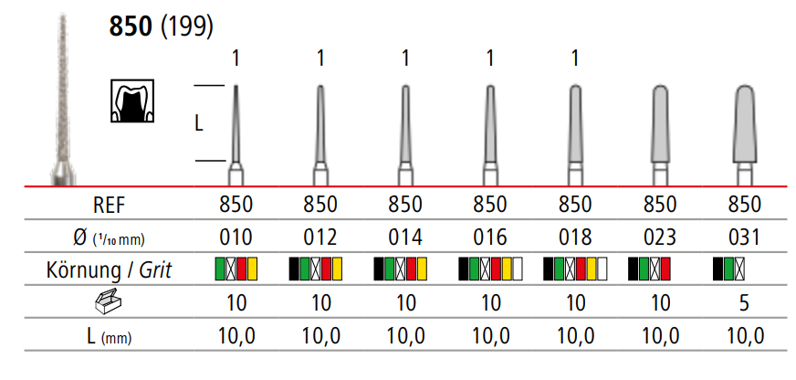

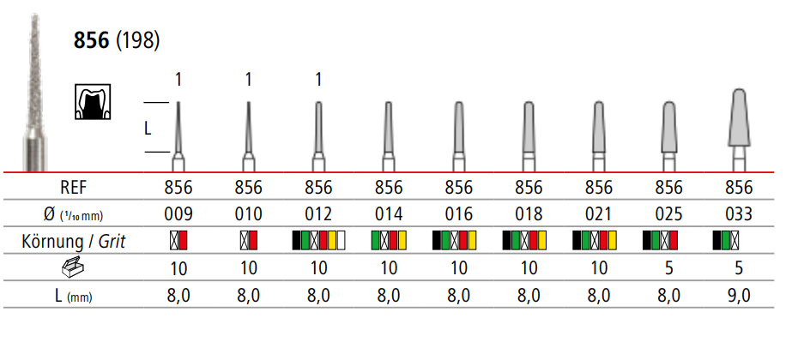

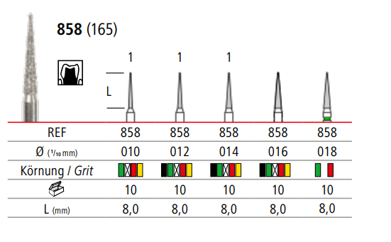

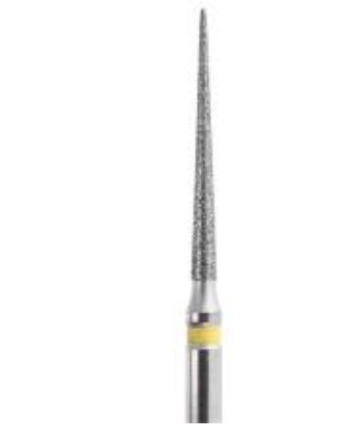

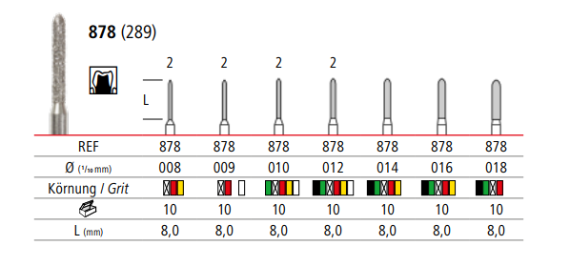 SUPÉR Multi-Use Diamond Burs Modified Chamfer 879K/014C Coarse Grit (30 Burs)  | eBay

