### **نکات کلی و توضیحات:**

* ایده و نمونه کاتالوگ مورد نظر ما برای برخی صفحات در فولدر Sample آورده شده است.
* رنگ های مجاز به استفاده، 5 رنگ ذکر شده در فایل Colors.pdf است.
* فولدر Brand Logos شامل لوگو های مورد استفاده در صفحه 1
* فولدر Gordita-Font-Windows شامل فونت های مورد استفاده در کاتالوگ
* فولدر Images شامل عکس های با کیفیت بالاتر مورد استفاده در این فایل
* فولدر Our Company Logo شامل لوگو ما است.
* فولدر Sample شامل نمونه از صفحه اول یک کاتالوگ شبیه به چیزی که مد نظر ما هست، ولی لطفا سلیقه گرافیکی و طراحی مناسب اعمال شود.

### **نام شرکت:**

### **Sahara Tech Enterprises**

### **Page 1:**

### **🔹 Visual Elements:**

* لوگو و نام شرکت در بالای کاتالوگ
* دسته بندی محصولات: به صورت زیر به گونه ای که جلب توجه هم نماید(در مقایسه با فایل نمونه در فولدر Sample صفحه یک که در آن برند ها جلب توجه نمیکنند یکی از عللش ریز بودن هست):
* Product Categories:
* Servers
* HGX/DGX Servers
* Storages
* GPUs
* Switches
* Routers
* Firewalls
* Base Stations & Refurbished Equipment

At Sahara Tech, we bring over 15 years of industry expertise and are committed to long-term partnerships, innovation, and excellence, ensuring that businesses worldwide have access to cutting-edge IT solutions tailored to their needs.

قراردادن لوگو های برند ها: در مرکز آنها لوگو ما باشد به صورت متمایز. ولی در طراحی نمونه لبه ها تیز هستند، ما نمیخواهیم تیز باشند.

نام لوگو ها به ترتیب اهمیت: (تصویر با کیفیت بالای لوگو ها در پوشه Brand Logos ضمیمه شده است)(نیازی به نوشتن نام لوگو نیست، لوگو آن به تنهایی کفایت میکند.)

1. Cisco
2. Supermicro
3. Nvidia
4. Dell
5. HPE
6. Brocade
7. Lenovo
8. Fortinet
9. NetApp
10. Hitachi
11. IBM
12. Huawei
13. Inspur
14. Juniper
15. Quantum
16. Qnap
17. Nokia
18. Ericson

* طراحی یک تصویر مشابه زیر(یک نقشه جغرافیای کشورها) که در آن سه دسته کشور مشخص شده باشند.

دسته 1: کشور هایی که ازشون محصول میخریم با یک آیکون مرتبط با خرید به جز سبد خرید مشخص شود شامل:China, Vietnam, USA, UK, India

دسته 2:کشور هایی که بهشون محصول میفروشیم با یک آیکون روی کشور ها مشخص شوند شامل Saudi Arabia, Iran, Russia UAE

دسته 3:کشور هایی که در آن دفتر داریم با یک آیکون مثل ساختمان دفتر مشخص شوند. شامل UAE, Canada, UK

یک راهنما هم تصویر داشته باشه:  
آیکون خرید:Sourcing Countries, [Icon]

آیکون فروش:Sales Countries, [Icon]

آیکون دفتر:Office Locations

## **Page 2:**

**About Sahara Tech Enterprises**

Sahara Tech Enterprises is a trusted global provider of enterprise IT hardware, specializing in network infrastructure, high-performance computing, and cybersecurity solutions. With a presence across UAE, China, Hong Kong, and Europe, we have built a reputation for authentic technology solutions, efficient global logistics, and flexible financial solutions.

**Company Strengths**

* **Extensive Inventory & Rapid Fulfillment:** Sahara Tech maintains state-of-the-art warehouses in key global trade hubs, ensuring fast, reliable deliveries of enterprise servers, storage solutions, networking hardware, and AI computing products.
* **Certified Technical Expertise:** Our team includes industry-certified engineers and IT specialists with expertise in Dell EMC, HPE, Cisco, Huawei, Lenovo, and Fortinet solutions to provide seamless pre-sales consultation, technical support, and after-sales service.
* **Strong Supplier Partnerships:** As a trusted supplier and certified reseller, we have established strategic partnerships with over 25 global ICT brands, ensuring access to genuine, vendor-backed solutions with competitive pricing.
* **Global B2B Network:** We serve over 200 enterprises worldwide, catering to industries such as banking, telecom, AI, cloud computing, and education with tailored ICT solutions.

**What Sets Sahara Tech Apart:**

Over 15 Years of Industry Expertise – Trusted leader in B2B enterprise IT hardware.  
🔹Direct Vendor Portal Access – Gain exclusive access to a wide range of vendor portals for seamless quoting and procurement.  
🔹 Comprehensive Product Portfolio – Covering servers, storage, networking, AI computing, and cybersecurity.  
🔹 Competitive Regional Pricing – Strategic sourcing from UAE, China, Europe, and the US to maximize cost efficiency.  
🔹 Flexible Financial Solutions – Multi-currency transactions (AED, USD, HKD) and supplier-backed financing for enterprise buyers.  
🔹 Global Logistics Expertise – Warehouses in UAE, China, HK, and Europe, ensuring fast, reliable deliveries.  
🔹 New Original & Replacement Products – Flexible sourcing for New Original Dell, Lenovo, and Cisco products, plus trusted CPU, Storage, and Memory replacements from Samsung, Hynix, and Intel.  
🔹 Reliable Post-Sales Support – Direct vendor warranties and dedicated customer service.

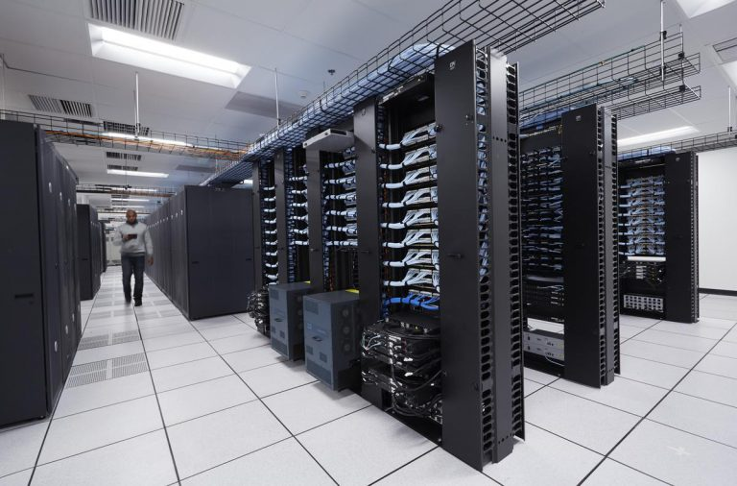

## **Page 3: High-Performance Computing and AI Hardware**

As artificial intelligence, deep learning, and high-performance computing (HPC) continue to revolutionize industries, Sahara Tech delivers cutting-edge solutions designed for enterprises requiring **unmatched performance, scalability, and efficiency**.

**AI-Optimized Server & GPU Solutions**

🔹 **Enterprise AI Servers** – High-performance AI computing for deep learning, neural networks, and large-scale AI models.  
🔹 **NVIDIA HGX & DGX Systems** – Featuring the latest:

* **HGX H100 & H200** – Designed for extreme scalability in AI training and inference.
* **DGX H100 & DGX H200** – Purpose-built AI supercomputing for enterprise and research applications.
* **NVIDIA B100 & B200**– Next-generation AI acceleration for data centers and high-performance workloads.  
  🔹 **Scalable HPC Infrastructure** – Optimized for **AI research, cloud computing, and big data analytics**.

**Competitive Advantages**

* **Exclusive Supplier Pricing** – Preferred access to NVIDIA, HPE, Dell, Super Micro, Lenovo, and xFusion AI solutions.
* **Global AI-Driven Procurement** – Strategic sourcing from **UAE, HK, US, UK, and Singapore** ensures cost-effective and timely delivery.
* **Compliance & Market Flexibility** – Direct vendor portal access for **certified AI hardware, enterprise support, and warranty-backed solutions**.

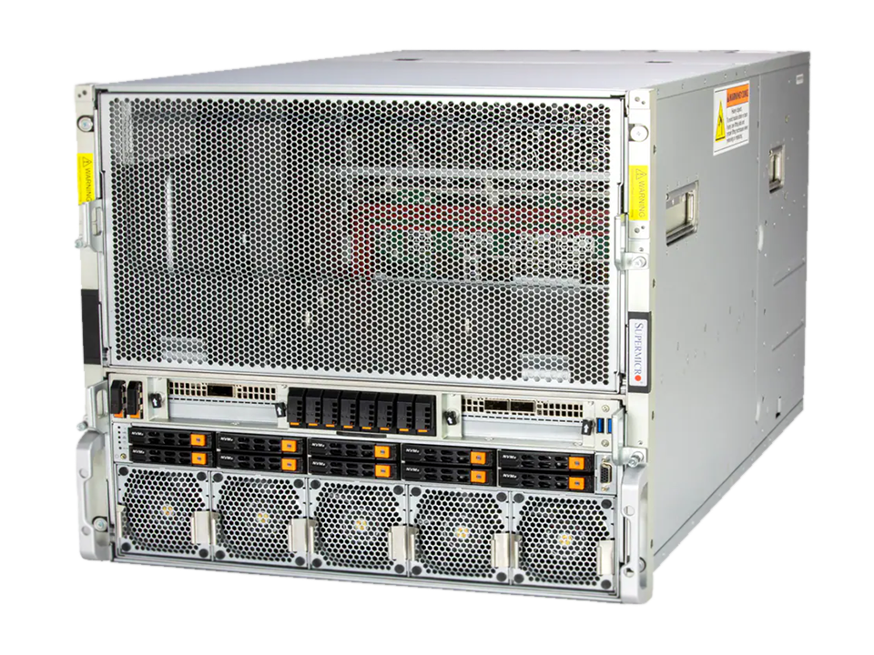

SuperMicro NVIDIA HGX B200 System

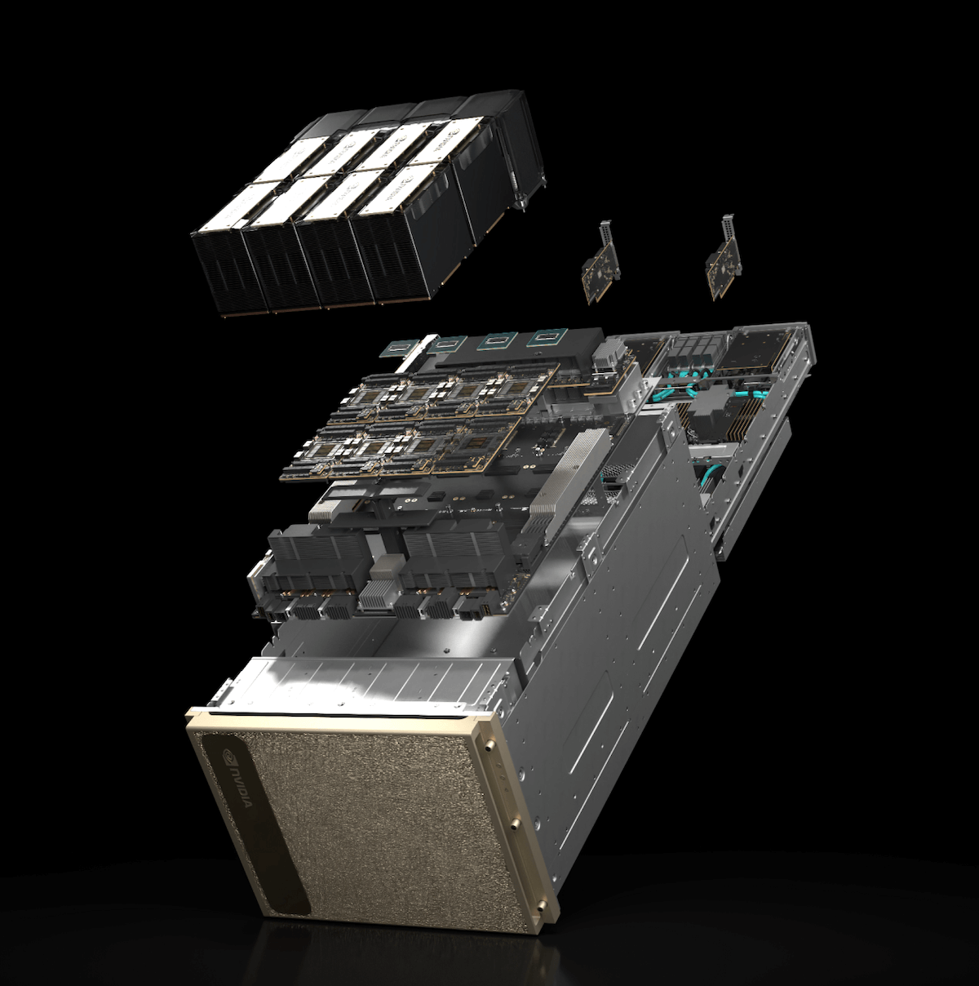

NVIDIA DGX H200

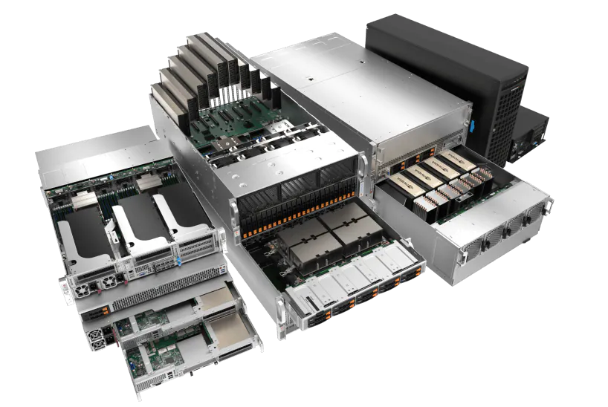

Supermicro H200, H100 & L40 GPU Platforms

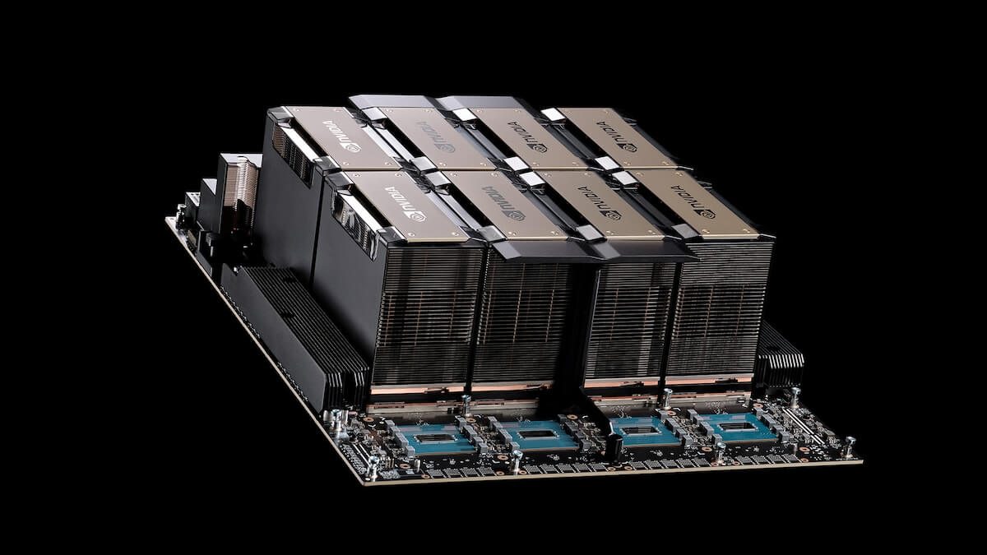

HGX H200 Baseboard

## **Page 4:** **Enterprise Servers & Storage Solutions**

In today’s data-driven world, enterprises require **high-performance, scalable, and secure** server and storage solutions. Sahara Tech delivers cutting-edge infrastructure for **mission-critical workloads**, **AI-optimized computing**, and **enterprise data management**.

**Scalable & Reliable Server Infrastructure**

* **Enterprise Servers** – Performance-driven solutions from **Dell, HPE, Lenovo, IBM, Huawei, and SuperMicro**.
* **Hyperscale & Data Center Solutions** – AI-optimized, **high-density computing for cloud, finance, and research applications**.

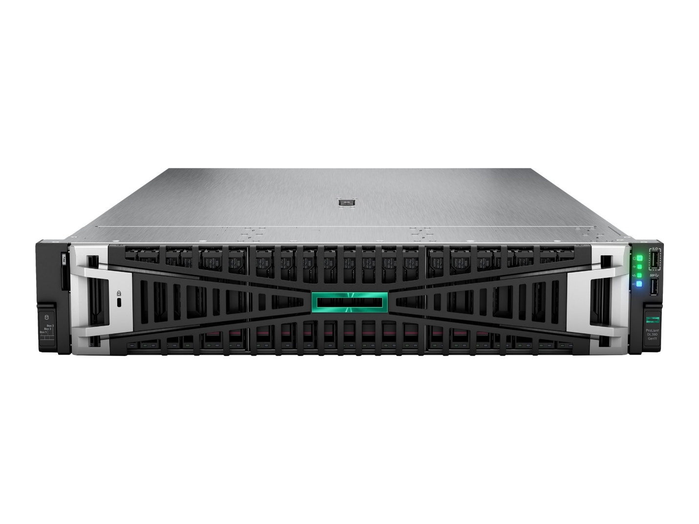

HPE ProLiant DL380 Gen11

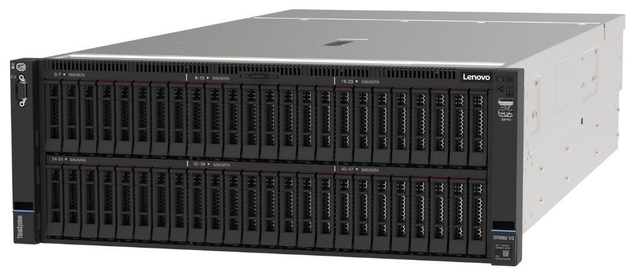

Lenovo ThinkSystem SR860 V3

**Enterprise Storage Solutions**

* **High-Performance Storage** – Scalable storage architecture from **Dell EMC, NetApp, IBM, and Huawei OceanStore & OceanProtect**.
* **Hybrid Cloud Storage** – Secure, **compliance-ready storage for financial institutions, healthcare, and AI-driven enterprises**.

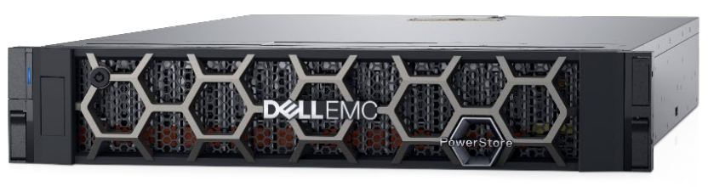

Dell EMC PowerStore 9000T

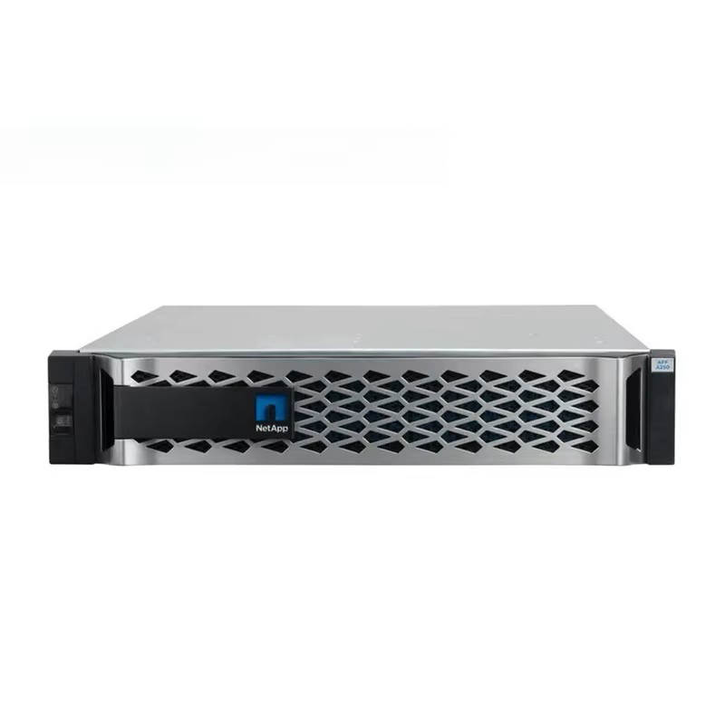

NetApp FAS9500

**Competitive Advantages**

* **Direct Supplier Pricing** – Access **preferred pricing** on **Dell EMC, Lenovo, and IBM** enterprise solutions.
* **Flexible Component Sourcing** – Quote **New Original** Dell, Lenovo, and Cisco products, with the option to source **CPU, Storage, and Memory replacements** from **trusted brands like Samsung, Hynix, and Intel**.
* **Exclusive Vendor Portal Access** – **Priority order fulfillment** through **direct access to Dell EMC & Lenovo vendor portals**, ensuring compliance, authenticity, and supply chain efficiency.
* **Customizable Regional Sourcing** – Sahara Tech can provide **cost-efficient China-sourced** solutions for price-sensitive customers or **European-manufactured versions** for those requiring **strict compliance and regional preferences**.

## **Page 5: Enterprise Networking & Security Solutions**

In today’s hyper-connected world, businesses demand **scalable, high-speed networking** and **AI-driven cybersecurity** to protect their critical infrastructure. Sahara Tech delivers **enterprise-grade solutions** designed for **banking, telecom, cloud providers, and large-scale enterprises**.

**Enterprise Networking Solutions**

* **High-Performance Connectivity** – Seamless, scalable enterprise networking with **Cisco, Huawei, and Aruba**.
* **Data Center & Cloud Networking** – Optimized for **ultra-low latency and high-bandwidth applications**.

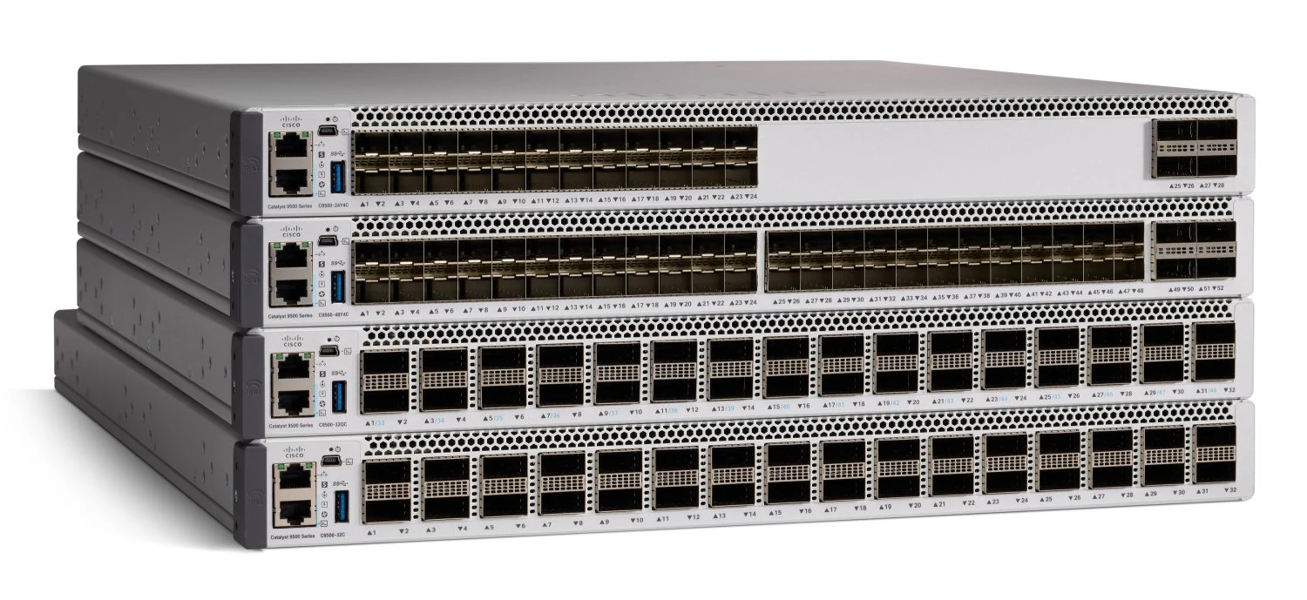

Cisco Catalyst 9500 Series switches

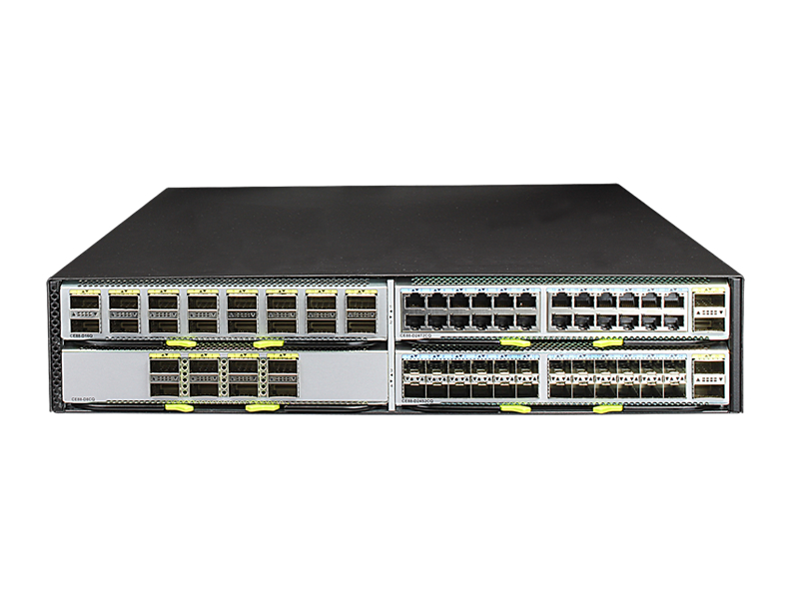

Huawei CloudEngine 8800

**Cybersecurity & Threat Protection**

* **Next-Gen Firewalls & AI-Driven Security** – Fortinet & Cisco solutions for **threat detection, intrusion prevention, and endpoint security**.
* **Zero Trust & Compliance-Ready Security** – Tailored for **banking, telecom, healthcare, and critical infrastructure enterprises**.
* **Fortinet Regional Sourcing Expertise** – Sahara Tech provides insights on **which Fortinet models are best ordered from specific regions** to optimize pricing and availability.

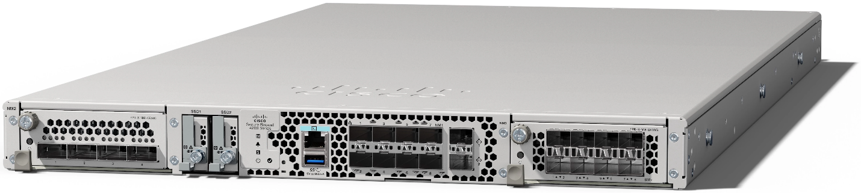

Cisco Secure Firewall 4200

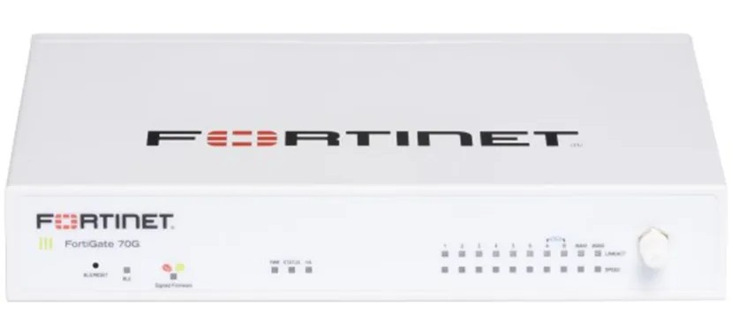

Fortinet FortiGate 70G

**Competitive Advantages**

* **Exclusive Supplier Pricing** – Sahara Tech secures **preferred pricing** on Huawei networking solutions.
* **Custom Security Integrations** – Enterprise-grade **cybersecurity and threat protection models** designed for high-compliance industries.
* **Scalable Network & Security Solutions** – Optimized for **hybrid cloud, AI-driven traffic monitoring, and enterprise infrastructure protection**.
* **Customizable Regional Sourcing** – Sahara Tech can provide **cost-efficient China-sourced** networking solutions for price-sensitive customers or **European-manufactured versions** for those requiring **strict compliance and regional preferences**.

## **Page 6: Telecom 4G & 5G Infrastructure Equipment**

As **4G, 5G and next-generation telecom networks** reshape global connectivity, Sahara Tech empowers **telecom operators, enterprises, and government projects** with cutting-edge **base stations, refurbished equipment, and network infrastructure**.

**Base Stations & Refurb Solutions**

* **Carrier-Grade Base Stations** – Featuring **Huawei, Nokia, and Ericsson**, designed for **high-performance network expansion and reliable connectivity**.
* **Refurb Base Stations & Antenna Solutions** – Optimized for **wide-area coverage, enhanced signal strength, and seamless urban & rural deployments**.
* **4G & 5G Infrastructure** – Sahara Tech provides solutions for both 4G and 5G networks, catering to regions still expanding 4G coverage while preparing for future 5G rollouts.

**Competitive Advantages**

* **Strategic Stockpiling** – Ensuring **fast delivery** and **priority fulfillment** for **high-demand telecom hardware**.
* **Best Pricing & Regional Sourcing** – Leveraging **UAE and European procurement hubs** for cost-effective **5G infrastructure expansion**.
* **Africa & Eastern Europe Market Expansion** – Supporting telecom operators with **scalable, future-proof solutions** for emerging markets.

**Contact us today for bulk orders, partnerships, and custom telecom solutions.**

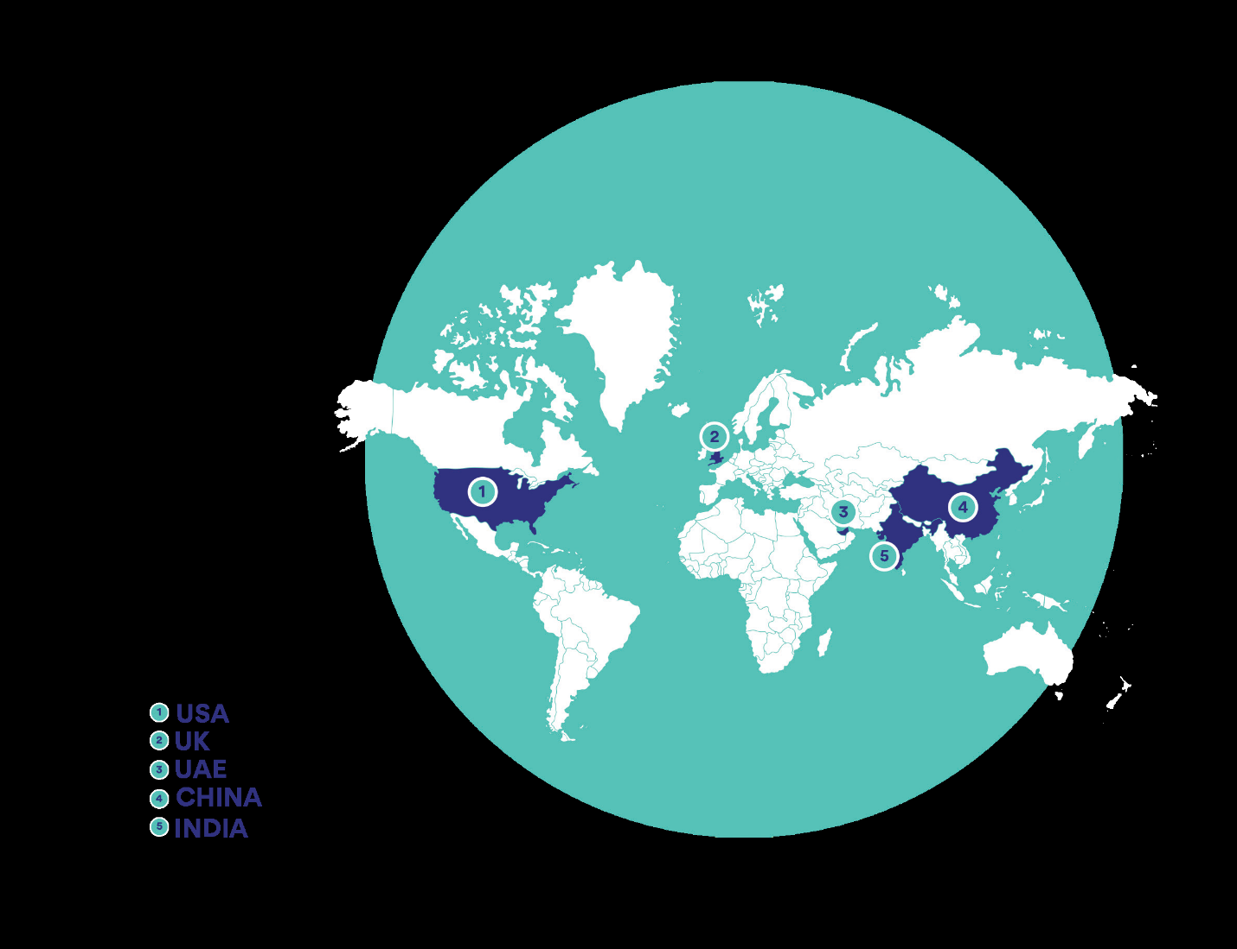

Sahara Global Partner Network

**Contact Us**

**Website:** <https://saharatech.ae>  
**Email:** info@saharatech.ae  
**Office:** No. 23, 7th Floor, Dubai National Insurance Building, Port Saeed, Dubai, UAE  
**Phone:** +971 4 252 5632  
**Mobile:** +971 55 882 3669