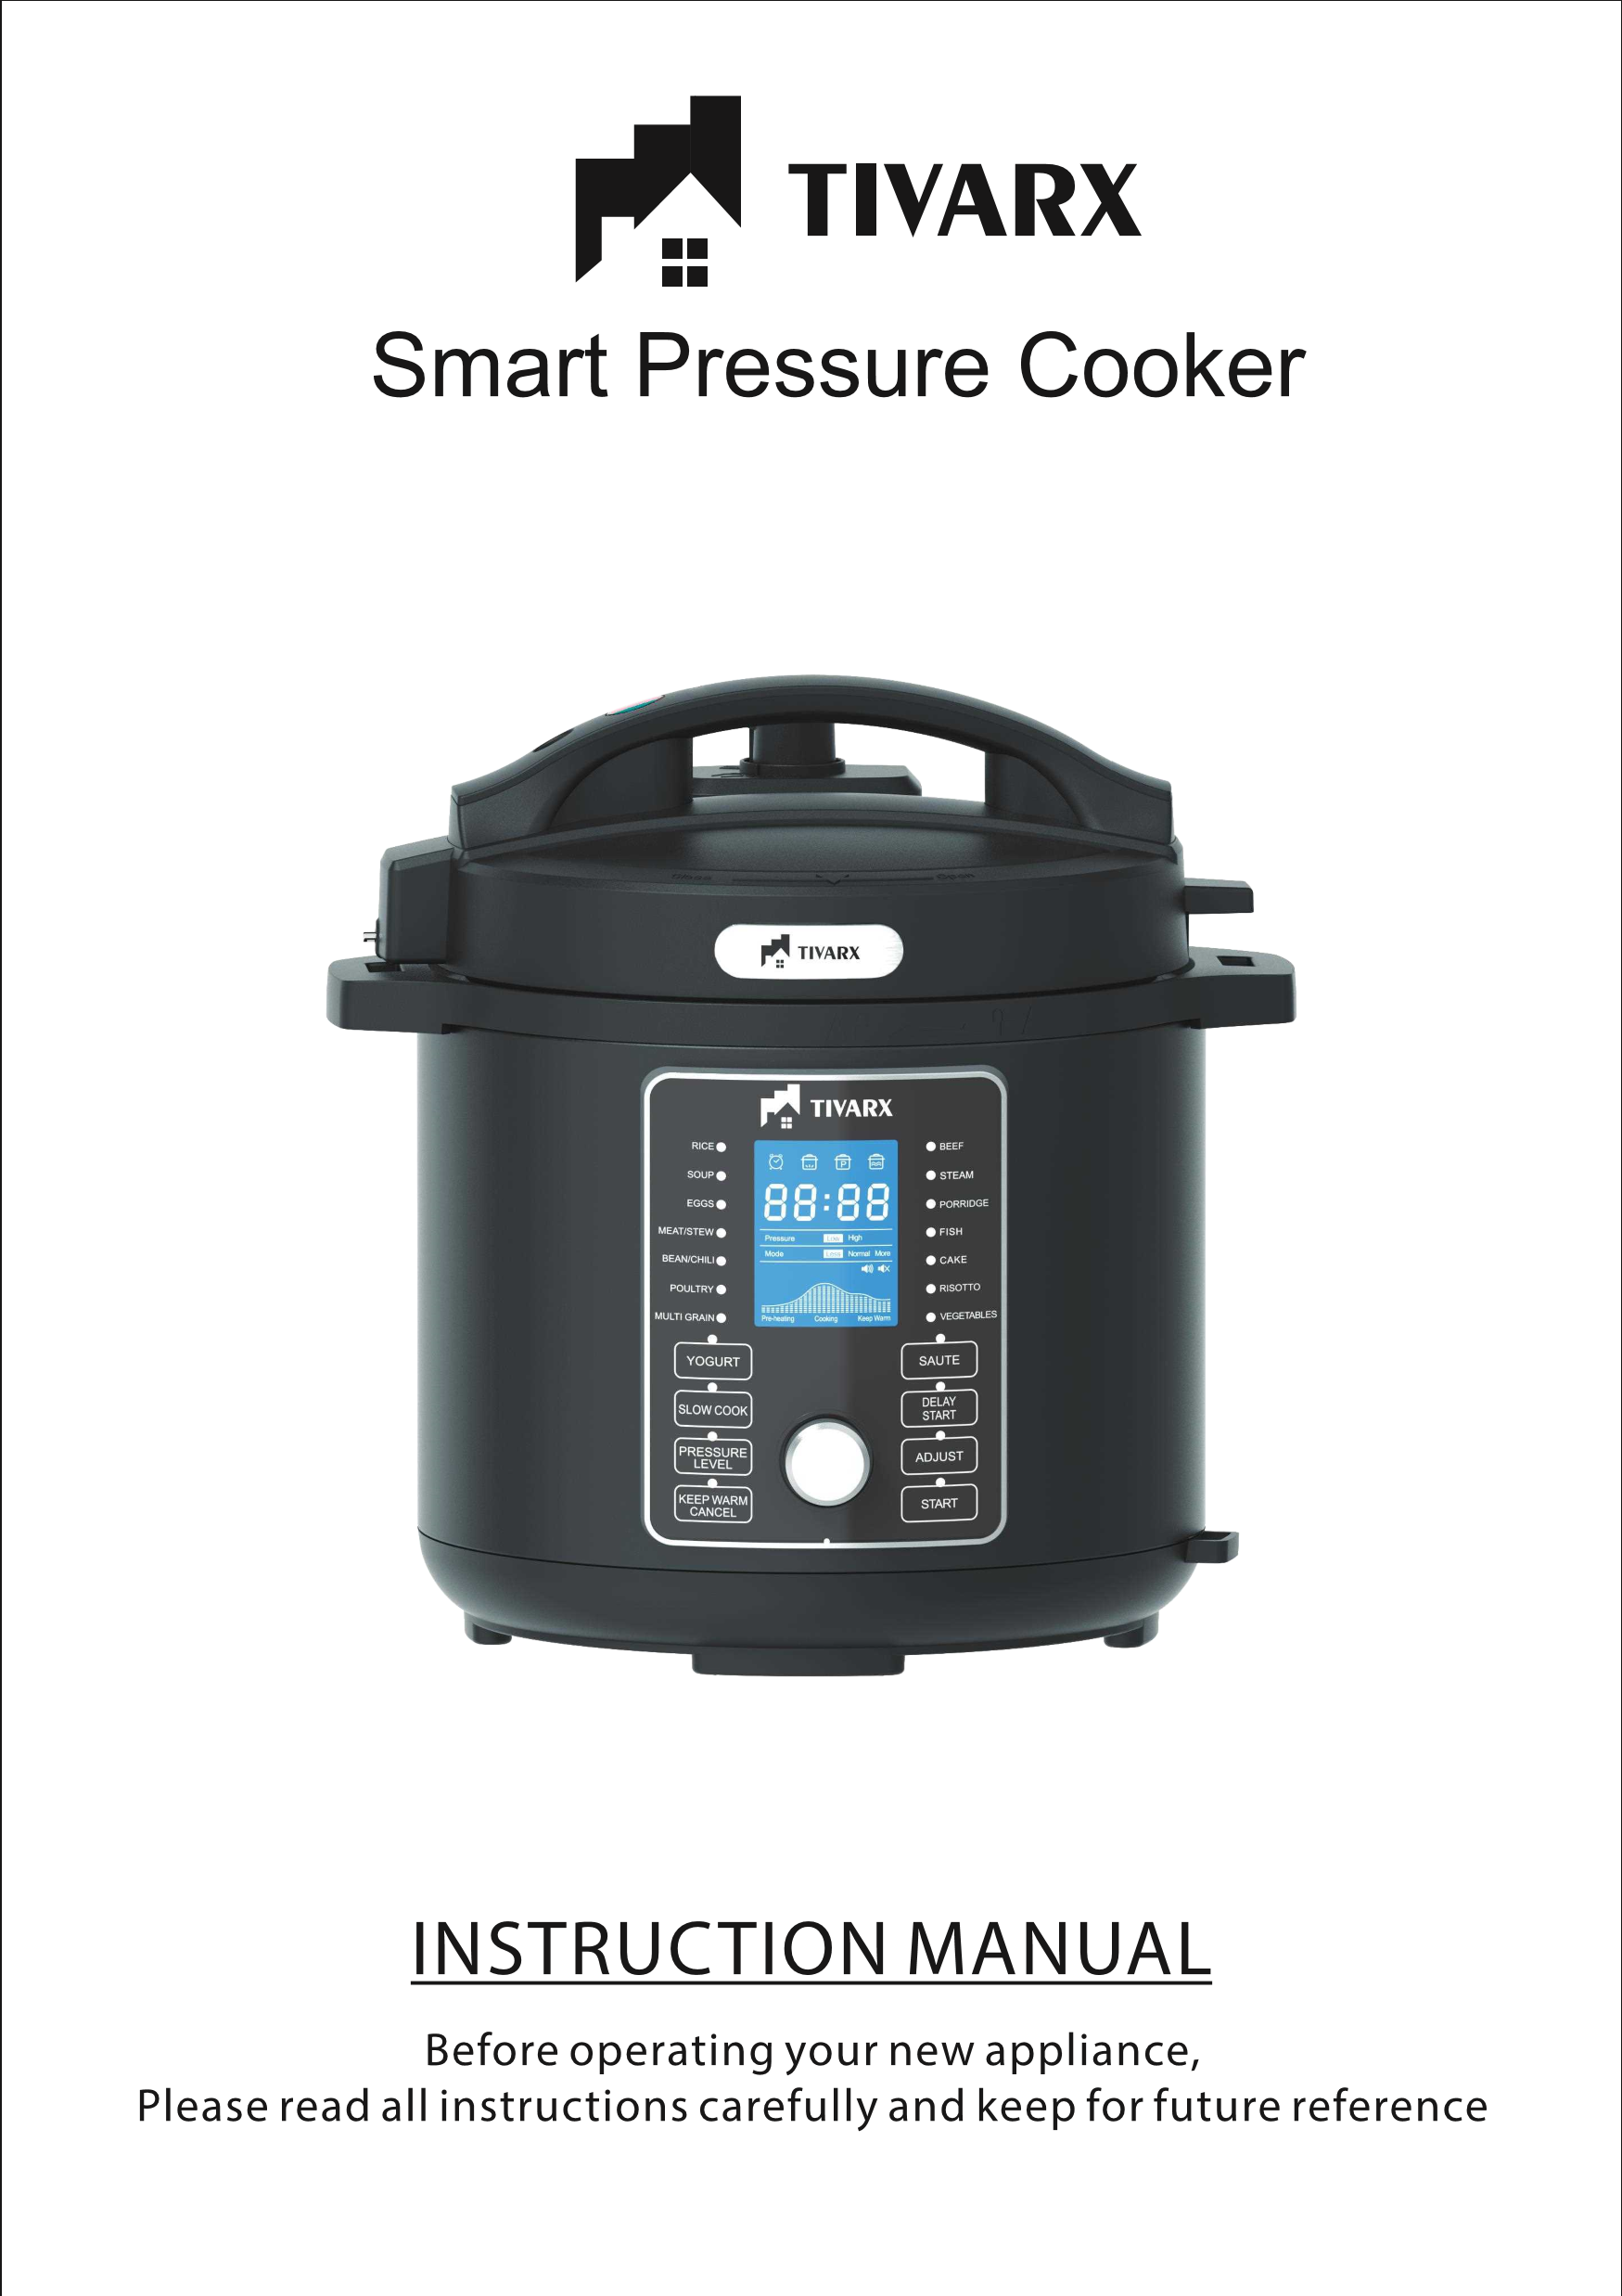

Smart Pressure Cooker

Model No:Tx-4066

CAUTION HOT STEAM
RISK OF SCALDING: USE TONGS OR LONG UTENSIL TO TURN THE PRESSURE LIMITING VALVE.
KEEP HANDS AND FACE AWAY FROM PRESSURE

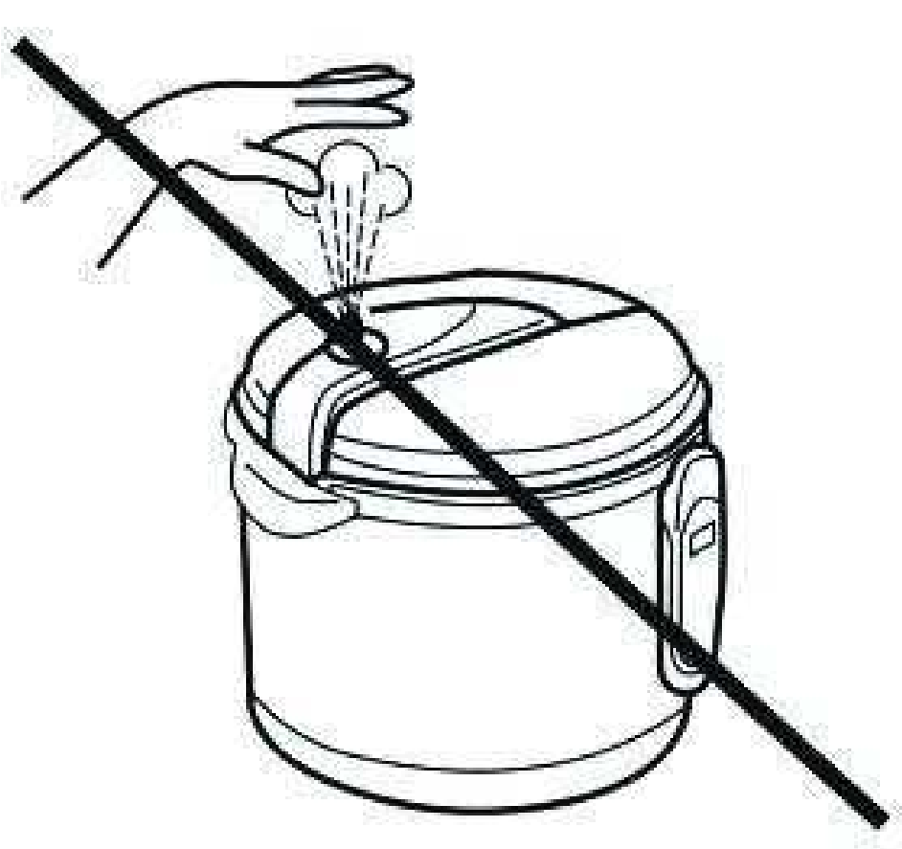
LIMITING VALVE WHILE IN THE EXHAUST POSITION.
FAILURE TO COMPLY MAY CAUSE SERIOUS INJURY.
DO NOT RELEASE PRESSURE UNDER HANGING
CABINETS WHICH CAN BE DAMAGED BY STEAM
.
Always use an oven mitt to reduce risk of injury.
To avoid liquid splatter, do not manually release the pressure from the valve for foods with a high volume of liquid (stews, soups, porridges, etc.).
| 2

DO NOT ALLOW
CHILDREN TO
OPERATE UNDER ANY CIRCUMSTANCES

CLOSE SUPERVISION IS MANDATORY WHEN THE PRESSURE COOKER IS USED NEAR CHILDREN.
3 |
Thank you for purchasing our product.
Make sure you have read the manual before using this product.
Please use the appliance in accordance with the instructions.
Please save these instructions. This item is intended for household use only.
IMPORTANT:
Do not use this appliance until you have read this entire manual thoroughly!
| 4

CONTENTS
- IMPORTANT SAFEGUARDS 6
- SAFETY WARNING 8
- ABOUT YOUR PRESSURE COOKER 9 • PARTS IDENTIFICATION 10
- PRESSURE COOKE R FUNCTIONS 13
- BEFORE FIRST USE 15
- INSTRUCTIONS FOR USE 16
- OPERATING INSTRUCTIONS 17
- CLEANING INSTRUCTIONS 23 • HELPFUL TIPS 24
5|
When using the pressure cooker, basic safety precautions should always be followed:
- Read all instructions before operation.
- DO NOT touch hot surfaces. Use handles and a potholder.
- This appliance should not be used near children, or individuals with certain disabilities.
- DO NOT ALLOW CHILDREN TO OPERATE UNDER ANY CIRCUMSTANCE.
- NEVER ATTEMPT TO OPEN LID WHILE THE UNIT IS OPERATING. Do not open the pressure cooker until
the unit has cooled down and all internal pressure has been released. this indicates that the cooker is still pressurized. Do not force it to open. Any pressure in the cooker can be hazardous.
- DO NOT place the pressure cooker on or near a hot gas stove-top, electric burner or in a heated oven.
- Extreme caution must be used when moving a pressure cooker containing hot liquids.
- DO NOT use the pressure cooker for any use other than as intended.
- This appliance cooks under pressure. IMPROPER USE MAY RESULT IN SCALDING INJURY.
- Ensure that the unit is properly closed before operating. (See “BEFORE FIRST USE” section, page 11)
- To protect against electrical shock, do not immerse cord, plugs, or outer vessel in water or other
liquids.
12.
clogging of the pressure limiting valve and excess pressure.
- Please note that certain foods (such as applesauce, cranberries, pearl barley, oatmeal or other
cereals, split peas, noodles, macaroni, spaghetti or rhubarb) can foam, froth, and sputter, clogging
foods should not be cooked in a pressure cooker.
Always check the pressure release
- for clogging before use.
- DO NOT use this pressure cooker with high amounts of Oil, it may NEVER be used as a fryer to fry
foods in hot oil.
|6
16.
- DO NOT tamper with the sealing ring in the lid using any tools or external forces. If the sealing ring is damaged, please stop using immediately.
- Never use additional weight on the pressure limiting valve or replace it with any other object.
- The surface of contact between the inner pot and the heating plate should always be clean. DO NOT
use the inner pot with other heating sources. DO NOT replace the inner pot with a container other than what is provided with your new Pressure Cooker.
- Unplug from outlet when not in use and before cleaning. Allow to cool before putting on, or removing parts.
- Do not operate this appliance with a damaged cord or plug, or after it malfunctions or has been
damaged in any manner. Return the appliance to the retailer .
22.
disconnect, press the “KEEP WARM/CANCEL” button, then unplug from wall outlet.
- Do not use outdoors.
- Some counter-top and table surfaces, such as wood and/or laminates, are not designed to withstand prolonged heat generated by certain appliances. It is recommended by countertop manufacturers that a hot pad or trivet be placed under your appliance to prevent possible damage to the surface.
- Do not use under hanging or wall cabinets; steam from pressure release may cause damage. DO NOT disassemble the product, or replace parts with parts not intended for this unit.
- unplug the unit from
the electrical outlet when storing in a garage.
- Should you have a malfunction with your new pressure cooker, please feel free to reach out to us at any
time!
- The use of accessories or attachments may cause injuries and is strictly prohibited by the appliance manufacturer.
7 |

as instructed. To reduce the risk of electric shock, please ensure the main power cord is connected to a properly grounded 220-240V|50-60Hz power outlet.
- This product is to be used indoors, in a dry environment only and is not intended for commercial use.

- The use of an extension cord, power adapter or other electric devices is not recommended.

LED ERROR INDICATOR
Indicator Code
Problem / Cause
E1
E2
E3
E4
Open circuit of the sensor
Short circuit of the sensor
Overheating
Signal Switch Malfunction

ABOUT YOUR PRESSURE COOKER
This digitally controlled and automatic pressure cooker uses advanced technology so you

Your Megachef Pressure Cooker seals in steam to cook hotter and quicker, while maintaining important nutrients for healthier meals. Cooking fast and with less water saves vital natural resources and energy!
The unit features easy touch-button settings, a countdown timer, and a cooking pot big enough for family gatherings! This pressure cooker is simple to use, makes meals quick and easy, and saves you money!
PRESSURE COOKER WITH MULTIPLE FUNCTIONS
Multiple functions for cooking, stewing, braising and simmering.
Cooking will be done automatically by selecting the different menu choices on the unit.
The pressure cooker also has its own memory; in case of interruptions, such as a power failure, the unit will automatically resume the cooking cycle where it was left off.
RAPID COOKING; TIME & POWER SAVING
By using high pressure and high temperature, food will be cooked much faster.
This will reduce the cooking time and consumption of power. For example: when cooking rice, this pressure cooker will save up to 20% of the electricity and up to 15% of the time when compared to a conventional rice cooker. When cooking stew, soups or braising meats, this cooker will save more than 40% of time and more than 45% of power as compared to a conventional slow cooker. Cooking can also be done at high altitudes.
PRESERVES NUTRIENTS & PROMOTES HEALTHY EATING

SPECIFICATIONS
Capacity | Voltage/ Frequency | Power
6 Liters | 220V-240V|50-60Hz | 1000W
8 Liters | 220V-240V|50-60Hz | 1200W
9|

PARTS IDENTIFICATION
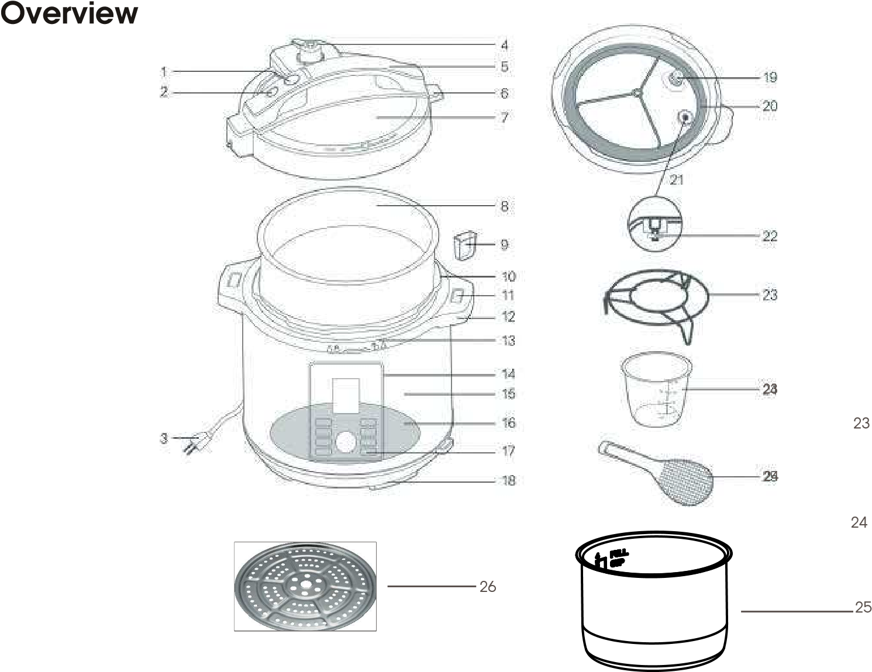
- Lid Release Button
- Float Valve (External View)
- Power Cord 14. Control Panel
- Pressure Limiting Valve ^{15.} ^{Main Body}
- Handle 16. Heating Plate
- Tab for lid Rest ^{17.} ^{Sensor}
  - Bottom Ring
- Lid
  - Filter
- Inner Pot
  - Rubber Seal Ring
- Condensation Cup 21. Float Valve (Internal View)
- ^{Outer pot} 22. Seal Ring for Float Valve
- Lid Rest (Lid Latches onto either side 23. Measuring Cup handles) 24. Spoon
- Main Body Handles 25. One more inner pot
- Upper Ring 26. Steamer
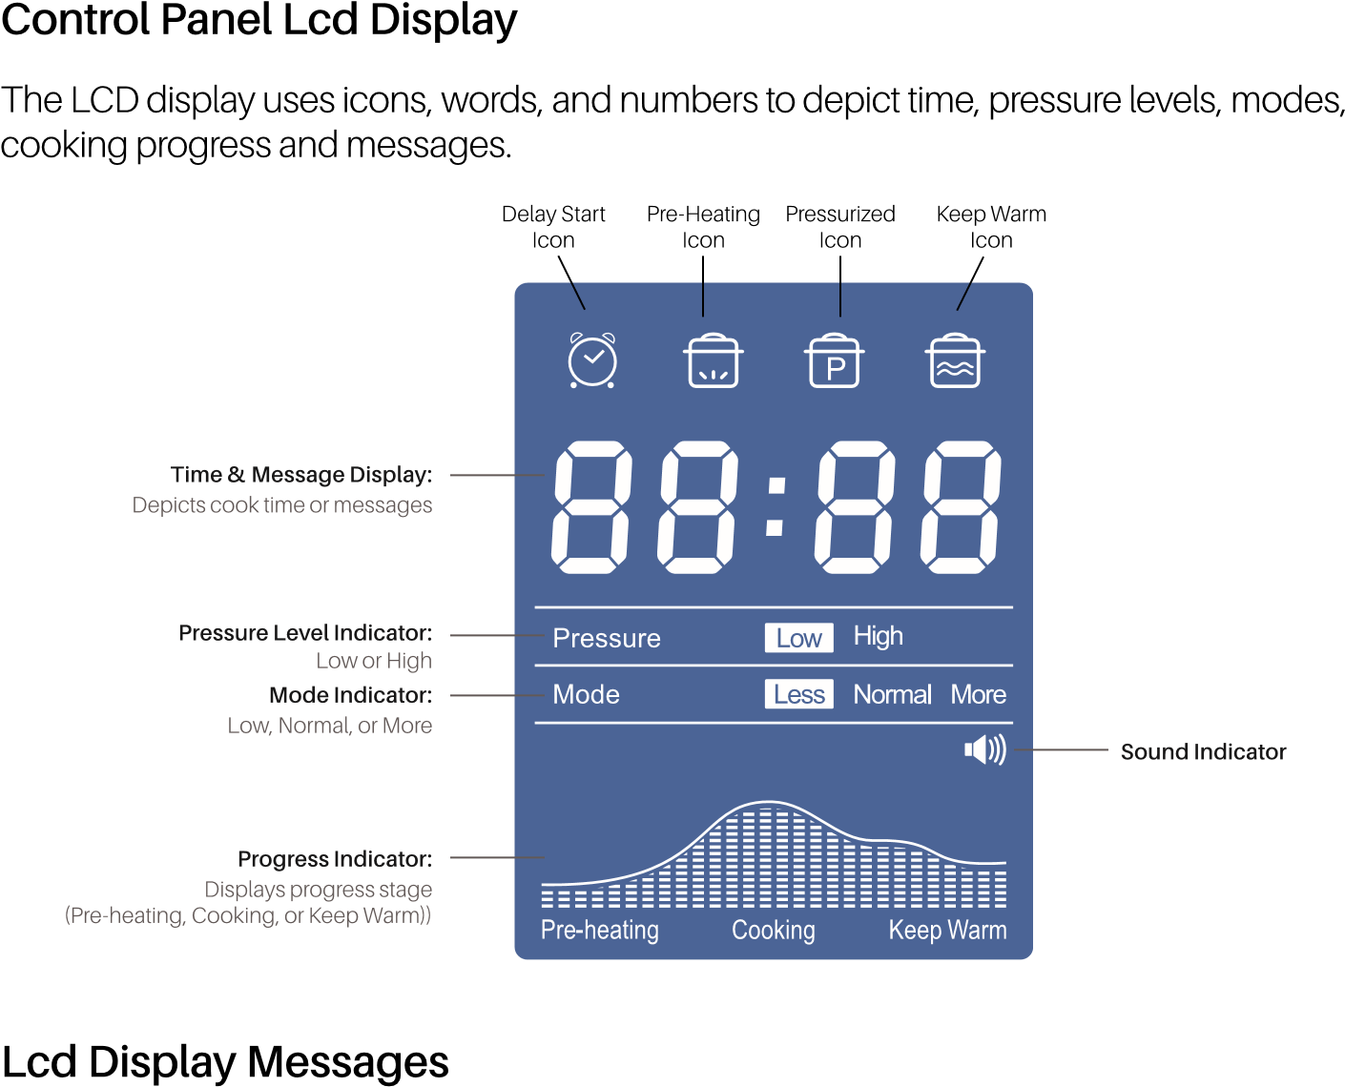
11 |

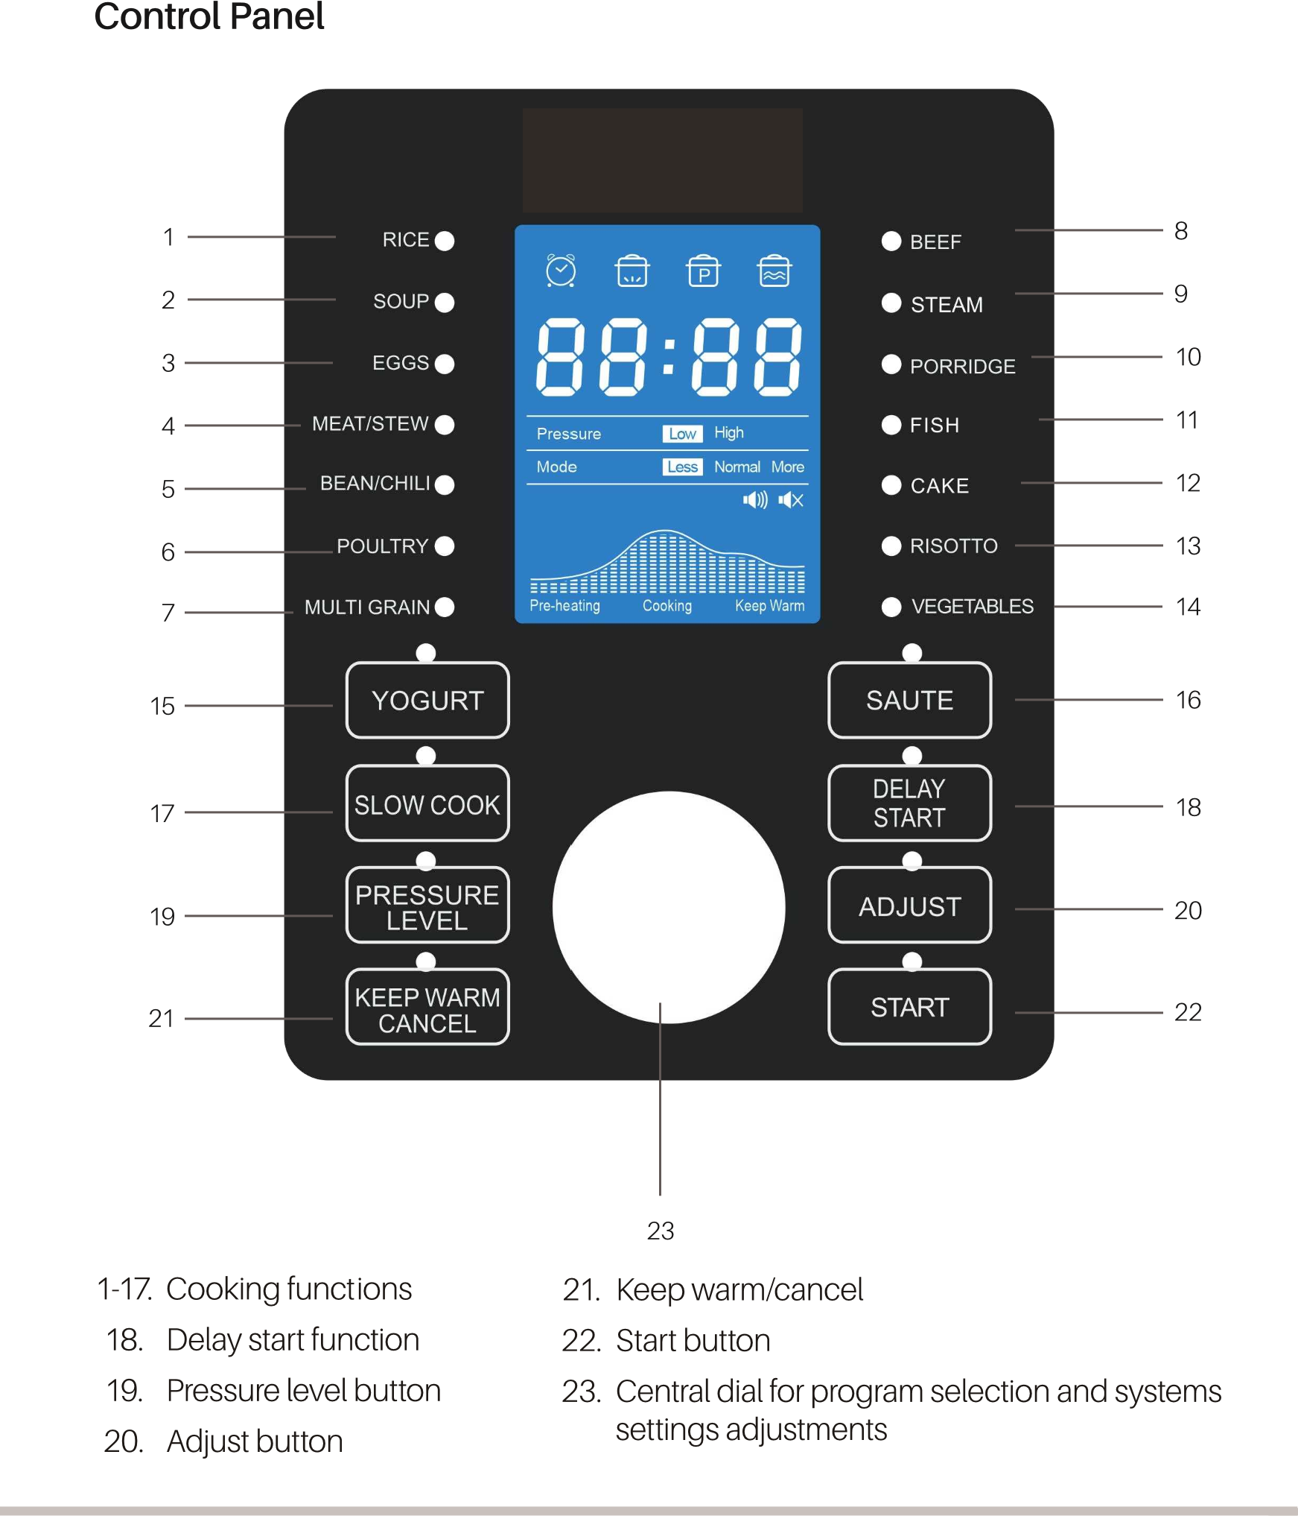

PRESSURE COOKER FUNCTIONS

Pressure Cooker with Multiple Functions
- Multiple functions for cooking, stewing, braising and simmering.
- Cooking will be done automatically by selecting the different menu choices on the unit.
- The pressure cooker also has its own memory. During interruptions such as a power failure, the unit will automatically renew the cooking cycle where the unit left off when the power resumes.

Rapid Cooking; Time & Power Saving
By means of high pressure cooking, your new pressure cooker can produce delicious healthy meals in a fraction of the time and with a higher nutrient density as compared to traditional cooking methods.
For example:
When cooking rice, this pressure cooker will save up to 20% of the electricity and up to 15% of the time when compared to a conventional rice cooker. When cooking stew, soups or braising meats, this cooker will save more than 40% of time and more than 45% of power as compared to a conventional slow cooker, Cooking can also be done at high altitudes.

Preserve Nutrients & Promotes Healthy Eating
Airtight cooking methods preserve nutrients and original flavor of food.
Cooking Feature for Eggs:
- Fill pressure cooker with the maximum (6 Cups) of water in the stainless steel pot.
- Place eggs in the stainless steel pot half way above the water.
- Choose the “Eggs” setting on the pressure cooker preset option
- Once cooked, make sure the steam has been fully released.
- Use cooking tongs to remove the Eggs carefully.
13|

Rubber Seal Ring Assembly
Always ensure the Rubber Seal Ring is securely fitted onto the metal Y-shaped ring in the interior of the Lid. Make sure the crease in the Rubber Seal Ring meets with the outside of the Y-Ring all the way around. Then place the Y-Ring and Rubber Seal Ring back in to the Lid making sure the hole in the center of the Y-Ring’s cross-section is lined up with the metal pin in the center of the Lid. Press down firmly until the Y-Ring is secured onto the Lid.
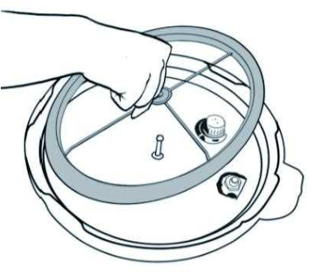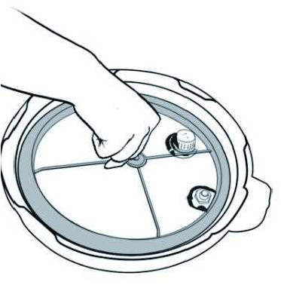

Pressure Cooker Lid Markings
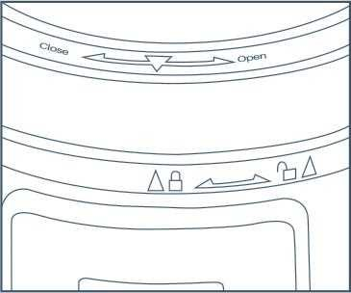
Please note the “OPEN” and “CLOSE” markings on the rim of the pressure cooker body and the “ “ on the rim of the Lid. To properly close and secure the pressure cooker Lid, Always line up the “ “ marking on the Upper Ring and the “ “ on the rim of the Lid.

Condensation Cup Assembly
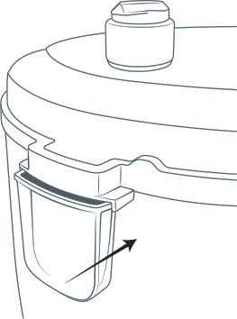
The Condensation Cup is the clear plastic piece that snaps into the back side of the pressure cooker as shown right picture. Place condensation cup in rear of the unit it locks into place, it is part 12 in the diagram on page 6

Pressure Limiting Valve Warning
WARNING:
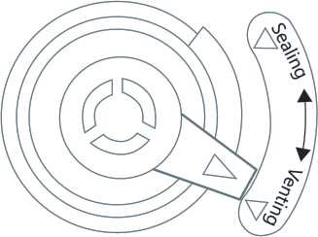


Avoid serious injury. Always use tongs or a long kitchen tool to set the valve to Venting.
CAUTION HOT STEAM:
Keep hands and face away from the pressure limiting valve when rotating to venting.

BEFORE THE FIRST USE
- Remove packaging materials such as cardboard, plastics or Styrofoam and discard appropriately.
- Clean all the parts by wiping with a soft damp cloth or sponge and dry thoroughly.
- Thoroughly clean the cooking pot in the dishwasher or with warm soapy water. Rinse, towel or air dry, and place in the pressure cooker.

Lid Assembly
- How to open the Lid:
Hold the handle firmly while pushing down on the red lid release button, turn the lid counterclockwise until it loosens and lift vertically, the lid can stand on the Lid Rest.
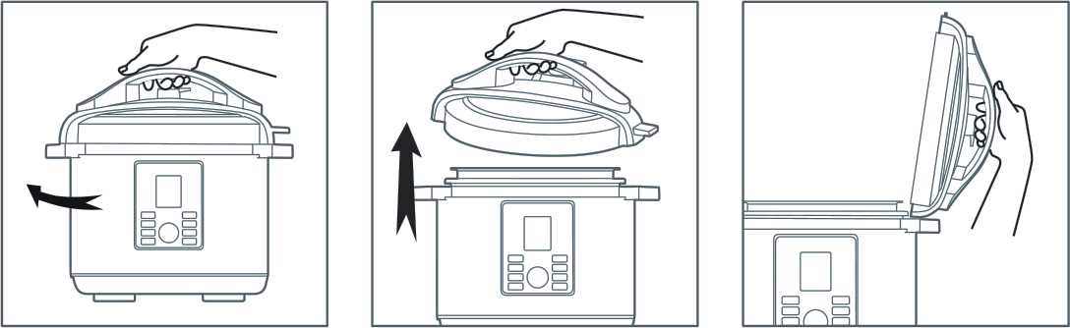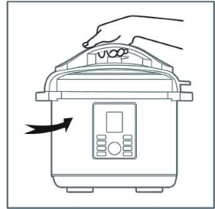
NOTE: For new units, the seal of the Lid may be slightly stronger than normal and may be slightly difficult to unlock. Once the Lid has been opened and closed several times, it will loosen up.
- How to close the Lid:
Observe the Rubber Seal Ring inside the Lid and ensure that it is fitted onto the lid all the way around.
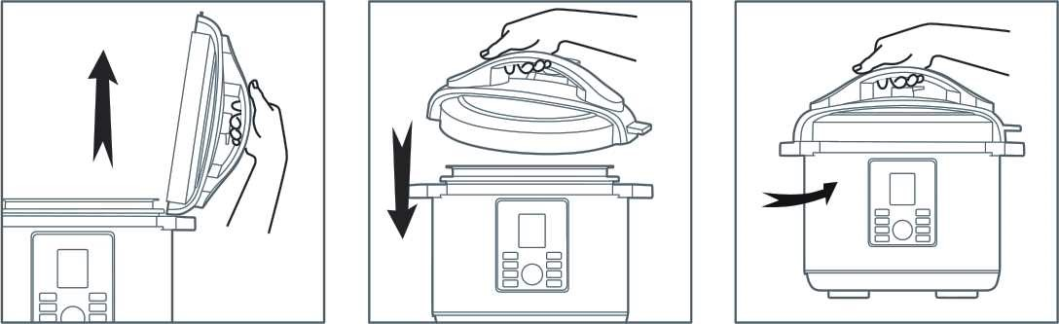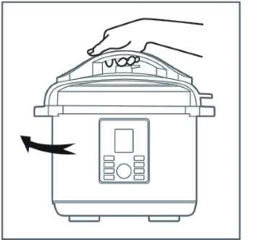
Caution:
- If the rubber seal ring is damaged, do not use the pressure cooker. Contact Customer Service to repair or replace.
- To Lock Lid in place, remove any food residue from rim of Upper Ring of cooking pot to ensure a proper seal. Take the Lid off the Lid Rest, hold the Handle and close it. downwards at the opened Lid position. Turn clockwise until you reach the Closed lid position. (A clamping sound can be heard).
- To ensure you are properly closing the lid, line up the OPEN and CLOSE markings on the Lid and Main Body.
15 |

Water Test
For the first use to ensure correct assembly of the Rubber Seal Ring, it is recommended to read the following instructions and fill the inner Pot with water to the 2/3 line and program to pressure cook for 30 minutes. Once completed, pour out the water. Rinse and towel dry the inner Pot. The pressure cooker is now ready for use.

Lid Safety Lock System
Note: This unit has a built-in safety feature the prevents all functions from activating if the Lid is not properly locked / secured into place.
A Cooking function cannot be selected if the Lid is not properly locked/secured into place. The display will show “Lid” and continuously beep until the Lid is properly closed You will not be able to select a cooking function.
This is to prevent the unit from cooking without the lid being properly secured. The Saute function will still work as the function does not use the lid.

INSTRUCTIONS FOR USE

Cooking Pot Markings
Inside the removable cooking pot are two sets of markings. Oneside is marked "4/5 MAX PRESSURE COOK", which indicates themaximum fill line when cooking any food, other than rice in thepressure cooker. The other marking is MAX RICE CUP and is usedwhen cooking rice. When pressure cooking rice, never fill thepressure cooker with water past the 6 cup marking.
1.Open lid, remove cooking pot from pressurecooker and add food and liquids.
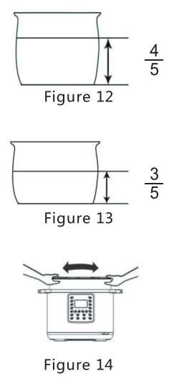
NOTE: The total volume of food andliquidmust not exceed 4/5 of the capacity of thecooking pot (Figure 12). For foods such asdried vegetables and beans, or rice and grains,the total volume must not exceed 3/5 thecapacity (Figure 13).Overfilling may clog thepressure limit valve, which can cause excesspressure to develop. Always use at least 3/5 cupliquid when pressure cooking.
WARNING: To avoid a serious burn injurywhen cooking foods other than rice, neverexceed the 4/5 MAX PRESSURE COOK mark ofthe combined volume of liquids and solids.

- Be certain the inner receptacle, where the plate is located, is clean and dry before inserting the inner Pot into the pressure cooker and adjust the pot left and right to ensure optimal contact between the inner Pot and the heating plate.
- Close and “LOCK” the lid.
- Adjust the Pressure Limiting Valve to the “Sealing” position, and ensure that the Float Valve sinks.
- When adjusting the Pressure Limiting Valve to either the “Sealing” or the “Venting” positions, line up the marking on the Pressure Limiting Valve with the arrow on the Handle as shown in the figure
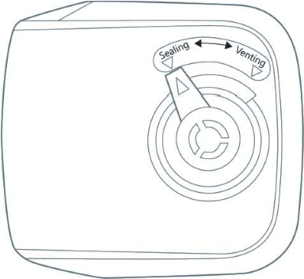
- Plug the power cord into the pressure cooker and than into the wall outlet. The LCD display will show “OFF”

OPERATING INSTRUCTIONS
- With the lid securely locked in place, unit on and the LCD displayed, select the button for the desired cooking function by reading the following instructions
- There are 17 Menu functions programmed for your pressure cooker. They are Rice, Soup, Eggs, Meat/Stew, Bean/Chili, Poultry, Multi grain, Beef, Steam, Porridge, Fish, Cake, Risotto, Vegetables, Yogurt, Slow cook, Saute.
- The default times are programmed for quick and easy cooking for small portions of food less than 3lbs. When cooking food that is more than 3lbs, use the Custom Manual function. Each of the default times is programmed to detect the weight of Manual function. Each of the default times is programmed to detect the weight of food being cooked and how much liquid is inside the pot during the cooking cycle.
- The unit will automatically build up the pressure, cook the food and go to Keep Warm when cooking is complete.

Fish
Cake


After Selecting A menu Button
- Turn the Menu Knob to select on of the preset functions. Then, select one mode among “less”, “normal” and “more” via the Adjust button. The Default Cook Time will display for the selected setting.
For Example:
If Rice is selected, the display will show 00 12. The cook time can be adjusted by rotating the dial after you select menu function and press the dial once.
- Once you press START, the LCD screen will display 00 XX, and the unit will begin heating.
- As the unit heats up and pressure builds, the Float Valve will rise. The amount of liquid and other ingredients in the pressure cooker determines the length of time needed for full pressure to build - generally 5 to 40 minutes.
- If you use the same Rice example, while the unit is building up pressure, the LCD display will show On. The Heating icon will illuminate. The LCD screen will not begin to countdown until the pressure has built up the capacity. Once it begins to pressure cook, the pressurized Icon _{P} will illuminate. The LCD display will show P:12 and begin countdown.
- The raised Float Valve indicates you are cooking under pressure. The lid is now locked and cannot be opened.
YOU SHOULD NEVER ATTEMPT TO OPEN THE LID WHILE PRESSURE COOKING.
Auto-Keep Warm Feature
When cooking has completed, the pressure cooker will beep and automatically go to keep Warm function Unless it is set to the Yogurt Function as Keep Warm can extend the cooking process for yogurt. The Keep Warm indicator light and the Keep Warm icon will illuminate and the display will show 00:00 and it shows how long the pressure cooker has kept warm.
After 24 hours, the cooker will automatically switch to OFF.
NOTE:
It is not recommended that the Keep Warm setting be used for more than 4hours. The quality and texture of the food will begin to change after 1 hour on keep Warm. A bit of condensation in the upper ring during keep Warm is normal. To set the cooker to keep Warm, press the Keep Warm button until the display shows 00:00
To Reset Or Cancel
User can reset or cancel any function at any time by pressing the keep Warm / Cancel button until it shows OFF.


Removing Lid After Pressure Cooking
When the pressure cooking cycle has completed, the unit will automatically switch to keep Warm. At this point, you may release pressure in either way - Natural Pressure Release or Quick Pressure Release.
1.Natural Release:
Following pressure cooking, allow the unit to remain on keep Warm. The pressure will begin to drop - time for pressure to drop depends on the amount of liquid in the cooker and the length of time that pressure was maintained. Natural Release can take from 15 to 30 minutes.
During this time cooking continues so it is recommended for certain cuts of meats, soups, rice, and some desserts. When pressure has fully released, the Float Valve will drop and the lid will unlock to open. With a safety feature, the lid will not open unless all pressure is released. Do not force the lid open. If the lid feels tight, please allow additional time for pressure to fully release before attempting to open the lid.
1.Quick Release (recommended for foods that should be Medium or MediumRare):
Following pressure cooking, the cooker will beep 3 times and go to keep Warm. Press the Cancel button. Using an oven mitt or long utensil, carefully turn the Pressure limiting valve to the “Venting” position to release pressure until the Float Valve sinks.
NOTE: You cannot adjust the Pressure Limiting Valve to the “Venting” position immediately after cooking, when using functions such as porridge or soup. It is IMPORTANT that the Float Valve sinks before any attempts are made to open the lid.
CAUTION HOT STEAM - RISK OF SCALDING: USE TONGS OR LONG UTENSIL TO TURN THE VALVE. KEEP HANDS AND FACE AWAY FROM PRESSURE LIMITING VALVE.

How To Use The Saute Function
This setting allows cooking over high heat without the lid. Before Pressure Cooking, most recipes will benefit from the golden color, richer flavors and moist results gained from Sautéing.
To Saute your meats or vegetables prior to pressure cooking
- Remove Lid from unit
- Add oil butter as directed in your recipe and then place food into the inner Pot.
- Select the saute function. Press start button
- Stir or turn food as needed until desired color and consistency is reached.
- Press the CANCEL button if you want to cancel the Saute function before the timer finishes counting down.

Allow the unit to rest 2-3 minutes after canceling the Saute function before beginning to pressure cook. If the unit will not begin pressure cooking allow it to cool a longer period after Sautéing before selecting before selecting another function.
HOW TO SLOW COOK WITH YOUR PRESSURE COOKER
- Prepare desired food and place into Inner Pot.
- Cover the pressure cooker with the venter glass lid.
- Plug the power cord into a 220V-240V outlet. The LCD screen will display 0000
- Select the SLOW COOK function and the display will show the default SLOW COOK time of 06:00. You can increase and decrease the timer
- Increase or decrease the SLOW COOK time in 30-minute fluctuation by pressing the middle knob and turning the clock wise or counter clockwise using the knob
- Press the START button to begin the cooking cycle.
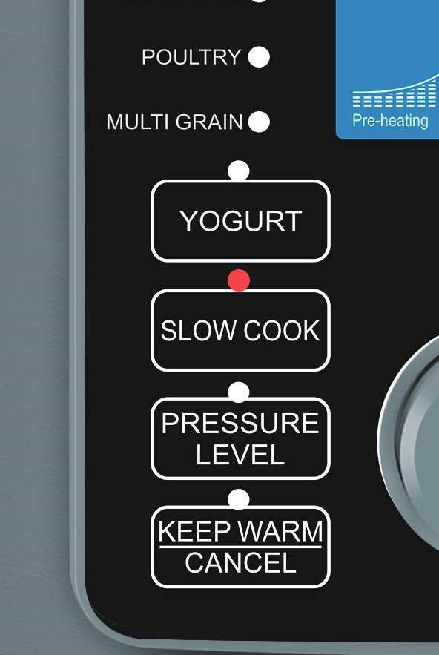
•
- The unit may take between 5-20 minutes to reach temperature before beginning count down.
- When cooking is complete, the cooker will beep and automatically go to KEEP WARM How to Use The Yogurt Function
Making Yogurt is simple and fun using your pressure cooker. All you need is some milk and a bit of active culture yogurt! The process consists of two parts:
Step One: Pasteurize
- Place the inner Pot inside the base and plug in your pressure cooker. The LCD screen will display OFF.
- pour milk into the inner Pot according to your recipe.
- Lock the lid in place and turn the pressure limiting valve to seating.
- Lock the lid in place and turn the pressure limiting valve to seating.
- Select Yogurt. Press Adjust to switch cooking mode until the LCD screen shows boil and flash.
- Once you press START, the LCD screen will display a solid boil.
- When cooking is complete, the pressure cooker beeps and the LCD screen displays Yogt.
- Remove the inner Pot with milk, place pot with milk, place pot on a wire rack, and cool until milk reaches 40ʧ

Step Two: Making Yogurt Culture
- Stir active culture into warm milk according to your recipe. Return steel pot to pressure cooker base.
- Lock the lid in place. Turn the vent position to “Sealing”
- Select Yogurt, Normal displays with an 8 hour timer on the LCD screen. Press Start button.
- When cooking is complete, the pressure cooker beeps several times and the LCD screen displays Yogt. Transfer yogurt to containers and refrigerate as directed by your recipe.

How To Use The Delay Start Function
If you wish to Program your pressure cooker to automatically cook prepared food at a later time, you can program the pressure cooker to delay cooking by up to 24-hours
CAUTION:
It is not recommended to use the Delay Start function to cook foods that may spoil. Leaving raw foods inside the pressure cooker for long periods of time prior to cooking may result in the food spoiling. Cook food that can be left out such as rice, beans, grains or other foods that will not spoil.
This setting is used in combination with the menu functions and the manual setting function
- Prepare desired food and place into cooking pot.
- Secure the Lid onto the unit, turn it clockwise to lock it in place.
- Make sure the Pressure Limiting Valve is set to the “Sealing” position
- Plug the power cord into a 220-240V power outlet.
- Press the DELAY START button. The DELAY START indicator, icon will illuminate, the screen will show 0:30 which is equal to 30 minutes of delay time. Press the Delay Start button again to set your delay time. The maximum Delay period is 24-hours. (The time that displays on the LCD screen shows how long the user wants the unit to wait before the cooking process begins.)
- EX: If you wish to program the pressure cooker to automatically turn on in 3-hours, press the Delay Start button until the LCD screen displays 3:00).
- After programming the your Delay time, select the desired function.
- Once the pressure cooker completes the countdown, the unit will begin operation of the cooking sequence for the chosen selection.
- Follow instructions under “HOW TO REMOVE LID AFTER PRESSURE COOKING” to finish the cooking process.

CLEANING THE PRESSURE COOKER
- Always make sure the Pressure Cooker is unplugged, de-pressurized and completely cooled down before dismantling.
- Use a non-abrasive sponge or damp wash cloth to clean the outer body. NEVER immerse the outer body in any liquids or pour liquids into it.
- Remove the Condensation Cup and rinse it thoroughly and let dry. Clean the inner Main Body and Upper Ring with a damp sponge or wash cloth.
- Remove the pressure limiting valve by gripping and firmly pulling upwards. Rinse with warm water and dry.
- Clean the Lid with warm soapy water, including the Rubber Seal Ring, Filter, Vent, Float Valve and let dry thoroughly.
- On the underside of the lid below the pressure limiting valve, is a small metal filter which can be easily removed to clean.
- Let parts dry completely before reassembling.
- Wash the Inner Pot, Wire Rack, allow to air dry or use a towel. It is not recommended to use any type of scouring pad that can scratch the non-stick surface of the inner Pot.
- Store the inner pot inside of the Pressure Cooker Store Pressure Cooker in a cool, dry location.
- Do not store pressure cooker with lid on tightly. This saves on gasket wear and tear
- NOTE: Any other servicing should be performed by an authorized service representative or from the original manufacturer or distributor.

How to Clean the Filter
To clean the filter, remove it by pulling vertically. To re-attach,, simply line up the filter and press down to secure the filter.
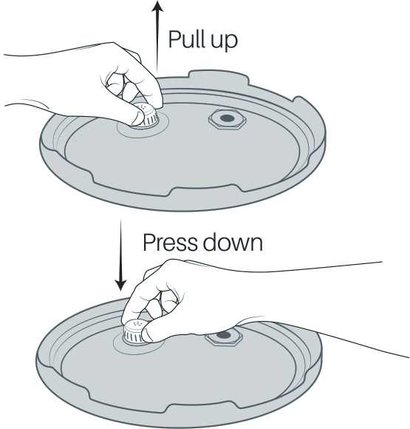

HELPFUL TIPS 
Read this manual thoroughly and follow all instructions.
Be familiar with the recipe and have all ingredients prepped before you begin.
Be sure the lid is secured and locked properly before beginning.
You may wish to brown some meats before cooking with other ingredients.
Cut foods into equal-sized pieces to promote even cooking. In recipes that call for multiple ingredients, cut those that cook more quickly into larger pieces and those that take longer to cook into smaller pieces.
A large variety of liquids can be used for pressure cooking, such as wine, beer, bouillon, fruit juices, water, broth and more.
After becoming familiar with your pressure cooker, you can adapt conventional recipes to be used with it. As a general rule, cut cooking times of your conventional recipes by two thirds. The amount of liquid used may also have to be reduced because there is very little evaporation in the pressure cooker. Remember, however, there must always be some liquid in the pressure cooker to produce the necessary steam. As a rule of thumb, add 1 cup of
15 minutes. This rule may vary depending on the type and amount of food cooked.
In the event that the unit is unable to build pressure, simply add more liquid until it can pressurize.
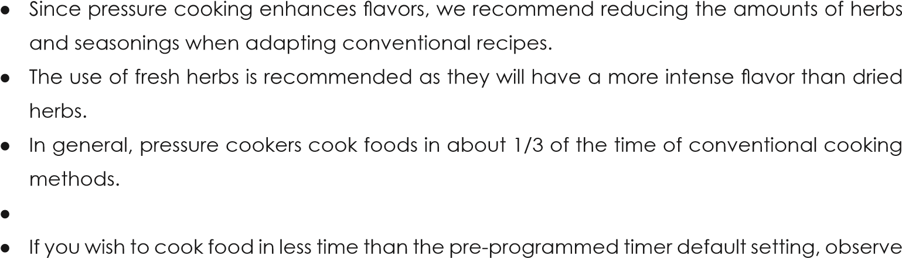Increase cooking times by about 10% when cooking in high altitudes of over 3,500 feet.
the timer and press CANCEL when you would like to stop the cooking process before the timer has reached

Standards Compliance

The following standards have been adhered to by this device in the areas of health and electrical appliance standards:
1. ASTM A240
2. ISO 9444
3. FDA (U.S. Food and Drug Administration)
4. EU Regulation (EC) No 1935/2004
5. ISO 9001
6. ISO 14001
7. ASTM F899
8. EN 10088
- IEC 60335-1
- IEC 60335-2-15
- IEC 63399:2024




 www.tivarx.co

