Task Description – Social Media Content Creation
Create 5–6 high-quality social media posts for the dental client using the provided logos and pictures. All content must be designed to match the existing feed style and brand image, ensuring a consistent and cohesive look across the account.

Requirements:
- Brand Consistency: Maintain the clinic’s colors, fonts, tone, and overall aesthetic to ensure a seamless feed appearance.
- Content Variety: Include a mix of carousels, reels, static posts, and animations to maximize engagement.
- Captions & CTAs: Each post must include a caption with a strong call-to-action (e.g., “Book your appointment today,” “Call us for a brighter smile,” “Visit our website to learn more”).
- Creativity & Engagement: Use sounds, trending music, or light animations (where possible) to increase audience impact.
- Stock Content: If client-provided photos or videos are not available, you may use high-quality stock videos and images.
- Direct Usability: Deliver final posts ready to be published without additional editing or adjustments.

Client Information (must be included where appropriate):
Phone: 877-347-5530
Website: sunshinedentistry.ca
Email: smile@sunshinedentistry.ca
Address: 8763 Bayview Avenue unit 10, Richmond Hill , ON
smil8

Goal:
Produce visually appealing, professional, and engaging content that enhances the client’s online presence while reinforcing their brand identity.
@sunshinedentistry.ca
Post/ Reel 1
Theme: Back-to-school dental checkups
Content Idea:
Remind parents to book their kids’ dental checkups before school starts. Include a checklist for school-ready smiles (e.g., toothbrush, floss, mouthguard for sports, etc.).
Caption post:
"Start the school year off right — with a healthy smile!
✨ Book your child’s back-to-school dental checkup today. #HealthySmiles #BackToSchoolReady"
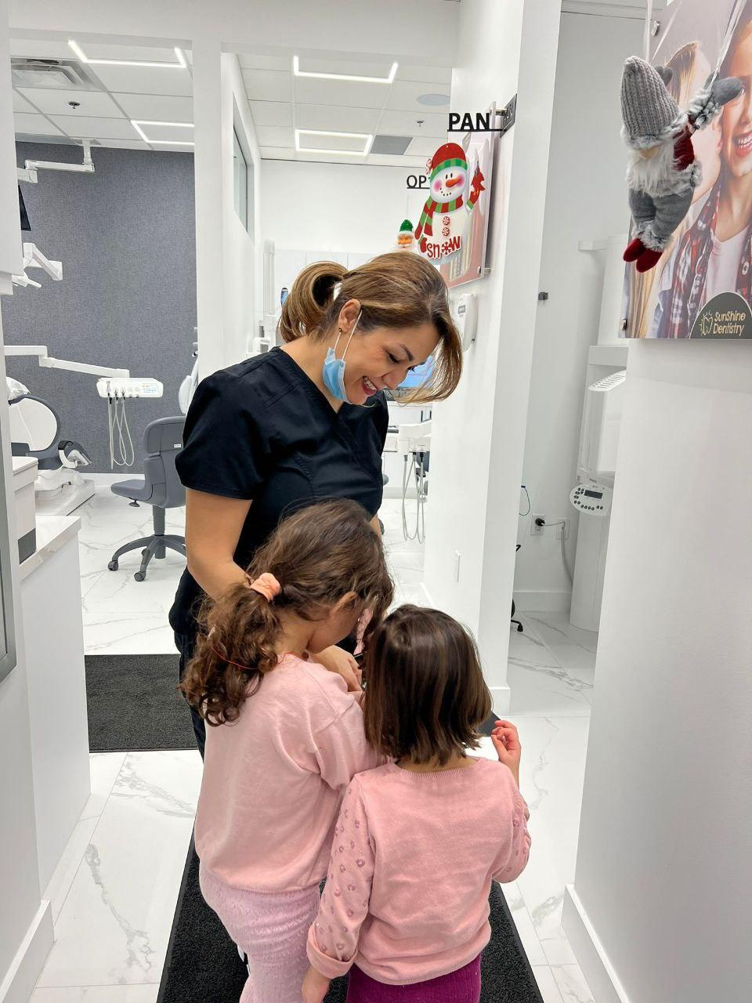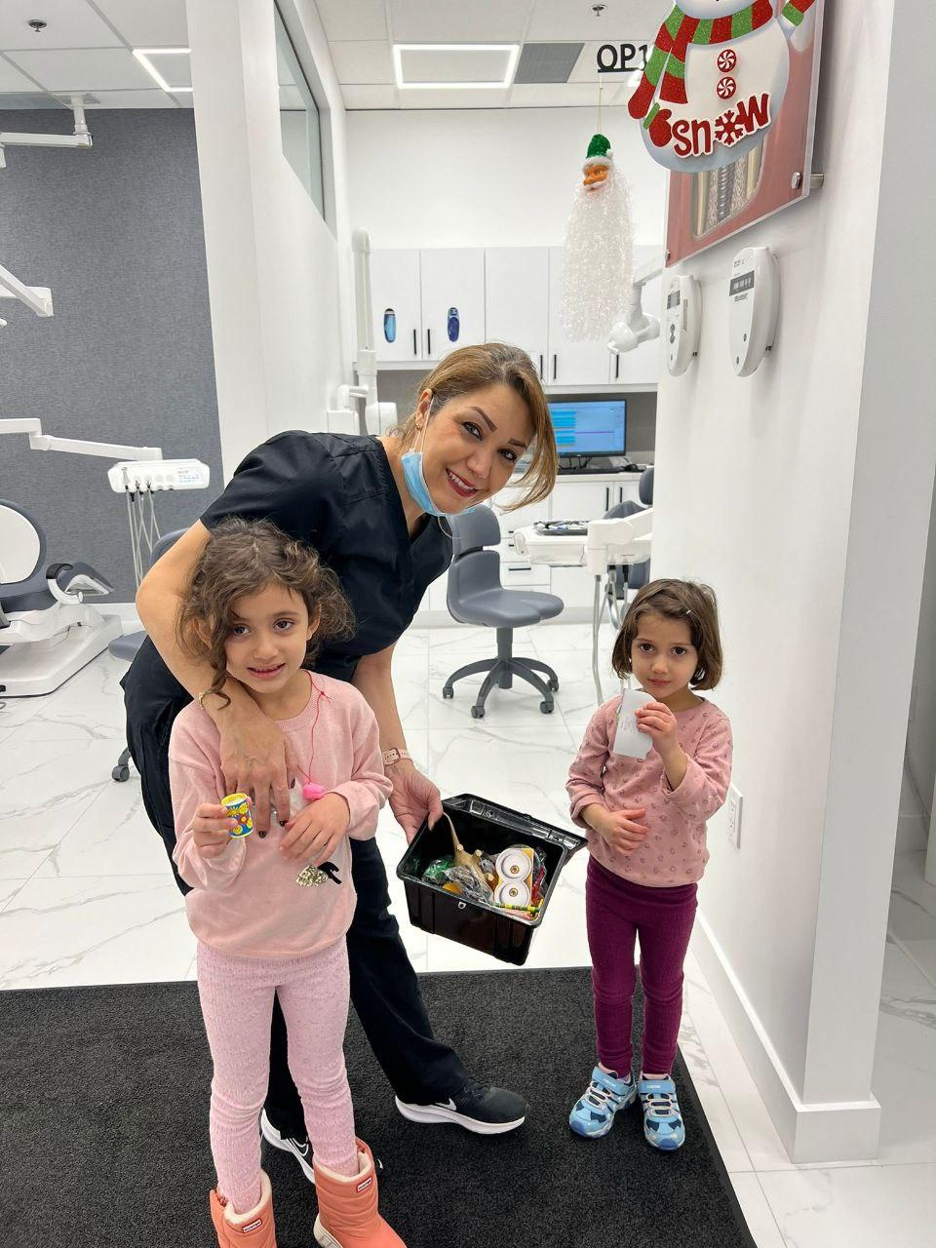
Post/Reel 2
Theme: Smile transformation with Invisalign
Content Idea:
Create a reel or carousel showing the Invisalign pros

- Discreet
- Comfortable
- Removable
- No wires
- Real results
Caption Example:
"A new smile starts here. ✨
Invisalign offers a clear, comfortable way to straighten your teeth — without the look of braces.
Start your journey with a FREE consultation today. 💬🦷

Post/ Reel 3
Theme: Build trust through team introductions
Content Idea:
Create a carousel or short reel showcasing the attached photos.
- A smiling photo or wave
Encourage familiarity and comfort by making the team relatable and warm.
Caption Example:
"Get to know the team behind your smile! 😄
At Sunshine , we believe a comfortable visit starts with a friendly face.
Meet our amazing staff who are here to make your dental experience feel personal, professional, and positive. 💙

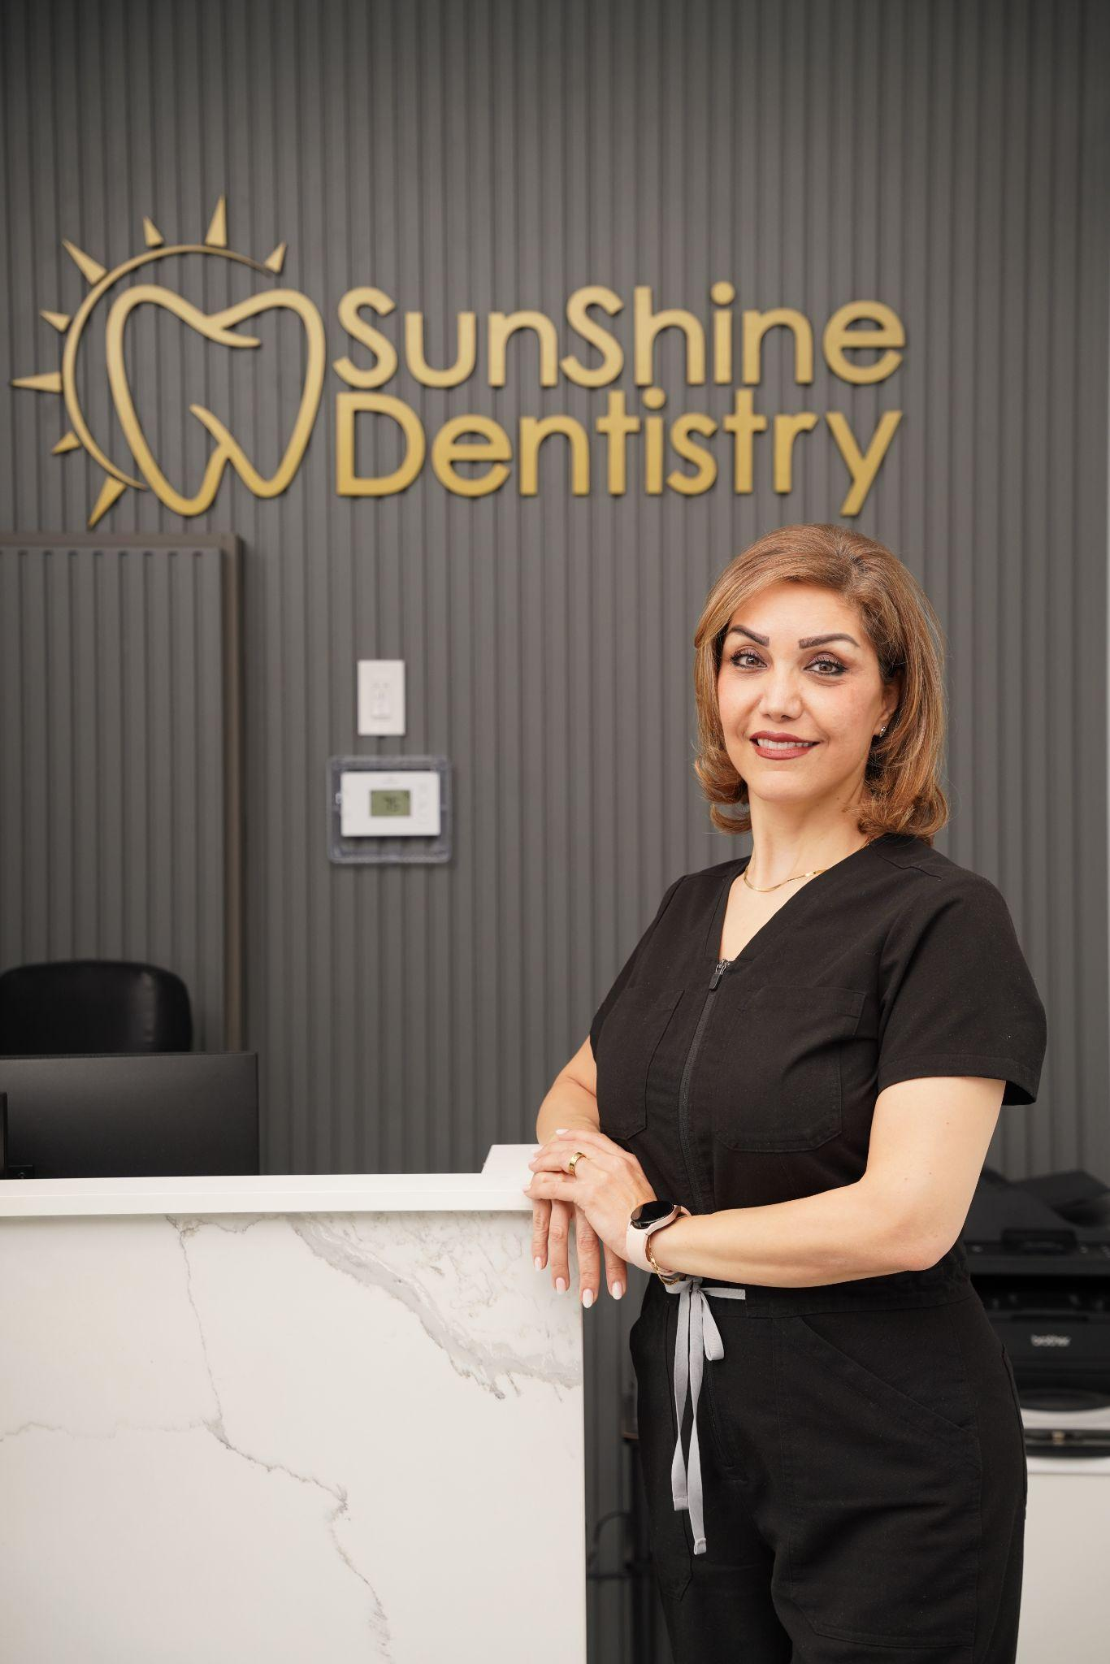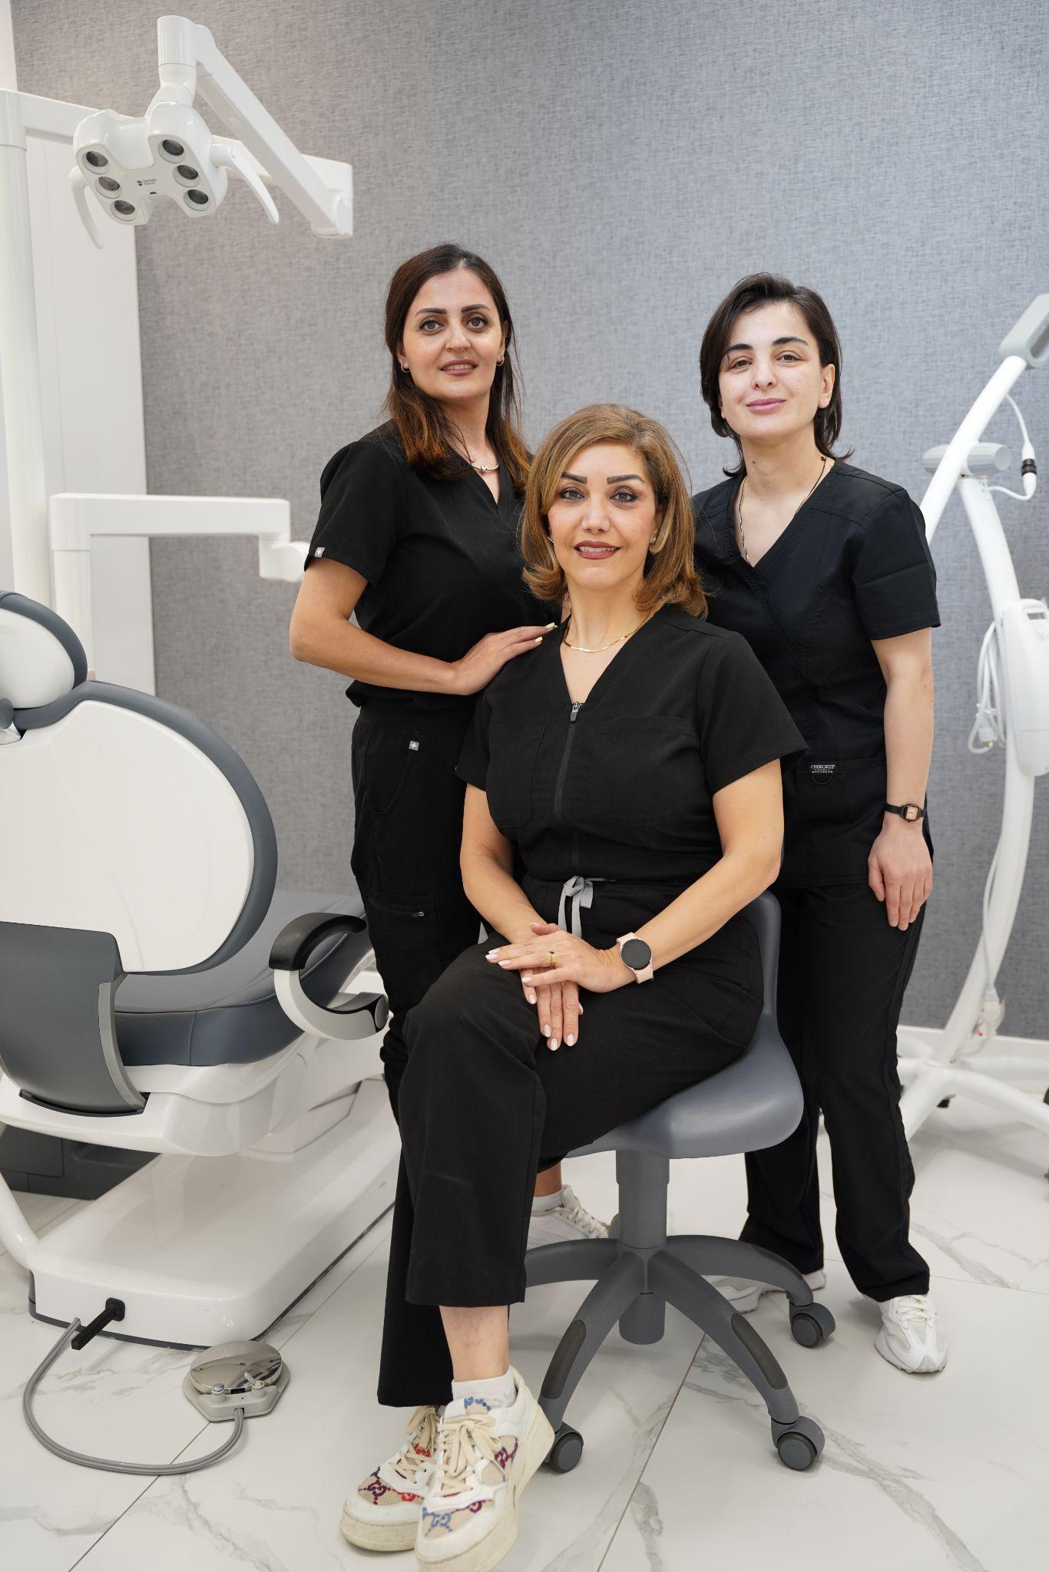
Post/ reel 4
Theme: Oral health education – cavity prevention
Content Idea:
Create a carousel or short reel that shows 5 common causes of cavities and how to prevent them. Use simple visuals or animations, with each slide/clip showing:
- Too much sugar 🍭
- Skipping flossing 🧵
- Not brushing properly 🪥
- Skipping dental checkups 📆
Caption:
Cavities don't happen overnight — but they do sneak up when good habits slip. 👀
Post/ Reel 5
Theme: Dental milestones by age
Content Idea:
Create a carousel or vertical infographic reel showing a visual timeline of a child’s dental development. Each slide or scene highlights a key age and milestone.

Suggested Milestones:
- 0–6 months: First tooth erupts
- 6–3 years: Full set of 20 baby teeth
- 6–12 years: Baby teeth fall out, adult teeth come in
- 7+ years: First dental check-up with potential ortho evaluation
- 10–14 years: Braces or aligners if needed
- 16+ years: Wisdom teeth evaluations
Visual Style:
Clean icons, playful but informative graphics — ideal for Instagram carousels or reels with voiceover or soft background music.
Post 6
Format: Carousel or Reel
Idea: Show each part of your clinic in order — reception, waiting area, consultation rooms, sterilization zone, etc.
Caption Example:
"New here? Take a tour of our clinic before your visit! 🏡
From our cozy waiting room to our state-of-the-art treatment suites, we’ve designed every detail with your comfort in mind.
