HR, Administration and Logistics Requirements for Odoo Implementation
Karan Sa Industrial Group
Prepared for joint review by Human Resources, Administration and Logistics, and the Odoo implementation team. The implementation team should identify how each need will be delivered, solution limitations, effort, cost, timing and acceptance evidence.

Scope and use
This English edition covers 36 HR processes and 17 active or proposed Administration and Logistics processes. Each process has its English workflow directly below its heading, followed by requirements and review fields.
Unit statuses are retained: approved, amendments requested, review required, not currently performed, not currently available but required, and no system required. These statuses do not confirm Odoo capabilities; the workshop must convert them into implementation decisions.
Ten administrative activities explicitly removed by the unit appear only in the scope-control register. Cleaning and security are retained solely for potential links to service requests, complaints or costs.
The HR service desk also carries a deletion note from the unit. Its review page is retained to resolve exclusion or consolidation before implementation.
Read chart steps in numbered order. Exception outcomes are displayed separately; their precise attachment and return points require process-owner agreement.
Version 1, English edition | 10 September 2026
Business approval owner: HR Manager

System boundaries and responsibilities
Area | Recorded context or requirement | Workshop decision
Recruitment | Sourcing and selection partly operate in Adilar. | Adilar/Odoo boundary and employee creation point.
Records and contracts | Employee records, printable contracts and change history are required. | Master data owner and document permissions.
Time and payroll | Attendance, leave, missions, Rahkaran and Finance are interdependent. | Time authority, payroll calculation and Finance exchange.
Entry, change and exit | Coordinate IT, Administration, Warehouse and Finance tasks. | Task owners and completion or settlement holds.
Administrative services | Requests need manager approval, priority, routing and sometimes budget. | Shared service desk and service-level rules.
Fleet and courier | Vehicles, drivers, Snapp, couriers, tracking and costs are connected. | Odoo scope and SMS or external service exchange.
Equipment and maintenance | Procurement, quarantine, delivery, repair and financial assets intersect. | Item, asset, repair and cost ownership.
Reporting | HR and Management require editable dashboards. | Indicator definitions, data sources and refresh cycle.

Shared controls
Use unique identifiers for employees, candidates, positions, requests, contracts, missions, assets and payments; retain ownership and change timestamps.
Separate submission and approval. Restrict access to pay, grievances, appraisals, medical information and identity documents.
Apply effective dates and retain prior contracts, positions, managers, cost centers, pay and access records.
Prevent duplicate execution or payment on retries. Record errors, recovery owners, deadlines and outcomes.

Priority workshop decisions
Topic | Decision required
Implementation scope | Decide future implementation or exclusion for activities not performed or requiring no system; resolve the HR service desk deletion note.
Adilar | Define recruitment and interview boundaries, employee record creation and duplicate prevention.
Leave and missions | Finalize line manager and HR manager approval order and attendance effects.
Payroll and time | Choose Rahkaran or Odoo calculation ownership and the Finance exchange method.
Employee advances | Finalize manager, HR and Finance checks before payment and deductions.
Employment exit | Define clearance requirements from managers, IT, Administration, Warehouse and Finance before settlement.
Administrative requests | Define service targets, special priority, manager approval and budget review.
Vehicles and couriers | Agree overlapping bookings, Snapp referral, vehicle handover, SMS and proof of delivery.
Equipment | Define consumables, administrative equipment, fixed assets, quarantine and repairs.
Reports and confidentiality | Agree KPI definitions, access and HR staff permissions to create and edit dashboards.

Process register
ID | Area | Process | Unit status
HR-01 | HR | Workforce strategy and planning | Not currently performed
HR-02 | HR | Organization structure management | Approved
HR-03 | HR | Job design, descriptions and requirements | Amendments requested
HR-04 | HR | Recruitment requests and authorization | Amendments requested
HR-05 | HR | Candidate sourcing | Approved
HR-06 | HR | Screening, interviewing and selection | Amendments requested
HR-07 | HR | Job offers and hiring | Approved
HR-08 | HR | Onboarding and probation | Amendments requested
HR-09 | HR | Employee records management | Amendments requested
HR-10 | HR | Employee contract management | Approved
HR-11 | HR | Work calendars and shifts | Approved
HR-12 | HR | Attendance and monthly time records | Amendments requested
HR-13 | HR | Leave and absence management | Amendments requested
HR-14 | HR | Business missions and attendance impact | Approved
HR-15 | HR | Payroll inputs and calculation | Approved
HR-16 | HR | Compensation and pay structure | Approved
HR-17 | HR | Loans, advances and deductions | Approved
HR-18 | HR | Performance appraisal | Approved
HR-19 | HR | Performance improvement | Approved
HR-20 | HR | Competencies and skill matrix | Not currently performed
HR-21 | HR | Training needs and planning | Review required
HR-22 | HR | Training delivery and effectiveness | Review required
HR-23 | HR | Career progression, promotion and succession | Review required
HR-24 | HR | Employee changes and transfers | Review required
HR-25 | HR | Satisfaction, engagement and retention | Not currently performed
HR-26 | HR | Internal communications and HR self-service | Amendments requested
HR-27 | HR | Employee relations, grievances and discipline | Review required
HR-28 | HR | HR compliance management | Approved
HR-29 | HR | Contract and nonstandard workers | Approved
HR-30 | HR | Welfare policies and eligibility | Approved
HR-31 | HR | Employee equipment and access coordination | Approved
HR-32 | HR | HR service desk | Not currently performed
HR-33 | HR | Employee exit, resignation and termination | Approved
HR-34 | HR | Retirement and planned exits | Not currently performed
HR-35 | HR | HR analytics and reporting | Not currently performed
HR-36 | HR | HR data confidentiality and integration | Not currently performed
AD-01 | Admin / Logistics | Administrative service desk and prioritization | Amendments requested
AD-02 | Admin / Logistics | Meetings, hospitality and events | Not currently available but required
AD-03 | Admin / Logistics | Cleaning and workplace services | No system required
AD-04 | Admin / Logistics | Security and access control | No system required
AD-05 | Admin / Logistics | Vehicle and driver requests | Amendments requested
AD-06 | Admin / Logistics | Fleet use, fuel and maintenance | Not currently available but required
AD-07 | Admin / Logistics | Courier, mail and internal consignments | Amendments requested
AD-08 | Admin / Logistics | Corporate Snapp and urban transport | Amendments requested
AD-09 | Admin / Logistics | Supplementary insurance and welfare services | Approved
AD-10 | Admin / Logistics | Administrative consumables | Not currently available but required
AD-11 | Admin / Logistics | Non-consumable items and administrative equipment | Amendments requested
AD-12 | Admin / Logistics | Administrative equipment lifecycle and repairs | Not currently available but required
AD-13 | Admin / Logistics | Building and facilities maintenance | Not currently available but required
AD-14 | Admin / Logistics | Service contractor management | Not currently available but required
AD-15 | Admin / Logistics | Administrative petty cash | Amendments requested
AD-16 | Admin / Logistics | Administrative and logistics analytics | Not currently available but required
AD-17 | Admin / Logistics | Administrative mission execution and travel services | Amendments requested

1. Workforce strategy and planning
HR-01 | Human Resources | Unit status: Not currently performed
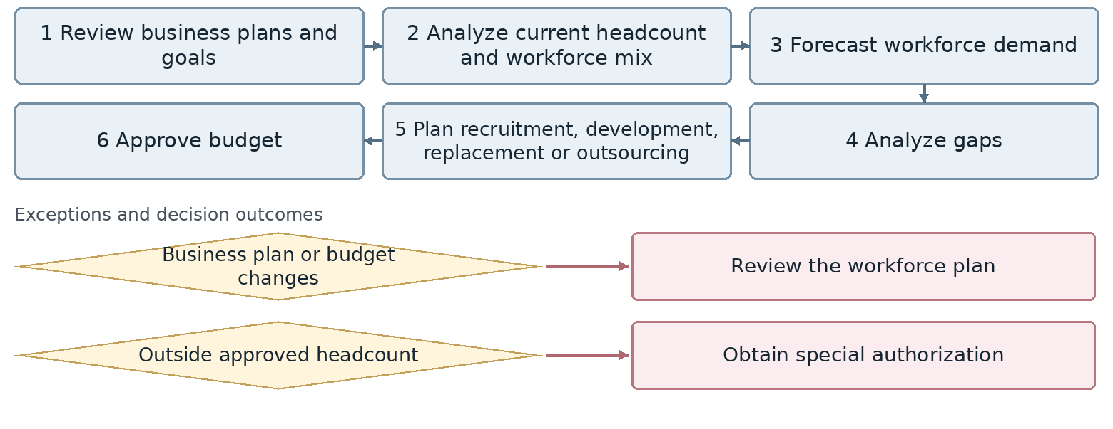
Confirm exact exception attachment and return points with the process owner.
Outcome Approved workforce plan and headcount for Management, Finance and units
Proposed owner and interfaces HR Manager; interfaces: Management, unit managers, Finance and Training.
Target requirement Support the workflow through completion with accountable owners, statuses, deadlines, attachments, notifications, approvals and full history.
Required data Company, branch, unit, job, position, grade, headcount, line manager, cost center, requirements, competencies, version and effective date.
Decisions and controls Confirm who authorizes headcount or position changes and how prior versions and dependent records are retained. Confirm whether to implement in a future phase or leave outside the current scope.
Reports and indicators Approved versus actual headcount, vacancies, workforce forecasts and cost.
Acceptance scenario Record an effective-dated change; verify prior history and the impact on hierarchy, cost center, competencies and reports.
Odoo response / coverage: [ ] Standard [ ] Configuration [ ] Studio [ ] Development
[ ] Integration [ ] Alternative / not covered | Limitations / evidence: ................................
Action owner: .................................... Due date: ....................................

2. Organization structure management
HR-02 | Human Resources | Unit status: Approved
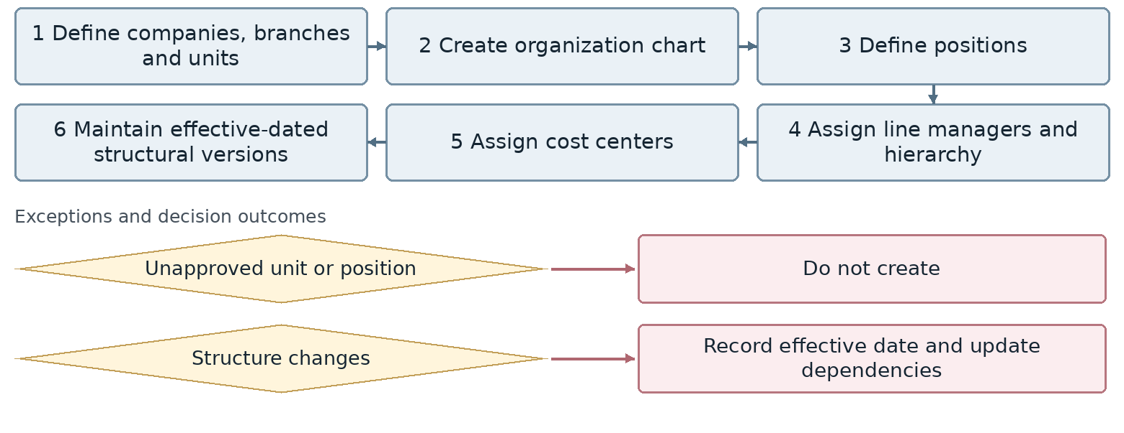
Confirm exact exception attachment and return points with the process owner.
Outcome Valid organization chart and position register
Proposed owner and interfaces HR Manager; interfaces: Management, unit managers, Finance and Training.
Target requirement Support the workflow through completion with accountable owners, statuses, deadlines, attachments, notifications, approvals and full history.
Required data Company, branch, unit, job, position, grade, headcount, line manager, cost center, requirements, competencies, version and effective date.
Decisions and controls Confirm who authorizes headcount or position changes and how prior versions and dependent records are retained. Confirm authority for structural changes and retention of previous versions.
Reports and indicators Approved, occupied and vacant positions, structural changes and span of control.
Acceptance scenario Record an effective-dated change; verify prior history and the impact on hierarchy, cost center, competencies and reports.
Odoo response / coverage: [ ] Standard [ ] Configuration [ ] Studio [ ] Development
[ ] Integration [ ] Alternative / not covered | Limitations / evidence: ................................
Action owner: .................................... Due date: ....................................

3. Job design, descriptions and requirements
HR-03 | Human Resources | Unit status: Amendments requested
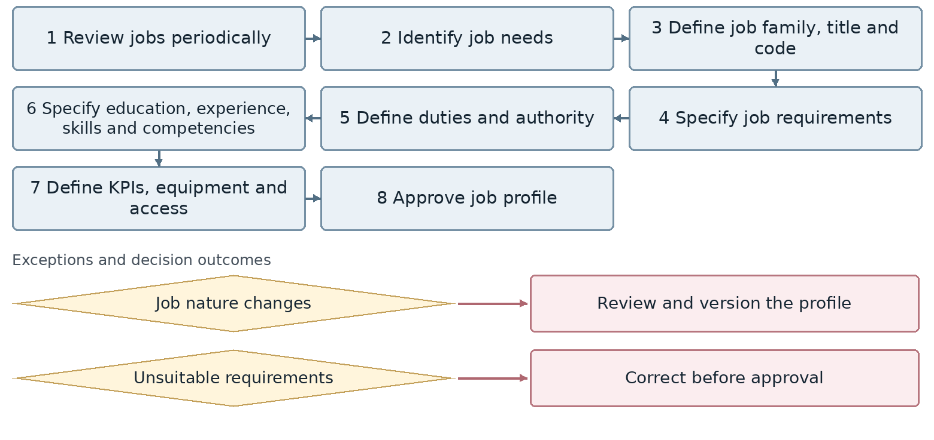
Confirm exact exception attachment and return points with the process owner.
Outcome Approved job descriptions and requirements
Proposed owner and interfaces HR Manager; interfaces: Management, unit managers, Finance and Training.
Target requirement Support the workflow through completion with accountable owners, statuses, deadlines, attachments, notifications, approvals and full history.
Required data Company, branch, unit, job, position, grade, headcount, line manager, cost center, requirements, competencies, version and effective date.
Decisions and controls Confirm who authorizes headcount or position changes and how prior versions and dependent records are retained. Include periodic review and equipment and access requirements in each job profile.
Reports and indicators Missing or outdated job profiles, review dates and requirements.
Acceptance scenario Record an effective-dated change; verify prior history and the impact on hierarchy, cost center, competencies and reports.
Odoo response / coverage: [ ] Standard [ ] Configuration [ ] Studio [ ] Development
[ ] Integration [ ] Alternative / not covered | Limitations / evidence: ................................
Action owner: .................................... Due date: ....................................

4. Recruitment requests and authorization
HR-04 | Human Resources | Unit status: Amendments requested
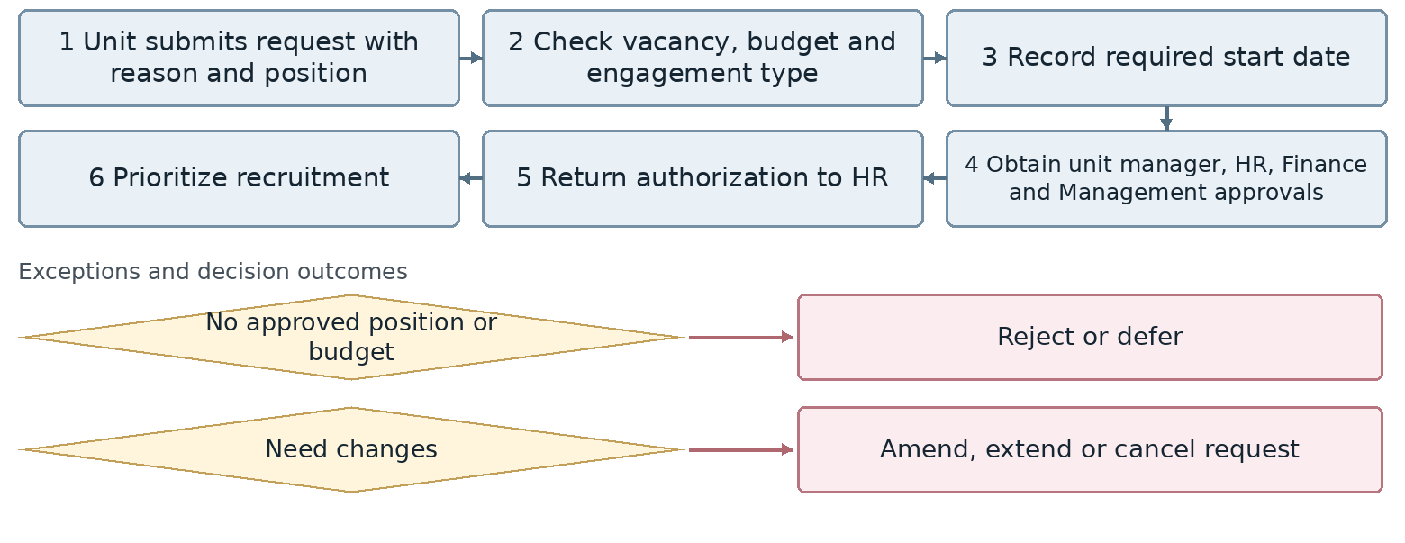
Confirm exact exception attachment and return points with the process owner.
Outcome Active recruitment authorization
Proposed owner and interfaces HR Manager; interfaces: Unit manager, Management, Finance and Adilar.
Target requirement Support the workflow through completion with accountable owners, statuses, deadlines, attachments, notifications, approvals and full history.
Required data Recruitment authorization, position, budget, candidate, stage, assessor, score, offer, start date and rejection or withdrawal reason.
Decisions and controls Agree the Adilar/Odoo boundary, duplicate prevention and the candidate-to-employee conversion point. Confirm approval sequence and recruitment authorization validity.
Reports and indicators Open requests, approval time, rejected or cancelled requests and request age.
Acceptance scenario Trace approved recruitment through hiring; test rejection, offer revision and missing documents without losing history.
Odoo response / coverage: [ ] Standard [ ] Configuration [ ] Studio [ ] Development
[ ] Integration [ ] Alternative / not covered | Limitations / evidence: ................................
Action owner: .................................... Due date: ....................................

5. Candidate sourcing
HR-05 | Human Resources | Unit status: Approved
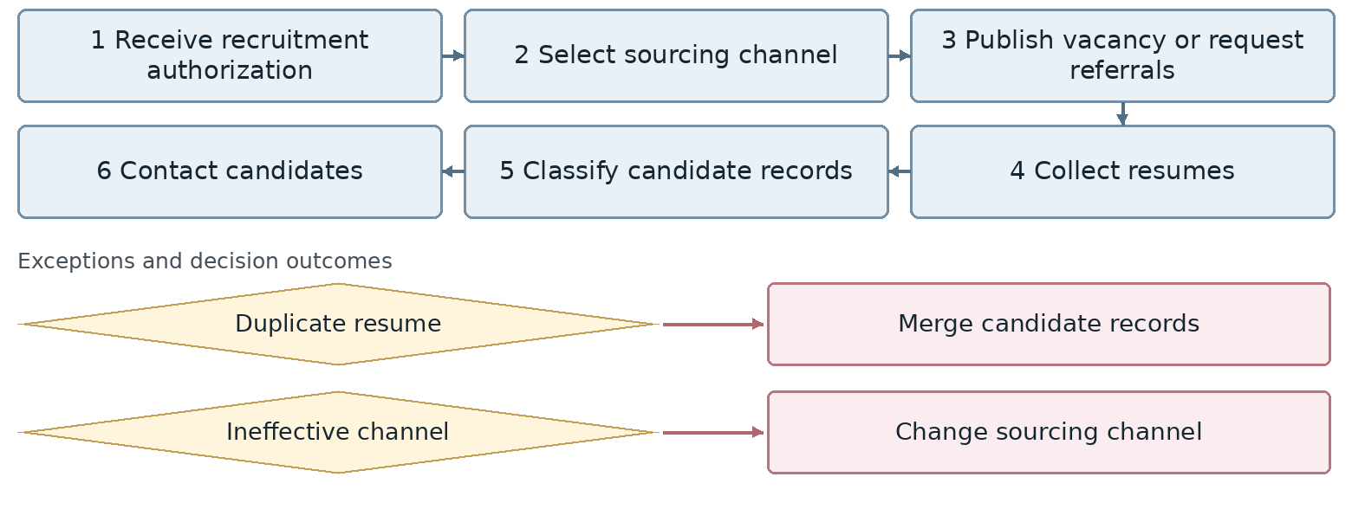
Confirm exact exception attachment and return points with the process owner.
Outcome Candidate pool for selection
Proposed owner and interfaces HR Manager; interfaces: Unit manager, Management, Finance and Adilar.
Target requirement Support the workflow through completion with accountable owners, statuses, deadlines, attachments, notifications, approvals and full history.
Required data Recruitment authorization, position, budget, candidate, stage, assessor, score, offer, start date and rejection or withdrawal reason.
Decisions and controls Agree the Adilar/Odoo boundary, duplicate prevention and the candidate-to-employee conversion point. This activity is performed in Adilar. Define the data boundary and exchange with Odoo.
Reports and indicators Resumes by source, sourcing cost and conversion rates.
Acceptance scenario Trace approved recruitment through hiring; test rejection, offer revision and missing documents without losing history.
Odoo response / coverage: [ ] Standard [ ] Configuration [ ] Studio [ ] Development
[ ] Integration [ ] Alternative / not covered | Limitations / evidence: ................................
Action owner: .................................... Due date: ....................................

6. Screening, interviewing and selection
HR-06 | Human Resources | Unit status: Amendments requested
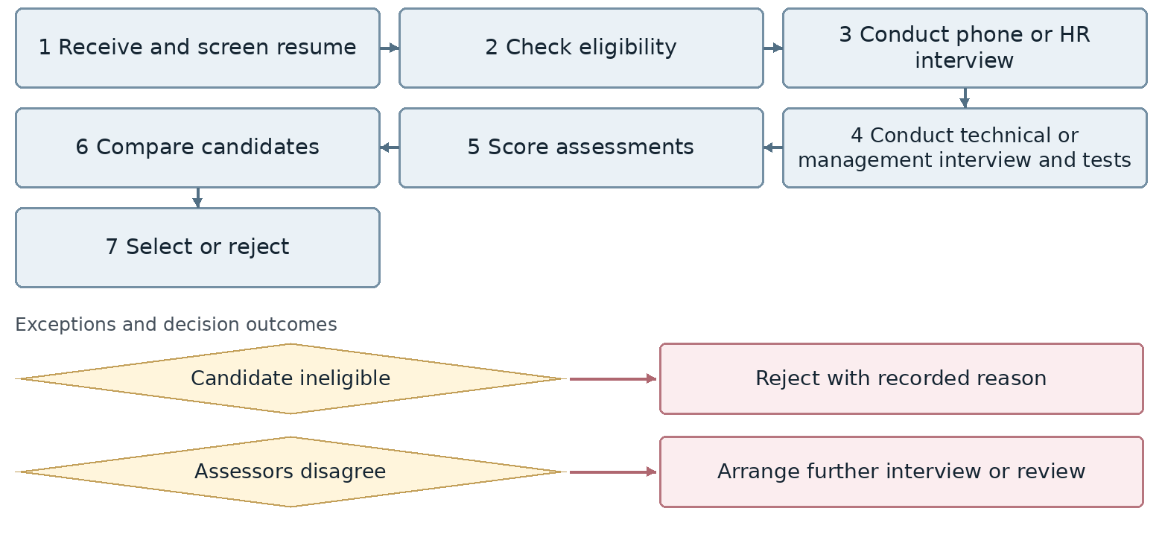
Confirm exact exception attachment and return points with the process owner.
Outcome Selected candidate and assessment evidence
Proposed owner and interfaces HR Manager; interfaces: Unit manager, Management, Finance and Adilar.
Target requirement Support the workflow through completion with accountable owners, statuses, deadlines, attachments, notifications, approvals and full history.
Required data Recruitment authorization, position, budget, candidate, stage, assessor, score, offer, start date and rejection or withdrawal reason.
Decisions and controls Agree the Adilar/Odoo boundary, duplicate prevention and the candidate-to-employee conversion point. Selection is performed in Adilar. Include resume conversion and recruitment completion reports.
Reports and indicators Stage conversion, rejection and withdrawal reasons, hiring quality and recruitment lead time.
Acceptance scenario Trace approved recruitment through hiring; test rejection, offer revision and missing documents without losing history.
Odoo response / coverage: [ ] Standard [ ] Configuration [ ] Studio [ ] Development
[ ] Integration [ ] Alternative / not covered | Limitations / evidence: ................................
Action owner: .................................... Due date: ....................................

7. Job offers and hiring
HR-07 | Human Resources | Unit status: Approved
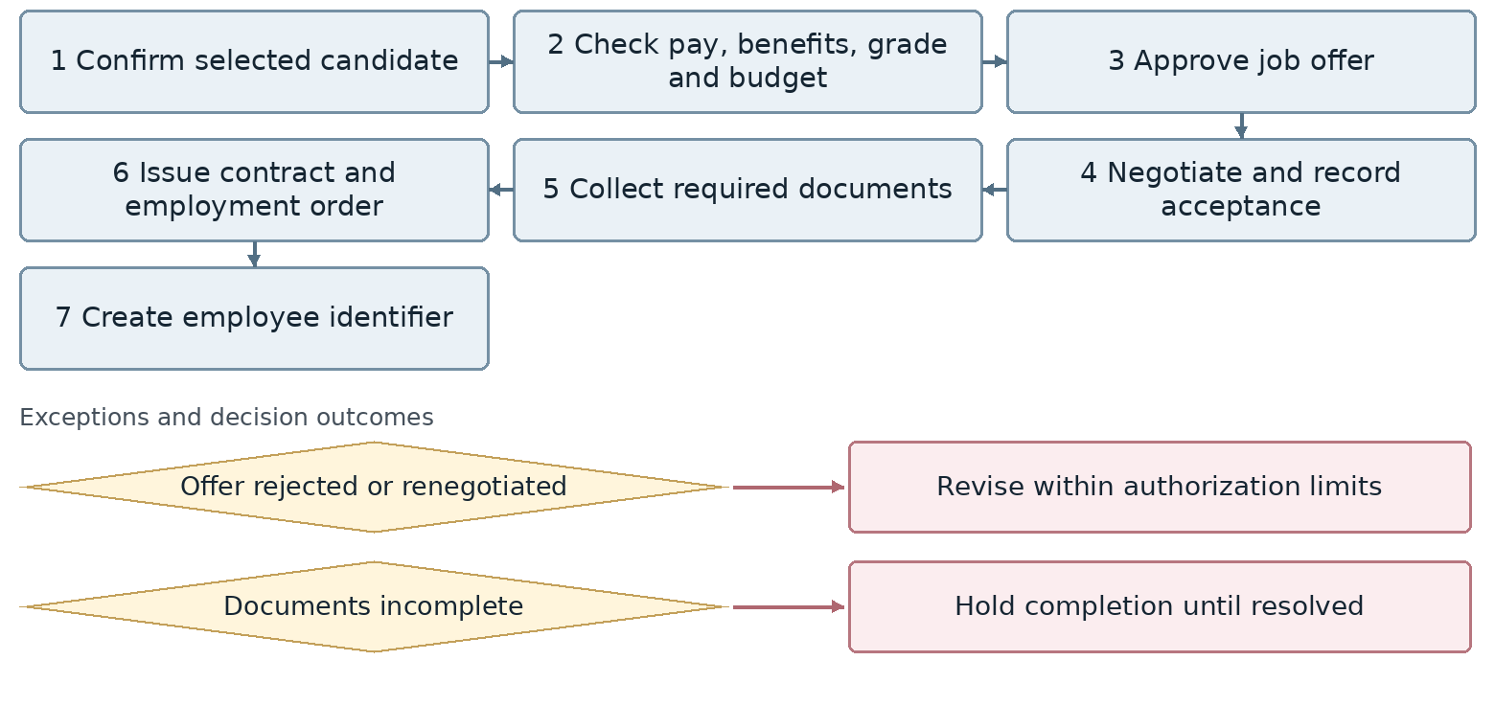
Confirm exact exception attachment and return points with the process owner.
Outcome Hired employee and initial employee record
Proposed owner and interfaces HR Manager; interfaces: Unit manager, Management, Finance and Adilar.
Target requirement Support the workflow through completion with accountable owners, statuses, deadlines, attachments, notifications, approvals and full history.
Required data Recruitment authorization, position, budget, candidate, stage, assessor, score, offer, start date and rejection or withdrawal reason.
Decisions and controls Agree the Adilar/Odoo boundary, duplicate prevention and the candidate-to-employee conversion point. Define the candidate-to-employee conversion point and required hiring documents.
Reports and indicators Offer acceptance rate, offer-to-start time and new contracts.
Acceptance scenario Trace approved recruitment through hiring; test rejection, offer revision and missing documents without losing history.
Odoo response / coverage: [ ] Standard [ ] Configuration [ ] Studio [ ] Development
[ ] Integration [ ] Alternative / not covered | Limitations / evidence: ................................
Action owner: .................................... Due date: ....................................

8. Onboarding and probation
HR-08 | Human Resources | Unit status: Amendments requested
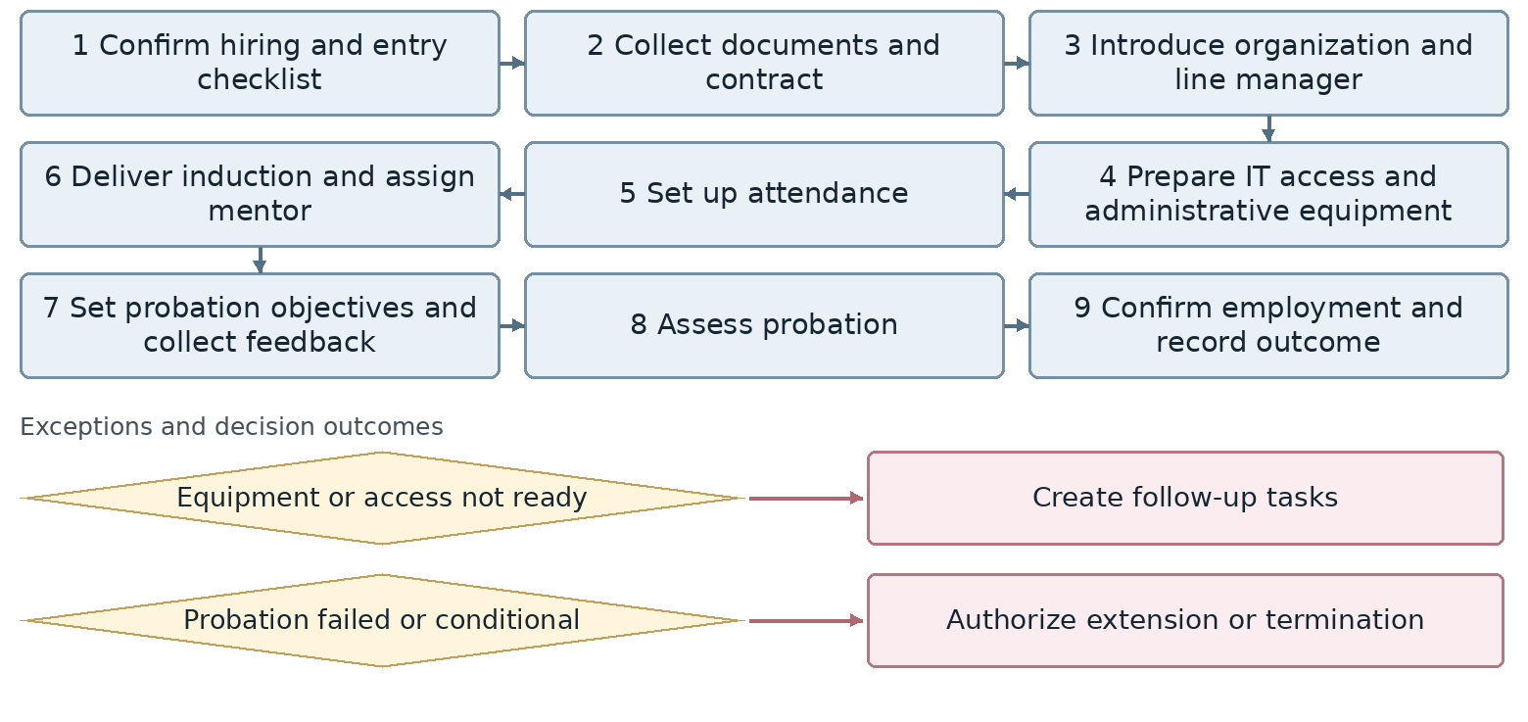
Confirm exact exception attachment and return points with the process owner.
Outcome Onboarded employee and documented probation decision
Proposed owner and interfaces HR Manager; interfaces: Unit manager, IT, Administration, Warehouse and Finance.
Target requirement Support the workflow through completion with accountable owners, statuses, deadlines, attachments, notifications, approvals and full history.
Required data Employee, engagement type, contract, position, manager, location, effective date, documents, assets, access, assigned tasks and completion status.
Decisions and controls Define each data owner, permissions for sensitive changes and conditions for completing entry or an employee change. Assign owners and deadlines for onboarding tasks and probation feedback.
Reports and indicators Checklist completion, preparation time and probation success rate.
Acceptance scenario Run an entry or transfer with unavailable equipment or access; verify accountable open tasks and completion evidence.
Odoo response / coverage: [ ] Standard [ ] Configuration [ ] Studio [ ] Development
[ ] Integration [ ] Alternative / not covered | Limitations / evidence: ................................
Action owner: .................................... Due date: ....................................

9. Employee records management
HR-09 | Human Resources | Unit status: Amendments requested
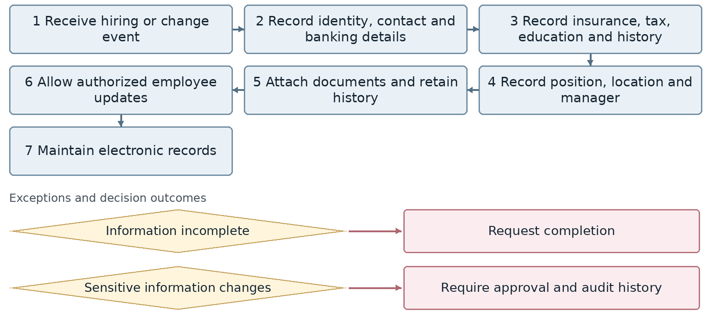
Confirm exact exception attachment and return points with the process owner.
Outcome Complete and current employee record
Proposed owner and interfaces HR Manager; interfaces: Unit manager, IT, Administration, Warehouse and Finance.
Target requirement Support the workflow through completion with accountable owners, statuses, deadlines, attachments, notifications, approvals and full history.
Required data Employee, engagement type, contract, position, manager, location, effective date, documents, assets, access, assigned tasks and completion status.
Decisions and controls Define each data owner, permissions for sensitive changes and conditions for completing entry or an employee change. Define employee self-service permissions and approval of sensitive changes.
Reports and indicators Incomplete files, expired documents, changes and data quality.
Acceptance scenario Run an entry or transfer with unavailable equipment or access; verify accountable open tasks and completion evidence.
Odoo response / coverage: [ ] Standard [ ] Configuration [ ] Studio [ ] Development
[ ] Integration [ ] Alternative / not covered | Limitations / evidence: ................................
Action owner: .................................... Due date: ....................................

10. Employee contract management
HR-10 | Human Resources | Unit status: Approved
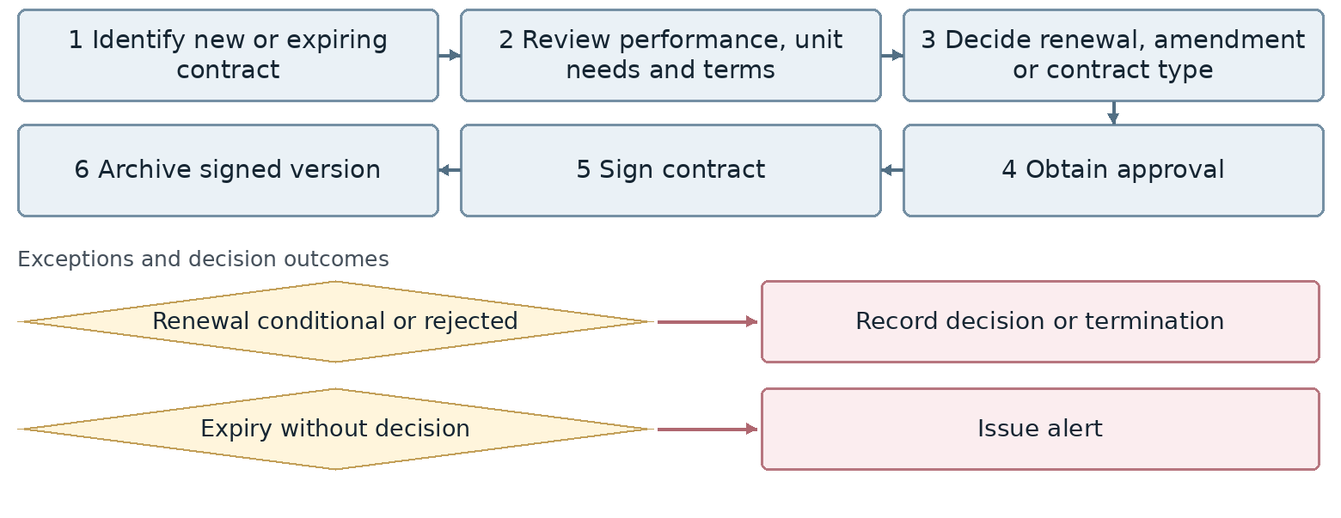
Confirm exact exception attachment and return points with the process owner.
Outcome Valid contract or documented non-renewal decision
Proposed owner and interfaces HR Manager; interfaces: Unit manager, IT, Administration, Warehouse and Finance.
Target requirement Support the workflow through completion with accountable owners, statuses, deadlines, attachments, notifications, approvals and full history.
Required data Employee, engagement type, contract, position, manager, location, effective date, documents, assets, access, assigned tasks and completion status.
Decisions and controls Define each data owner, permissions for sensitive changes and conditions for completing entry or an employee change. Create contracts in the system and provide printable versions.
Reports and indicators Upcoming expiry, renewals, amendments and invalid contracts.
Acceptance scenario Run an entry or transfer with unavailable equipment or access; verify accountable open tasks and completion evidence.
Odoo response / coverage: [ ] Standard [ ] Configuration [ ] Studio [ ] Development
[ ] Integration [ ] Alternative / not covered | Limitations / evidence: ................................
Action owner: .................................... Due date: ....................................

11. Work calendars and shifts
HR-11 | Human Resources | Unit status: Approved
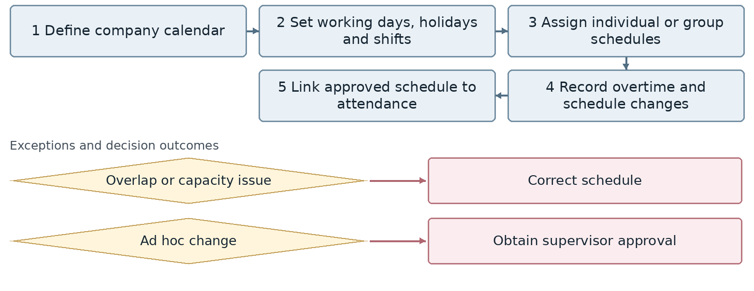
Confirm exact exception attachment and return points with the process owner.
Outcome Approved work schedule
Proposed owner and interfaces HR Manager; interfaces: Unit managers, Administration, Finance and Payroll.
Target requirement Support the workflow through completion with accountable owners, statuses, deadlines, attachments, notifications, approvals and full history.
Required data Employee, calendar, shift, entry/exit, request type, dates and hours, leave balance, approvers, mission, time records and corrections.
Decisions and controls Agree manager/HR approval order, leave carryover, corrections after period closure and mission impact on time records. Define approval of shift changes and treatment of exceptional working days.
Reports and indicators Shift coverage, schedule changes and planned overtime.
Acceptance scenario Test ordinary and exceptional time requests, multi-day missions and corrections; reconcile approved hours and leave balances.
Odoo response / coverage: [ ] Standard [ ] Configuration [ ] Studio [ ] Development
[ ] Integration [ ] Alternative / not covered | Limitations / evidence: ................................
Action owner: .................................... Due date: ....................................

12. Attendance and monthly time records
HR-12 | Human Resources | Unit status: Amendments requested
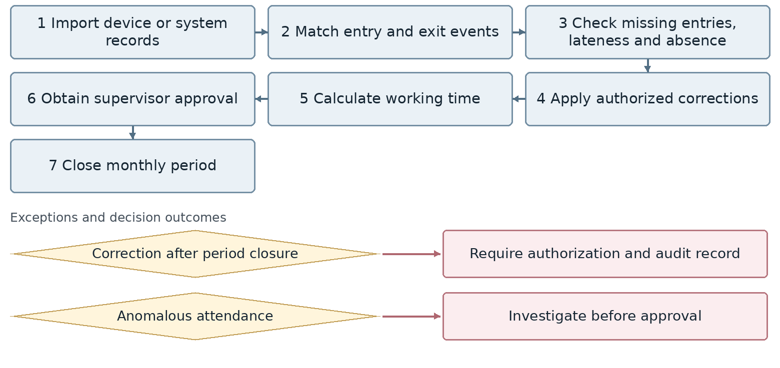
Confirm exact exception attachment and return points with the process owner.
Outcome Approved monthly time records for Payroll
Proposed owner and interfaces HR Manager; interfaces: Unit managers, Administration, Finance and Payroll.
Target requirement Support the workflow through completion with accountable owners, statuses, deadlines, attachments, notifications, approvals and full history.
Required data Employee, calendar, shift, entry/exit, request type, dates and hours, leave balance, approvers, mission, time records and corrections.
Decisions and controls Agree manager/HR approval order, leave carryover, corrections after period closure and mission impact on time records. Provide comprehensive undertime reports including lateness and absence, together with overtime and mission reports.
Reports and indicators Lateness, absence, undertime, missing records, corrections, overtime, missions and leave balances.
Acceptance scenario Test ordinary and exceptional time requests, multi-day missions and corrections; reconcile approved hours and leave balances.
Odoo response / coverage: [ ] Standard [ ] Configuration [ ] Studio [ ] Development
[ ] Integration [ ] Alternative / not covered | Limitations / evidence: ................................
Action owner: .................................... Due date: ....................................

13. Leave and absence management
HR-13 | Human Resources | Unit status: Amendments requested
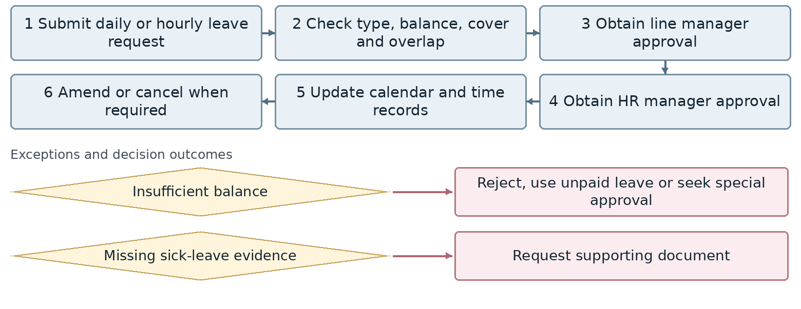
Confirm exact exception attachment and return points with the process owner.
Outcome Approved leave and updated balance
Proposed owner and interfaces HR Manager; interfaces: Unit managers, Administration, Finance and Payroll.
Target requirement Support the workflow through completion with accountable owners, statuses, deadlines, attachments, notifications, approvals and full history.
Required data Employee, calendar, shift, entry/exit, request type, dates and hours, leave balance, approvers, mission, time records and corrections.
Decisions and controls Agree manager/HR approval order, leave carryover, corrections after period closure and mission impact on time records. Carry remaining leave into the following year according to the approved company rule.
Reports and indicators Leave balances and consumption, excused and unexcused absence, rejected requests.
Acceptance scenario Test ordinary and exceptional time requests, multi-day missions and corrections; reconcile approved hours and leave balances.
Odoo response / coverage: [ ] Standard [ ] Configuration [ ] Studio [ ] Development
[ ] Integration [ ] Alternative / not covered | Limitations / evidence: ................................
Action owner: .................................... Due date: ....................................

14. Business missions and attendance impact
HR-14 | Human Resources | Unit status: Approved
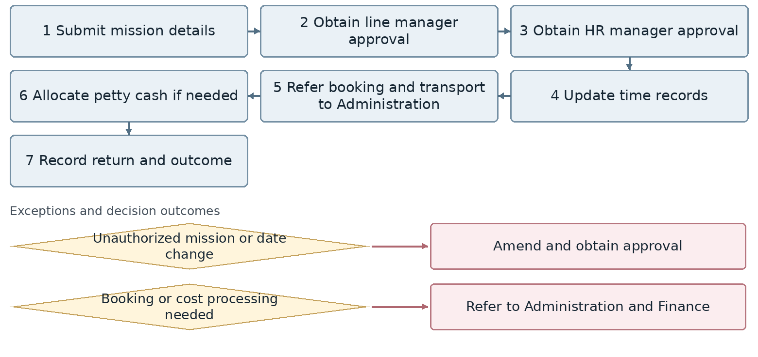
Confirm exact exception attachment and return points with the process owner.
Outcome Approved mission and accurate time records
Proposed owner and interfaces HR Manager; interfaces: Unit managers, Administration, Finance and Payroll.
Target requirement Support the workflow through completion with accountable owners, statuses, deadlines, attachments, notifications, approvals and full history.
Required data Employee, calendar, shift, entry/exit, request type, dates and hours, leave balance, approvers, mission, time records and corrections.
Decisions and controls Agree manager/HR approval order, leave carryover, corrections after period closure and mission impact on time records. HR owns approval and time impact; Administration and Finance own travel execution and costs.
Reports and indicators Missions by employee and unit, mission days and cancellations.
Acceptance scenario Test ordinary and exceptional time requests, multi-day missions and corrections; reconcile approved hours and leave balances.
Odoo response / coverage: [ ] Standard [ ] Configuration [ ] Studio [ ] Development
[ ] Integration [ ] Alternative / not covered | Limitations / evidence: ................................
Action owner: .................................... Due date: ....................................

15. Payroll inputs and calculation
HR-15 | Human Resources | Unit status: Approved
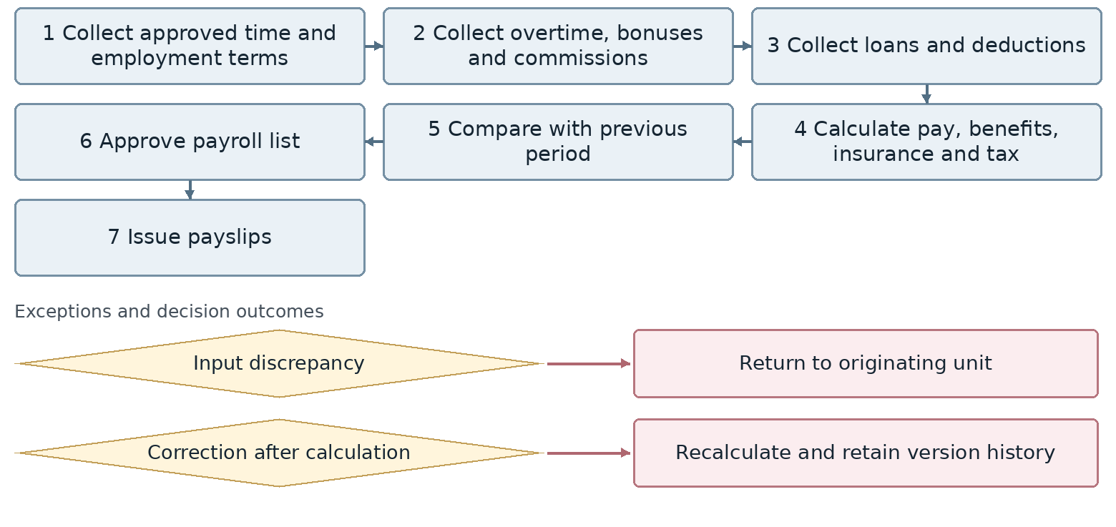
Confirm exact exception attachment and return points with the process owner.
Outcome Approved payroll list and payslips for Finance payment and posting
Proposed owner and interfaces HR Manager; interfaces: Finance, Treasury, unit managers and Management.
Target requirement Support the workflow through completion with accountable owners, statuses, deadlines, attachments, notifications, approvals and full history.
Required data Employee, period, employment order, time records, benefits, deductions, loan or advance, installments, net pay, budget and calculation version.
Decisions and controls Agree Rahkaran/Odoo calculation ownership, payroll approval and manager, HR and Finance controls for advances. Confirm whether Rahkaran or Odoo calculates payroll and define the Finance handoff.
Reports and indicators Payroll cost, period variance, net pay, deductions and corrections.
Acceptance scenario Calculate a period with corrected time and an advance installment; retain a new version without duplicate payment or deduction.
Odoo response / coverage: [ ] Standard [ ] Configuration [ ] Studio [ ] Development
[ ] Integration [ ] Alternative / not covered | Limitations / evidence: ................................
Action owner: .................................... Due date: ....................................

16. Compensation and pay structure
HR-16 | Human Resources | Unit status: Approved
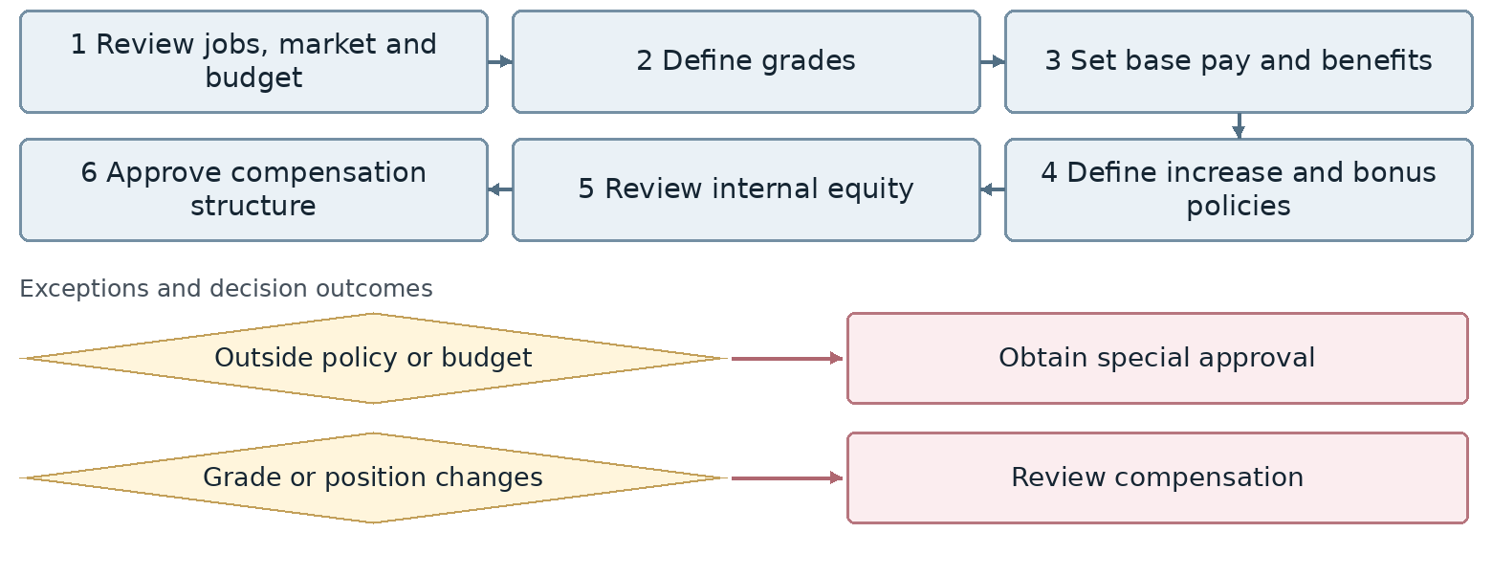
Confirm exact exception attachment and return points with the process owner.
Outcome Approved compensation structure and employment orders
Proposed owner and interfaces HR Manager; interfaces: Finance, Treasury, unit managers and Management.
Target requirement Support the workflow through completion with accountable owners, statuses, deadlines, attachments, notifications, approvals and full history.
Required data Employee, period, employment order, time records, benefits, deductions, loan or advance, installments, net pay, budget and calculation version.
Decisions and controls Agree Rahkaran/Odoo calculation ownership, payroll approval and manager, HR and Finance controls for advances. Define approval limits and effective dates for compensation changes.
Reports and indicators Pay by grade, increases, total cost and internal equity.
Acceptance scenario Calculate a period with corrected time and an advance installment; retain a new version without duplicate payment or deduction.
Odoo response / coverage: [ ] Standard [ ] Configuration [ ] Studio [ ] Development
[ ] Integration [ ] Alternative / not covered | Limitations / evidence: ................................
Action owner: .................................... Due date: ....................................

17. Loans, advances and deductions
HR-17 | Human Resources | Unit status: Approved
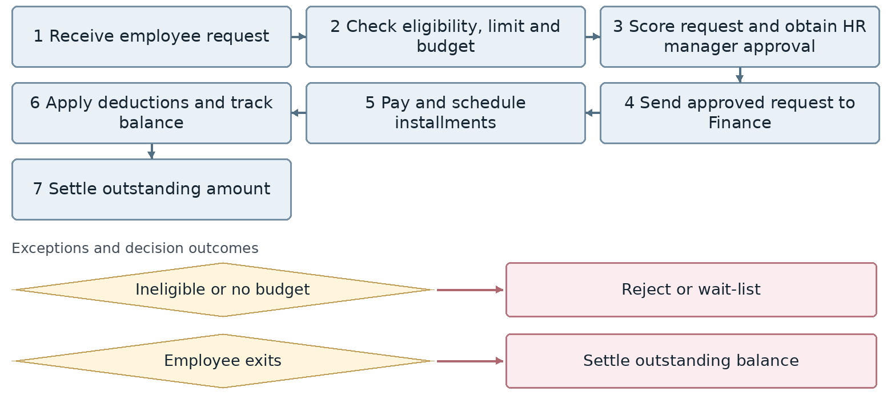
Confirm exact exception attachment and return points with the process owner.
Outcome Approved loan or advance and deduction schedule
Proposed owner and interfaces HR Manager; interfaces: Finance, Treasury, unit managers and Management.
Target requirement Support the workflow through completion with accountable owners, statuses, deadlines, attachments, notifications, approvals and full history.
Required data Employee, period, employment order, time records, benefits, deductions, loan or advance, installments, net pay, budget and calculation version.
Decisions and controls Agree Rahkaran/Odoo calculation ownership, payroll approval and manager, HR and Finance controls for advances. Finalize manager, HR and Finance controls before payment and deduction scheduling.
Reports and indicators Requests, debt balances, installments, counts and amounts.
Acceptance scenario Calculate a period with corrected time and an advance installment; retain a new version without duplicate payment or deduction.
Odoo response / coverage: [ ] Standard [ ] Configuration [ ] Studio [ ] Development
[ ] Integration [ ] Alternative / not covered | Limitations / evidence: ................................
Action owner: .................................... Due date: ....................................

18. Performance appraisal
HR-18 | Human Resources | Unit status: Approved
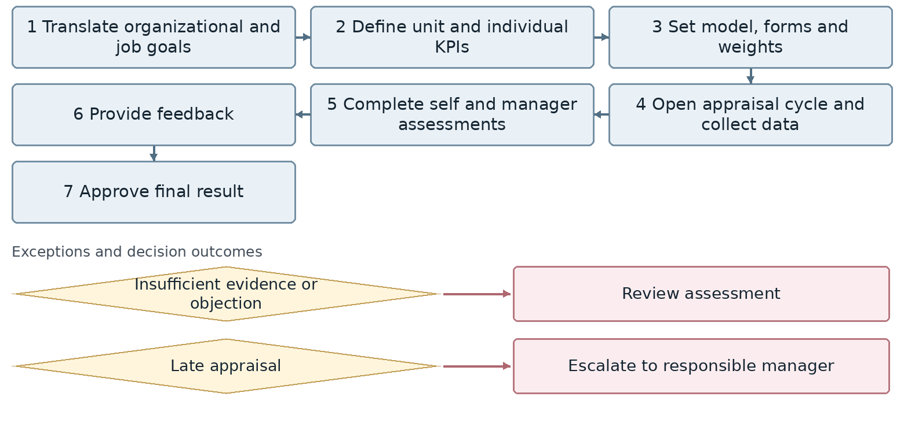
Confirm exact exception attachment and return points with the process owner.
Outcome Approved performance appraisal
Proposed owner and interfaces HR Manager; interfaces: Management, unit managers, Systems and Methods, and Training.
Target requirement Support the workflow through completion with accountable owners, statuses, deadlines, attachments, notifications, approvals and full history.
Required data Cycle, goal, indicator, weight, data source, self-assessment, manager score, evidence, feedback, appeal and improvement action.
Decisions and controls Define score sources, edit permissions, appeals and links to training and compensation. Define indicator sources, score-edit permissions and the appeal route.
Reports and indicators On-time completion, score distribution, variance and evidence coverage.
Acceptance scenario Complete an appraisal and an appealed case; trace weights, evidence, final decision and improvement actions.
Odoo response / coverage: [ ] Standard [ ] Configuration [ ] Studio [ ] Development
[ ] Integration [ ] Alternative / not covered | Limitations / evidence: ................................
Action owner: .................................... Due date: ....................................

19. Performance improvement
HR-19 | Human Resources | Unit status: Approved
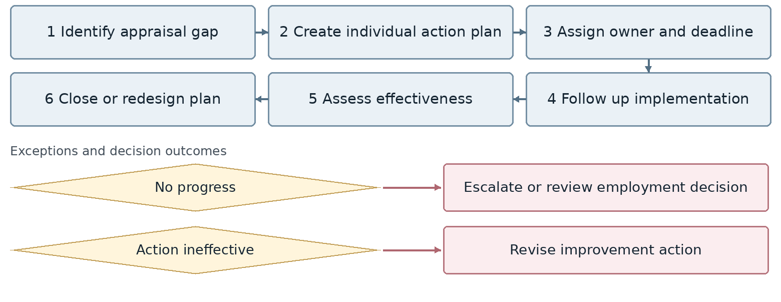
Confirm exact exception attachment and return points with the process owner.
Outcome Completed improvement plan with assessed results
Proposed owner and interfaces HR Manager; interfaces: Management, unit managers, Systems and Methods, and Training.
Target requirement Support the workflow through completion with accountable owners, statuses, deadlines, attachments, notifications, approvals and full history.
Required data Cycle, goal, indicator, weight, data source, self-assessment, manager score, evidence, feedback, appeal and improvement action.
Decisions and controls Define score sources, edit permissions, appeals and links to training and compensation. Link improvement actions to the originating appraisal and supporting evidence.
Reports and indicators Executed and open actions, completion and effectiveness.
Acceptance scenario Complete an appraisal and an appealed case; trace weights, evidence, final decision and improvement actions.
Odoo response / coverage: [ ] Standard [ ] Configuration [ ] Studio [ ] Development
[ ] Integration [ ] Alternative / not covered | Limitations / evidence: ................................
Action owner: .................................... Due date: ....................................

20. Competencies and skill matrix
HR-20 | Human Resources | Unit status: Not currently performed
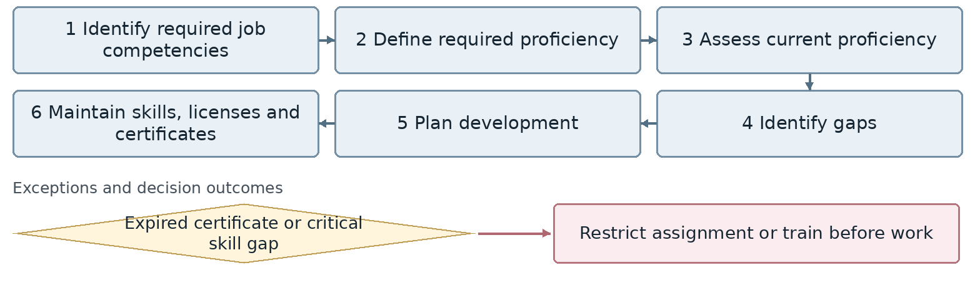
Confirm exact exception attachment and return points with the process owner.
Outcome Competency matrix and development gaps
Proposed owner and interfaces HR Manager; interfaces: Management, unit managers, Finance and Training.
Target requirement Support the workflow through completion with accountable owners, statuses, deadlines, attachments, notifications, approvals and full history.
Required data Company, branch, unit, job, position, grade, headcount, line manager, cost center, requirements, competencies, version and effective date.
Decisions and controls Confirm who authorizes headcount or position changes and how prior versions and dependent records are retained. Confirm future-phase inclusion and restrictions for critical competency gaps.
Reports and indicators Competency coverage, expired certificates, skill gaps and qualified employees.
Acceptance scenario Record an effective-dated change; verify prior history and the impact on hierarchy, cost center, competencies and reports.
Odoo response / coverage: [ ] Standard [ ] Configuration [ ] Studio [ ] Development
[ ] Integration [ ] Alternative / not covered | Limitations / evidence: ................................
Action owner: .................................... Due date: ....................................

21. Training needs and planning
HR-21 | Human Resources | Unit status: Review required
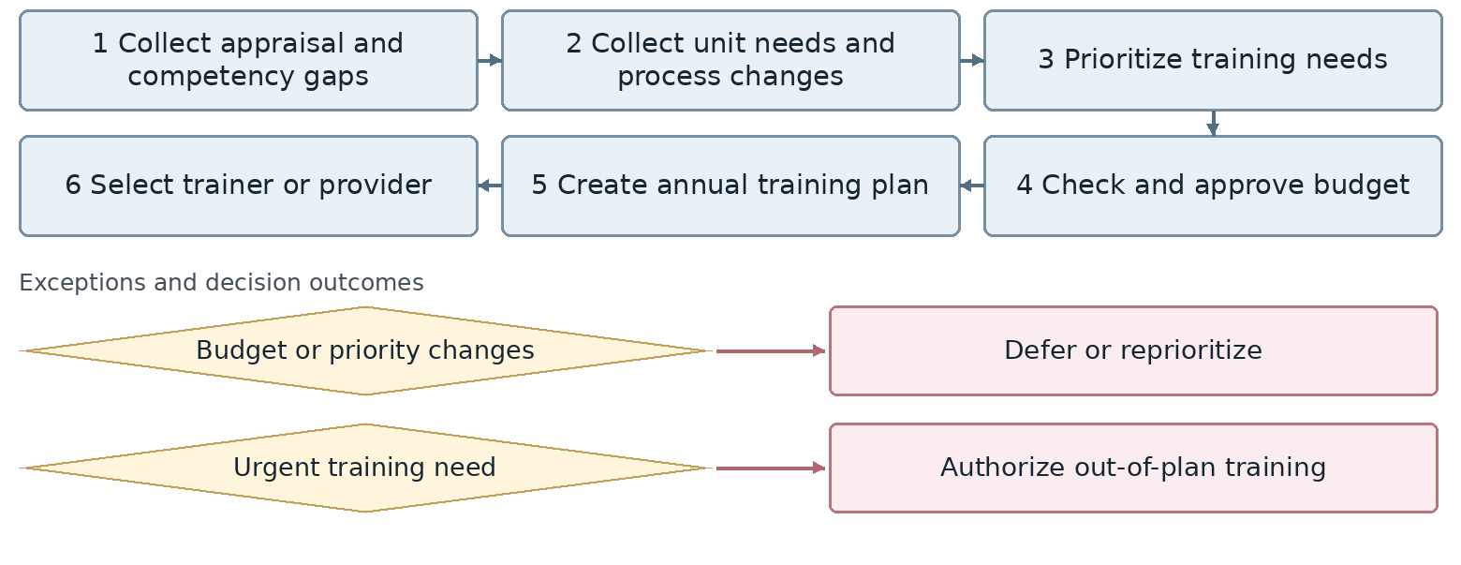
Confirm exact exception attachment and return points with the process owner.
Outcome Approved training plan
Proposed owner and interfaces HR Manager; interfaces: Unit managers, Finance, training providers and Performance Management.
Target requirement Support the workflow through completion with accountable owners, statuses, deadlines, attachments, notifications, approvals and full history.
Required data Training need, gap source, priority, budget, course, trainer, participant, attendance, test, satisfaction, effectiveness and certificate.
Decisions and controls Define effectiveness measurement, result approval and conditions for continuing or stopping training. Not currently supported in the system; implementation may be considered.
Reports and indicators Plan completion, budget and outstanding training needs.
Acceptance scenario Carry a need from appraisal to training, then verify attendance, learning and workplace impact.
Odoo response / coverage: [ ] Standard [ ] Configuration [ ] Studio [ ] Development
[ ] Integration [ ] Alternative / not covered | Limitations / evidence: ................................
Action owner: .................................... Due date: ....................................

22. Training delivery and effectiveness
HR-22 | Human Resources | Unit status: Review required
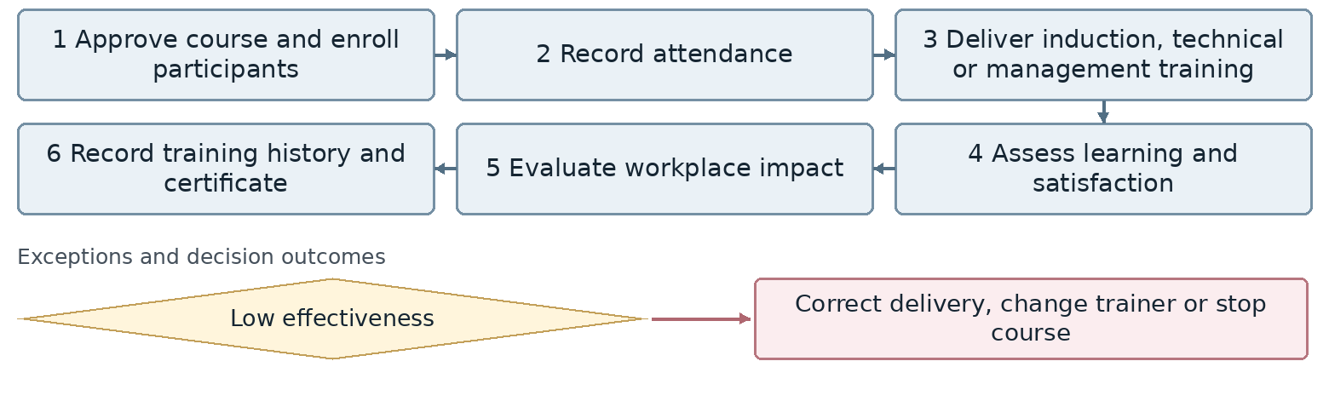
Confirm exact exception attachment and return points with the process owner.
Outcome Training records and effectiveness results
Proposed owner and interfaces HR Manager; interfaces: Unit managers, Finance, training providers and Performance Management.
Target requirement Support the workflow through completion with accountable owners, statuses, deadlines, attachments, notifications, approvals and full history.
Required data Training need, gap source, priority, budget, course, trainer, participant, attendance, test, satisfaction, effectiveness and certificate.
Decisions and controls Define effectiveness measurement, result approval and conditions for continuing or stopping training. Not currently supported in the system; define how learning and job impact will be measured.
Reports and indicators Effectiveness, hours per employee, cost and attendance.
Acceptance scenario Carry a need from appraisal to training, then verify attendance, learning and workplace impact.
Odoo response / coverage: [ ] Standard [ ] Configuration [ ] Studio [ ] Development
[ ] Integration [ ] Alternative / not covered | Limitations / evidence: ................................
Action owner: .................................... Due date: ....................................

23. Career progression, promotion and succession
HR-23 | Human Resources | Unit status: Review required
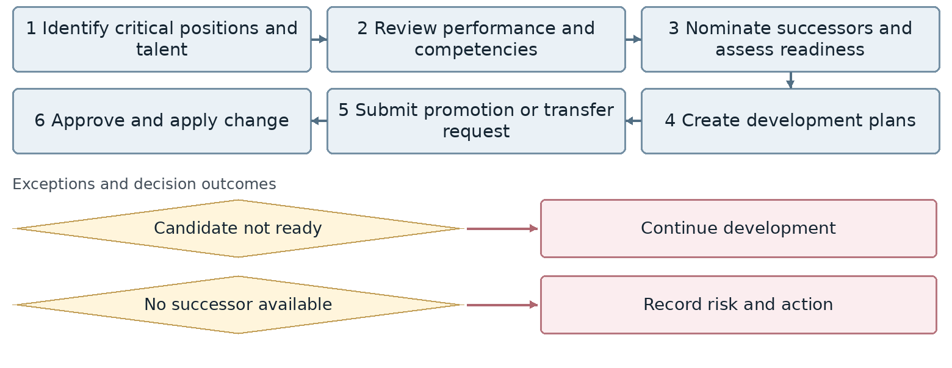
Confirm exact exception attachment and return points with the process owner.
Outcome Succession plan and approved promotion or job change
Proposed owner and interfaces HR Manager; interfaces: Management, unit managers, Finance and Training.
Target requirement Support the workflow through completion with accountable owners, statuses, deadlines, attachments, notifications, approvals and full history.
Required data Company, branch, unit, job, position, grade, headcount, line manager, cost center, requirements, competencies, version and effective date.
Decisions and controls Confirm who authorizes headcount or position changes and how prior versions and dependent records are retained. Implementation may be considered; retain effective-dated promotion and succession decisions.
Reports and indicators Succession coverage, internal promotions and key roles without backup.
Acceptance scenario Record an effective-dated change; verify prior history and the impact on hierarchy, cost center, competencies and reports.
Odoo response / coverage: [ ] Standard [ ] Configuration [ ] Studio [ ] Development
[ ] Integration [ ] Alternative / not covered | Limitations / evidence: ................................
Action owner: .................................... Due date: ....................................

24. Employee changes and transfers
HR-24 | Human Resources | Unit status: Review required
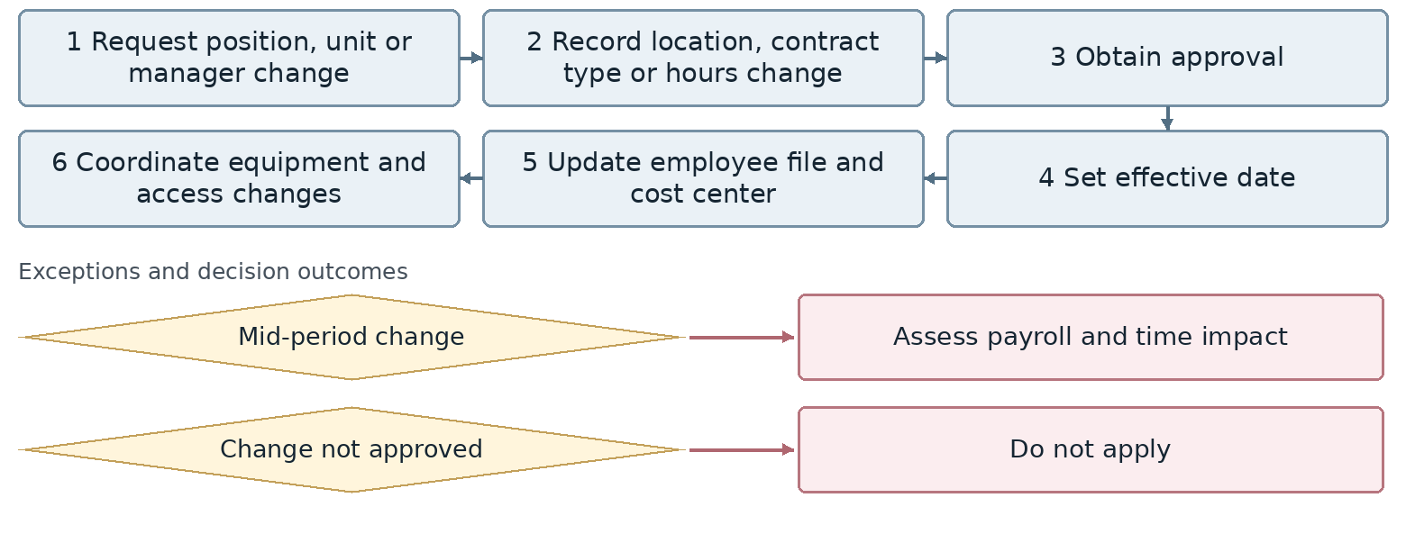
Confirm exact exception attachment and return points with the process owner.
Outcome Updated organizational and employment status
Proposed owner and interfaces HR Manager; interfaces: Unit manager, IT, Administration, Warehouse and Finance.
Target requirement Support the workflow through completion with accountable owners, statuses, deadlines, attachments, notifications, approvals and full history.
Required data Employee, engagement type, contract, position, manager, location, effective date, documents, assets, access, assigned tasks and completion status.
Decisions and controls Define each data owner, permissions for sensitive changes and conditions for completing entry or an employee change. Preserve service history across transfers for final settlement calculations.
Reports and indicators Changes, transfers, effective dates and overdue actions.
Acceptance scenario Run an entry or transfer with unavailable equipment or access; verify accountable open tasks and completion evidence.
Odoo response / coverage: [ ] Standard [ ] Configuration [ ] Studio [ ] Development
[ ] Integration [ ] Alternative / not covered | Limitations / evidence: ................................
Action owner: .................................... Due date: ....................................

25. Satisfaction, engagement and retention
HR-25 | Human Resources | Unit status: Not currently performed
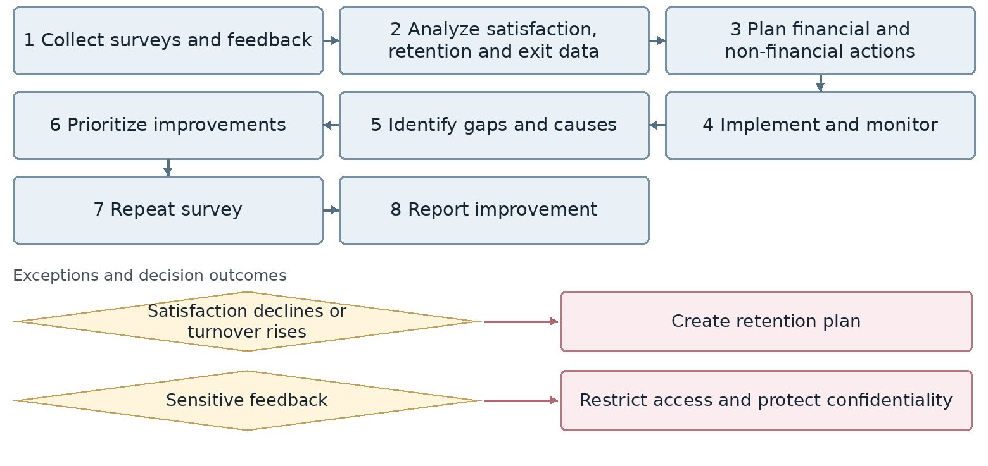
Confirm exact exception attachment and return points with the process owner.
Outcome Retention and employee experience improvement plan
Proposed owner and interfaces HR Manager; interfaces: Management, Legal, unit managers and Administration.
Target requirement Support the workflow through completion with accountable owners, statuses, deadlines, attachments, notifications, approvals and full history.
Required data Subject, target group, confidentiality, request or complaint, documents, case owner, decision, action, due date, result and satisfaction.
Decisions and controls Agree confidential access, decision authority, appeal or legal referral and evidence required for closure. Include follow-up surveys and improvement reporting; confirm implementation phase.
Reports and indicators Satisfaction, engagement, turnover, action completion and exit causes.
Acceptance scenario Run an ordinary and a confidential case; verify access, deadlines, decisions, appeals and closure documents.
Odoo response / coverage: [ ] Standard [ ] Configuration [ ] Studio [ ] Development
[ ] Integration [ ] Alternative / not covered | Limitations / evidence: ................................
Action owner: .................................... Due date: ....................................

26. Internal communications and HR self-service
HR-26 | Human Resources | Unit status: Amendments requested
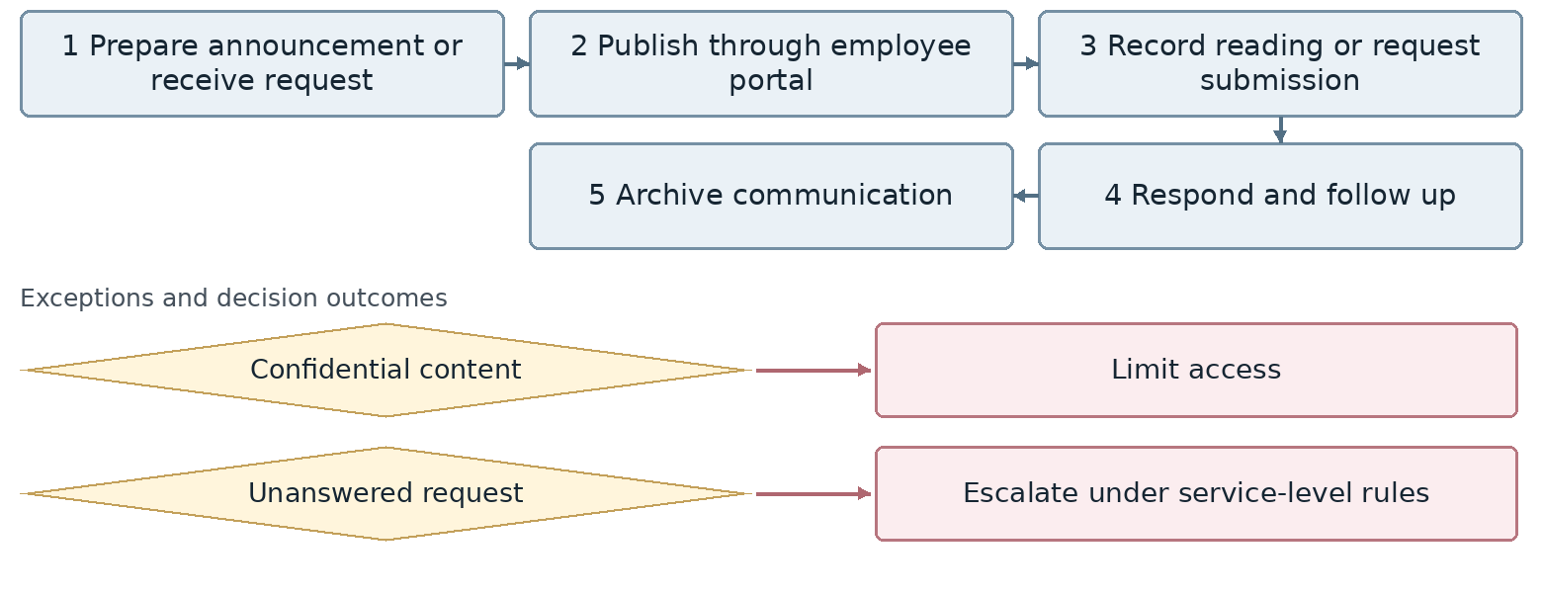
Confirm exact exception attachment and return points with the process owner.
Outcome Traceable announcements and employee requests
Proposed owner and interfaces HR Manager; interfaces: Management, Legal, unit managers and Administration.
Target requirement Support the workflow through completion with accountable owners, statuses, deadlines, attachments, notifications, approvals and full history.
Required data Subject, target group, confidentiality, request or complaint, documents, case owner, decision, action, due date, result and satisfaction.
Decisions and controls Agree confidential access, decision authority, appeal or legal referral and evidence required for closure. Enable publication of HR news and announcements.
Reports and indicators Request volume, response time, portal use and read confirmations.
Acceptance scenario Run an ordinary and a confidential case; verify access, deadlines, decisions, appeals and closure documents.
Odoo response / coverage: [ ] Standard [ ] Configuration [ ] Studio [ ] Development
[ ] Integration [ ] Alternative / not covered | Limitations / evidence: ................................
Action owner: .................................... Due date: ....................................

27. Employee relations, grievances and discipline
HR-27 | Human Resources | Unit status: Review required
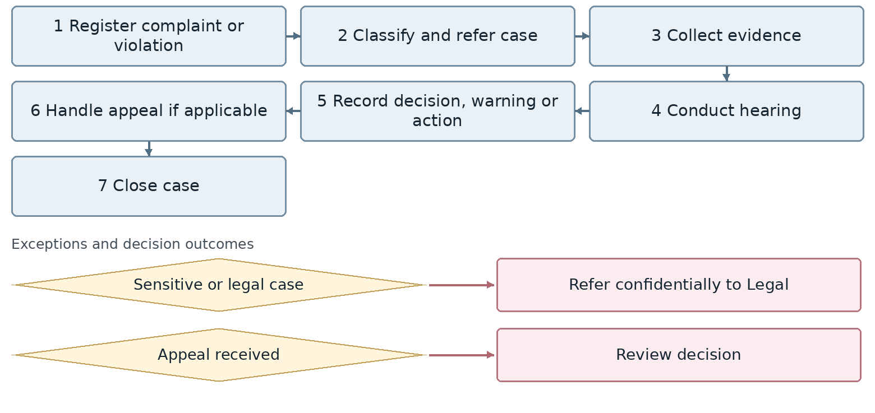
Confirm exact exception attachment and return points with the process owner.
Outcome Resolved employee relations case
Proposed owner and interfaces HR Manager; interfaces: Management, Legal, unit managers and Administration.
Target requirement Support the workflow through completion with accountable owners, statuses, deadlines, attachments, notifications, approvals and full history.
Required data Subject, target group, confidentiality, request or complaint, documents, case owner, decision, action, due date, result and satisfaction.
Decisions and controls Agree confidential access, decision authority, appeal or legal referral and evidence required for closure. Confirm confidentiality, hearing authority, appeal permissions and closure evidence.
Reports and indicators Case count, resolution time and recurring issues.
Acceptance scenario Run an ordinary and a confidential case; verify access, deadlines, decisions, appeals and closure documents.
Odoo response / coverage: [ ] Standard [ ] Configuration [ ] Studio [ ] Development
[ ] Integration [ ] Alternative / not covered | Limitations / evidence: ................................
Action owner: .................................... Due date: ....................................

28. HR compliance management
HR-28 | Human Resources | Unit status: Approved
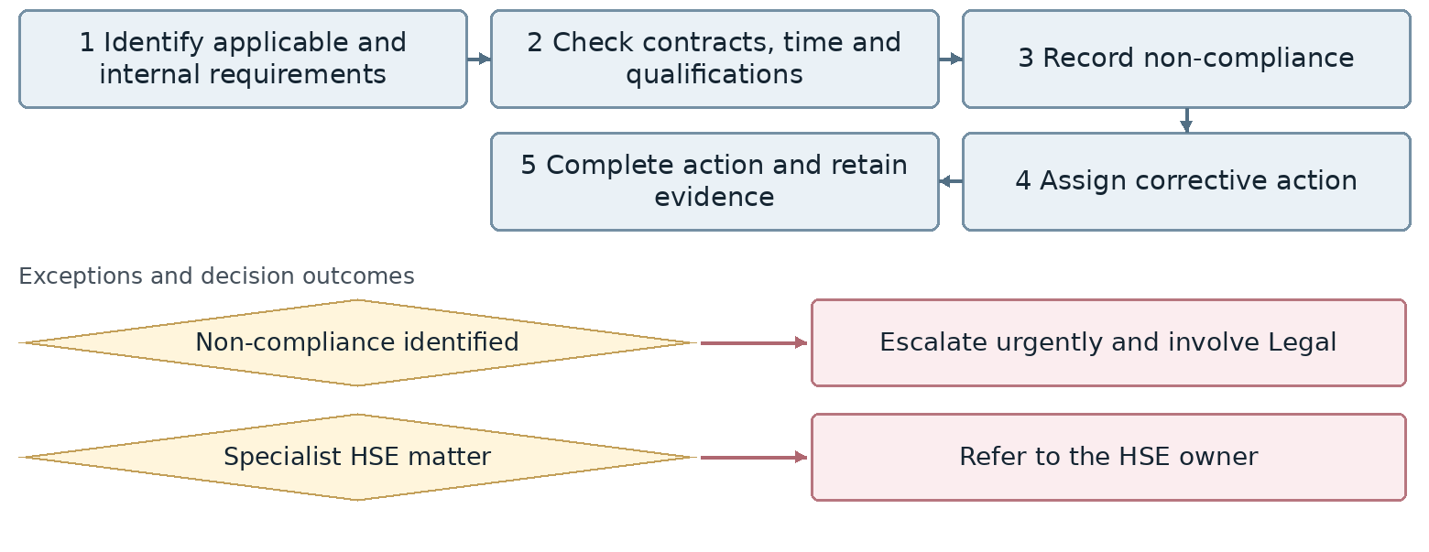
Confirm exact exception attachment and return points with the process owner.
Outcome Documented HR compliance and corrective actions
Proposed owner and interfaces HR Manager; interfaces: Management, Legal, unit managers and Administration.
Target requirement Support the workflow through completion with accountable owners, statuses, deadlines, attachments, notifications, approvals and full history.
Required data Subject, target group, confidentiality, request or complaint, documents, case owner, decision, action, due date, result and satisfaction.
Decisions and controls Agree confidential access, decision authority, appeal or legal referral and evidence required for closure. Support uploading the insurance list to the Social Security portal; confirm the agreed submission method.
Reports and indicators Non-compliance, penalties, legal complaints and expired permits.
Acceptance scenario Run an ordinary and a confidential case; verify access, deadlines, decisions, appeals and closure documents.
Odoo response / coverage: [ ] Standard [ ] Configuration [ ] Studio [ ] Development
[ ] Integration [ ] Alternative / not covered | Limitations / evidence: ................................
Action owner: .................................... Due date: ....................................

29. Contract and nonstandard workers
HR-29 | Human Resources | Unit status: Approved
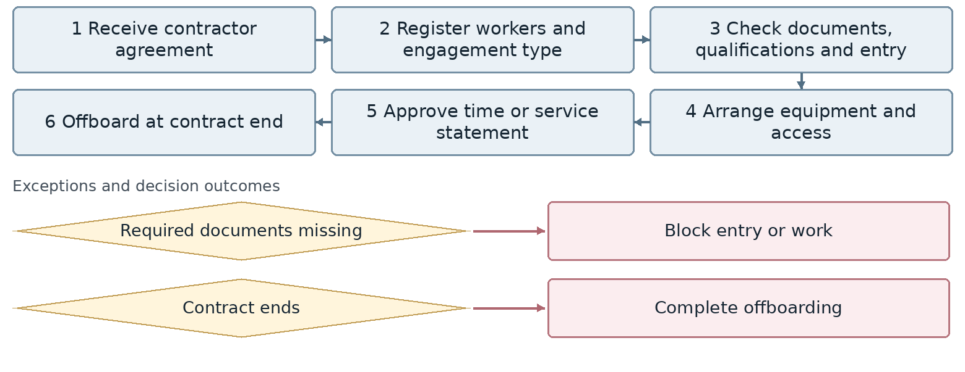
Confirm exact exception attachment and return points with the process owner.
Outcome Worker record and valid engagement status
Proposed owner and interfaces HR Manager; interfaces: Unit manager, IT, Administration, Warehouse and Finance.
Target requirement Support the workflow through completion with accountable owners, statuses, deadlines, attachments, notifications, approvals and full history.
Required data Employee, engagement type, contract, position, manager, location, effective date, documents, assets, access, assigned tasks and completion status.
Decisions and controls Define each data owner, permissions for sensitive changes and conditions for completing entry or an employee change. Distinguish the engagement type within employee contracts.
Reports and indicators Worker counts, costs, attendance, contracts and access.
Acceptance scenario Run an entry or transfer with unavailable equipment or access; verify accountable open tasks and completion evidence.
Odoo response / coverage: [ ] Standard [ ] Configuration [ ] Studio [ ] Development
[ ] Integration [ ] Alternative / not covered | Limitations / evidence: ................................
Action owner: .................................... Due date: ....................................

30. Welfare policies and eligibility
HR-30 | Human Resources | Unit status: Approved
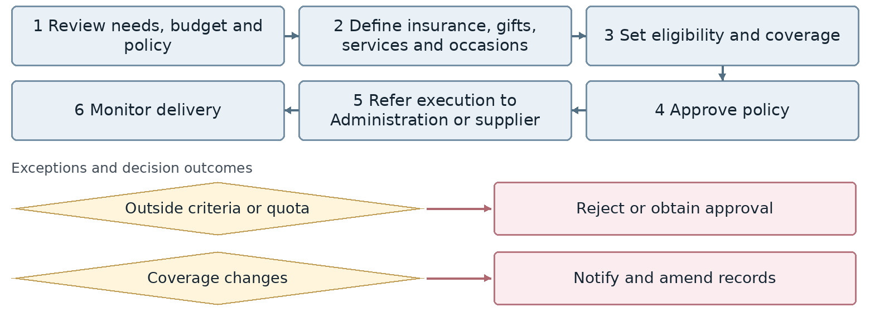
Confirm exact exception attachment and return points with the process owner.
Outcome Approved welfare policy and eligibility rules
Proposed owner and interfaces HR Manager; interfaces: Management, Legal, unit managers and Administration.
Target requirement Support the workflow through completion with accountable owners, statuses, deadlines, attachments, notifications, approvals and full history.
Required data Subject, target group, confidentiality, request or complaint, documents, case owner, decision, action, due date, result and satisfaction.
Decisions and controls Agree confidential access, decision authority, appeal or legal referral and evidence required for closure. Not currently supported in the system; implementation may be considered.
Reports and indicators Cost, participation, satisfaction and coverage.
Acceptance scenario Run an ordinary and a confidential case; verify access, deadlines, decisions, appeals and closure documents.
Odoo response / coverage: [ ] Standard [ ] Configuration [ ] Studio [ ] Development
[ ] Integration [ ] Alternative / not covered | Limitations / evidence: ................................
Action owner: .................................... Due date: ....................................

31. Employee equipment and access coordination
HR-31 | Human Resources | Unit status: Approved
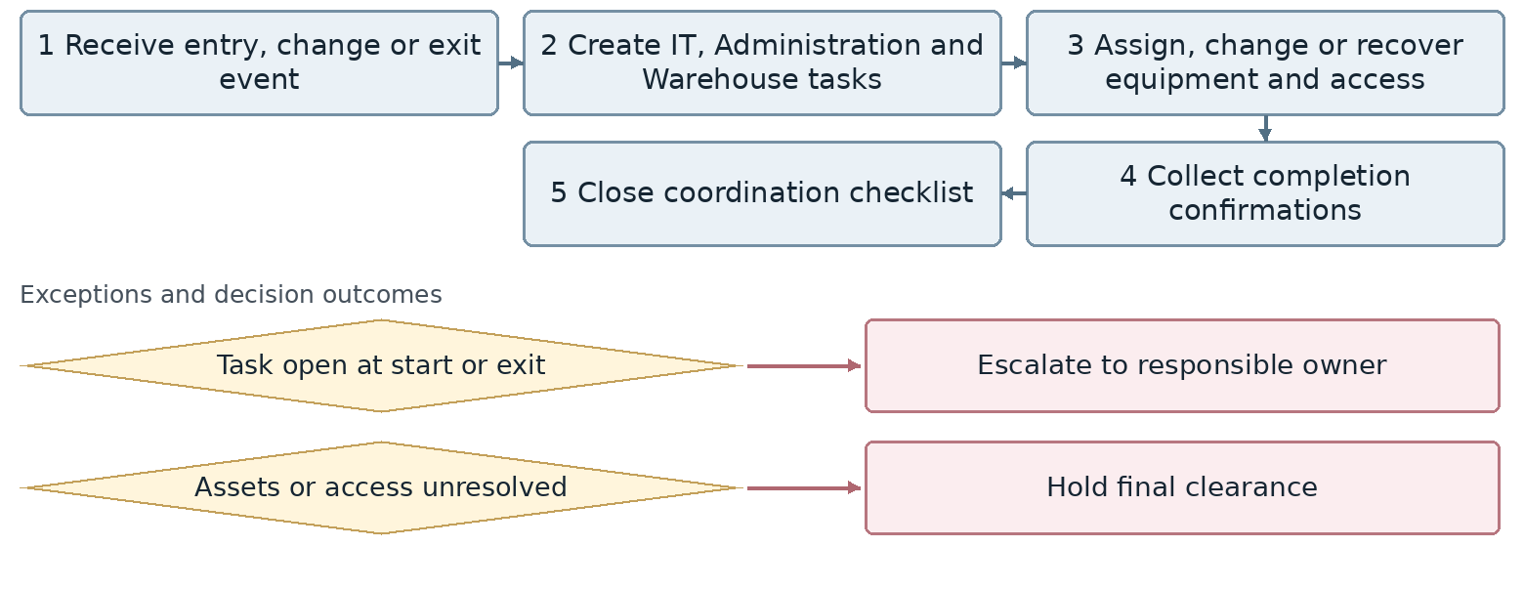
Confirm exact exception attachment and return points with the process owner.
Outcome Equipment and access aligned with employment status
Proposed owner and interfaces HR Manager; interfaces: Unit manager, IT, Administration, Warehouse and Finance.
Target requirement Support the workflow through completion with accountable owners, statuses, deadlines, attachments, notifications, approvals and full history.
Required data Employee, engagement type, contract, position, manager, location, effective date, documents, assets, access, assigned tasks and completion status.
Decisions and controls Define each data owner, permissions for sensitive changes and conditions for completing entry or an employee change. Define ownership of each task and evidence required for clearance.
Reports and indicators Open onboarding and offboarding tasks, assets and access.
Acceptance scenario Run an entry or transfer with unavailable equipment or access; verify accountable open tasks and completion evidence.
Odoo response / coverage: [ ] Standard [ ] Configuration [ ] Studio [ ] Development
[ ] Integration [ ] Alternative / not covered | Limitations / evidence: ................................
Action owner: .................................... Due date: ....................................

32. HR service desk
HR-32 | Human Resources | Unit status: Not currently performed
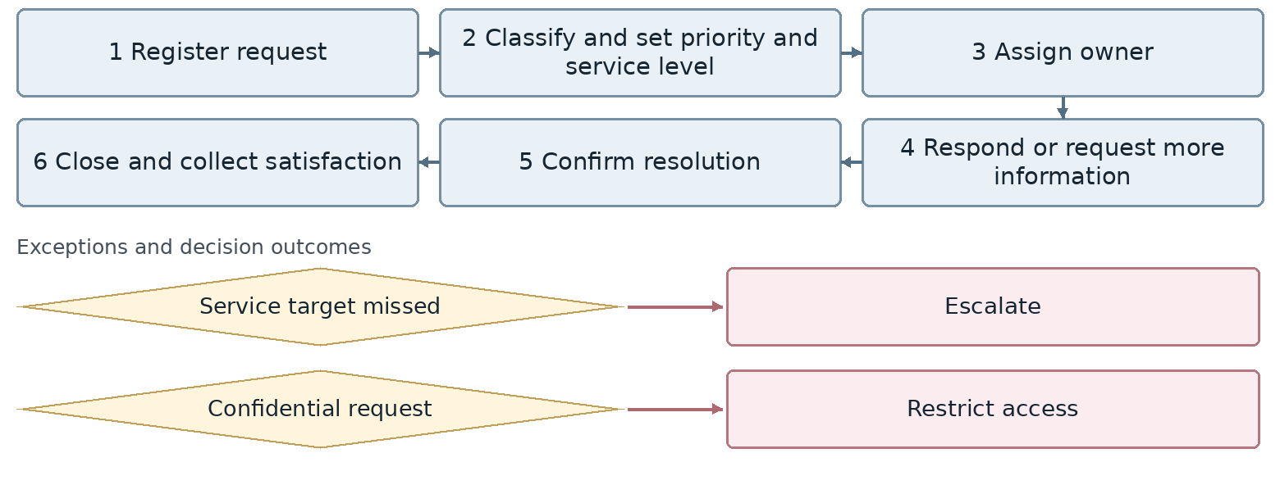
Confirm exact exception attachment and return points with the process owner.
Outcome Closed and traceable HR request
Proposed owner and interfaces HR Manager; interfaces: All units, Finance, Procurement and Management.
Target requirement Support the workflow through completion with accountable owners, statuses, deadlines, attachments, notifications, approvals and full history.
Required data Requester, approving manager, service type, priority, time, location, headcount, budget, assignee, due date, cost, delivery confirmation and feedback.
Decisions and controls Define priority classification, service targets, cost approval and stakeholder notifications. The unit also marked this item for deletion. Confirm exclusion or consolidation with the shared service desk before implementation.
Reports and indicators Request volume, service compliance, resolution time, feedback and recurrence.
Acceptance scenario Run an ordinary, urgent and budget-dependent request; retain approvals, notifications and elapsed service time.
Odoo response / coverage: [ ] Standard [ ] Configuration [ ] Studio [ ] Development
[ ] Integration [ ] Alternative / not covered | Limitations / evidence: ................................
Action owner: .................................... Due date: ....................................

33. Employee exit, resignation and termination
HR-33 | Human Resources | Unit status: Approved
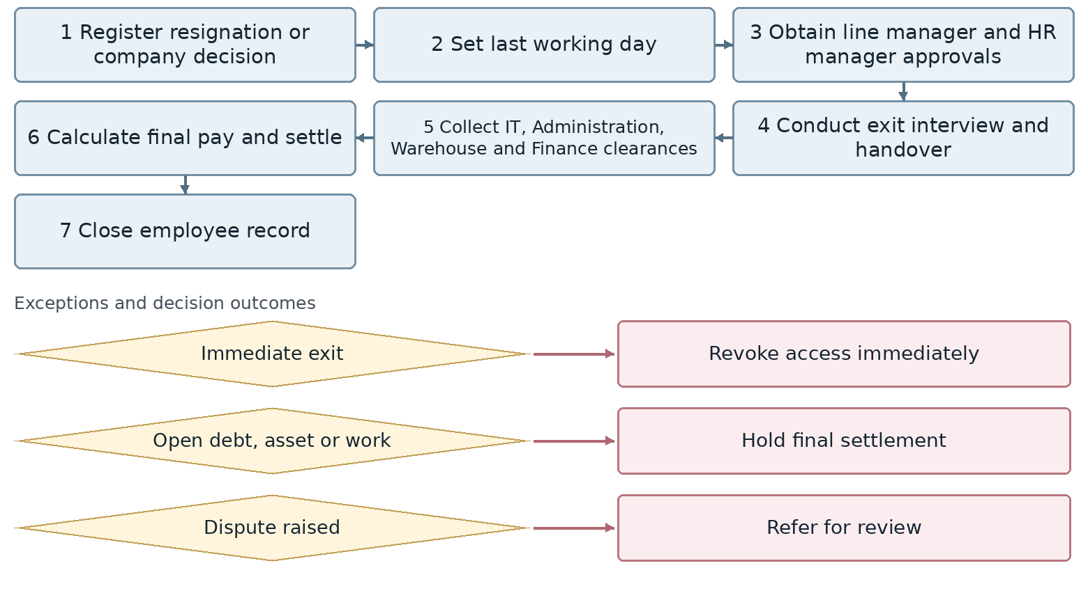
Confirm exact exception attachment and return points with the process owner.
Outcome Final settlement and closed employee record
Proposed owner and interfaces HR Manager; interfaces: Unit manager, IT, Administration, Warehouse and Finance.
Target requirement Support the workflow through completion with accountable owners, statuses, deadlines, attachments, notifications, approvals and full history.
Required data Employee, exit reason and date, manager approvals, exit interview, handover, assets, access, debt, settlement and rehire eligibility.
Decisions and controls Confirm manager and HR approval, access revocation timing and clearance conditions before final settlement. Require line manager and HR manager approvals and retain each clearance decision.
Reports and indicators Exit reasons, settlement time, outstanding assets and debt, rehire eligibility.
Acceptance scenario Run ordinary and urgent exits; open debt or assets must hold settlement while access revocation and payment remain traceable.
Odoo response / coverage: [ ] Standard [ ] Configuration [ ] Studio [ ] Development
[ ] Integration [ ] Alternative / not covered | Limitations / evidence: ................................
Action owner: .................................... Due date: ....................................

34. Retirement and planned exits
HR-34 | Human Resources | Unit status: Not currently performed
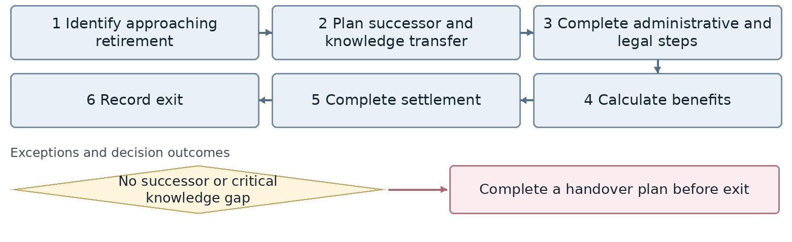
Confirm exact exception attachment and return points with the process owner.
Outcome Planned exit and retained organizational knowledge
Proposed owner and interfaces HR Manager; interfaces: Unit manager, IT, Administration, Warehouse and Finance.
Target requirement Support the workflow through completion with accountable owners, statuses, deadlines, attachments, notifications, approvals and full history.
Required data Employee, exit reason and date, manager approvals, exit interview, handover, assets, access, debt, settlement and rehire eligibility.
Decisions and controls Confirm manager and HR approval, access revocation timing and clearance conditions before final settlement. Confirm inclusion in a future phase and ownership of retirement planning.
Reports and indicators Critical exit risks, successor coverage and upcoming retirements.
Acceptance scenario Run ordinary and urgent exits; open debt or assets must hold settlement while access revocation and payment remain traceable.
Odoo response / coverage: [ ] Standard [ ] Configuration [ ] Studio [ ] Development
[ ] Integration [ ] Alternative / not covered | Limitations / evidence: ................................
Action owner: .................................... Due date: ....................................

35. HR analytics and reporting
HR-35 | Human Resources | Unit status: Not currently performed
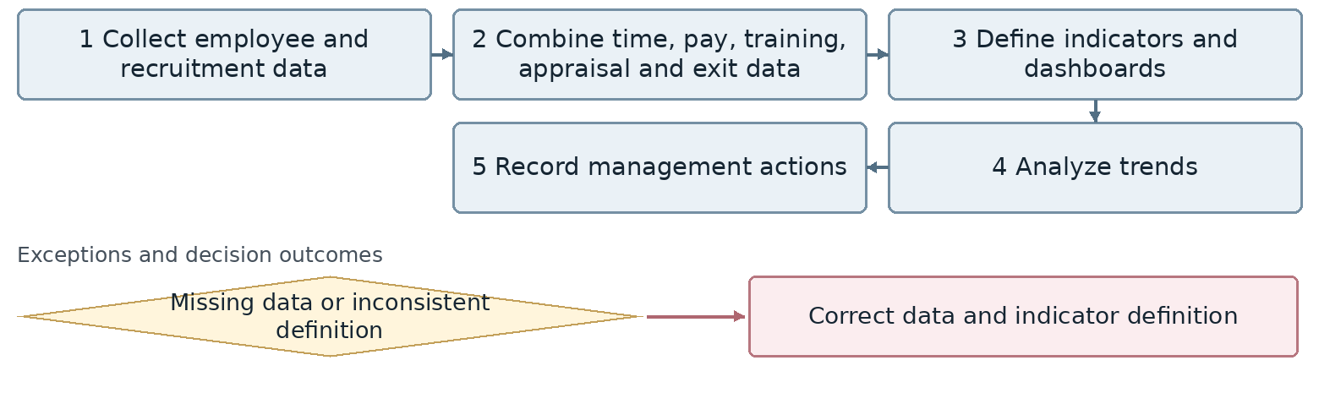
Confirm exact exception attachment and return points with the process owner.
Outcome HR dashboard and management insights
Proposed owner and interfaces HR Manager; interfaces: Management, Finance, IT and Business Intelligence.
Target requirement Support the workflow through completion with accountable owners, statuses, deadlines, attachments, notifications, approvals and full history.
Required data Indicator definition, period, unit, source record, data owner, value, refresh time, reconciliation status and access level.
Decisions and controls Agree systems of record, KPI definitions, refresh frequency, error handling and confidential data access. Provide simple tools for HR staff to create, edit, update and present dashboards.
Reports and indicators Headcount, hiring quality, turnover, training, performance, cost, succession and feedback.
Acceptance scenario Trace a dashboard indicator to its source records and reconcile totals; test unauthorized access and data errors.
Odoo response / coverage: [ ] Standard [ ] Configuration [ ] Studio [ ] Development
[ ] Integration [ ] Alternative / not covered | Limitations / evidence: ................................
Action owner: .................................... Due date: ....................................

36. HR data confidentiality and integration
HR-36 | Human Resources | Unit status: Not currently performed
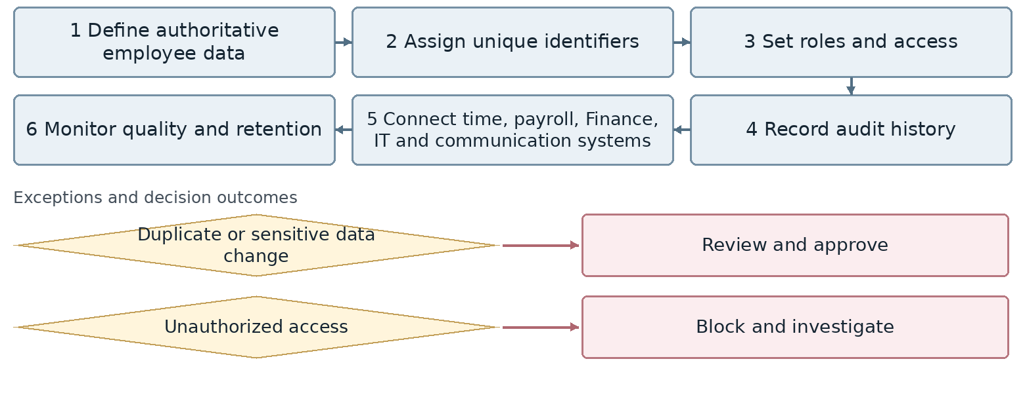
Confirm exact exception attachment and return points with the process owner.
Outcome Secure, integrated and reliable HR data
Proposed owner and interfaces HR Manager; interfaces: Management, Finance, IT and Business Intelligence.
Target requirement Support the workflow through completion with accountable owners, statuses, deadlines, attachments, notifications, approvals and full history.
Required data Indicator definition, period, unit, source record, data owner, value, refresh time, reconciliation status and access level.
Decisions and controls Agree systems of record, KPI definitions, refresh frequency, error handling and confidential data access. Define systems of record, exchange timing, error recovery and confidential data access.
Reports and indicators Synchronization errors, missing or duplicate data, changes and access events.
Acceptance scenario Trace a dashboard indicator to its source records and reconcile totals; test unauthorized access and data errors.
Odoo response / coverage: [ ] Standard [ ] Configuration [ ] Studio [ ] Development
[ ] Integration [ ] Alternative / not covered | Limitations / evidence: ................................
Action owner: .................................... Due date: ....................................

37. Administrative service desk and prioritization
AD-01 | Administration and Logistics | Unit status: Amendments requested
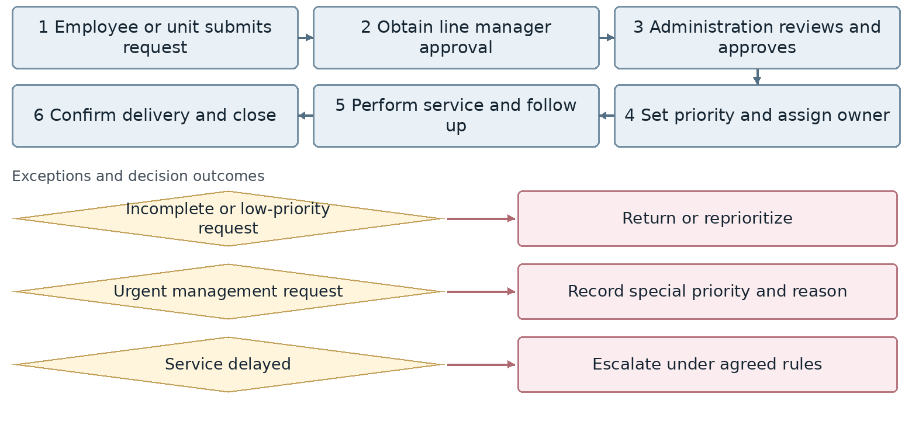
Confirm exact exception attachment and return points with the process owner.
Outcome Closed and traceable administrative request
Proposed owner and interfaces Administration and Logistics Lead; interfaces: All units, Finance, Procurement and Management.
Target requirement Support the workflow through completion with accountable owners, statuses, deadlines, attachments, notifications, approvals and full history.
Required data Requester, approving manager, service type, priority, time, location, headcount, budget, assignee, due date, cost, delivery confirmation and feedback.
Decisions and controls Define priority classification, service targets, cost approval and stakeholder notifications. Check Finance and budget where cost is involved and notify relevant stakeholders.
Reports and indicators Response time, on-time delivery and satisfaction.
Acceptance scenario Run an ordinary, urgent and budget-dependent request; retain approvals, notifications and elapsed service time.
Odoo response / coverage: [ ] Standard [ ] Configuration [ ] Studio [ ] Development
[ ] Integration [ ] Alternative / not covered | Limitations / evidence: ................................
Action owner: .................................... Due date: ....................................

38. Meetings, hospitality and events
AD-02 | Administration and Logistics | Unit status: Not currently available but required
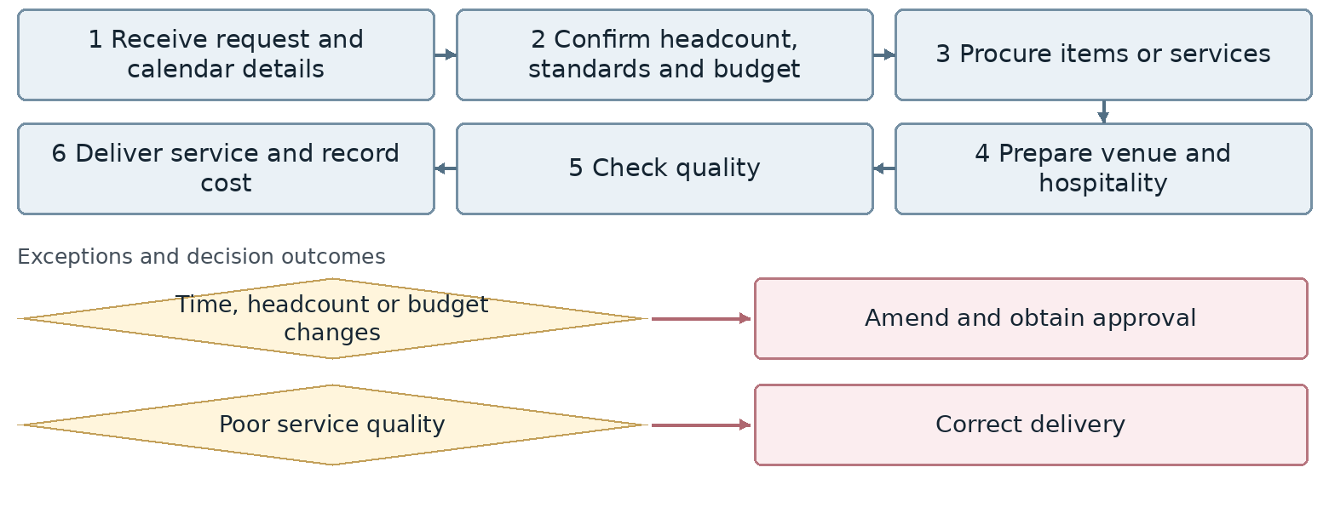
Confirm exact exception attachment and return points with the process owner.
Outcome Completed hospitality or event service
Proposed owner and interfaces Administration and Logistics Lead; interfaces: All units, Finance, Procurement and Management.
Target requirement Support the workflow through completion with accountable owners, statuses, deadlines, attachments, notifications, approvals and full history.
Required data Requester, approving manager, service type, priority, time, location, headcount, budget, assignee, due date, cost, delivery confirmation and feedback.
Decisions and controls Define priority classification, service targets, cost approval and stakeholder notifications. Define service categories, budget checks and confirmation of delivery.
Reports and indicators Cost, event count, feedback and budget variance.
Acceptance scenario Run an ordinary, urgent and budget-dependent request; retain approvals, notifications and elapsed service time.
Odoo response / coverage: [ ] Standard [ ] Configuration [ ] Studio [ ] Development
[ ] Integration [ ] Alternative / not covered | Limitations / evidence: ................................
Action owner: .................................... Due date: ....................................

39. Cleaning and workplace services
AD-03 | Administration and Logistics | Unit status: No system required
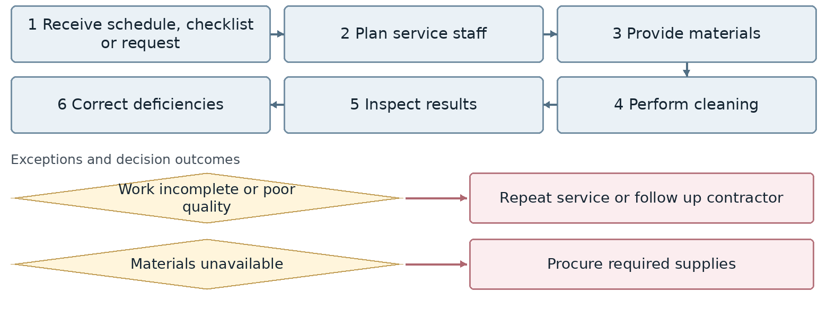
Confirm exact exception attachment and return points with the process owner.
Outcome Clean and ready workplace
Proposed owner and interfaces Administration and Logistics Lead; interfaces: Unit managers and Management.
Target requirement No standalone operational system is requested. Refer related requests, complaints or costs through the shared service desk only where needed.
Required data Request ID, requester, unit, owner, status, creation date, due date, attachments and change history.
Decisions and controls Agree responsibilities, approval levels, workflow transitions and access rights. No standalone operational system is requested; related requests, complaints or costs may be referred through the shared service desk.
Reports and indicators Checklist completion, materials, complaints and plan adherence.
Acceptance scenario Run a real case from creation to completion, then an exception; verify return, notification and audit history.
Odoo response / coverage: [ ] Standard [ ] Configuration [ ] Studio [ ] Development
[ ] Integration [ ] Alternative / not covered | Limitations / evidence: ................................
Action owner: .................................... Due date: ....................................

40. Security and access control
AD-04 | Administration and Logistics | Unit status: No system required
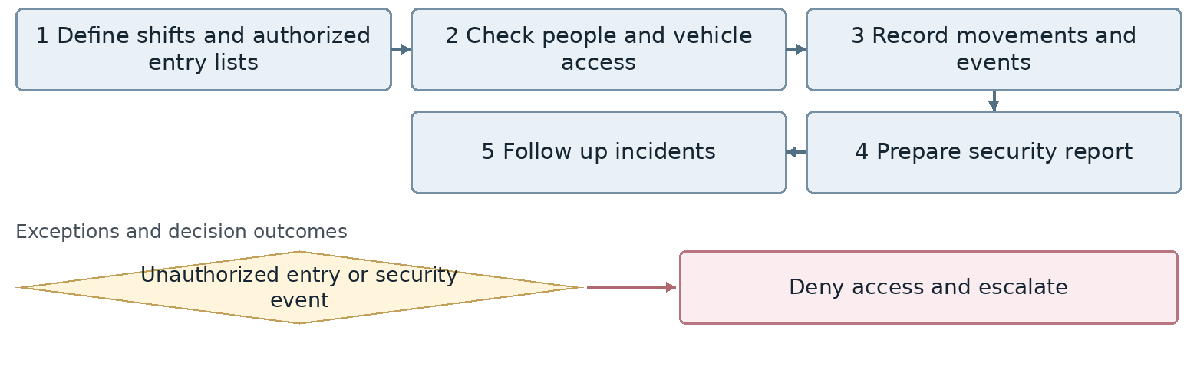
Confirm exact exception attachment and return points with the process owner.
Outcome Secure workplace and security records
Proposed owner and interfaces Administration and Logistics Lead; interfaces: Unit managers and Management.
Target requirement No standalone operational system is requested. Refer related requests, complaints or costs through the shared service desk only where needed.
Required data Request ID, requester, unit, owner, status, creation date, due date, attachments and change history.
Decisions and controls Agree responsibilities, approval levels, workflow transitions and access rights. No standalone operational system is requested; related service requests or incidents may be referred through the shared service desk.
Reports and indicators Movements, incidents, shift coverage and unauthorized entry attempts.
Acceptance scenario Run a real case from creation to completion, then an exception; verify return, notification and audit history.
Odoo response / coverage: [ ] Standard [ ] Configuration [ ] Studio [ ] Development
[ ] Integration [ ] Alternative / not covered | Limitations / evidence: ................................
Action owner: .................................... Due date: ....................................

41. Vehicle and driver requests
AD-05 | Administration and Logistics | Unit status: Amendments requested
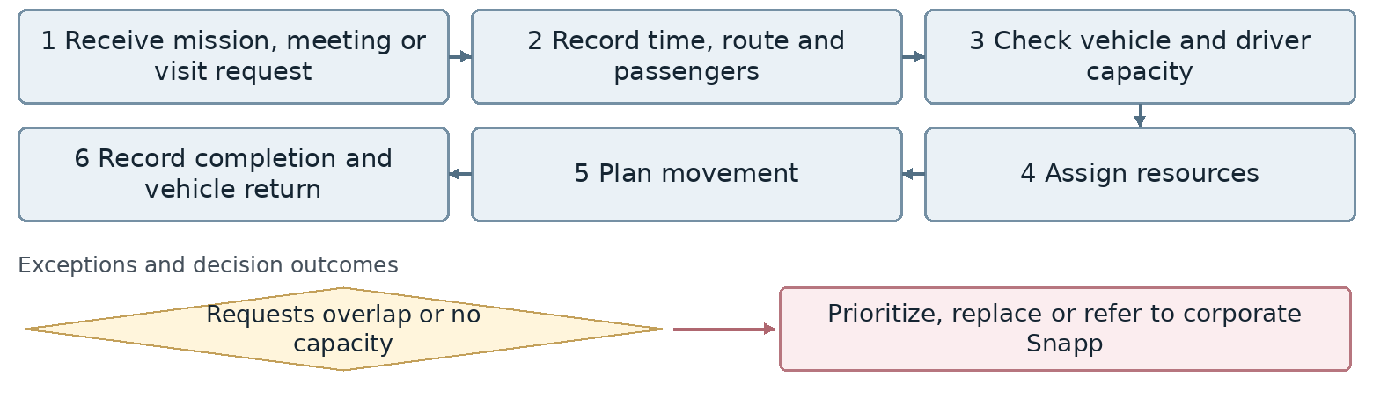
Confirm exact exception attachment and return points with the process owner.
Outcome Assigned vehicle and completed transport service
Proposed owner and interfaces Administration and Logistics Lead; interfaces: HR, Finance, Warehouse, Sales and transport providers.
Target requirement Support the workflow through completion with accountable owners, statuses, deadlines, attachments, notifications, approvals and full history.
Required data Requester, mission, origin, destination, time, passenger or consignment, vehicle, driver or courier, mileage, fuel, cost, tracking and delivery receipt.
Decisions and controls Agree capacity priority, Snapp referral, courier SMS, vehicle handover, maintenance and consumption controls. Include vehicle handover forms and return reports; define referral to corporate Snapp.
Reports and indicators Request count, response time, mileage, utilization, vehicle handover and return reports.
Acceptance scenario Exercise the relevant exception: competing bookings, breakdown, failed delivery or credit overrun; verify recovery, evidence and cost.
Odoo response / coverage: [ ] Standard [ ] Configuration [ ] Studio [ ] Development
[ ] Integration [ ] Alternative / not covered | Limitations / evidence: ................................
Action owner: .................................... Due date: ....................................

42. Fleet use, fuel and maintenance
AD-06 | Administration and Logistics | Unit status: Not currently available but required
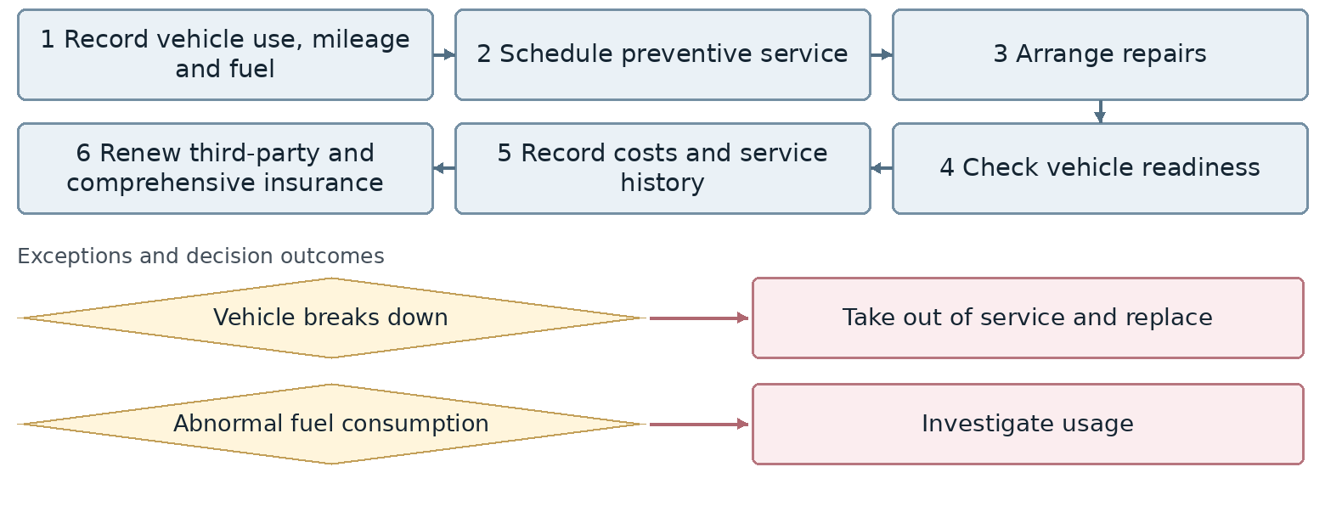
Confirm exact exception attachment and return points with the process owner.
Outcome Available vehicle with maintenance and insurance history
Proposed owner and interfaces Administration and Logistics Lead; interfaces: HR, Finance, Warehouse, Sales and transport providers.
Target requirement Support the workflow through completion with accountable owners, statuses, deadlines, attachments, notifications, approvals and full history.
Required data Requester, mission, origin, destination, time, passenger or consignment, vehicle, driver or courier, mileage, fuel, cost, tracking and delivery receipt.
Decisions and controls Agree capacity priority, Snapp referral, courier SMS, vehicle handover, maintenance and consumption controls. Maintain vehicle files, forms and document archive, including insurance renewals.
Reports and indicators Fuel, repair costs, downtime, overdue service, usage and vehicle files.
Acceptance scenario Exercise the relevant exception: competing bookings, breakdown, failed delivery or credit overrun; verify recovery, evidence and cost.
Odoo response / coverage: [ ] Standard [ ] Configuration [ ] Studio [ ] Development
[ ] Integration [ ] Alternative / not covered | Limitations / evidence: ................................
Action owner: .................................... Due date: ....................................

43. Courier, mail and internal consignments
AD-07 | Administration and Logistics | Unit status: Amendments requested
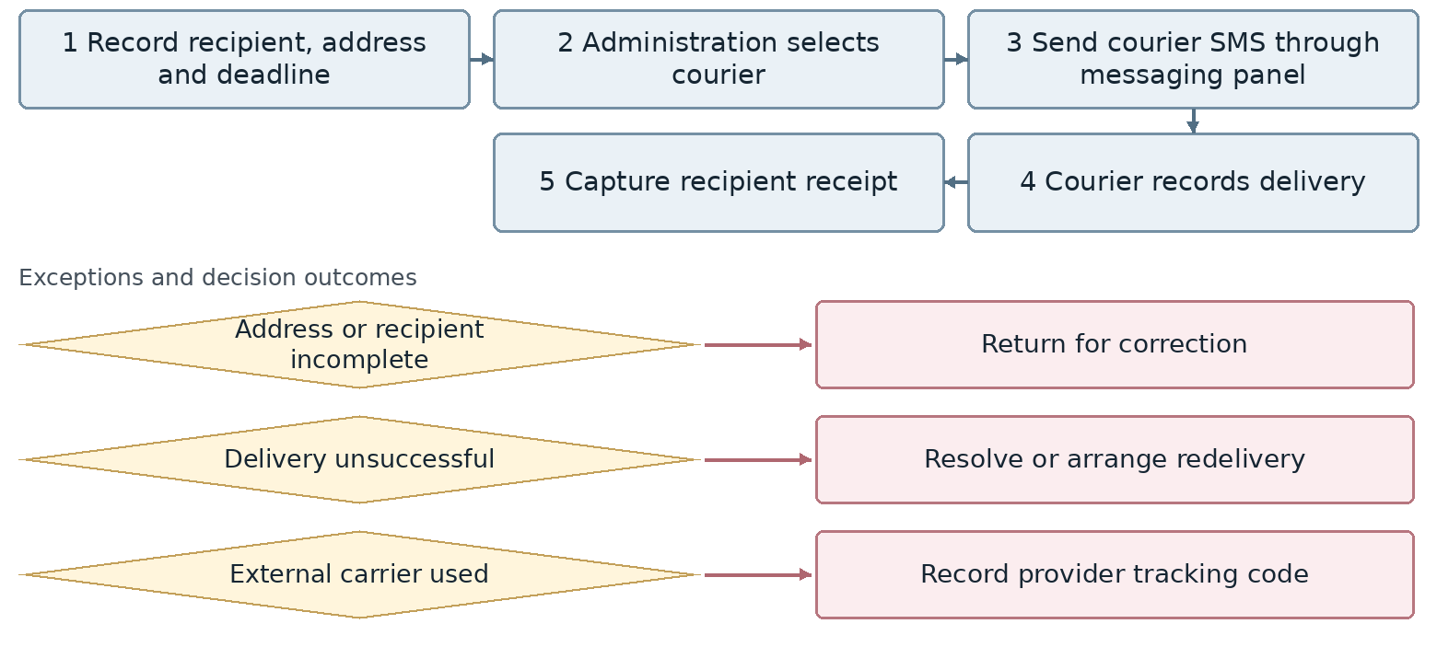
Confirm exact exception attachment and return points with the process owner.
Outcome Delivered document or consignment with proof of delivery
Proposed owner and interfaces Administration and Logistics Lead; interfaces: HR, Finance, Warehouse, Sales and transport providers.
Target requirement Support the workflow through completion with accountable owners, statuses, deadlines, attachments, notifications, approvals and full history.
Required data Requester, mission, origin, destination, time, passenger or consignment, vehicle, driver or courier, mileage, fuel, cost, tracking and delivery receipt.
Decisions and controls Agree capacity priority, Snapp referral, courier SMS, vehicle handover, maintenance and consumption controls. Consolidate internal consignment transport here; retain SMS status, tracking and delivery evidence.
Reports and indicators Consignment count, delivery time, failed deliveries and cost.
Acceptance scenario Exercise the relevant exception: competing bookings, breakdown, failed delivery or credit overrun; verify recovery, evidence and cost.
Odoo response / coverage: [ ] Standard [ ] Configuration [ ] Studio [ ] Development
[ ] Integration [ ] Alternative / not covered | Limitations / evidence: ................................
Action owner: .................................... Due date: ....................................

44. Corporate Snapp and urban transport
AD-08 | Administration and Logistics | Unit status: Amendments requested
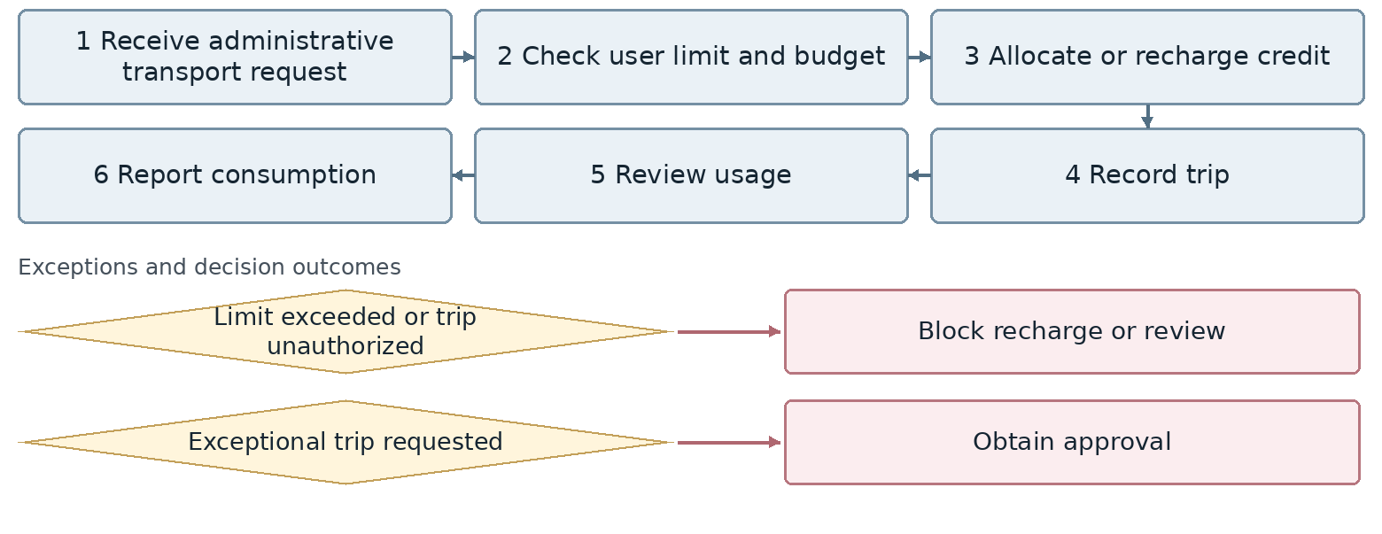
Confirm exact exception attachment and return points with the process owner.
Outcome Allocated transport credit and recorded trips
Proposed owner and interfaces Administration and Logistics Lead; interfaces: HR, Finance, Warehouse, Sales and transport providers.
Target requirement Support the workflow through completion with accountable owners, statuses, deadlines, attachments, notifications, approvals and full history.
Required data Requester, mission, origin, destination, time, passenger or consignment, vehicle, driver or courier, mileage, fuel, cost, tracking and delivery receipt.
Decisions and controls Agree capacity priority, Snapp referral, courier SMS, vehicle handover, maintenance and consumption controls. Define user limits, exceptional approvals and reconciliation of trip consumption.
Reports and indicators Indicators and records to be agreed with the process owner.
Acceptance scenario Exercise the relevant exception: competing bookings, breakdown, failed delivery or credit overrun; verify recovery, evidence and cost.
Odoo response / coverage: [ ] Standard [ ] Configuration [ ] Studio [ ] Development
[ ] Integration [ ] Alternative / not covered | Limitations / evidence: ................................
Action owner: .................................... Due date: ....................................

45. Supplementary insurance and welfare services
AD-09 | Administration and Logistics | Unit status: Approved
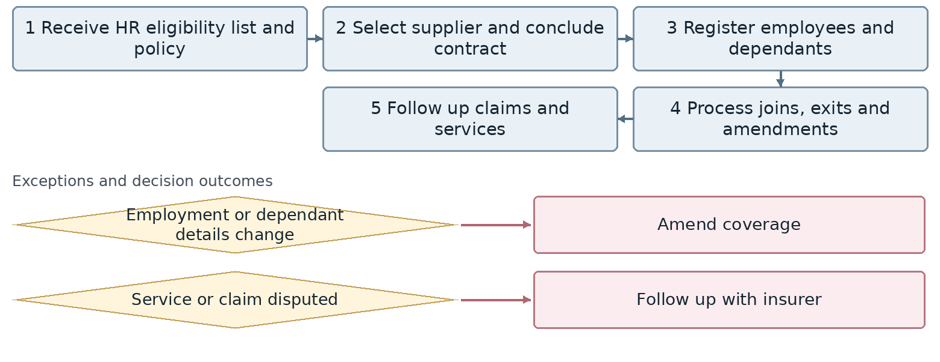
Confirm exact exception attachment and return points with the process owner.
Outcome Current coverage list and service status shared with HR
Proposed owner and interfaces Administration and Logistics Lead; interfaces: HR, Finance, employees and insurer.
Target requirement Support the workflow through completion with accountable owners, statuses, deadlines, attachments, notifications, approvals and full history.
Required data Employee and dependants, employment start, probation completion, plan, premium, coverage entry/exit, claim and provider.
Decisions and controls Confirm the one-month eligibility rule, effective dates and invoice reconciliation ownership. Start coverage after one month of probation; confirm effective dates and invoice reconciliation.
Reports and indicators Coverage, claims, resolution time, feedback and cost.
Acceptance scenario Add an eligible employee after one month, then process exit; check coverage, cost and claim history on the correct dates.
Odoo response / coverage: [ ] Standard [ ] Configuration [ ] Studio [ ] Development
[ ] Integration [ ] Alternative / not covered | Limitations / evidence: ................................
Action owner: .................................... Due date: ....................................

46. Administrative consumables
AD-10 | Administration and Logistics | Unit status: Not currently available but required
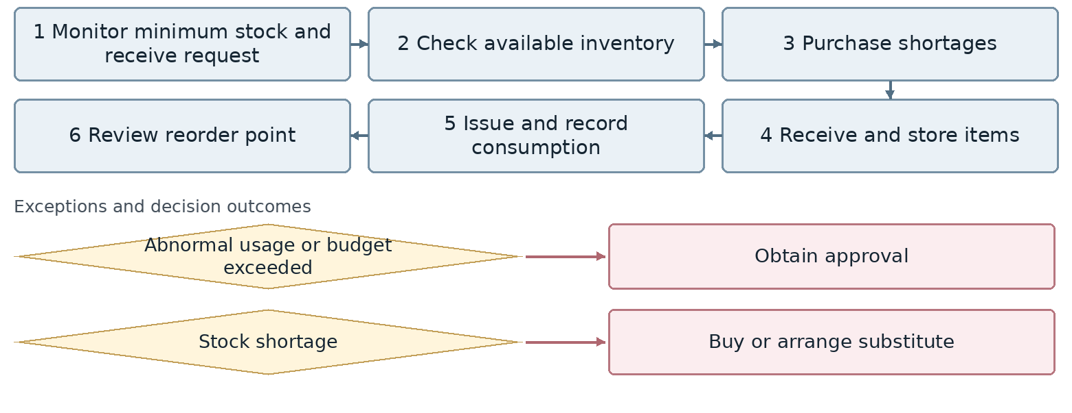
Confirm exact exception attachment and return points with the process owner.
Outcome Updated consumable stock and issue records
Proposed owner and interfaces Administration and Logistics Lead; interfaces: Requesting unit, Finance, Procurement, Warehouse and Technical.
Target requirement Support the workflow through completion with accountable owners, statuses, deadlines, attachments, notifications, approvals and full history.
Required data Request, item or equipment, quantity, stock, reorder level, quotation, budget, approvals, supplier, quarantine, handover and cost.
Decisions and controls Agree procurement and inventory boundaries, pro forma approval, quarantine release and asset classification. Define inventory ownership, replenishment rules and cost allocation.
Reports and indicators Consumption by unit, minimum levels, periodic purchases and shortages.
Acceptance scenario Run stocked and unstocked requests; require relevant approval before release of quarantined or capital equipment.
Odoo response / coverage: [ ] Standard [ ] Configuration [ ] Studio [ ] Development
[ ] Integration [ ] Alternative / not covered | Limitations / evidence: ................................
Action owner: .................................... Due date: ....................................

47. Non-consumable items and administrative equipment
AD-11 | Administration and Logistics | Unit status: Amendments requested
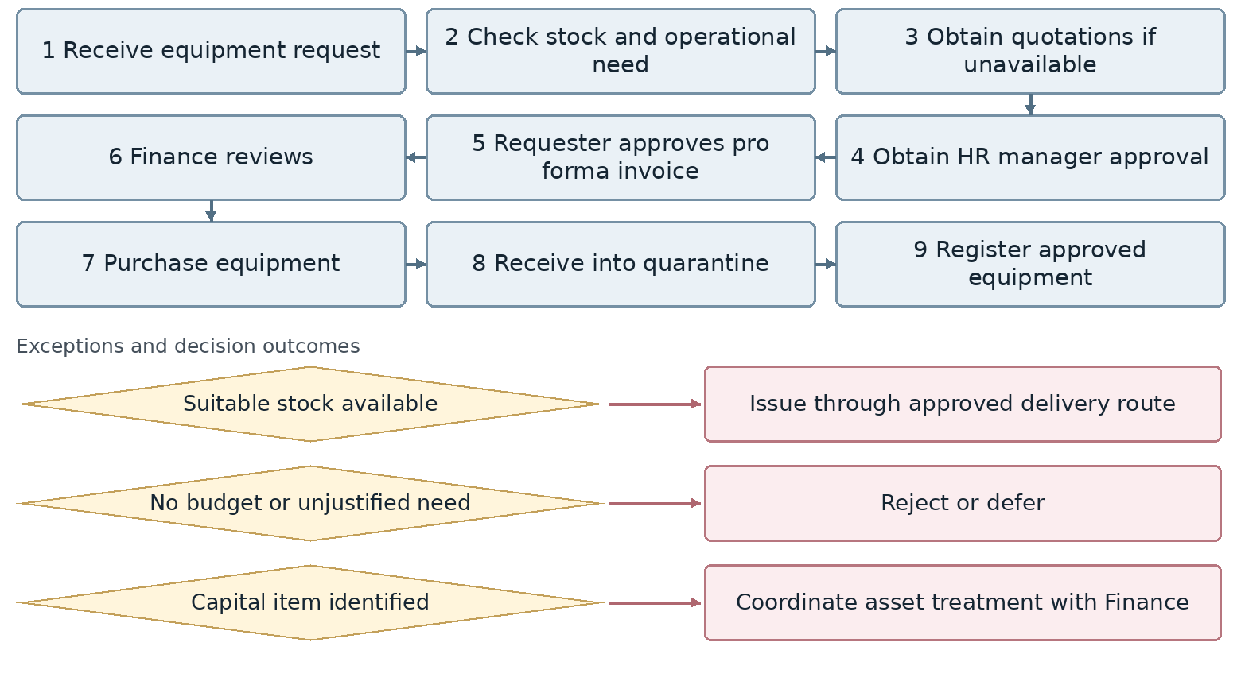
Confirm exact exception attachment and return points with the process owner.
Outcome Procured or allocated administrative equipment
Proposed owner and interfaces Administration and Logistics Lead; interfaces: Requesting unit, Finance, Procurement, Warehouse and Technical.
Target requirement Support the workflow through completion with accountable owners, statuses, deadlines, attachments, notifications, approvals and full history.
Required data Request, item or equipment, quantity, stock, reorder level, quotation, budget, approvals, supplier, quarantine, handover and cost.
Decisions and controls Agree procurement and inventory boundaries, pro forma approval, quarantine release and asset classification. Confirm pro forma approval sequence, quarantine release and the inventory-to-fixed-asset boundary.
Reports and indicators Open requests, procurement lead time, costs and unbudgeted purchases.
Acceptance scenario Run stocked and unstocked requests; require relevant approval before release of quarantined or capital equipment.
Odoo response / coverage: [ ] Standard [ ] Configuration [ ] Studio [ ] Development
[ ] Integration [ ] Alternative / not covered | Limitations / evidence: ................................
Action owner: .................................... Due date: ....................................

48. Administrative equipment lifecycle and repairs
AD-12 | Administration and Logistics | Unit status: Not currently available but required
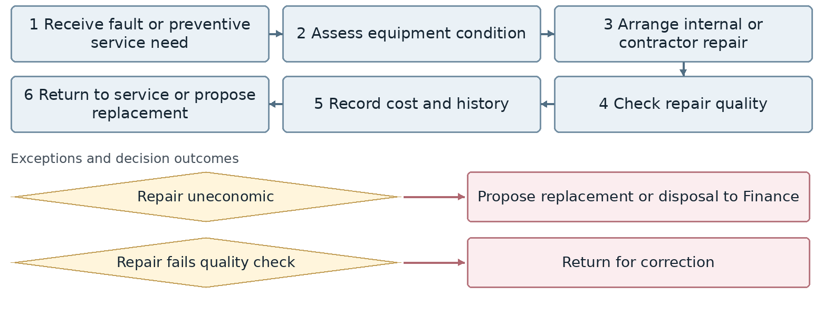
Confirm exact exception attachment and return points with the process owner.
Outcome Serviceable equipment or approved lifecycle decision
Proposed owner and interfaces Administration and Logistics Lead; interfaces: Finance, Procurement, Safety, user unit and contractor.
Target requirement Support the workflow through completion with accountable owners, statuses, deadlines, attachments, notifications, approvals and full history.
Required data Asset or location, fault, severity, service plan, contractor, contract, downtime, parts, cost, quality result and next service.
Decisions and controls Agree emergency authority, contractor selection, uneconomic repair criteria and quality acceptance. Agree the uneconomic repair threshold, quality approval and disposal authority.
Reports and indicators Breakdowns, repair costs, downtime and repeated repairs.
Acceptance scenario Run planned and urgent work; trace downtime, cost, failed repair, quality acceptance and the next service obligation.
Odoo response / coverage: [ ] Standard [ ] Configuration [ ] Studio [ ] Development
[ ] Integration [ ] Alternative / not covered | Limitations / evidence: ................................
Action owner: .................................... Due date: ....................................

49. Building and facilities maintenance
AD-13 | Administration and Logistics | Unit status: Not currently available but required
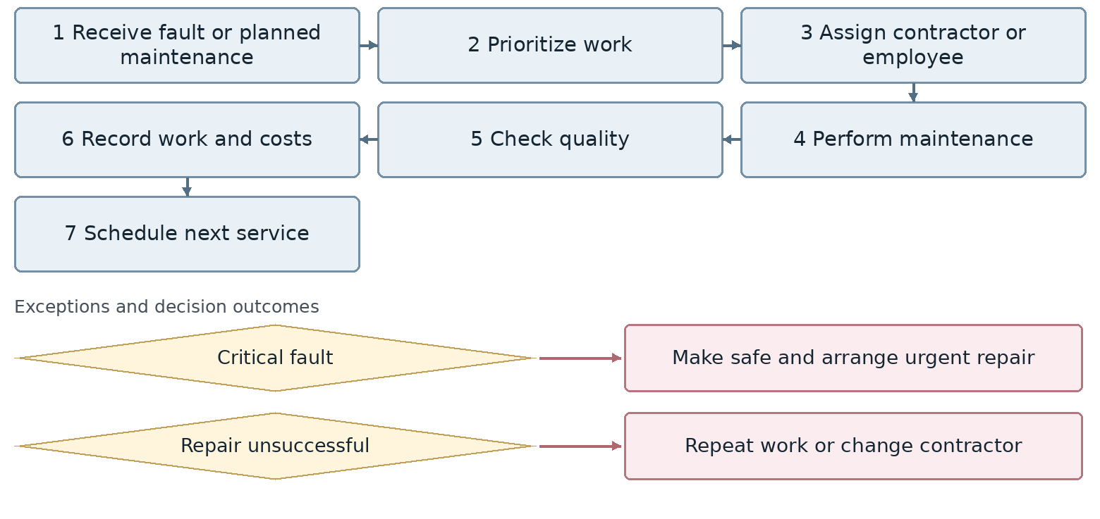
Confirm exact exception attachment and return points with the process owner.
Outcome Ready and maintained facilities
Proposed owner and interfaces Administration and Logistics Lead; interfaces: Finance, Procurement, Safety, user unit and contractor.
Target requirement Support the workflow through completion with accountable owners, statuses, deadlines, attachments, notifications, approvals and full history.
Required data Asset or location, fault, severity, service plan, contractor, contract, downtime, parts, cost, quality result and next service.
Decisions and controls Agree emergency authority, contractor selection, uneconomic repair criteria and quality acceptance. Define criticality levels, emergency authority and completion evidence.
Reports and indicators Preventive maintenance completion, fault resolution time, costs and overdue work.
Acceptance scenario Run planned and urgent work; trace downtime, cost, failed repair, quality acceptance and the next service obligation.
Odoo response / coverage: [ ] Standard [ ] Configuration [ ] Studio [ ] Development
[ ] Integration [ ] Alternative / not covered | Limitations / evidence: ................................
Action owner: .................................... Due date: ....................................

50. Service contractor management
AD-14 | Administration and Logistics | Unit status: Not currently available but required
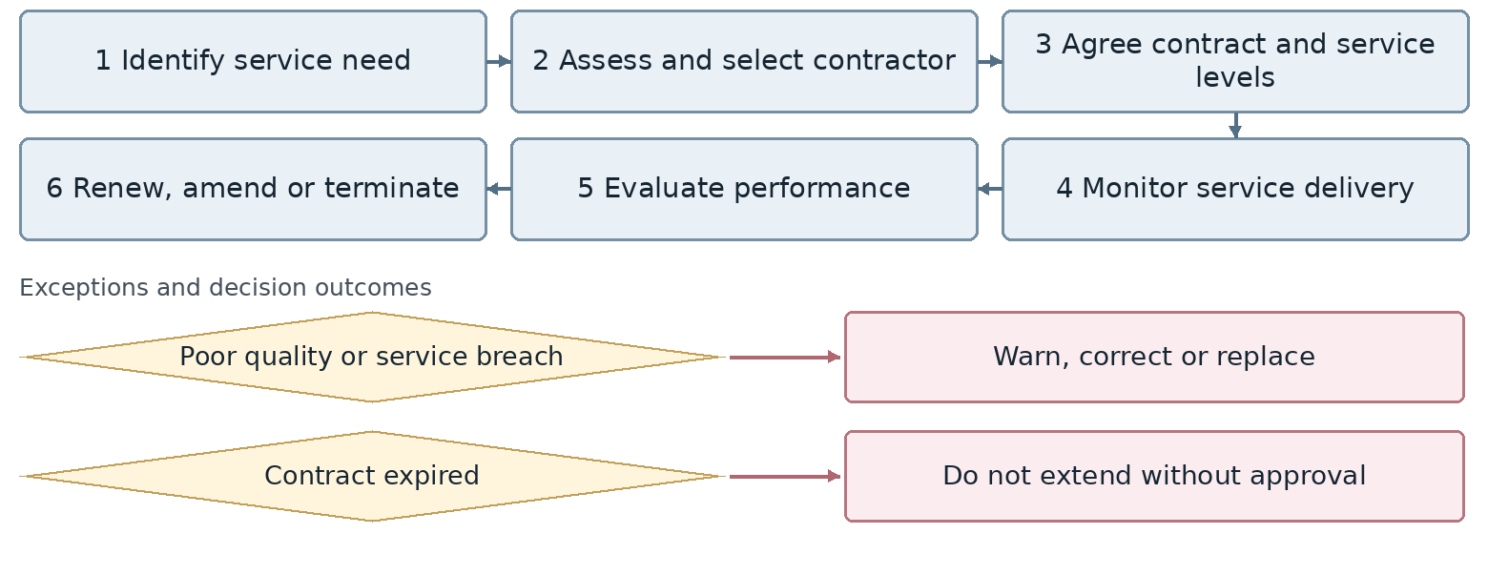
Confirm exact exception attachment and return points with the process owner.
Outcome Approved contractor and performance record
Proposed owner and interfaces Administration and Logistics Lead; interfaces: Finance, Procurement, Safety, user unit and contractor.
Target requirement Support the workflow through completion with accountable owners, statuses, deadlines, attachments, notifications, approvals and full history.
Required data Asset or location, fault, severity, service plan, contractor, contract, downtime, parts, cost, quality result and next service.
Decisions and controls Agree emergency authority, contractor selection, uneconomic repair criteria and quality acceptance. Define evaluation criteria, renewal authority and treatment of service-level breaches.
Reports and indicators Contractor ratings, service compliance, expiring contracts and complaints.
Acceptance scenario Run planned and urgent work; trace downtime, cost, failed repair, quality acceptance and the next service obligation.
Odoo response / coverage: [ ] Standard [ ] Configuration [ ] Studio [ ] Development
[ ] Integration [ ] Alternative / not covered | Limitations / evidence: ................................
Action owner: .................................... Due date: ....................................

51. Administrative petty cash
AD-15 | Administration and Logistics | Unit status: Amendments requested
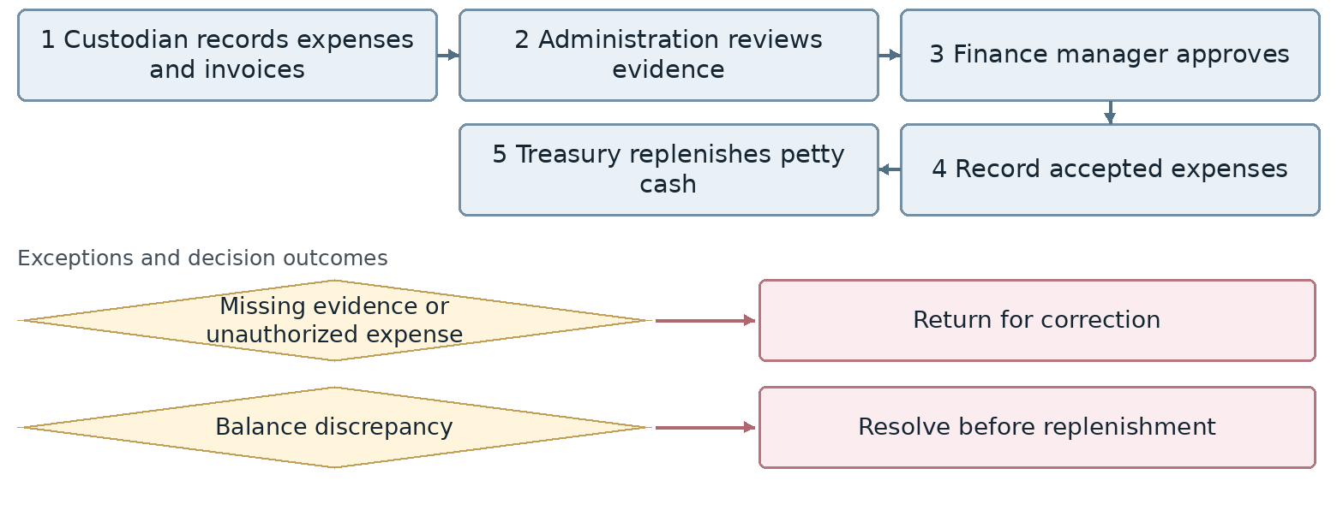
Confirm exact exception attachment and return points with the process owner.
Outcome Settled petty cash and valid replenishment request to Finance
Proposed owner and interfaces Administration and Logistics Lead; interfaces: Finance, Treasury, branch units and HR Manager.
Target requirement Support the workflow through completion with accountable owners, statuses, deadlines, attachments, notifications, approvals and full history.
Required data Custodian, period, expense line, invoice, attachment, cost center, accepted or rejected amount, administrative approval, Finance approval and replenishment.
Decisions and controls Agree evidence requirements, administrative and Finance review order and replenishment conditions. Confirm administrative review, Finance approval and Treasury replenishment responsibilities.
Reports and indicators Balances, costs, returned items and settlement time.
Acceptance scenario Submit petty cash with an incomplete line; post and replenish only accepted expenses without duplication.
Odoo response / coverage: [ ] Standard [ ] Configuration [ ] Studio [ ] Development
[ ] Integration [ ] Alternative / not covered | Limitations / evidence: ................................
Action owner: .................................... Due date: ....................................

52. Administrative and logistics analytics
AD-16 | Administration and Logistics | Unit status: Not currently available but required
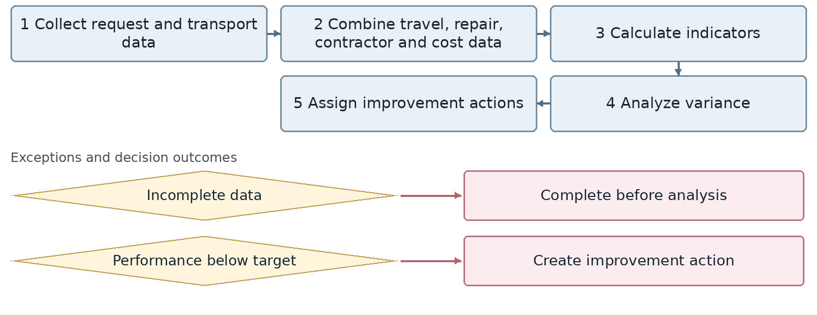
Confirm exact exception attachment and return points with the process owner.
Outcome Administrative and logistics dashboard
Proposed owner and interfaces Administration and Logistics Lead; interfaces: Management, Finance, IT and Business Intelligence.
Target requirement Support the workflow through completion with accountable owners, statuses, deadlines, attachments, notifications, approvals and full history.
Required data Indicator definition, period, unit, source record, data owner, value, refresh time, reconciliation status and access level.
Decisions and controls Agree systems of record, KPI definitions, refresh frequency, error handling and confidential data access. Define indicator owners, source records, refresh frequency and access rights.
Reports and indicators Response time, on-time delivery, satisfaction, transport and travel costs, fuel, preventive maintenance and facilities cost.
Acceptance scenario Trace a dashboard indicator to its source records and reconcile totals; test unauthorized access and data errors.
Odoo response / coverage: [ ] Standard [ ] Configuration [ ] Studio [ ] Development
[ ] Integration [ ] Alternative / not covered | Limitations / evidence: ................................
Action owner: .................................... Due date: ....................................

53. Administrative mission execution and travel services
AD-17 | Administration and Logistics | Unit status: Amendments requested
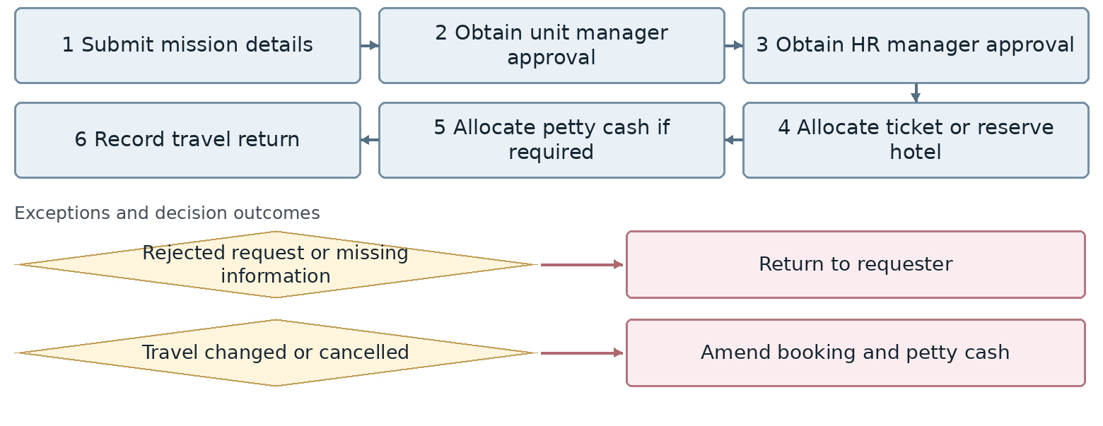
Confirm exact exception attachment and return points with the process owner.
Outcome Completed mission and resolved travel services
Proposed owner and interfaces Administration and Logistics Lead; interfaces: Unit managers, Administration, Finance and Payroll.
Target requirement Support the workflow through completion with accountable owners, statuses, deadlines, attachments, notifications, approvals and full history.
Required data Employee, calendar, shift, entry/exit, request type, dates and hours, leave balance, approvers, mission, time records and corrections.
Decisions and controls Agree manager/HR approval order, leave carryover, corrections after period closure and mission impact on time records. Link the administrative travel record to the HR mission and Finance settlement without duplicate approval or payment.
Reports and indicators Open missions, approval time, travel costs, changes, cancellations and open petty cash.
Acceptance scenario Test ordinary and exceptional time requests, multi-day missions and corrections; reconcile approved hours and leave balances.
Odoo response / coverage: [ ] Standard [ ] Configuration [ ] Studio [ ] Development
[ ] Integration [ ] Alternative / not covered | Limitations / evidence: ................................
Action owner: .................................... Due date: ....................................

Removed activities: scope-control register
The Administration and Logistics unit explicitly removed these activities from the main requirements. Reinstatement requires a new process-owner decision. Consolidated activities remain within their retained process where applicable.
Activity no. | Activity | Status
8 | Internal logistics and consignment transport | Removed
9 | Carriers and freight rates | Removed
10 | Transport costs and provider invoice reconciliation | Removed
11 | Corporate travel management | Removed
16 | Equipment allocation and handover | Removed
19 | Utility bills, energy and facilities consumption | Removed
22 | External administrative affairs | Removed
23 | Workspace allocation, moves and readiness | Removed
24 | General service safety and readiness | Removed
25 | Administrative document archive | Removed
Internal consignments are consolidated in AD-07. The revised administrative mission and travel service remains in AD-17. Equipment coordination is addressed through HR-31 and AD-11.

Workshop record
Activities reinstated: ....................................................................................
Reason and decision owner: ..........................................................................

Solution decisions and acceptance evidence
Response type | Required evidence
Standard | Demonstrate the full acceptance scenario in the agreed version and access roles.
Configuration | Document and test settings, rules, approval levels and limitations.
Studio | Specify fields, forms and workflows, including licensing and maintenance constraints.
Development | Record scope, tests, maintenance owner, time, cost and upgrade impact.
Integration | Define the system of record, exchange method, timing, errors, retries and reconciliation.
Alternative / not covered | Document remaining manual work and the effect on the project decision.

Shared acceptance tests
Recruitment from approved request to onboarding, with correct Adilar/Odoo data exchange.
Leave and missions with multi-stage approval, time corrections and balance reporting.
Payroll with amended time, an advance installment, a failed payment file and duplicate prevention.
Employee entry, transfer and exit with outstanding equipment, access tasks and financial clearance.
Budget-dependent administrative requests, missed service targets and stakeholder notifications.
Competing vehicle requests, Snapp referral, failed consignment delivery and receipt evidence.
Equipment procurement, quarantine, uneconomic repair and financial asset coordination.
Unauthorized attempts to view pay or grievance data, with recorded access-control results.
Workshop decision: .......................................................................................
HR Manager approval: ........................... Odoo team approval: ...........................

