Finance Requirements for Odoo Implementation
Karan Sa Industrial Group
We ask the Odoo implementation team to define how each financial requirement will operate, identify solution limitations, and estimate the required effort, cost and time. Final decisions require Finance Manager approval and evidence from the acceptance scenarios.

Scope and use
This English edition contains 61 financial processes in the same order and with the same identifiers as the Persian edition. It covers interfaces with Sales, Commerce, Warehouse, Technical, HR and the branches.
Each process has its workflow directly below the heading, followed by its outcome, proposed ownership, target requirement, required data, decisions, reports and acceptance scenario.
All 61 processes remain subject to business approval. Requirements, proposed ownership and solution areas are for review. They do not establish confirmed software coverage or an approved operating procedure.
Read workflow steps in numbered order. Exception outcomes are shown separately where the exact branch or return point still requires agreement; an unconfirmed connection is not implied.
For each process, the implementation team should select a delivery approach and record limitations, evidence, action owner and due date. Approval thresholds and execution responsibilities must be agreed with Finance.
Version 1 English edition | 9 September 2026
Business approval owner Finance Manager

Financial architecture and system boundaries
Agree the system of record for each financial event before configuring the workflow. Parallel posting of invoices, receipts, stock or payroll can otherwise create inconsistent balances. Odoo 18 is the project review baseline; confirm the installed version and edition in the workshop.
Area | Business context | Decision required
Invoices and entries | Sepidar posting and electronic invoice corrections are part of current operations. | Invoice and ledger authority; statutory submission owner.
Requests and approvals | Requests and authorizations currently have operational workflows. | Transfer to Odoo and preservation of transaction identifiers.
Inventory and cost | Finance performs financial valuation of inventory. | Owners of quantities, values and stock accounting entries.
Payroll | HR payroll must reconcile with Finance deductions. | Calculation and integration boundary between Rahkaran and Odoo.
Exchange rates | The Head of Sales announces a rate. | Separate pricing rates from accounting and revaluation rates.
Branches and overseas offices | Dubai, Turkey and international funding are in scope for discussion. | Branch versus legal entity and the Iran implementation boundary.
Reporting and BI | Sales, collections, expenses and balances feed reporting. | Indicator definitions, data authority and refresh frequency.

Shared controls
Use unique customer, supplier, product, order, invoice, payment and journal identifiers, with the authoritative system and last reconciliation time.
Prevent duplicate posting and payment after retries or interruptions. Assign each interface error an owner, reason, deadline and recovery result.
Separate preparers, approvers and payers. Restrict company and branch access and confidential payroll information.
Distinguish payment request, payment instruction, bank confirmation and debt settlement. Incomplete evidence alone must not establish settlement.

Priority decisions for the workshop
Topic | Decision to resolve
Business approval | Finance must approve, amend or exclude each of the 61 requirements.
Receivable aging | Agree treatment of overdue and not yet due invoices, reporting date and a numeric reconciliation example.
Employee advances | Confirm whether Finance and supervisor checks are required before HR authorizes payment.
Exit settlement | Specify whether all departmental clearances are prerequisites for payment.
International offices | Define CEO rejection and document correction after final review.
Foreign purchases | Confirm distinct approvals for advances and remaining balances, including payment evidence and settlement.
Transport payments | Define the conditions for formal and other payments, management approval and duplicate prevention.
Workflow routing | Define approval, rejection, unconditional and parallel routes explicitly with the process owner.
Exchange rates | Confirm separate sales, accounting and revaluation rates and their approving authority.
Retain unresolved business decisions as open items. Validate rejection, return and escalation paths with the process owner before configuration.

Financial process index
ID | Process | Area
FIN-01 | Budget preparation and allocation | Budget and planning
FIN-02 | Unbudgeted requests and budget amendments | Budget and planning
FIN-03 | Financial forecasting and scenarios | Budget and planning
FIN-04 | Financial control of sales invoices | Sales accounting
FIN-05 | Sales invoice corrections cancellations and returns | Sales accounting
FIN-06 | Sales and customer account reconciliation | Sales accounting
FIN-07 | Customer credit assessment and limits | Customer credit
FIN-08 | Credit control and order hold or release | Customer credit
FIN-09 | Periodic customer credit and risk review | Customer credit
FIN-10 | Customer receipt recording and allocation | Receipts and collections
FIN-11 | Unidentified customer deposits | Receipts and collections
FIN-12 | Receivable check management | Receipts and collections
FIN-13 | Receivable balances and aging | Receipts and collections
FIN-14 | Collection follow up | Receipts and collections
FIN-15 | High risk receivables and balance confirmations | Receipts and collections
FIN-16 | Supplier financial master data | Suppliers and payments
FIN-17 | Supplier invoice recording and control | Suppliers and payments
FIN-18 | Supplier advance payments | Suppliers and payments
FIN-19 | Purchase returns supplier credits and adjustments | Suppliers and payments
FIN-20 | Domestic funding requests and ad hoc payments | Suppliers and payments
FIN-21 | International office funding and payments | Suppliers and payments
FIN-22 | Supplier payment planning and approval | Suppliers and payments
FIN-23 | Supplier payment execution and settlement | Suppliers and payments
FIN-24 | Supplier balance reconciliation and confirmation | Suppliers and payments
FIN-25 | Petty cash management | Employee expenses
FIN-26 | Employee salary advances | Employee expenses
FIN-27 | Business travel advances and settlement | Employee expenses
FIN-28 | Other employee expense reimbursements | Employee expenses
FIN-29 | Bank cash and internal transfers | Banking and obligations
FIN-30 | Bank reconciliation | Banking and obligations
FIN-31 | Deposits loans guarantees and letters of credit | Banking and obligations
FIN-32 | Chart of accounts dimensions and fiscal periods | Ledger and fiscal periods
FIN-33 | Journal entry preparation and approval | Ledger and fiscal periods
FIN-34 | Accruals prepayments provisions and cost allocation | Ledger and fiscal periods
FIN-35 | General ledger and clearing account reconciliation | Ledger and fiscal periods
FIN-36 | Period close lock and reopening | Ledger and fiscal periods
FIN-37 | Opening a period and carrying balances forward | Ledger and fiscal periods
FIN-38 | Accounting for inventory movements | Inventory and costing
FIN-39 | Accounting for consignment and test items | Inventory and costing
FIN-40 | Inventory valuation and cost of goods sold | Inventory and costing
FIN-41 | Landed cost calculation | Inventory and costing
FIN-42 | Stock count discrepancy resolution | Inventory and costing
FIN-43 | Asset requests purchases and initial registration | Fixed assets
FIN-44 | Asset capitalization depreciation and transfers | Fixed assets
FIN-45 | Asset revaluation counts sales and disposal | Fixed assets
FIN-46 | Payroll review and payment | Payroll and exit settlement
FIN-47 | Payroll entries and insurance and tax liabilities | Payroll and exit settlement
FIN-48 | Employee exit financial settlement | Payroll and exit settlement
FIN-49 | VAT and electronic invoicing | Statutory obligations
FIN-50 | Tax returns and other tax obligations | Statutory obligations
FIN-51 | Tax and insurance assessments and appeals | Statutory obligations
FIN-52 | Exchange rates and foreign currency transactions | Currency and imports
FIN-53 | Foreign purchase payments and currency settlement | Currency and imports
FIN-54 | Import case and foreign currency obligation reconciliation | Currency and imports
FIN-55 | Financial statements and profitability reporting | Financial reporting
FIN-56 | Receivables payables liquidity and budget reports | Financial reporting
FIN-57 | Branch company and ad hoc performance reports | Financial reporting
FIN-58 | Financial access authority and sensitive transactions | Controls and documents
FIN-59 | Audit findings and corrective actions | Controls and documents
FIN-60 | Financial management of nonemployment contracts | Controls and documents
FIN-61 | Financial document archiving and traceability | Controls and documents

1 Budget preparation and allocation
FIN-01 | Business approval pending
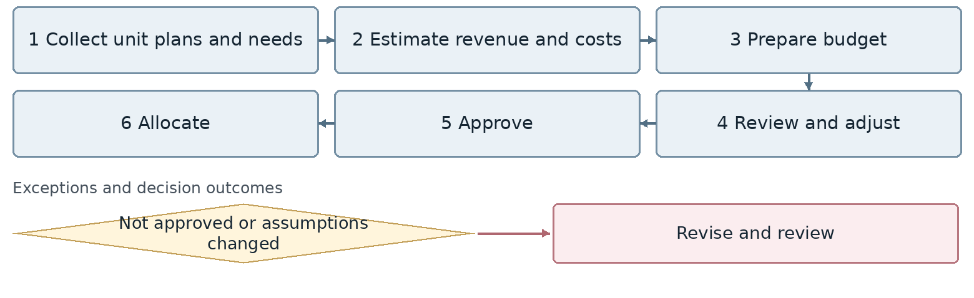
Confirm the connection point for any exception whose branch or return route is still undecided.
Outcome Approved budget for units and management
Proposed owner Finance and Budget. Interfaces: Management and all units.
Target requirement Record budget versions and allocations by cost center, project and branch. Keep the approved budget separate from revisable forecasts.
Required data Year and period, cost center, scenario, budget line, approved and committed amounts. Common tracking: record identifier, owner, status, date and attachments.
Decision required At which event is budget checked: request, order, expense posting or payment? How are commitments distinguished from cash consumption?
Reports and indicators Approved budget, consumption, balance and variance.
Acceptance scenario A purchase creates a commitment; paying for the same purchase does not consume the budget twice.
Odoo review area Budget and analytical dimensions. Delivery approach remains open.
□ Standard □ Configuration □ Studio □ Development □ Integration □ Alternative or gap
Limitations and evidence: __________________________________________________
Action owner: _____________________ Due date: _____________________

2 Unbudgeted requests and budget amendments
FIN-02 | Business approval pending
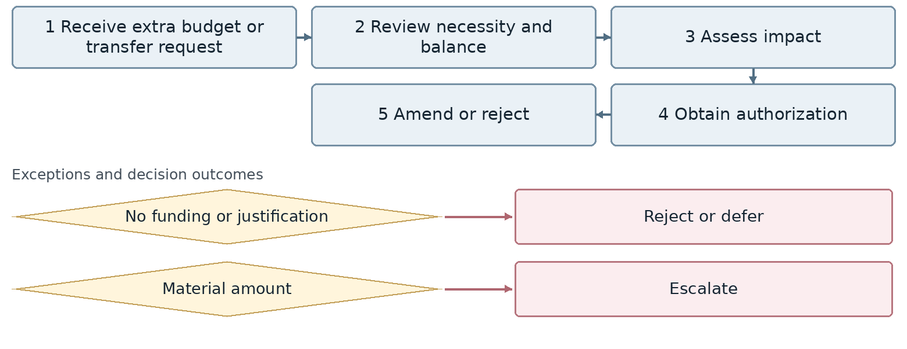
Confirm the connection point for any exception whose branch or return route is still undecided.
Outcome Spending authorization or revised budget
Proposed owner Finance and Budget. Interfaces: Management and all units.
Target requirement Link a budget transfer or increase to its previous version and reason. Control authorization by amount and approval level.
Required data Origin and destination budget lines, amount, reason, funding source, authorization. Common tracking: record identifier, owner, status, date and attachments.
Decision required What are the authority limits and final rejection or deferral routes? Is spending before approval allowed?
Reports and indicators Unbudgeted requests, transfers and reasons for amendment.
Acceptance scenario Reject an unfunded request. An approved transfer changes both budget balances with a traceable history.
Odoo review area Budget and analytical dimensions. Delivery approach remains open.
□ Standard □ Configuration □ Studio □ Development □ Integration □ Alternative or gap
Limitations and evidence: __________________________________________________
Action owner: _____________________ Due date: _____________________

3 Financial forecasting and scenarios
FIN-03 | Business approval pending
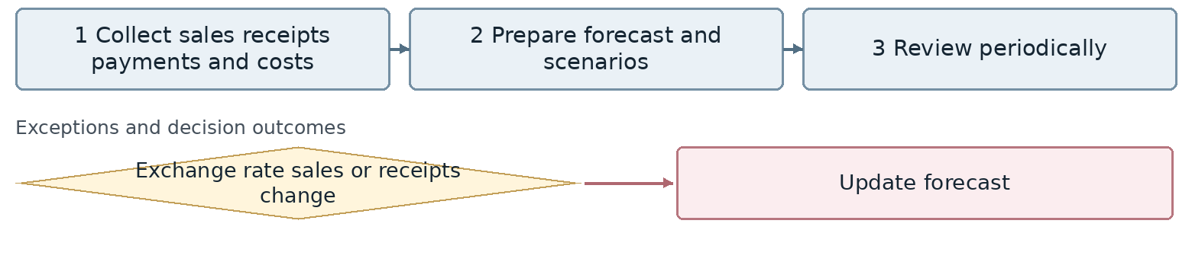
Confirm the connection point for any exception whose branch or return route is still undecided.
Outcome Financial and cash forecasts for management
Proposed owner Finance and Budget. Interfaces: Management and all units.
Target requirement Maintain dated sales, collection, payment and currency forecasts with separate scenarios. Preserve assumptions when actual results become available.
Required data Forecast horizon, exchange rate, expected collections, committed and possible payments. Common tracking: record identifier, owner, status, date and attachments.
Decision required What are the forecast horizon and review frequency? Which data belongs in Odoo or business intelligence?
Reports and indicators Forecasts, actual versus forecast variance and scenarios.
Acceptance scenario A reduction in one week's collections exposes a cash shortfall and payments at risk of delay.
Odoo review area Budget and analytical dimensions. Delivery approach remains open.
□ Standard □ Configuration □ Studio □ Development □ Integration □ Alternative or gap
Limitations and evidence: __________________________________________________
Action owner: _____________________ Due date: _____________________

4 Financial control of sales invoices
FIN-04 | Business approval pending
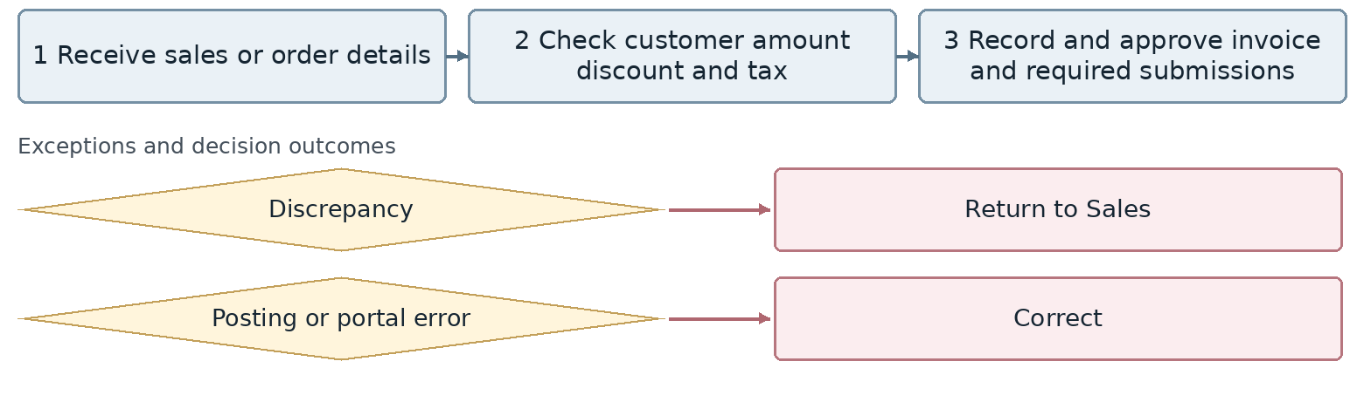
Confirm the connection point for any exception whose branch or return route is still undecided.
Outcome Valid sales invoice and receivable
Proposed owner Sales Accounting. Interfaces: Sales and Call Center.
Target requirement Link each invoice to its order and shared customer record. Distinguish amount and tax checks, statutory submission status and accounting posting.
Required data Order, customer, tax identifier, amount, discount, due date, invoice identifier. Common tracking: record identifier, owner, status, date and attachments.
Decision required When is the invoice issued relative to payment and delivery? Is Odoo or Sepidar the invoice system of record?
Reports and indicators Posted and rejected invoices, discrepancies and posting errors.
Acceptance scenario Return an inconsistent invoice to Sales. Its correction creates one valid receivable without duplicate posting.
Odoo review area Sales and Accounting. Delivery approach remains open.
□ Standard □ Configuration □ Studio □ Development □ Integration □ Alternative or gap
Limitations and evidence: __________________________________________________
Action owner: _____________________ Due date: _____________________

5 Sales invoice corrections cancellations and returns
FIN-05 | Business approval pending
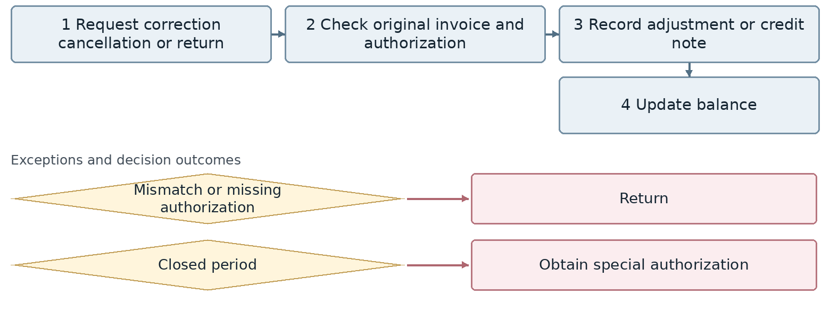
Confirm the connection point for any exception whose branch or return route is still undecided.
Outcome Corrected invoice or accounting document
Proposed owner Sales Accounting. Interfaces: Sales and Call Center.
Target requirement Reference the original invoice in a separate adjustment document. Reconcile the effects on stock, customer balance and statutory status.
Required data Original invoice, reason, items, amount, authorization, period, return document. Common tracking: record identifier, owner, status, date and attachments.
Decision required What approval is required for a closed period? When is a physical return reconciled with the credit note?
Reports and indicators Corrections, cancellations, returns and their reasons.
Acceptance scenario Process a partial return against an invoice with a previous receipt; verify balance, stock and statutory document effects.
Odoo review area Sales and Accounting. Delivery approach remains open.
□ Standard □ Configuration □ Studio □ Development □ Integration □ Alternative or gap
Limitations and evidence: __________________________________________________
Action owner: _____________________ Due date: _____________________

6 Sales and customer account reconciliation
FIN-06 | Business approval pending
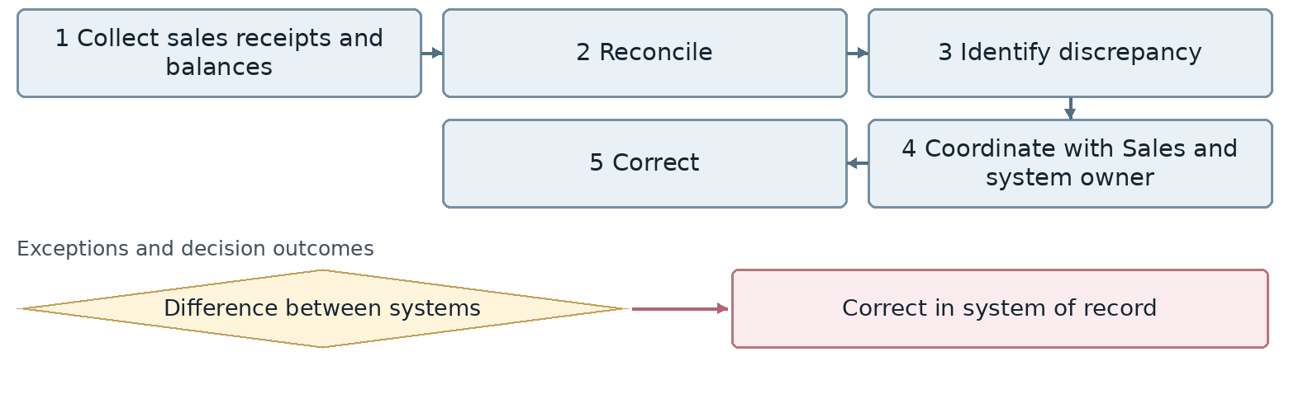
Confirm the connection point for any exception whose branch or return route is still undecided.
Outcome Resolved discrepancy
Proposed owner Sales Accounting. Interfaces: Sales and Call Center.
Target requirement Create a discrepancy case with origin, amount, owner and corrective action. Correct the authoritative record and reconcile again.
Required data Customer, period, difference, both document identifiers, cause, reconciliation result. Common tracking: record identifier, owner, status, date and attachments.
Decision required Which system owns the customer balance, and which unit corrects each type of discrepancy?
Reports and indicators Sales versus receipts and unresolved discrepancies.
Acceptance scenario A receipt missing from the sales report is corrected at source, then the case is closed with evidence.
Odoo review area Sales and Accounting. Delivery approach remains open.
□ Standard □ Configuration □ Studio □ Development □ Integration □ Alternative or gap
Limitations and evidence: __________________________________________________
Action owner: _____________________ Due date: _____________________

7 Customer credit assessment and limits
FIN-07 | Business approval pending
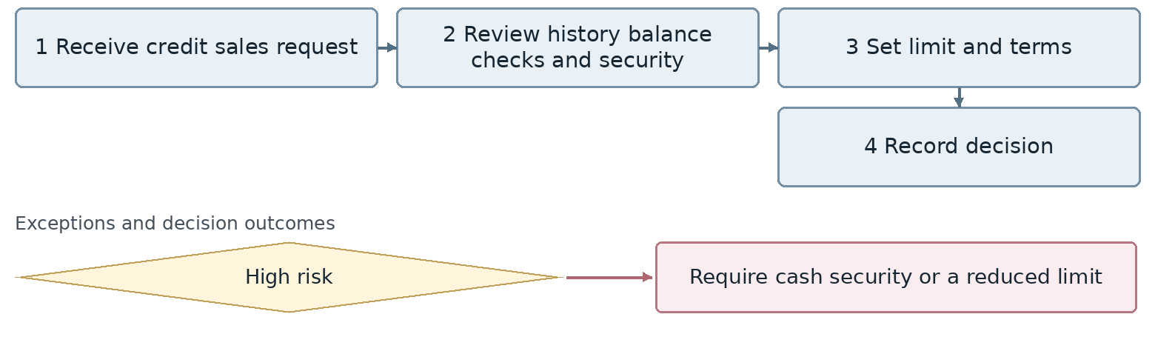
Confirm the connection point for any exception whose branch or return route is still undecided.
Outcome Credit limit and terms available to Sales
Proposed owner Finance and Credit. Interfaces: Sales and Business Intelligence.
Target requirement Link evidence, credit limit, terms, validity and approver to the customer. Make the decision visible to Sales.
Required data Limit, term, guarantees, balance, checks, risk score, review date. Common tracking: record identifier, owner, status, date and attachments.
Decision required Does Finance or business intelligence own the rating? Who approves changes to the limit?
Reports and indicators Credit limits and rejected or restricted customers.
Acceptance scenario Permit a high risk customer to trade only with an approved advance payment or guarantee.
Odoo review area Sales and credit control. Delivery approach remains open.
□ Standard □ Configuration □ Studio □ Development □ Integration □ Alternative or gap
Limitations and evidence: __________________________________________________
Action owner: _____________________ Due date: _____________________

8 Credit control and order hold or release
FIN-08 | Business approval pending
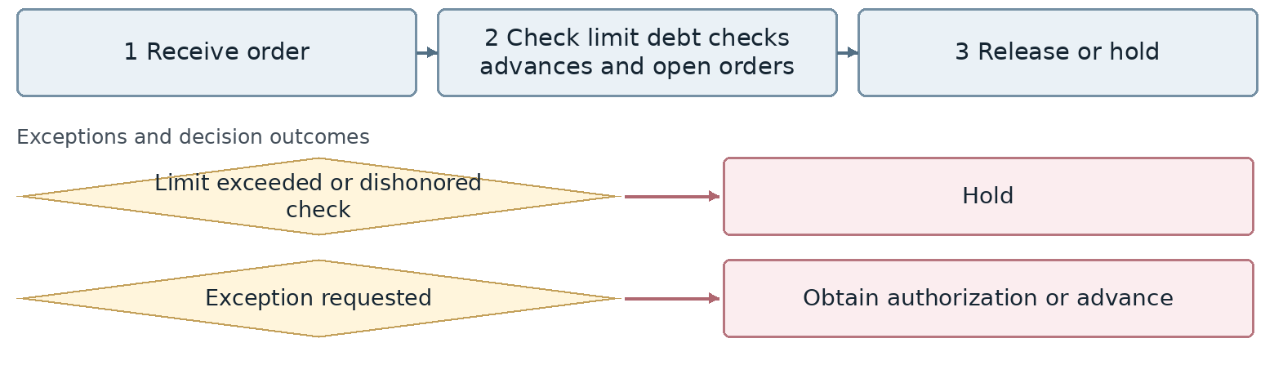
Confirm the connection point for any exception whose branch or return route is still undecided.
Outcome Order status available to Sales
Proposed owner Finance and Credit. Interfaces: Sales and Business Intelligence.
Target requirement Distinguish an enforced hold from a warning. Include debt, open orders and checks in credit usage according to approved rules.
Required data Limit, used credit, open orders, overdue debt, dishonored checks, exception approval. Common tracking: record identifier, owner, status, date and attachments.
Decision required Is the hold applied at order confirmation or delivery? Does check receipt or final clearance release credit?
Reports and indicators Holds, exceptions and blocked customers.
Acceptance scenario A dishonored check blocks an order. Only an authorized person grants an exception with a recorded reason and limit.
Odoo review area Sales and credit control. Delivery approach remains open.
□ Standard □ Configuration □ Studio □ Development □ Integration □ Alternative or gap
Limitations and evidence: __________________________________________________
Action owner: _____________________ Due date: _____________________

9 Periodic customer credit and risk review
FIN-09 | Business approval pending
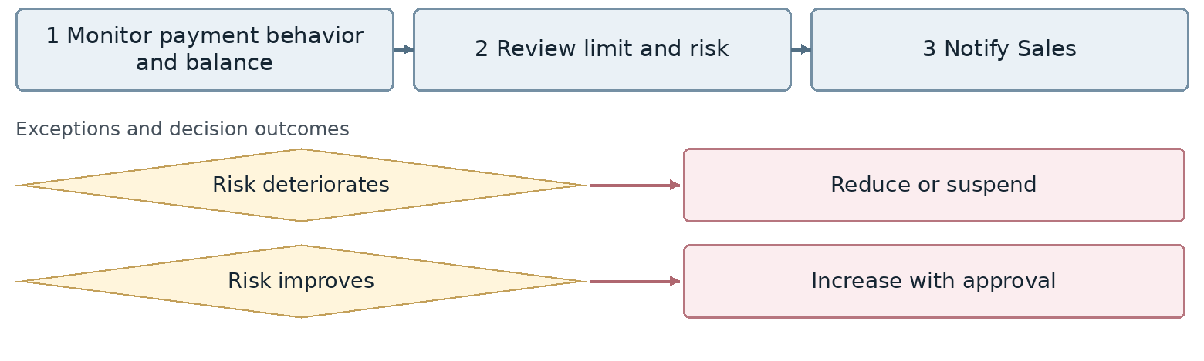
Confirm the connection point for any exception whose branch or return route is still undecided.
Outcome Updated customer credit
Proposed owner Finance and Credit. Interfaces: Sales and Business Intelligence.
Target requirement Retain limit history and Sales notifications for periodic and event triggered credit reviews.
Required data Last review, payment behavior, overdue balance, previous and new limits, approver. Common tracking: record identifier, owner, status, date and attachments.
Decision required How does a reduced limit affect orders that have already been approved?
Reports and indicators Aging, dishonored checks and limit changes.
Acceptance scenario Reduce the limit after deteriorating payment behavior and verify its effect on an open order.
Odoo review area Sales and credit control. Delivery approach remains open.
□ Standard □ Configuration □ Studio □ Development □ Integration □ Alternative or gap
Limitations and evidence: __________________________________________________
Action owner: _____________________ Due date: _____________________

10 Customer receipt recording and allocation
FIN-10 | Business approval pending
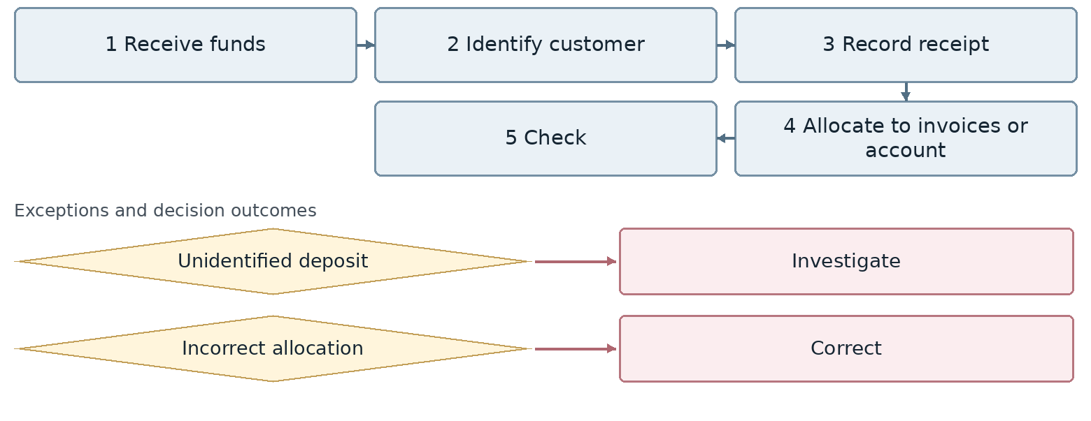
Confirm the connection point for any exception whose branch or return route is still undecided.
Outcome Updated customer balance
Proposed owner Treasury and Accounts Receivable. Interfaces: Sales, Call Center and Legal.
Target requirement Record a receipt with a unique bank reference and allocate it to one or several invoices. Keep unallocated amounts separate.
Required data Bank, transaction identifier, customer, value date, amount, invoices, unallocated balance. Common tracking: record identifier, owner, status, date and attachments.
Decision required What rules govern automatic allocation, payments on account and allocation corrections?
Reports and indicators Daily receipts, allocations and balances.
Acceptance scenario Split one deposit between two invoices and retain the excess without incorrectly closing another invoice.
Odoo review area Accounting and collections. Delivery approach remains open.
□ Standard □ Configuration □ Studio □ Development □ Integration □ Alternative or gap
Limitations and evidence: __________________________________________________
Action owner: _____________________ Due date: _____________________

11 Unidentified customer deposits
FIN-11 | Business approval pending
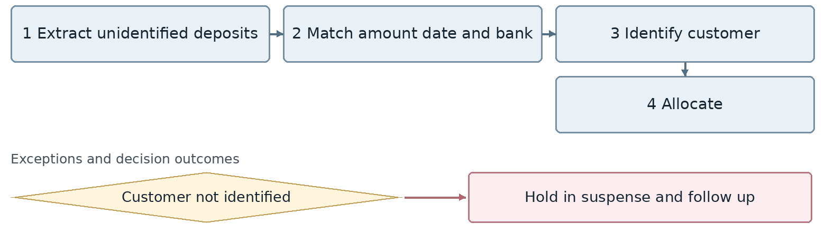
Confirm the connection point for any exception whose branch or return route is still undecided.
Outcome Identified and allocated deposit
Proposed owner Treasury and Accounts Receivable. Interfaces: Sales, Call Center and Legal.
Target requirement Record unidentified funds in a suspense account with a follow up owner. Require evidence and approval before assigning a customer.
Required data Bank, amount, date, deposit identifier, claimed payer, identification evidence. Common tracking: record identifier, owner, status, date and attachments.
Decision required Who approves ownership of the funds, and how is credit release restricted until then?
Reports and indicators Unidentified deposits and outstanding items.
Acceptance scenario Two customers claim a similar payment; allocate it to neither without supporting evidence.
Odoo review area Accounting and collections. Delivery approach remains open.
□ Standard □ Configuration □ Studio □ Development □ Integration □ Alternative or gap
Limitations and evidence: __________________________________________________
Action owner: _____________________ Due date: _____________________

12 Receivable check management
FIN-12 | Business approval pending
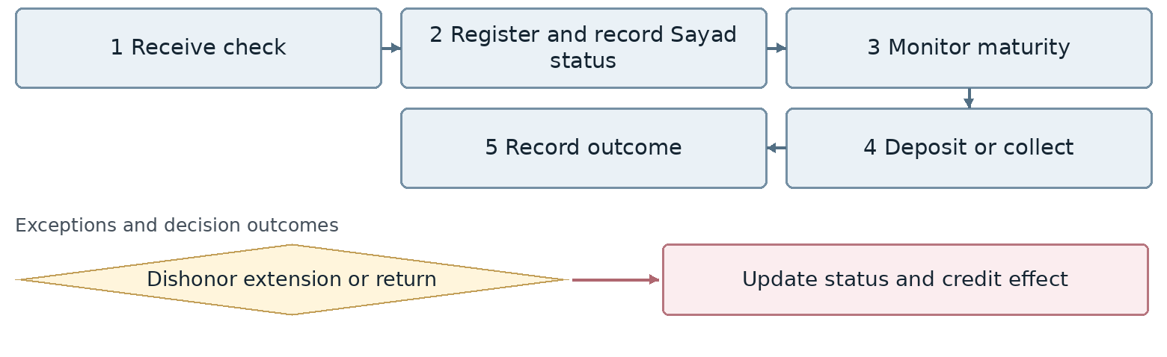
Confirm the connection point for any exception whose branch or return route is still undecided.
Outcome Check with a resolved status
Proposed owner Treasury and Accounts Receivable. Interfaces: Sales, Call Center and Legal.
Target requirement Track receipt, Sayad registration, deposit, clearance, dishonor, extension and return with history and credit effects.
Required data Sayad identifier, issuer, due date, bank, status, security check flag, clearance evidence. Common tracking: record identifier, owner, status, date and attachments.
Decision required Is Sayad registration manual or integrated? Which event settles the debt and releases credit?
Reports and indicators Checks in process, maturities, collections and dishonored checks.
Acceptance scenario Move a check from in process to dishonored; update debt and credit restrictions according to the approved rule.
Odoo review area Accounting and collections. Delivery approach remains open.
□ Standard □ Configuration □ Studio □ Development □ Integration □ Alternative or gap
Limitations and evidence: __________________________________________________
Action owner: _____________________ Due date: _____________________

13 Receivable balances and aging
FIN-13 | Business approval pending
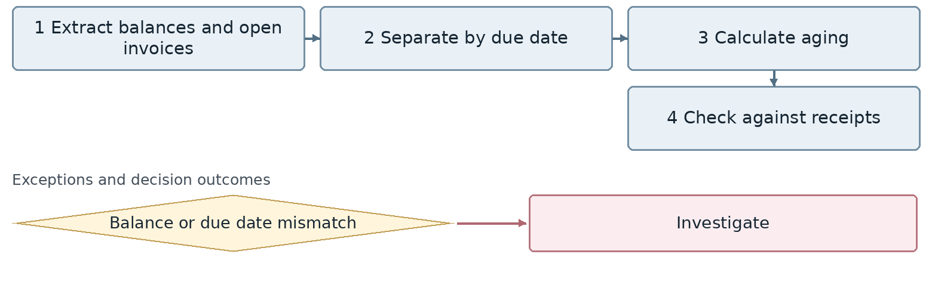
Confirm the connection point for any exception whose branch or return route is still undecided.
Outcome Reliable receivable aging
Proposed owner Treasury and Accounts Receivable. Interfaces: Sales, Call Center and Legal.
Target requirement Build aging from open items and valid due dates, reconciled with allocated receipts. Show total balance separately from overdue debt.
Required data Open invoice, due date, reporting date, unpaid balance, aging bucket. Common tracking: record identifier, owner, status, date and attachments.
Decision required What is the agreed treatment of due and not yet due invoices when calculating overdue receivables?
Reports and indicators Customer balances, aging and maturities.
Acceptance scenario Separate a partially settled invoice from a future due invoice and reconcile report totals to the ledger.
Odoo review area Accounting and collections. Delivery approach remains open.
□ Standard □ Configuration □ Studio □ Development □ Integration □ Alternative or gap
Limitations and evidence: __________________________________________________
Action owner: _____________________ Due date: _____________________

14 Collection follow up
FIN-14 | Business approval pending
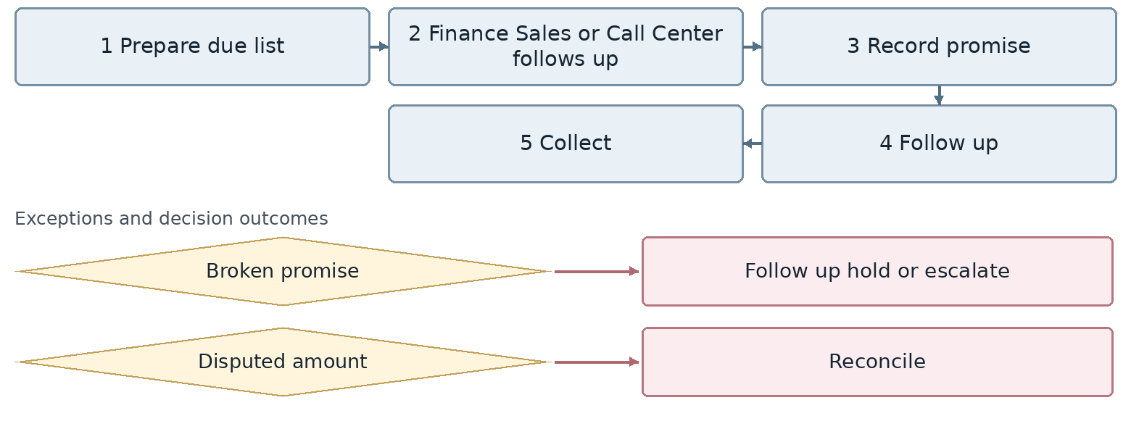
Confirm the connection point for any exception whose branch or return route is still undecided.
Outcome Collected receivable or agreed next action
Proposed owner Treasury and Accounts Receivable. Interfaces: Sales, Call Center and Legal.
Target requirement Maintain one shared collection case across Finance, Sales and Call Center with a promise, owner, next action date and collection result.
Required data Invoice, payment promise, promised amount, contact owner, next action date. Common tracking: record identifier, owner, status, date and attachments.
Decision required Who owns each customer segment? When does a broken promise trigger a hold or legal escalation?
Reports and indicators Collection rate, promises and overdue receivables.
Acceptance scenario A broken promise triggers an alert. Confirmed receipt closes the related case without duplicate follow up.
Odoo review area Accounting and collections. Delivery approach remains open.
□ Standard □ Configuration □ Studio □ Development □ Integration □ Alternative or gap
Limitations and evidence: __________________________________________________
Action owner: _____________________ Due date: _____________________

15 High risk receivables and balance confirmations
FIN-15 | Business approval pending
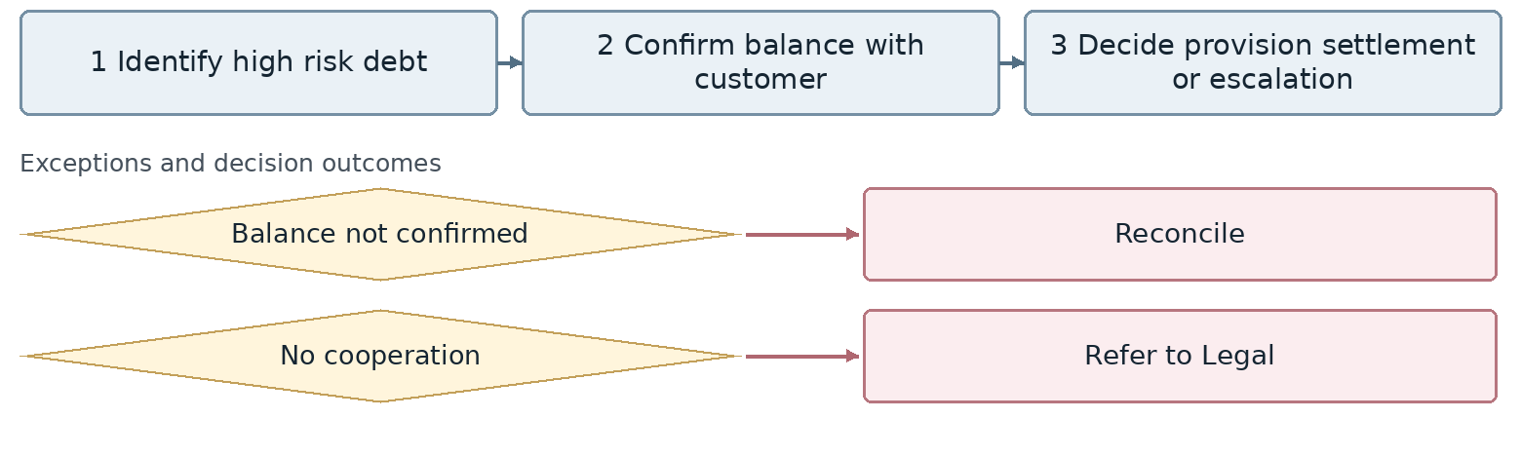
Confirm the connection point for any exception whose branch or return route is still undecided.
Outcome Receivable case with an agreed disposition
Proposed owner Treasury and Accounts Receivable. Interfaces: Sales, Call Center and Legal.
Target requirement Keep confirmations, customer objections and legal referrals in the receivable case. Require authorization for provisions or waivers.
Required data Receivable, confirmation, disputed amount, evidence, settlement agreement, adjustment approval. Common tracking: record identifier, owner, status, date and attachments.
Decision required What defines high risk, who authorizes provisions, and how are balance disputes resolved?
Reports and indicators Doubtful debts, balance confirmations and legal cases.
Acceptance scenario A refused balance confirmation creates a reconciliation case and does not remove debt without approval.
Odoo review area Accounting and collections. Delivery approach remains open.
□ Standard □ Configuration □ Studio □ Development □ Integration □ Alternative or gap
Limitations and evidence: __________________________________________________
Action owner: _____________________ Due date: _____________________

16 Supplier financial master data
FIN-16 | Business approval pending
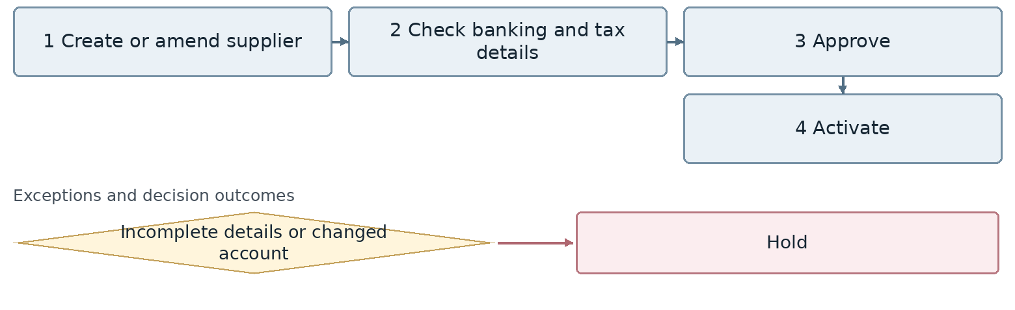
Confirm the connection point for any exception whose branch or return route is still undecided.
Outcome Valid supplier financial profile
Proposed owner Accounts Payable and Treasury. Interfaces: Commerce, Procurement and Management.
Target requirement Maintain supplier bank details with change control and independent approval. Apply controls to ready payments when the account changes.
Required data Supplier identifier, bank account, ownership evidence, tax details, change date. Common tracking: record identifier, owner, status, date and attachments.
Decision required Who validates a new account? Can its creator approve the same change?
Reports and indicators Active suppliers and bank account changes.
Acceptance scenario A bank account change holds a ready payment until independent approval.
Odoo review area Purchase, Accounting and Approvals. Delivery approach remains open.
□ Standard □ Configuration □ Studio □ Development □ Integration □ Alternative or gap
Limitations and evidence: __________________________________________________
Action owner: _____________________ Due date: _____________________

17 Supplier invoice recording and control
FIN-17 | Business approval pending
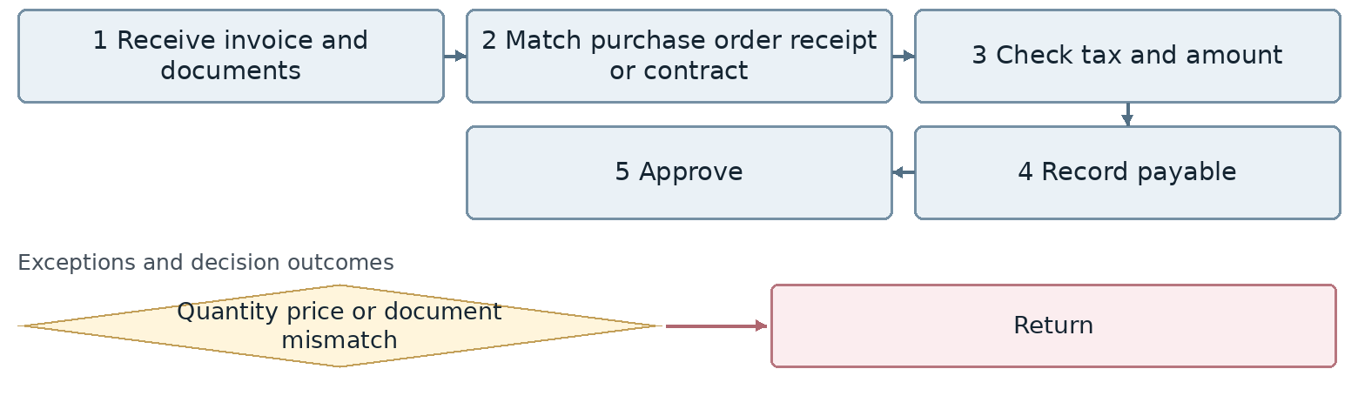
Confirm the connection point for any exception whose branch or return route is still undecided.
Outcome Valid supplier payable
Proposed owner Accounts Payable and Treasury. Interfaces: Commerce, Procurement and Management.
Target requirement Match bills to purchase orders, goods receipts or service acceptance and contracts. Resolve exceptions before payment.
Required data Invoice number, order, receipt, quantity, price, tax, currency, quality status. Common tracking: record identifier, owner, status, date and attachments.
Decision required What are the quantity and price tolerances? Can quarantined goods be paid for?
Reports and indicators Pending or disputed invoices and payables.
Acceptance scenario Hold a bill exceeding received quantity for review and detect a repeated invoice number.
Odoo review area Purchase, Accounting and Approvals. Delivery approach remains open.
□ Standard □ Configuration □ Studio □ Development □ Integration □ Alternative or gap
Limitations and evidence: __________________________________________________
Action owner: _____________________ Due date: _____________________

18 Supplier advance payments
FIN-18 | Business approval pending
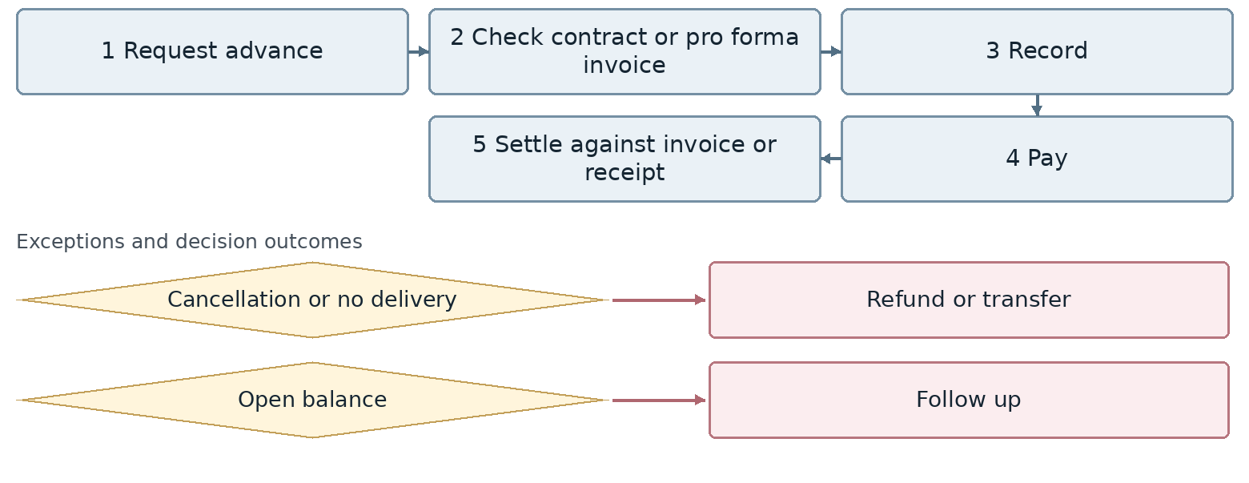
Confirm the connection point for any exception whose branch or return route is still undecided.
Outcome Settled supplier advance
Proposed owner Accounts Payable and Treasury. Interfaces: Commerce, Procurement and Management.
Target requirement Link advances to contracts and orders. Track them as open balances until receipt or refund.
Required data Pro forma invoice, order, currency, percentage and amount, guarantee, settlement date. Common tracking: record identifier, owner, status, date and attachments.
Decision required How are foreign currency advances offset, and who approves exchange rate effects?
Reports and indicators Open advances and remaining balances.
Acceptance scenario Settle an advance partly against two invoices and leave a canceled order balance open for refund.
Odoo review area Purchase, Accounting and Approvals. Delivery approach remains open.
□ Standard □ Configuration □ Studio □ Development □ Integration □ Alternative or gap
Limitations and evidence: __________________________________________________
Action owner: _____________________ Due date: _____________________

19 Purchase returns supplier credits and adjustments
FIN-19 | Business approval pending
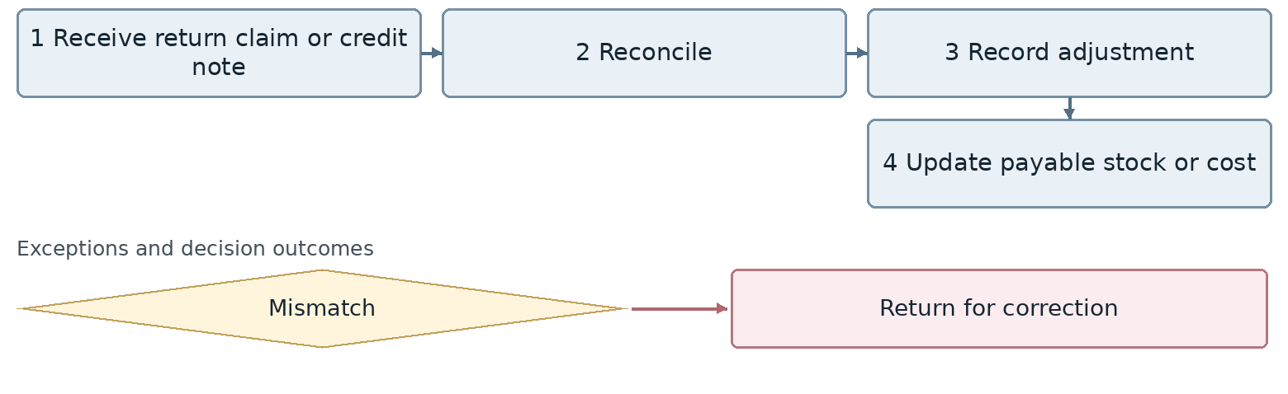
Confirm the connection point for any exception whose branch or return route is still undecided.
Outcome Corrected supplier balance
Proposed owner Accounts Payable and Treasury. Interfaces: Commerce, Procurement and Management.
Target requirement Link a supplier credit to a purchase return or technical claim and reconcile it with the payable and stock.
Required data Original invoice, return, nonconformity report, compensation amount, currency. Common tracking: record identifier, owner, status, date and attachments.
Decision required How do cash compensation, replacement goods and debt reduction differ in accounting treatment?
Reports and indicators Credit notes, purchase returns and adjustments.
Acceptance scenario An approved technical claim creates a supplier credit without compensating the same loss twice.
Odoo review area Purchase, Accounting and Approvals. Delivery approach remains open.
□ Standard □ Configuration □ Studio □ Development □ Integration □ Alternative or gap
Limitations and evidence: __________________________________________________
Action owner: _____________________ Due date: _____________________

20 Domestic funding requests and ad hoc payments
FIN-20 | Business approval pending
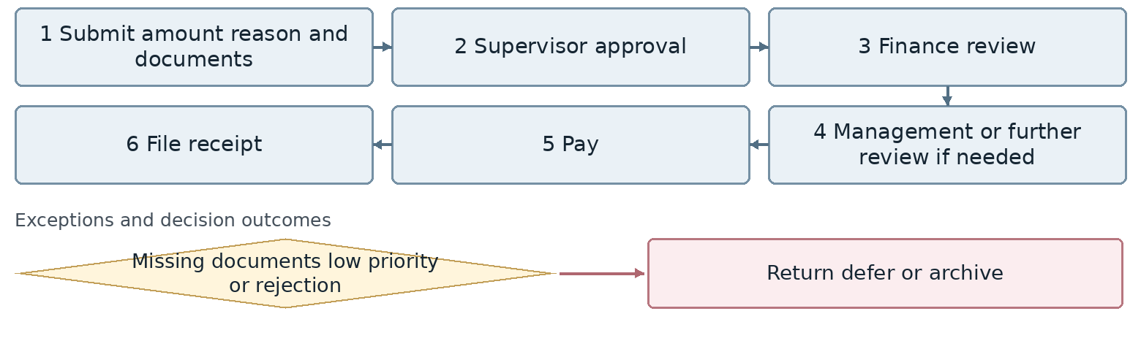
Confirm the connection point for any exception whose branch or return route is still undecided.
Outcome Completed payment or resolved request
Proposed owner Accounts Payable and Treasury. Interfaces: Commerce, Procurement and Management.
Target requirement Maintain request, supervisor review, Finance decision, management approval, payment and final receipt in one case.
Required data Reason, amount, beneficiary, cost center, documents, priority, authorization. Common tracking: record identifier, owner, status, date and attachments.
Decision required What conditions allow direct payment, management escalation, archiving or additional review?
Reports and indicators Open requests, approval and payment times, paid amounts.
Acceptance scenario Small and large requests follow their respective approved routes. A request without required evidence is not paid.
Odoo review area Purchase, Accounting and Approvals. Delivery approach remains open.
□ Standard □ Configuration □ Studio □ Development □ Integration □ Alternative or gap
Limitations and evidence: __________________________________________________
Action owner: _____________________ Due date: _____________________

21 International office funding and payments
FIN-21 | Business approval pending
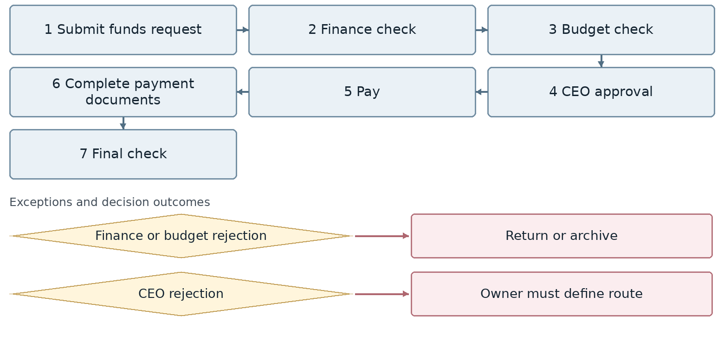
Confirm the connection point for any exception whose branch or return route is still undecided.
Outcome International payment with complete documentation
Proposed owner Accounts Payable and Treasury. Interfaces: Commerce, Procurement and Management.
Target requirement Connect an overseas office request to budget, currency, CEO authorization, payment and final document control.
Required data Office, legal entity, currency, budget, destination account, receipt, supporting documents. Common tracking: record identifier, owner, status, date and attachments.
Decision required What are the CEO rejection and final check return routes? Is the office a branch or an independent company?
Reports and indicators Office requests, amount and currency, budget status, payment and final documents.
Acceptance scenario Finance rejection returns to the requester; budget rejection is archived; CEO rejection follows the approved disposition.
Odoo review area Purchase, Accounting and Approvals. Delivery approach remains open.
□ Standard □ Configuration □ Studio □ Development □ Integration □ Alternative or gap
Limitations and evidence: __________________________________________________
Action owner: _____________________ Due date: _____________________

22 Supplier payment planning and approval
FIN-22 | Business approval pending
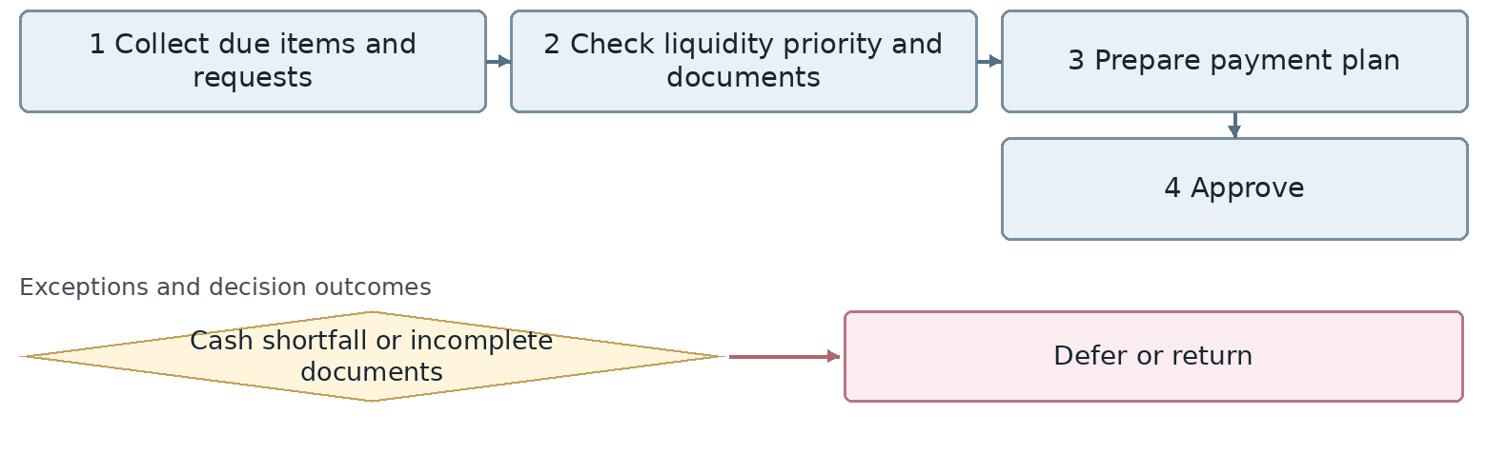
Confirm the connection point for any exception whose branch or return route is still undecided.
Outcome Authorized payment list
Proposed owner Accounts Payable and Treasury. Interfaces: Commerce, Procurement and Management.
Target requirement Build the payment plan from due liabilities and reliable cash availability. Record reasons for priority changes.
Required data Payable, due date, paying bank, priority, payable amount, planned date. Common tracking: record identifier, owner, status, date and attachments.
Decision required Who sets priorities, and what authorization permits emergency payments outside the plan?
Reports and indicators Upcoming and overdue payments and approval time.
Acceptance scenario A cash shortfall defers part of the payment list without marking those items as paid.
Odoo review area Purchase, Accounting and Approvals. Delivery approach remains open.
□ Standard □ Configuration □ Studio □ Development □ Integration □ Alternative or gap
Limitations and evidence: __________________________________________________
Action owner: _____________________ Due date: _____________________

23 Supplier payment execution and settlement
FIN-23 | Business approval pending
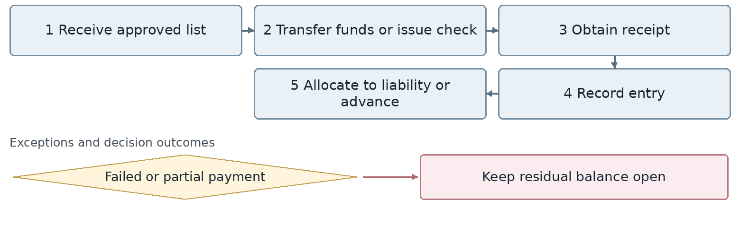
Confirm the connection point for any exception whose branch or return route is still undecided.
Outcome Updated supplier balance
Proposed owner Accounts Payable and Treasury. Interfaces: Commerce, Procurement and Management.
Target requirement Distinguish payment instruction, bank execution and allocation to liabilities, using a unique reference.
Required data Payment instruction, bank reference, successful amount, fee, settled liability. Common tracking: record identifier, owner, status, date and attachments.
Decision required How do failed payment status and bank file resubmission prevent duplicate payments?
Reports and indicators Successful and failed payments and remaining balances.
Acceptance scenario For a partial payment and a failed line, settle the liability only by the successfully paid amount.
Odoo review area Purchase, Accounting and Approvals. Delivery approach remains open.
□ Standard □ Configuration □ Studio □ Development □ Integration □ Alternative or gap
Limitations and evidence: __________________________________________________
Action owner: _____________________ Due date: _____________________

24 Supplier balance reconciliation and confirmation
FIN-24 | Business approval pending
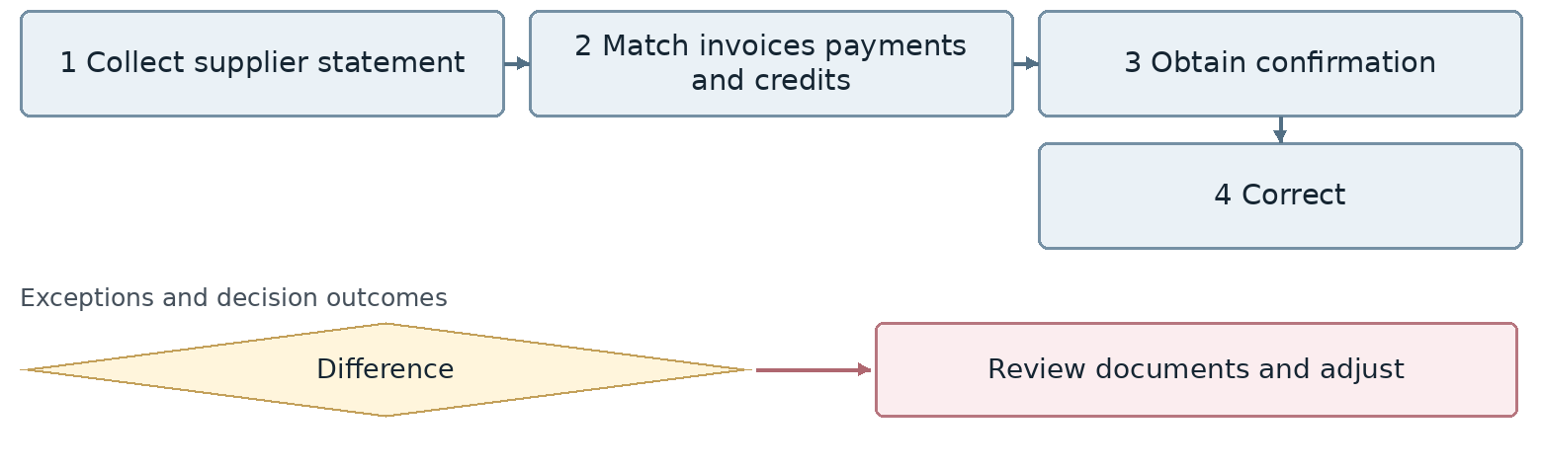
Confirm the connection point for any exception whose branch or return route is still undecided.
Outcome Confirmed supplier balance
Proposed owner Accounts Payable and Treasury. Interfaces: Commerce, Procurement and Management.
Target requirement Match the supplier statement to invoices, advances, payments and supplier credits.
Required data Supplier, period, both balances, open items, confirmation. Common tracking: record identifier, owner, status, date and attachments.
Decision required Does Finance or Commerce follow up discrepancies with the supplier?
Reports and indicators Balance confirmations and outstanding items.
Acceptance scenario Identify an unrecorded credit on the statement and correct the authoritative record after approval.
Odoo review area Purchase, Accounting and Approvals. Delivery approach remains open.
□ Standard □ Configuration □ Studio □ Development □ Integration □ Alternative or gap
Limitations and evidence: __________________________________________________
Action owner: _____________________ Due date: _____________________

25 Petty cash management
FIN-25 | Business approval pending
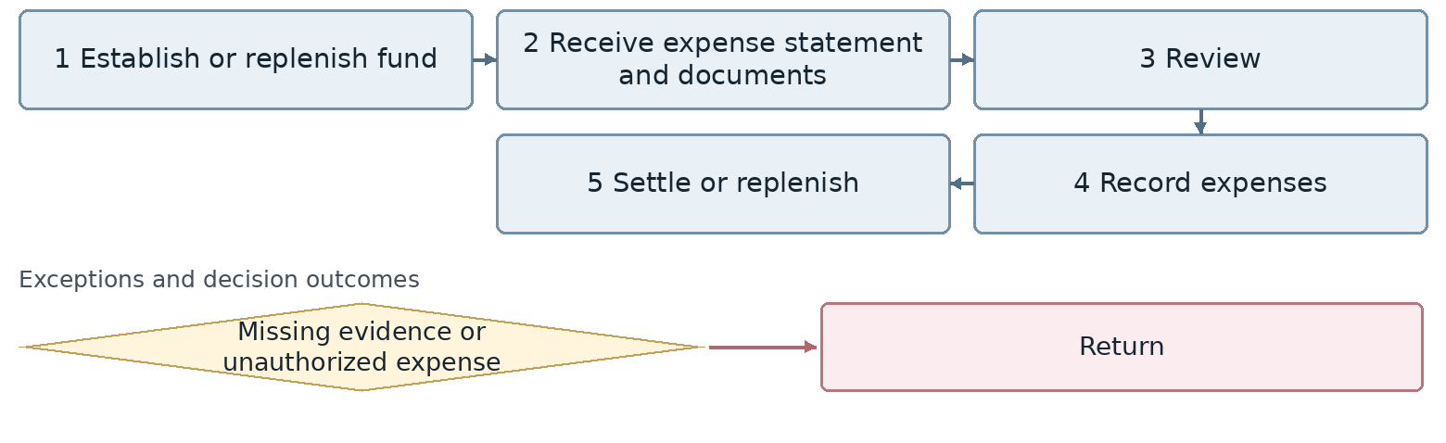
Confirm the connection point for any exception whose branch or return route is still undecided.
Outcome Settled or replenished petty cash
Proposed owner Finance and Treasury. Interfaces: HR and Administration.
Target requirement Record petty cash with supervisor, Administration and Finance Manager approvals, document checks and a settlement or replenishment decision.
Required data Custodian, period, expense lines, previous balance, rejected amount, replenishment. Common tracking: record identifier, owner, status, date and attachments.
Decision required Confirm the operating approval route. What conditions distinguish replenishment, settlement and archiving?
Reports and indicators Petty cash balance and settlement time.
Acceptance scenario Reject one expense and settle only accepted items. Replenishment must not post the same expense twice.
Odoo review area Expenses and payment requests. Delivery approach remains open.
□ Standard □ Configuration □ Studio □ Development □ Integration □ Alternative or gap
Limitations and evidence: __________________________________________________
Action owner: _____________________ Due date: _____________________

26 Employee salary advances
FIN-26 | Business approval pending
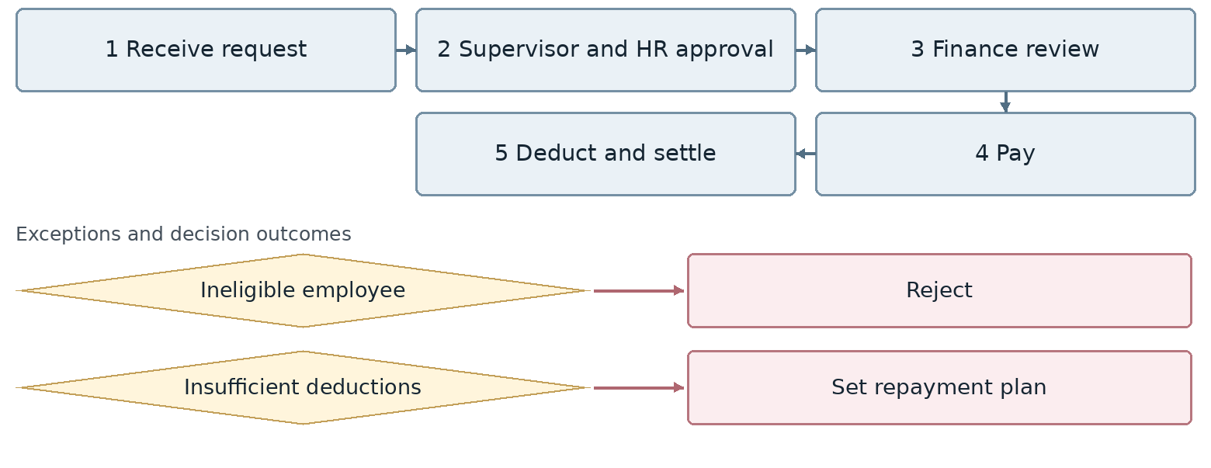
Confirm the connection point for any exception whose branch or return route is still undecided.
Outcome Paid employee advance
Proposed owner Finance and Treasury. Interfaces: HR and Administration.
Target requirement Connect an advance to the employee record, authorized approvals, payment and deduction schedule.
Required data Employee, amount, outstanding advances, eligibility, installments, deduction periods. Common tracking: record identifier, owner, status, date and attachments.
Decision required Is Finance and supervisor approval required before payment, or may HR authorize payment directly?
Reports and indicators Open advances, deductions and balances.
Acceptance scenario Do not pay without required approvals. Payroll deductions reduce the outstanding balance across several periods.
Odoo review area Expenses and payment requests. Delivery approach remains open.
□ Standard □ Configuration □ Studio □ Development □ Integration □ Alternative or gap
Limitations and evidence: __________________________________________________
Action owner: _____________________ Due date: _____________________

27 Business travel advances and settlement
FIN-27 | Business approval pending
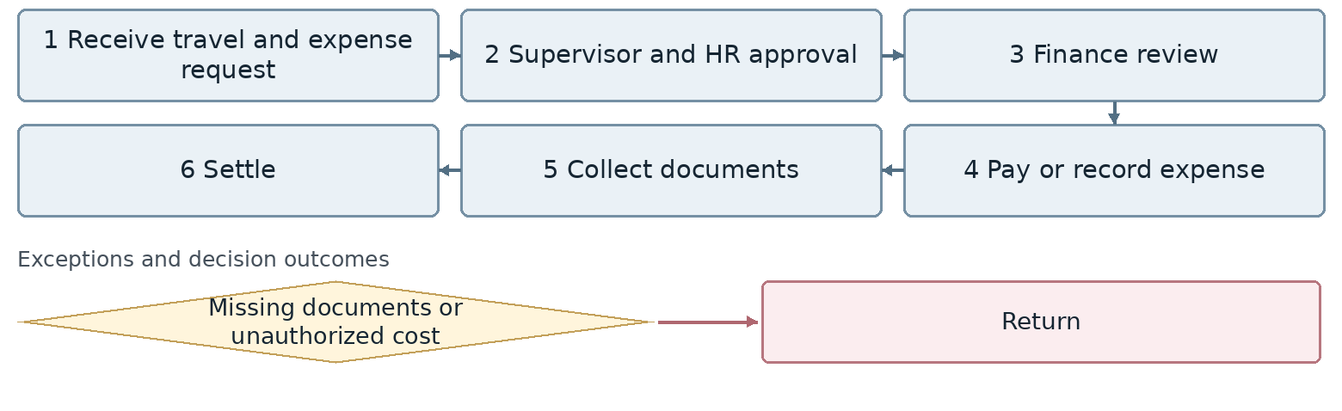
Confirm the connection point for any exception whose branch or return route is still undecided.
Outcome Settled travel expense
Proposed owner Finance and Treasury. Interfaces: HR and Administration.
Target requirement Connect approved travel, actual expense, HR approval, expense posting and advance settlement.
Required data Travel request number, dates, expense lines, advance, documents, approval. Common tracking: record identifier, owner, status, date and attachments.
Decision required What separate route is required for an advance when expense posting otherwise precedes payment?
Reports and indicators Open trips, amounts and settlement time.
Acceptance scenario Approve actual travel expenses, deduct the advance and pay only the remaining net amount.
Odoo review area Expenses and payment requests. Delivery approach remains open.
□ Standard □ Configuration □ Studio □ Development □ Integration □ Alternative or gap
Limitations and evidence: __________________________________________________
Action owner: _____________________ Due date: _____________________

28 Other employee expense reimbursements
FIN-28 | Business approval pending
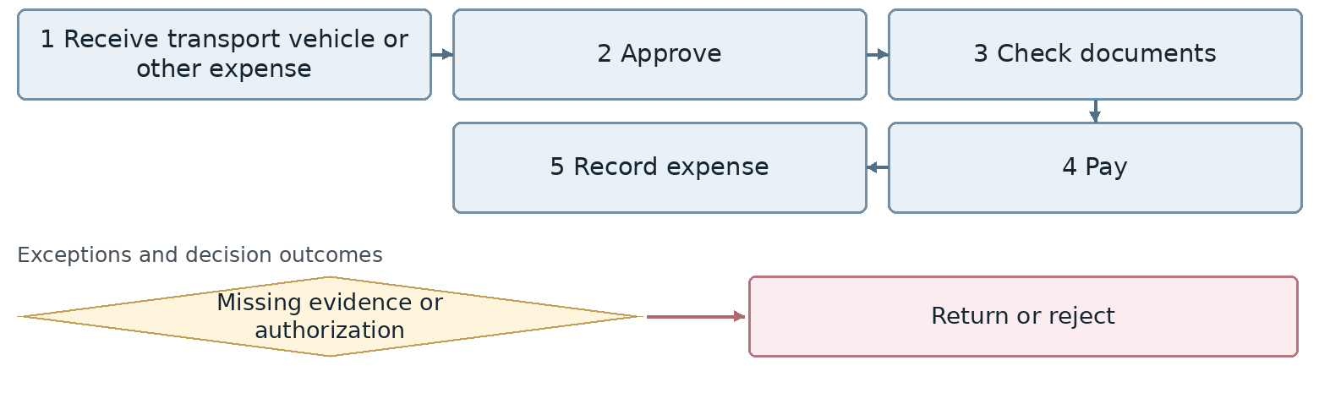
Confirm the connection point for any exception whose branch or return route is still undecided.
Outcome Recorded and reimbursed expense
Proposed owner Finance and Treasury. Interfaces: HR and Administration.
Target requirement Control reimbursement types using limits, required evidence, approvals and cost center allocations.
Required data Expense type, employee, amount, receipt, authorization, cost center. Common tracking: record identifier, owner, status, date and attachments.
Decision required What different limits and approvals apply to vehicle, commuting and other expenses?
Reports and indicators Reimbursements by type.
Acceptance scenario Route an expense without a receipt or above the limit for review and block payment without authorization.
Odoo review area Expenses and payment requests. Delivery approach remains open.
□ Standard □ Configuration □ Studio □ Development □ Integration □ Alternative or gap
Limitations and evidence: __________________________________________________
Action owner: _____________________ Due date: _____________________

29 Bank cash and internal transfers
FIN-29 | Business approval pending
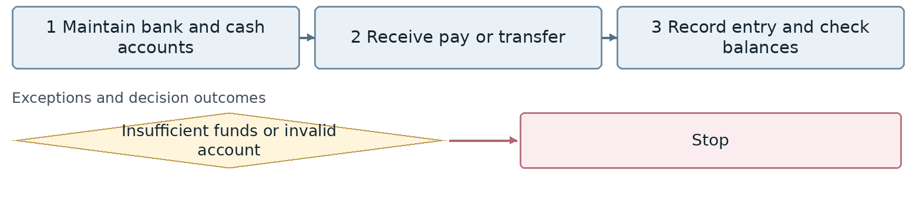
Confirm the connection point for any exception whose branch or return route is still undecided.
Outcome Correct bank and cash balances
Proposed owner Treasury. Interfaces: Banks and Management.
Target requirement Link each bank or cash account to its legal entity and office. Reconcile internal transfers through a clearing account.
Required data Bank, cash account, company, currency, origin and destination, value date. Common tracking: record identifier, owner, status, date and attachments.
Decision required How are transfers between branches distinguished from transfers between separate legal entities?
Reports and indicators Balances, transfers and daily movements.
Acceptance scenario A transfer between two accounts creates no artificial income or expense and both sides reconcile.
Odoo review area Banking and Accounting. Delivery approach remains open.
□ Standard □ Configuration □ Studio □ Development □ Integration □ Alternative or gap
Limitations and evidence: __________________________________________________
Action owner: _____________________ Due date: _____________________

30 Bank reconciliation
FIN-30 | Business approval pending
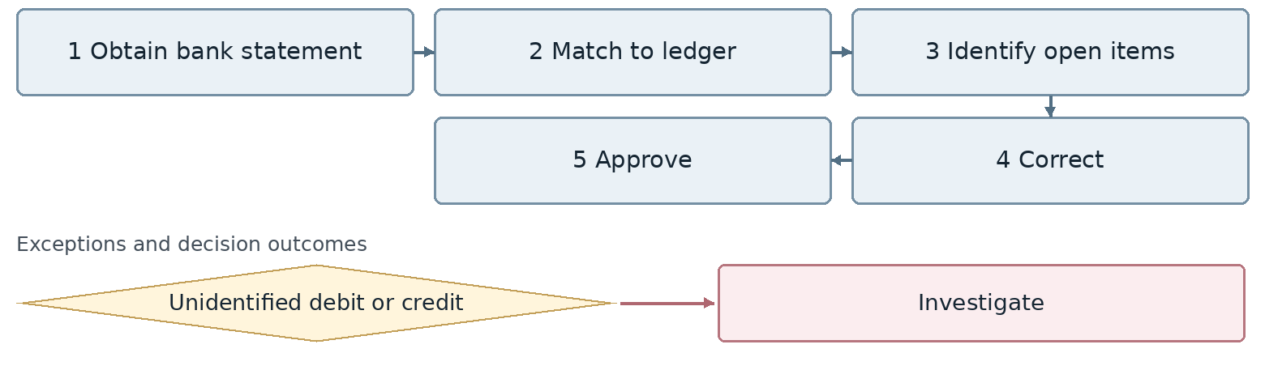
Confirm the connection point for any exception whose branch or return route is still undecided.
Outcome Reconciled bank and ledger
Proposed owner Treasury. Interfaces: Banks and Management.
Target requirement Import bank statements with transaction identifiers and track open items, fees and unidentified transactions separately.
Required data Bank, date, identifier, amount, matching entry, difference, follow up owner. Common tracking: record identifier, owner, status, date and attachments.
Decision required Are statements imported as files or through an integration? What are duplicate checks and automatic matching limits?
Reports and indicators Open items and resolution time.
Acceptance scenario Reimporting a statement creates no duplicates. Resolve fees and unidentified deposits separately.
Odoo review area Banking and Accounting. Delivery approach remains open.
□ Standard □ Configuration □ Studio □ Development □ Integration □ Alternative or gap
Limitations and evidence: __________________________________________________
Action owner: _____________________ Due date: _____________________

31 Deposits loans guarantees and letters of credit
FIN-31 | Business approval pending
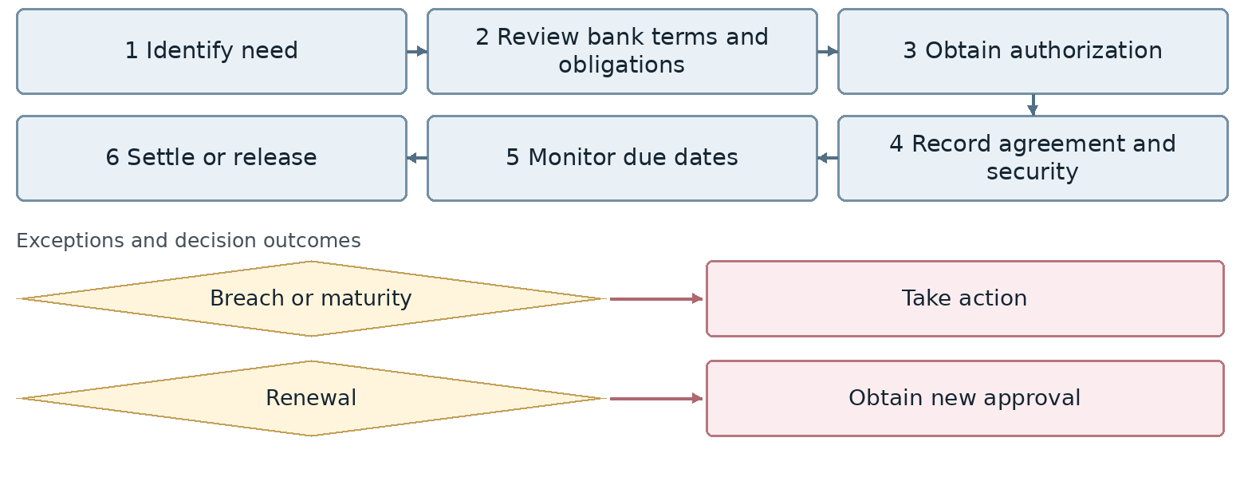
Confirm the connection point for any exception whose branch or return route is still undecided.
Outcome Controlled bank obligations
Proposed owner Treasury. Interfaces: Banks and Management.
Target requirement Maintain principal, finance charges, collateral and due schedules. Keep renewals as separate versions.
Required data Bank, instrument type, amount, collateral, installments, renewal, release date. Common tracking: record identifier, owner, status, date and attachments.
Decision required Which calculations, approvals and reports are required for each banking instrument?
Reports and indicators Loans, installments, guarantees and letters of credit.
Acceptance scenario An overdue loan installment triggers an alert. A renewed guarantee retains its previous history.
Odoo review area Banking and Accounting. Delivery approach remains open.
□ Standard □ Configuration □ Studio □ Development □ Integration □ Alternative or gap
Limitations and evidence: __________________________________________________
Action owner: _____________________ Due date: _____________________

32 Chart of accounts dimensions and fiscal periods
FIN-32 | Business approval pending
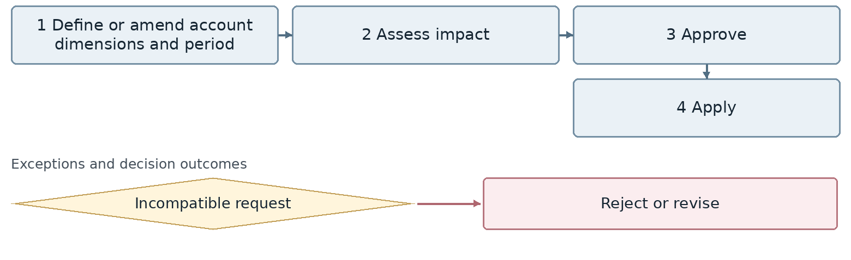
Confirm the connection point for any exception whose branch or return route is still undecided.
Outcome Valid accounting structure
Proposed owner Financial Accounting. Interfaces: All subledgers and IT.
Target requirement Define accounts and analytical dimensions with a single authority, owner and conversion mapping from Sepidar.
Required data Account, subsidiary detail, cost center, project, branch, company, period, legacy code. Common tracking: record identifier, owner, status, date and attachments.
Decision required Is a branch an analytical dimension or a separate company? How are changes to used accounts controlled?
Reports and indicators Account structure and period changes.
Acceptance scenario Migrate a legacy entry to the correct account and dimensions; reject an invalid code.
Odoo review area Accounting and analytical dimensions. Delivery approach remains open.
□ Standard □ Configuration □ Studio □ Development □ Integration □ Alternative or gap
Limitations and evidence: __________________________________________________
Action owner: _____________________ Due date: _____________________

33 Journal entry preparation and approval
FIN-33 | Business approval pending
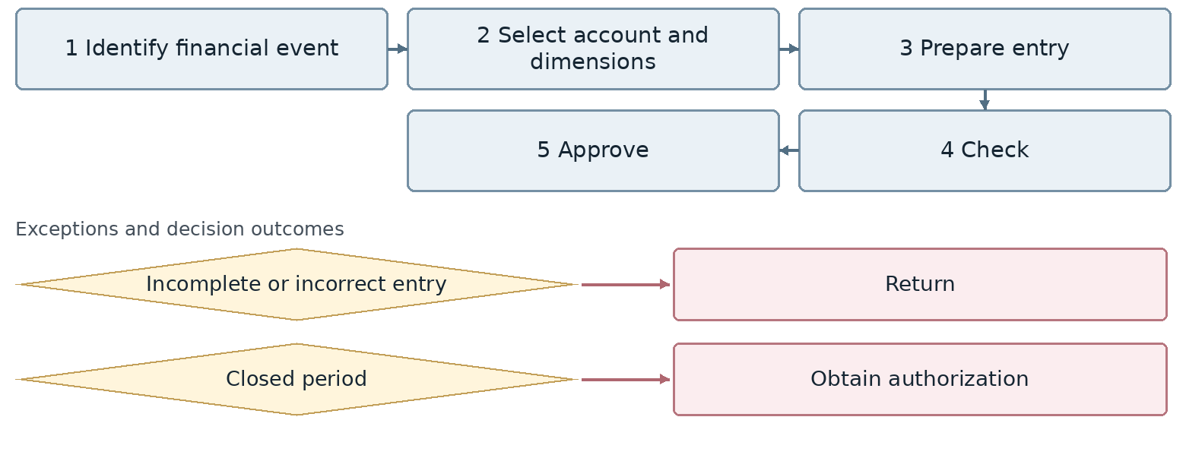
Confirm the connection point for any exception whose branch or return route is still undecided.
Outcome Valid journal entry
Proposed owner Financial Accounting. Interfaces: All subledgers and IT.
Target requirement Separate preparation and approval. Preserve event references, attachments and recorded corrections.
Required data Entry type, accounts and dimensions, debits and credits, period, reference, approval. Common tracking: record identifier, owner, status, date and attachments.
Decision required What permissions distinguish manual posting, automatic posting and corrections to finalized entries?
Reports and indicators Returned entries and posting errors.
Acceptance scenario Reject an unbalanced entry or posting to a closed period. An authorized correction retains history and the original reference.
Odoo review area Accounting and analytical dimensions. Delivery approach remains open.
□ Standard □ Configuration □ Studio □ Development □ Integration □ Alternative or gap
Limitations and evidence: __________________________________________________
Action owner: _____________________ Due date: _____________________

34 Accruals prepayments provisions and cost allocation
FIN-34 | Business approval pending
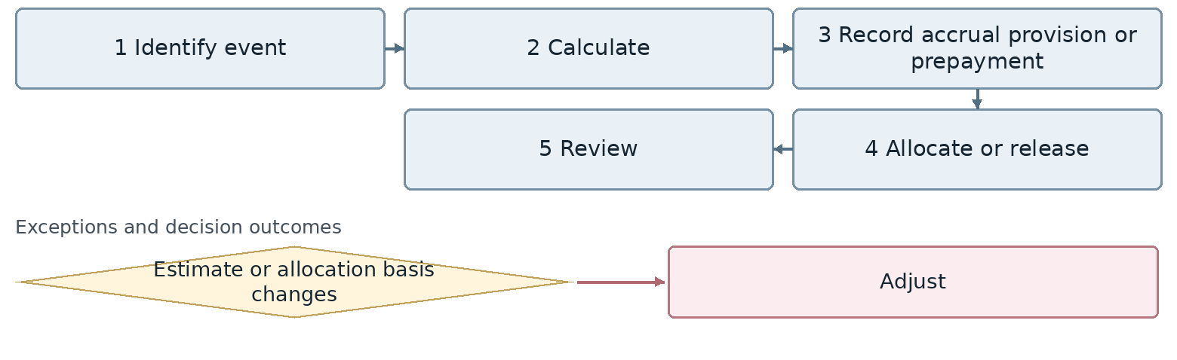
Confirm the connection point for any exception whose branch or return route is still undecided.
Outcome Correct period expense and obligation
Proposed owner Financial Accounting. Interfaces: All subledgers and IT.
Target requirement Maintain recognition and release schedules for expenses or obligations with their calculation basis and period.
Required data Obligation type, calculation basis, period, cost center, release schedule. Common tracking: record identifier, owner, status, date and attachments.
Decision required Who may change estimates and allocation methods? Which calculations will remain outside the system?
Reports and indicators Provisions, prepayments and allocations.
Acceptance scenario Release a prepayment over several periods as scheduled. An estimate change has a traceable effect.
Odoo review area Accounting and analytical dimensions. Delivery approach remains open.
□ Standard □ Configuration □ Studio □ Development □ Integration □ Alternative or gap
Limitations and evidence: __________________________________________________
Action owner: _____________________ Due date: _____________________

35 General ledger and clearing account reconciliation
FIN-35 | Business approval pending
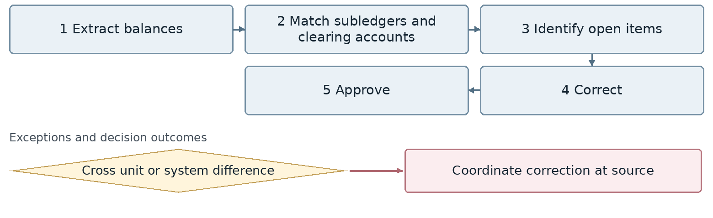
Confirm the connection point for any exception whose branch or return route is still undecided.
Outcome Reconciled general ledger
Proposed owner Financial Accounting. Interfaces: All subledgers and IT.
Target requirement Reconcile ledger balances with subledgers and clearing accounts and assign an owner to each difference.
Required data Clearing account, original entry, balance age, subledger, resolution owner. Common tracking: record identifier, owner, status, date and attachments.
Decision required Which accounts must be cleared or supported before period close?
Reports and indicators Clearing items and resolution time.
Acceptance scenario Identify a stock to ledger difference and close it only after a valid correction to the authoritative record.
Odoo review area Accounting and analytical dimensions. Delivery approach remains open.
□ Standard □ Configuration □ Studio □ Development □ Integration □ Alternative or gap
Limitations and evidence: __________________________________________________
Action owner: _____________________ Due date: _____________________

36 Period close lock and reopening
FIN-36 | Business approval pending
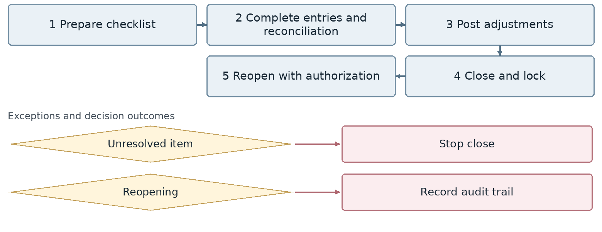
Confirm the connection point for any exception whose branch or return route is still undecided.
Outcome Closed reportable period
Proposed owner Financial Accounting. Interfaces: All subledgers and IT.
Target requirement Run a close checklist with owners, deadlines and evidence. Restrict and audit locking and reopening.
Required data Period, checklist, open items, lock date, reopening authorization. Common tracking: record identifier, owner, status, date and attachments.
Decision required Which issues block closing, and who may reopen a period?
Reports and indicators Close time, open items and adjustments.
Acceptance scenario An unresolved discrepancy blocks closing. An authorized reopening records the reason and subsequent changes.
Odoo review area Accounting and analytical dimensions. Delivery approach remains open.
□ Standard □ Configuration □ Studio □ Development □ Integration □ Alternative or gap
Limitations and evidence: __________________________________________________
Action owner: _____________________ Due date: _____________________

37 Opening a period and carrying balances forward
FIN-37 | Business approval pending
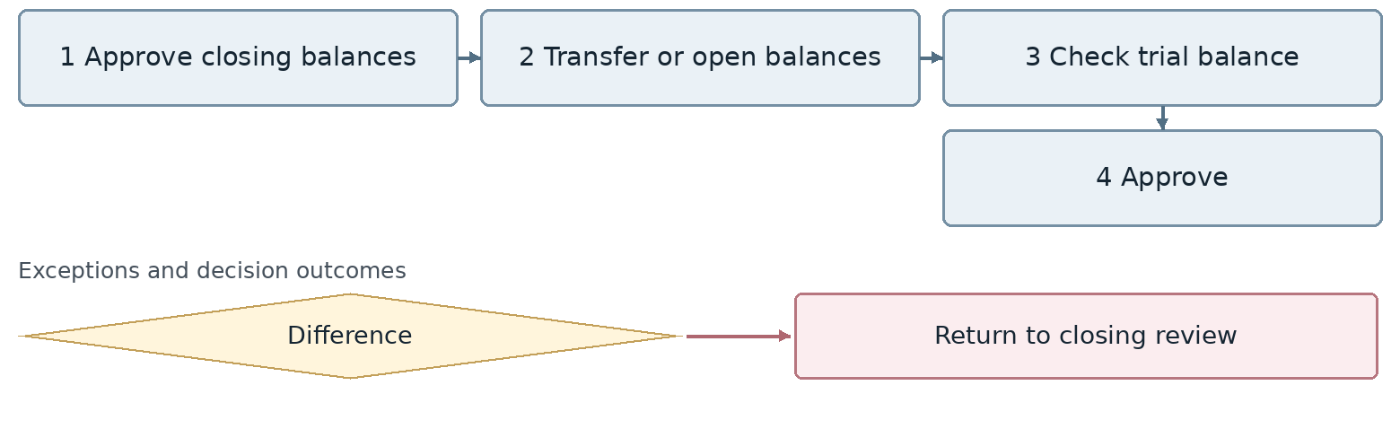
Confirm the connection point for any exception whose branch or return route is still undecided.
Outcome Valid opening balances
Proposed owner Financial Accounting. Interfaces: All subledgers and IT.
Target requirement Reconcile opening balances with the prior closing and partner details. Prevent duplicate transfers.
Required data Origin and destination years, account, subsidiary detail, currency, open items, balance. Common tracking: record identifier, owner, status, date and attachments.
Decision required Is this opening within the same database or migration from Sepidar? Which detailed balances are required?
Reports and indicators Opening balances and discrepancies.
Acceptance scenario Opening totals and details match the prior close. Repeating the operation does not double balances.
Odoo review area Accounting and analytical dimensions. Delivery approach remains open.
□ Standard □ Configuration □ Studio □ Development □ Integration □ Alternative or gap
Limitations and evidence: __________________________________________________
Action owner: _____________________ Due date: _____________________

38 Accounting for inventory movements
FIN-38 | Business approval pending
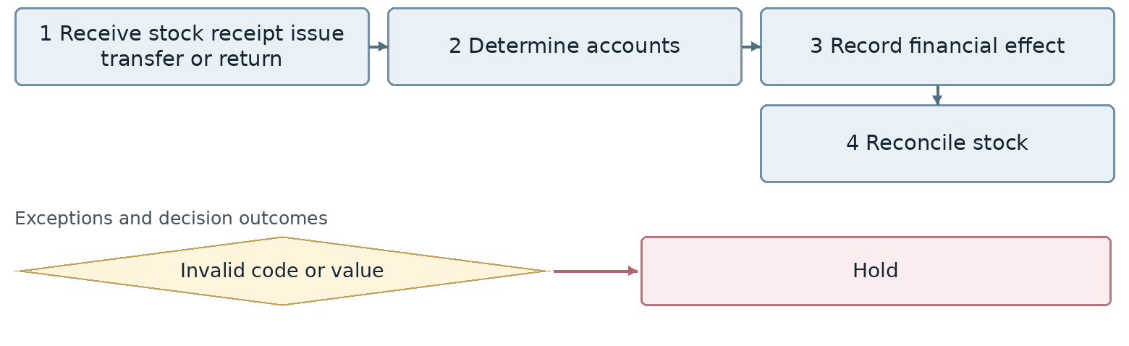
Confirm the connection point for any exception whose branch or return route is still undecided.
Outcome Correct financial effect of stock
Proposed owner Inventory Accounting. Interfaces: Warehouse, Commerce and Technical.
Target requirement Link every stock movement to the corresponding accounting entry and account. Apply distinct rules for returns and location transfers.
Required data Stock issue or receipt, item, quantity, value, location, company, journal entry. Common tracking: record identifier, owner, status, date and attachments.
Decision required Will stock accounting remain in Sepidar or move to Odoo? At what event is the financial effect recognized?
Reports and indicators Movements, unposted entries and discrepancies.
Acceptance scenario Execute a receipt, return and transfer and verify ledger effects without duplicate postings.
Odoo review area Inventory, Purchase and Accounting. Delivery approach remains open.
□ Standard □ Configuration □ Studio □ Development □ Integration □ Alternative or gap
Limitations and evidence: __________________________________________________
Action owner: _____________________ Due date: _____________________

39 Accounting for consignment and test items
FIN-39 | Business approval pending
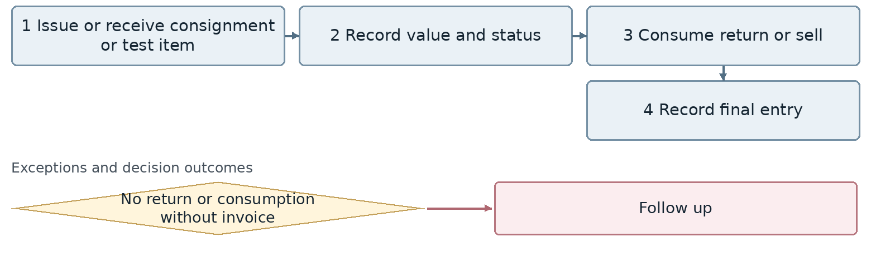
Confirm the connection point for any exception whose branch or return route is still undecided.
Outcome Resolved financial status of the item
Proposed owner Inventory Accounting. Interfaces: Warehouse, Commerce and Technical.
Target requirement Distinguish ownership of consignment and test goods from actual sales. Resolve consumption, return, damage or sale financially.
Required data Item, owner, customer, test, stock issue, amount, return deadline, outcome. Common tracking: record identifier, owner, status, date and attachments.
Decision required Is a sample issue invoice a real sale or a control document? How does nonreturn become debt or expense?
Reports and indicators Open consignment and test items and duration.
Acceptance scenario Issue and return a sample without artificial revenue. An actual sale of the sample creates a separate document.
Odoo review area Inventory, Purchase and Accounting. Delivery approach remains open.
□ Standard □ Configuration □ Studio □ Development □ Integration □ Alternative or gap
Limitations and evidence: __________________________________________________
Action owner: _____________________ Due date: _____________________

40 Inventory valuation and cost of goods sold
FIN-40 | Business approval pending
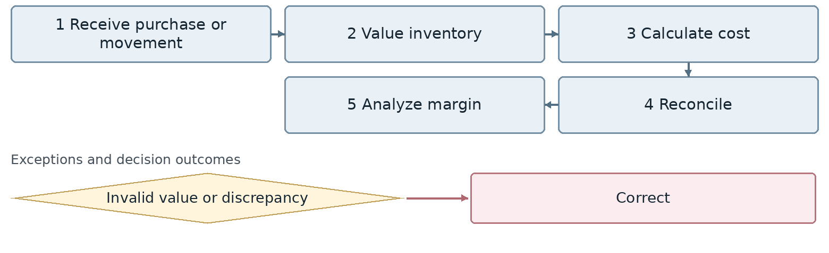
Confirm the connection point for any exception whose branch or return route is still undecided.
Outcome Reliable inventory value
Proposed owner Inventory Accounting. Interfaces: Warehouse, Commerce and Technical.
Target requirement Align valuation and cost of sales with stock records and the ledger. Preserve traceability for late cost adjustments.
Required data Item, valuation method, cost layer, quantity, allocated cost. Common tracking: record identifier, owner, status, date and attachments.
Decision required What is the current valuation method? How do negative stock and returns affect it?
Reports and indicators Inventory value, cost of sales and margin.
Acceptance scenario Purchase at two rates and sell part of the stock. Reconcile cost of sales to the approved method.
Odoo review area Inventory, Purchase and Accounting. Delivery approach remains open.
□ Standard □ Configuration □ Studio □ Development □ Integration □ Alternative or gap
Limitations and evidence: __________________________________________________
Action owner: _____________________ Due date: _____________________

41 Landed cost calculation
FIN-41 | Business approval pending
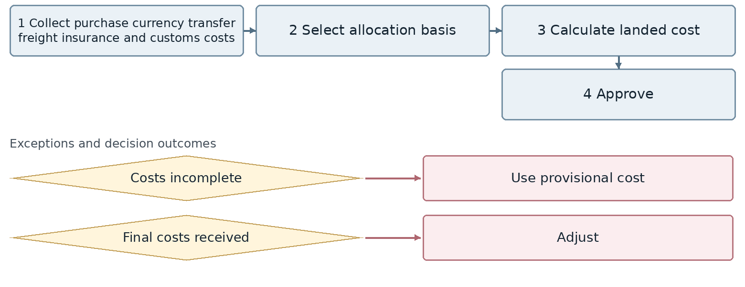
Confirm the connection point for any exception whose branch or return route is still undecided.
Outcome Final cost of imported goods
Proposed owner Inventory Accounting. Interfaces: Warehouse, Commerce and Technical.
Target requirement Collect purchase, freight, insurance and customs costs in the import cost case and apply an approved allocation basis.
Required data Shipment, purchase, currency, freight and customs costs, allocation basis, provisional and final costs. Common tracking: record identifier, owner, status, date and attachments.
Decision required Is allocation based on weight, value or quantity? How are costs received after a sale adjusted?
Reports and indicators Landed cost and estimated versus actual variance.
Acceptance scenario Allocate late freight across several products and show its effects on remaining stock and cost of sales.
Odoo review area Inventory, Purchase and Accounting. Delivery approach remains open.
□ Standard □ Configuration □ Studio □ Development □ Integration □ Alternative or gap
Limitations and evidence: __________________________________________________
Action owner: _____________________ Due date: _____________________

42 Stock count discrepancy resolution
FIN-42 | Business approval pending
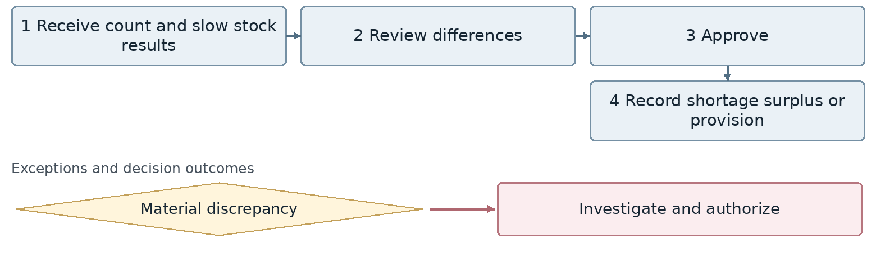
Confirm the connection point for any exception whose branch or return route is still undecided.
Outcome Corrected stock quantity and value
Proposed owner Inventory Accounting. Interfaces: Warehouse, Commerce and Technical.
Target requirement Link count results to reasons, approval and accounting for shortages or surpluses. Distinguish slow stock and impairment.
Required data Count, item, book and counted quantities, value, reason, authorization. Common tracking: record identifier, owner, status, date and attachments.
Decision required What are the materiality and approval limits? How is impairment separated from a physical shortage?
Reports and indicators Shortages, surpluses, slow stock and provisions.
Acceptance scenario Block a material shortage adjustment until approval, then reconcile both quantity and value.
Odoo review area Inventory, Purchase and Accounting. Delivery approach remains open.
□ Standard □ Configuration □ Studio □ Development □ Integration □ Alternative or gap
Limitations and evidence: __________________________________________________
Action owner: _____________________ Due date: _____________________

43 Asset requests purchases and initial registration
FIN-43 | Business approval pending
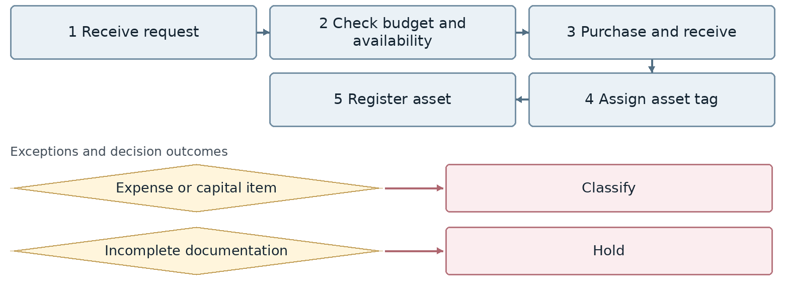
Confirm the connection point for any exception whose branch or return route is still undecided.
Outcome Registered asset
Proposed owner Asset Accounting. Interfaces: Administration, Procurement and asset custodians.
Target requirement Link asset requests to budget, purchase, receipt, tagging and the asset register. Control expense versus capitalization classification.
Required data Asset, class, purchase cost, tag, location, custodian, in service date. Common tracking: record identifier, owner, status, date and attachments.
Decision required What threshold and authority determine expense versus capitalization?
Reports and indicators New assets, missing tags and pending registrations.
Acceptance scenario Post two similar purchases with different approved classifications to the correct expense or asset accounts.
Odoo review area Assets and Accounting. Delivery approach remains open.
□ Standard □ Configuration □ Studio □ Development □ Integration □ Alternative or gap
Limitations and evidence: __________________________________________________
Action owner: _____________________ Due date: _____________________

44 Asset capitalization depreciation and transfers
FIN-44 | Business approval pending
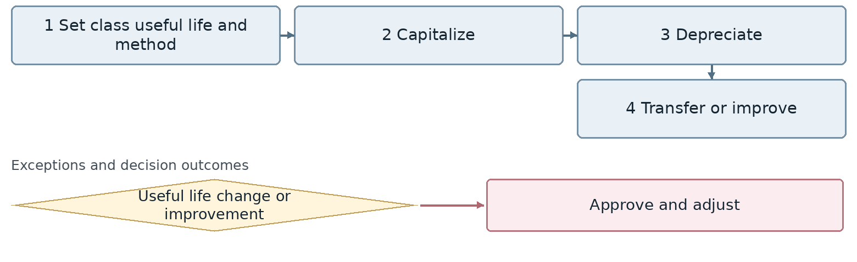
Confirm the connection point for any exception whose branch or return route is still undecided.
Outcome Updated asset value and location
Proposed owner Asset Accounting. Interfaces: Administration, Procurement and asset custodians.
Target requirement Maintain depreciation schedules and location or custodian transfers with history. Require approval for changes to method or useful life.
Required data Asset, useful life, method, residual value, start date, location, improvements. Common tracking: record identifier, owner, status, date and attachments.
Decision required Who approves life changes and improvements, and from what date are calculations revised?
Reports and indicators Depreciation, transfers and improvements.
Acceptance scenario Transfer an asset without creating a new purchase. An approved improvement changes future depreciation visibly.
Odoo review area Assets and Accounting. Delivery approach remains open.
□ Standard □ Configuration □ Studio □ Development □ Integration □ Alternative or gap
Limitations and evidence: __________________________________________________
Action owner: _____________________ Due date: _____________________

45 Asset revaluation counts sales and disposal
FIN-45 | Business approval pending
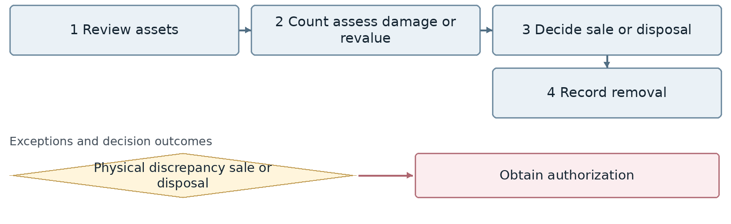
Confirm the connection point for any exception whose branch or return route is still undecided.
Outcome Asset with an approved disposition
Proposed owner Asset Accounting. Interfaces: Administration, Procurement and asset custodians.
Target requirement Treat asset counts, revaluation, sale and disposal as separate authorized events with removal records where appropriate.
Required data Asset tag, book value, count, selling price, disposal approval, removal document. Common tracking: record identifier, owner, status, date and attachments.
Decision required Who values assets and approves removal? How are physical discrepancies investigated?
Reports and indicators Missing or idle assets, sales and disposals.
Acceptance scenario Remove a sold asset from its depreciation schedule and record gain or loss using the approved basis.
Odoo review area Assets and Accounting. Delivery approach remains open.
□ Standard □ Configuration □ Studio □ Development □ Integration □ Alternative or gap
Limitations and evidence: __________________________________________________
Action owner: _____________________ Due date: _____________________

46 Payroll review and payment
FIN-46 | Business approval pending
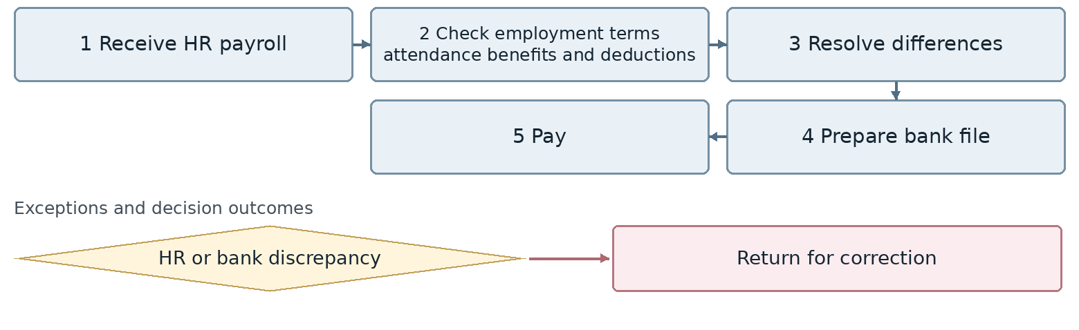
Confirm the connection point for any exception whose branch or return route is still undecided.
Outcome Paid payroll
Proposed owner Finance with defined HR responsibilities. Interfaces: HR, Administration and IT.
Target requirement Reconcile the approved HR payroll with Finance deductions. Record bank file versions and the result of each payment.
Required data Period, employee, net pay, deductions, bank account, file version, result. Common tracking: record identifier, owner, status, date and attachments.
Decision required Will payroll calculation remain in Rahkaran? Who owns employment terms and attendance? How is detail access restricted?
Reports and indicators Payroll discrepancies, failed payments and budget.
Acceptance scenario An invalid bank account blocks only that payment. A corrected file does not repay other employees.
Odoo review area Payroll, Accounting and Rahkaran integration. Delivery approach remains open.
□ Standard □ Configuration □ Studio □ Development □ Integration □ Alternative or gap
Limitations and evidence: __________________________________________________
Action owner: _____________________ Due date: _____________________

47 Payroll entries and insurance and tax liabilities
FIN-47 | Business approval pending
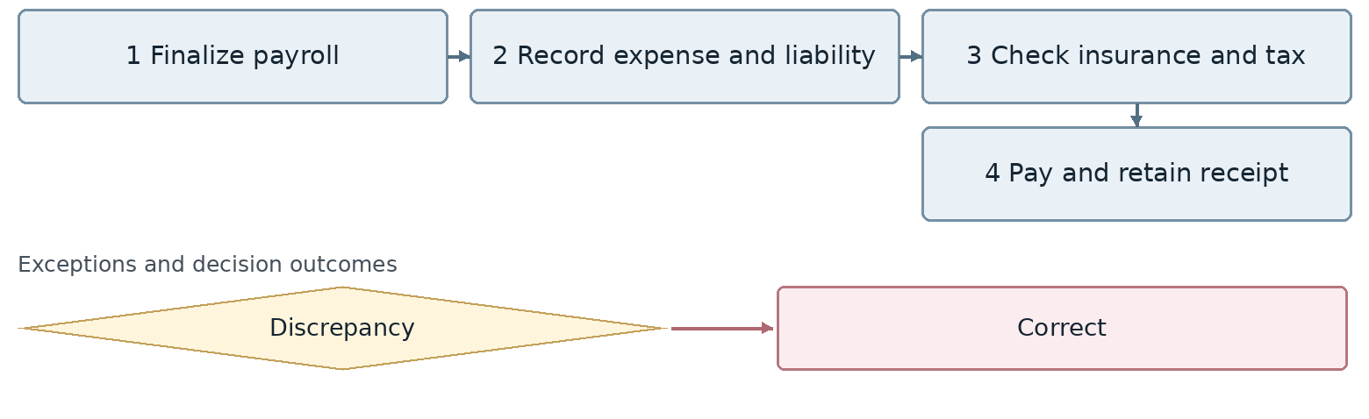
Confirm the connection point for any exception whose branch or return route is still undecided.
Outcome Recorded and settled payroll liabilities
Proposed owner Finance with defined HR responsibilities. Interfaces: HR, Administration and IT.
Target requirement Generate summary or detailed payroll entries and liabilities from the approved version. Reconcile with payments and insurance and tax receipts.
Required data Period, payroll version, cost center, insurance and tax liabilities, payment receipts. Common tracking: record identifier, owner, status, date and attachments.
Decision required What level of HR detail is transferred, and which system owns statutory calculations?
Reports and indicators Payroll insurance, tax and journal entries.
Acceptance scenario A payroll revision updates entries and liabilities with an audit trail, while totals remain equal to the approved payroll.
Odoo review area Payroll, Accounting and Rahkaran integration. Delivery approach remains open.
□ Standard □ Configuration □ Studio □ Development □ Integration □ Alternative or gap
Limitations and evidence: __________________________________________________
Action owner: _____________________ Due date: _____________________

48 Employee exit financial settlement
FIN-48 | Business approval pending
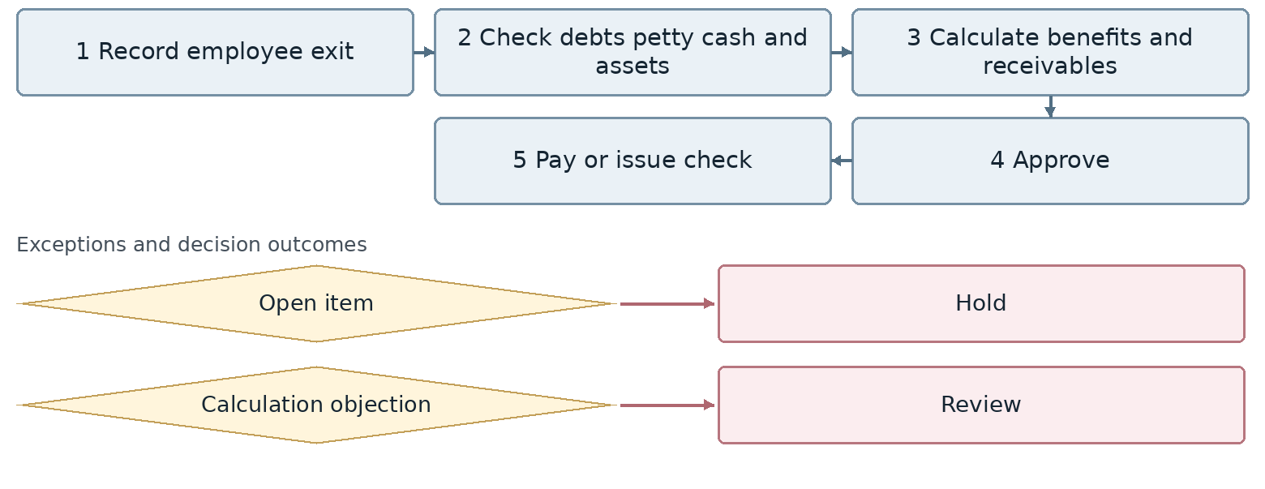
Confirm the connection point for any exception whose branch or return route is still undecided.
Outcome Final employee settlement
Proposed owner Finance with defined HR responsibilities. Interfaces: HR, Administration and IT.
Target requirement Require clearance of assets, petty cash, debts and HR calculations before authorized payment closes the settlement.
Required data Employee, exit date, debts, assets, termination benefits, net settlement, approvals. Common tracking: record identifier, owner, status, date and attachments.
Decision required Must Finance, Administration and Internal Procurement all complete clearance before payment? How are their approvals joined?
Reports and indicators Open settlements, termination benefits and debts.
Acceptance scenario An outstanding asset or petty cash balance holds settlement. After all required approvals, pay only the approved net amount.
Odoo review area Payroll, Accounting and Rahkaran integration. Delivery approach remains open.
□ Standard □ Configuration □ Studio □ Development □ Integration □ Alternative or gap
Limitations and evidence: __________________________________________________
Action owner: _____________________ Due date: _____________________

49 VAT and electronic invoicing
FIN-49 | Business approval pending
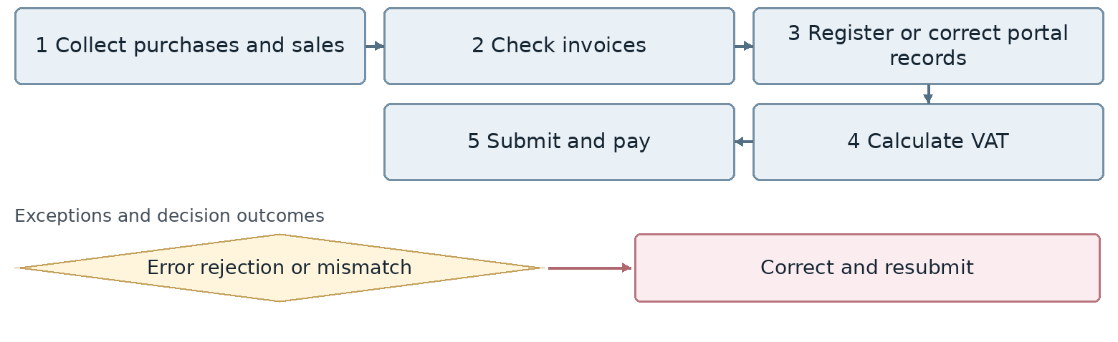
Confirm the connection point for any exception whose branch or return route is still undecided.
Outcome Completed VAT and electronic invoice obligations
Proposed owner Finance and Tax Officer. Interfaces: Legal, insurance and tax authorities.
Target requirement Keep invoice reference, submission status, portal responses and corrections or cancellations separate from ledger status.
Required data Tax identifier, invoice type, original reference, submission status, error, acknowledgment. Common tracking: record identifier, owner, status, date and attachments.
Decision required Who owns the Iran integration and compliance? How are credentials, retries and duplicate prevention managed?
Reports and indicators VAT, rejected or corrected invoices and errors.
Acceptance scenario A connection failure or rejected invoice creates a trackable queue. Resubmission does not create a duplicate statutory invoice.
Odoo review area Statutory reporting and integrations. Delivery approach remains open.
□ Standard □ Configuration □ Studio □ Development □ Integration □ Alternative or gap
Limitations and evidence: __________________________________________________
Action owner: _____________________ Due date: _____________________

50 Tax returns and other tax obligations
FIN-50 | Business approval pending
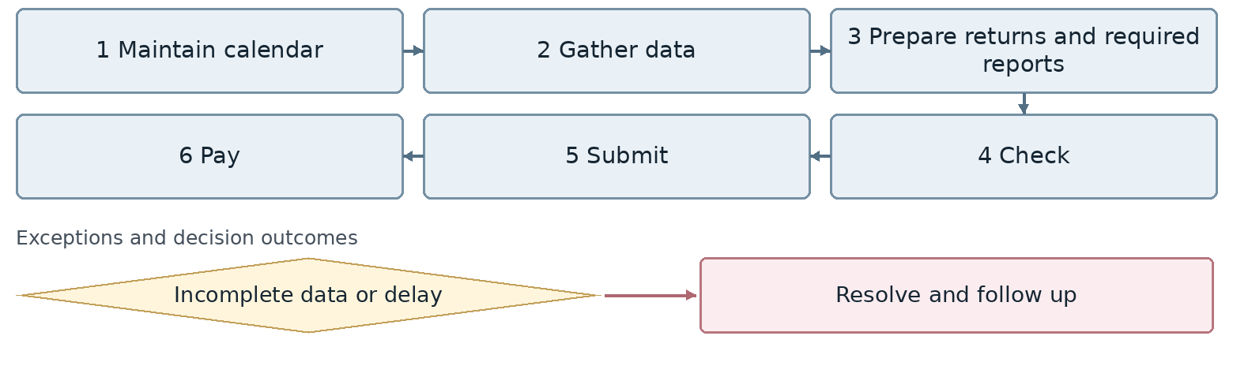
Confirm the connection point for any exception whose branch or return route is still undecided.
Outcome Submitted statutory report
Proposed owner Finance and Tax Officer. Interfaces: Legal, insurance and tax authorities.
Target requirement Maintain the obligation calendar with report type, period, owner, deadline and final acknowledgment. Reconcile data to the books.
Required data Obligation type, period, report version, approved deadline, owner, acknowledgment. Common tracking: record identifier, owner, status, date and attachments.
Decision required Finance must confirm the obligation list and formats. Which outputs require files and which require integrations?
Reports and indicators Returns, withholding taxes and delays.
Acceptance scenario Reconcile a report to the ledger before submission. Do not mark it completed without portal acknowledgment.
Odoo review area Statutory reporting and integrations. Delivery approach remains open.
□ Standard □ Configuration □ Studio □ Development □ Integration □ Alternative or gap
Limitations and evidence: __________________________________________________
Action owner: _____________________ Due date: _____________________

51 Tax and insurance assessments and appeals
FIN-51 | Business approval pending
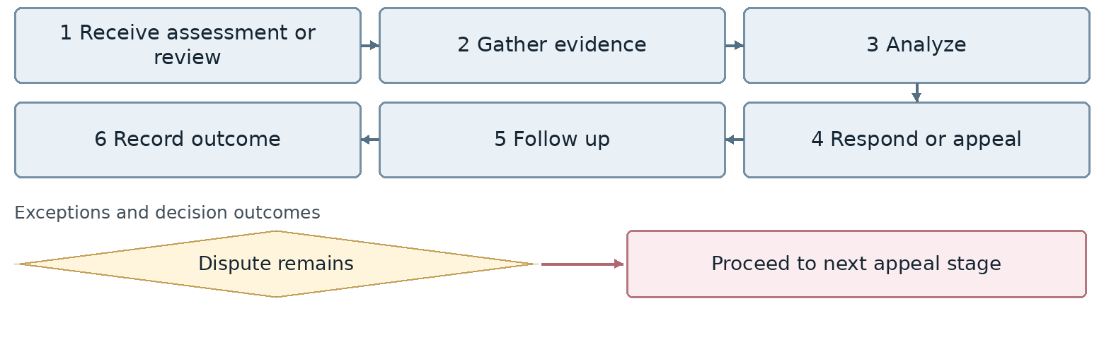
Confirm the connection point for any exception whose branch or return route is still undecided.
Outcome Resolved assessment case
Proposed owner Finance and Tax Officer. Interfaces: Legal, insurance and tax authorities.
Target requirement Link assessment evidence, disputed amount, response deadline and stage outcomes to the financial obligation.
Required data Case number, authority, amount, notice, deadline, response, outcome. Common tracking: record identifier, owner, status, date and attachments.
Decision required Who owns the response and legal approval? What authorizes escalation to the next appeal stage?
Reports and indicators Open cases, disputed amounts and outcomes.
Acceptance scenario A new notice creates a follow up deadline. Recording a response without a final outcome does not close the case.
Odoo review area Statutory reporting and integrations. Delivery approach remains open.
□ Standard □ Configuration □ Studio □ Development □ Integration □ Alternative or gap
Limitations and evidence: __________________________________________________
Action owner: _____________________ Due date: _____________________

52 Exchange rates and foreign currency transactions
FIN-52 | Business approval pending
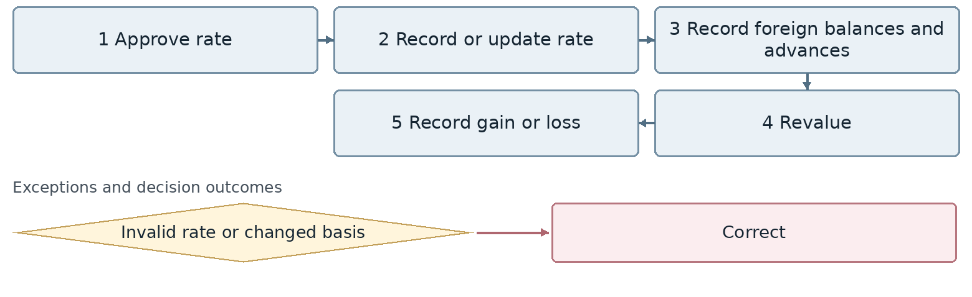
Confirm the connection point for any exception whose branch or return route is still undecided.
Outcome Correct foreign currency balances
Proposed owner Iran and International Finance. Interfaces: Commerce, Dubai office and Warehouse.
Target requirement Distinguish transaction rates, revaluation rules and approval authority from sales pricing rates. Retain effective dates.
Required data Currency, rate type, rate source, date, approver, foreign amount, local equivalent. Common tracking: record identifier, owner, status, date and attachments.
Decision required Is the rate announced by the Head of Sales also the accounting and revaluation rate, or are these separately approved?
Reports and indicators Rates, balances and exchange gains or losses.
Acceptance scenario A transaction and its settlement at different rates create a traceable difference. A new rate does not overwrite history.
Odoo review area Currencies, Purchase and Accounting. Delivery approach remains open.
□ Standard □ Configuration □ Studio □ Development □ Integration □ Alternative or gap
Limitations and evidence: __________________________________________________
Action owner: _____________________ Due date: _____________________

53 Foreign purchase payments and currency settlement
FIN-53 | Business approval pending
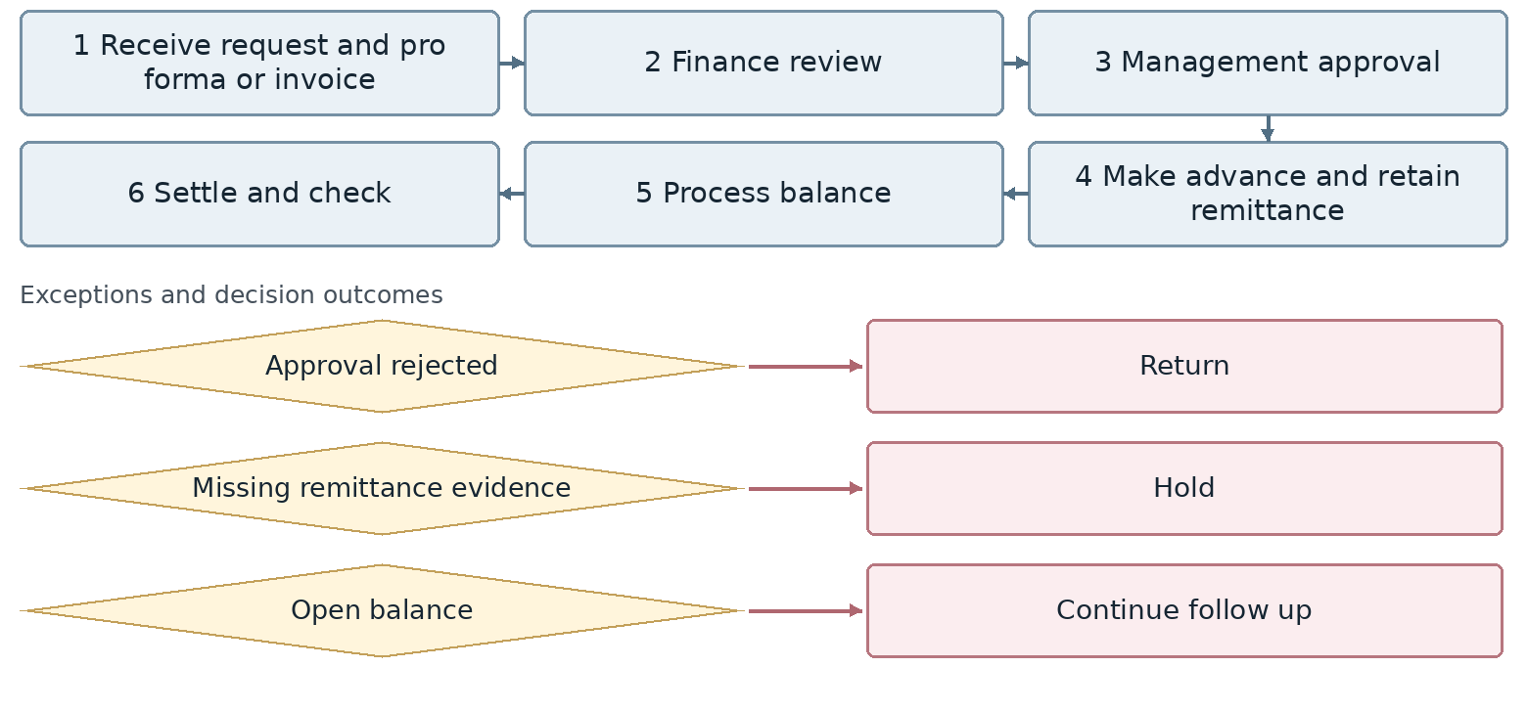
Confirm the connection point for any exception whose branch or return route is still undecided.
Outcome Updated foreign payment status for Commerce
Proposed owner Iran and International Finance. Interfaces: Commerce, Dubai office and Warehouse.
Target requirement Record advances and final payments in one purchase case with separate approvals, remittance evidence and Iran and international controls.
Required data Pro forma invoice, purchase, currency, installments, remittance evidence, shipment status, warehouse receipt. Common tracking: record identifier, owner, status, date and attachments.
Decision required What is the approved management route for the balance payment? Which payment and receipt checks are mandatory?
Reports and indicators Foreign payments, remittance evidence, balances and payment time.
Acceptance scenario Rejection returns to the prior stage. Advance and balance payments together do not exceed the authorized amount.
Odoo review area Currencies, Purchase and Accounting. Delivery approach remains open.
□ Standard □ Configuration □ Studio □ Development □ Integration □ Alternative or gap
Limitations and evidence: __________________________________________________
Action owner: _____________________ Due date: _____________________

54 Import case and foreign currency obligation reconciliation
FIN-54 | Business approval pending
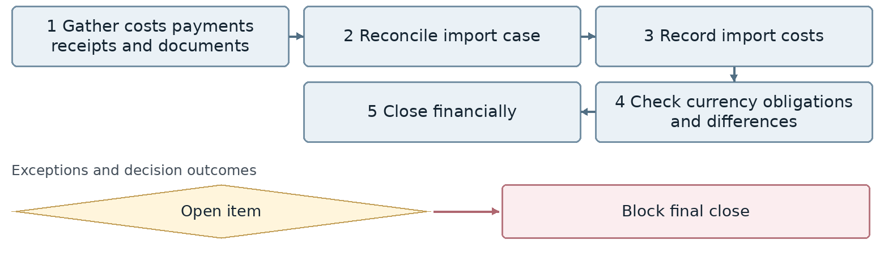
Confirm the connection point for any exception whose branch or return route is still undecided.
Outcome Settled import financial case
Proposed owner Iran and International Finance. Interfaces: Commerce, Dubai office and Warehouse.
Target requirement Reconcile payments, goods receipts, costs and currency obligation evidence in the import case. List all outstanding items.
Required data Import case, shipment, foreign payment, cost, receipt, outstanding obligation. Common tracking: record identifier, owner, status, date and attachments.
Decision required What evidence permits closure, and how will external systems be connected?
Reports and indicators Currency obligations, open cases and rate differences.
Acceptance scenario An open cost or obligation prevents final closure and has an assigned resolution owner.
Odoo review area Currencies, Purchase and Accounting. Delivery approach remains open.
□ Standard □ Configuration □ Studio □ Development □ Integration □ Alternative or gap
Limitations and evidence: __________________________________________________
Action owner: _____________________ Due date: _____________________

55 Financial statements and profitability reporting
FIN-55 | Business approval pending
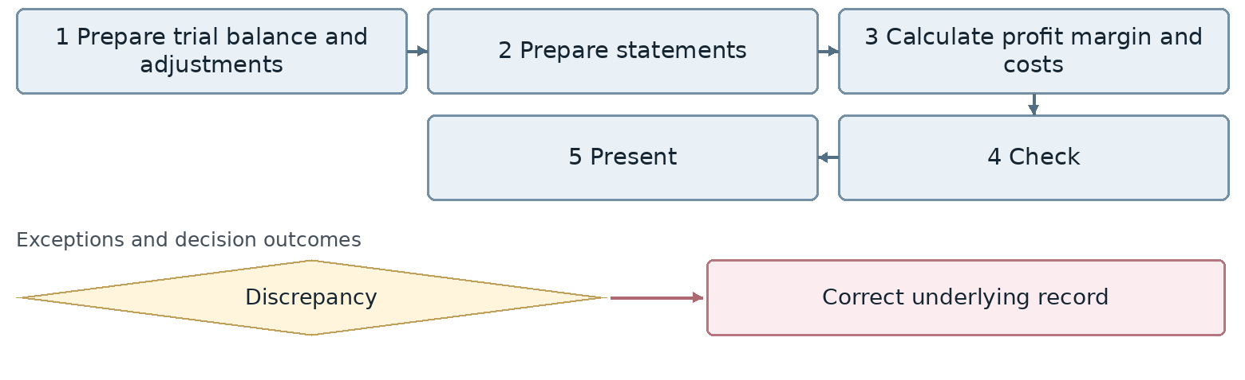
Confirm the connection point for any exception whose branch or return route is still undecided.
Outcome Reliable financial report
Proposed owner Management Accounting. Interfaces: Management, Business Intelligence and branches.
Target requirement Build financial reports from a reconcilable trial balance by company, branch and product, with drill down to transactions.
Required data Period, company, branch, account, product, revenue, cost, adjustments. Common tracking: record identifier, owner, status, date and attachments.
Decision required Which statement structure and margin formula does Finance approve? Which reports are statutory and which are managerial?
Reports and indicators Balance sheet, profit and loss, cash flow and margin.
Acceptance scenario Trace branch profit to invoices and product costs and reconcile report totals to the trial balance.
Odoo review area Financial reporting and Business Intelligence. Delivery approach remains open.
□ Standard □ Configuration □ Studio □ Development □ Integration □ Alternative or gap
Limitations and evidence: __________________________________________________
Action owner: _____________________ Due date: _____________________

56 Receivables payables liquidity and budget reports
FIN-56 | Business approval pending
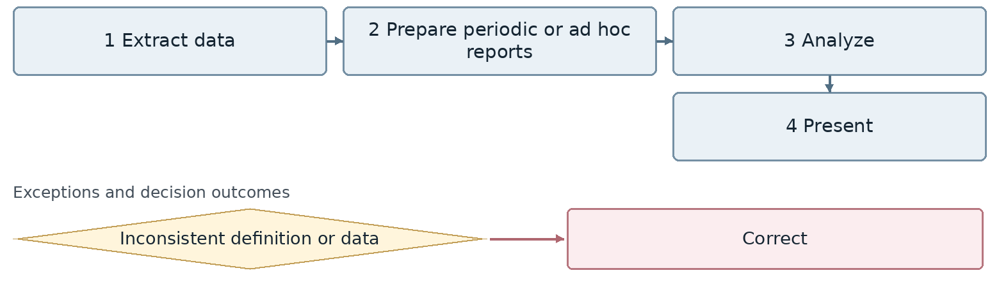
Confirm the connection point for any exception whose branch or return route is still undecided.
Outcome Management report
Proposed owner Management Accounting. Interfaces: Management, Business Intelligence and branches.
Target requirement Reconcile reports across Odoo, Sepidar and business intelligence using a common reporting date and definitions.
Required data Reporting date, balance, maturity, commitment, payment, budget, data owner. Common tracking: record identifier, owner, status, date and attachments.
Decision required Which system owns each indicator and what is the refresh frequency? How are actual liquidity and forecasts displayed separately?
Reports and indicators Receivables, payables, liquidity, budget, spending and currencies.
Acceptance scenario An actual payment changes cash and debt balances without consuming a commitment or budget twice.
Odoo review area Financial reporting and Business Intelligence. Delivery approach remains open.
□ Standard □ Configuration □ Studio □ Development □ Integration □ Alternative or gap
Limitations and evidence: __________________________________________________
Action owner: _____________________ Due date: _____________________

57 Branch company and ad hoc performance reports
FIN-57 | Business approval pending
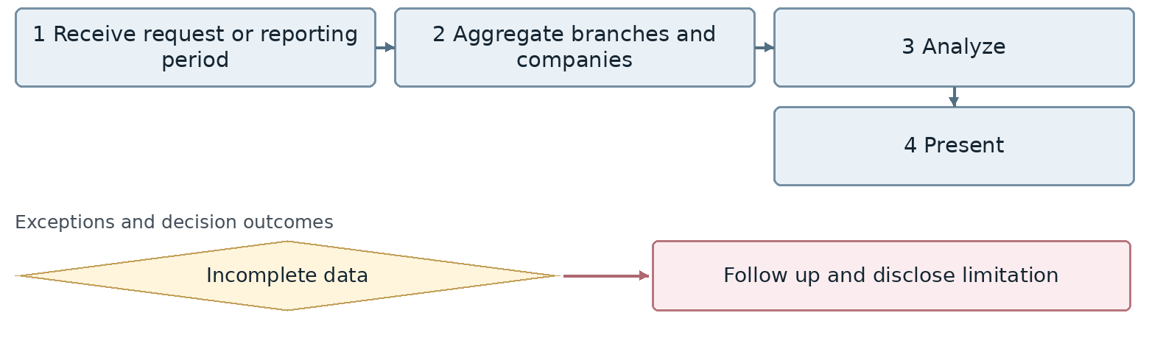
Confirm the connection point for any exception whose branch or return route is still undecided.
Outcome Performance or ad hoc report
Proposed owner Management Accounting. Interfaces: Management, Business Intelligence and branches.
Target requirement Set a clear legal scope for branch and company reporting and define aggregation and internal transaction elimination rules.
Required data Company, branch, currency, period, internal transaction, conversion rate, data owner. Common tracking: record identifier, owner, status, date and attachments.
Decision required Which offices are independent companies? Is management aggregation sufficient or are consolidated statements required?
Reports and indicators Branches, sales, collections and costs.
Acceptance scenario An internal transfer is not counted twice in group sales and missing branch data remains visible.
Odoo review area Financial reporting and Business Intelligence. Delivery approach remains open.
□ Standard □ Configuration □ Studio □ Development □ Integration □ Alternative or gap
Limitations and evidence: __________________________________________________
Action owner: _____________________ Due date: _____________________

58 Financial access authority and sensitive transactions
FIN-58 | Business approval pending
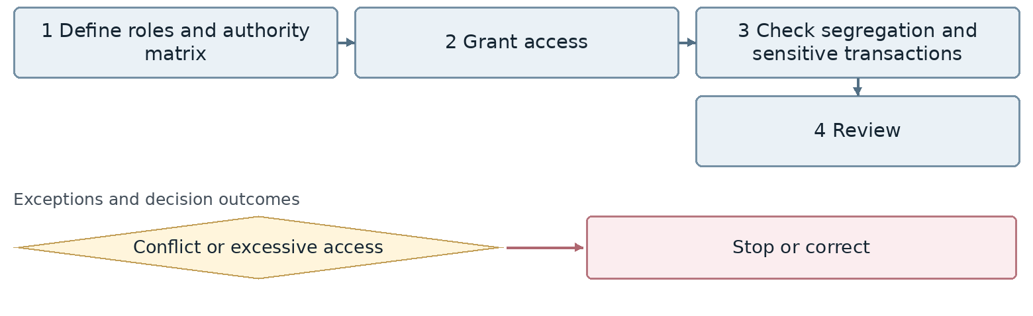
Confirm the connection point for any exception whose branch or return route is still undecided.
Outcome Valid financial access
Proposed owner Finance Manager. Interfaces: IT, Legal and auditors.
Target requirement Separate preparation, approval and payment permissions by company or branch. Retain a history of sensitive operations.
Required data Role, user, scope, authority limit, sensitive operation, access approval. Common tracking: record identifier, owner, status, date and attachments.
Decision required What compensating control permits an exception to segregation of duties in a small team?
Reports and indicators Authorities, access and exceptions.
Acceptance scenario A bank account editor cannot approve both their own change and its payment. Unauthorized attempts remain reviewable.
Odoo review area Access, Documents and Activities. Delivery approach remains open.
□ Standard □ Configuration □ Studio □ Development □ Integration □ Alternative or gap
Limitations and evidence: __________________________________________________
Action owner: _____________________ Due date: _____________________

59 Audit findings and corrective actions
FIN-59 | Business approval pending
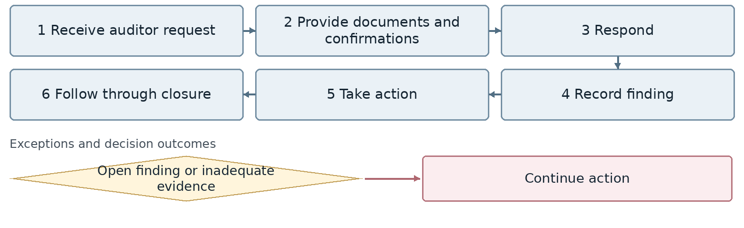
Confirm the connection point for any exception whose branch or return route is still undecided.
Outcome Audit case and evidence
Proposed owner Finance Manager. Interfaces: IT, Legal and auditors.
Target requirement Connect audit requests, submitted evidence, findings and corrective actions with owners and deadlines.
Required data Auditor, request, document reference, finding, severity, action, deadline. Common tracking: record identifier, owner, status, date and attachments.
Decision required Who approves finding closure and when does auditor access expire?
Reports and indicators Open findings, response time and actions.
Acceptance scenario Uploading a file alone does not close a finding. Require evidence of resolution and effectiveness approval.
Odoo review area Access, Documents and Activities. Delivery approach remains open.
□ Standard □ Configuration □ Studio □ Development □ Integration □ Alternative or gap
Limitations and evidence: __________________________________________________
Action owner: _____________________ Due date: _____________________

60 Financial management of nonemployment contracts
FIN-60 | Business approval pending
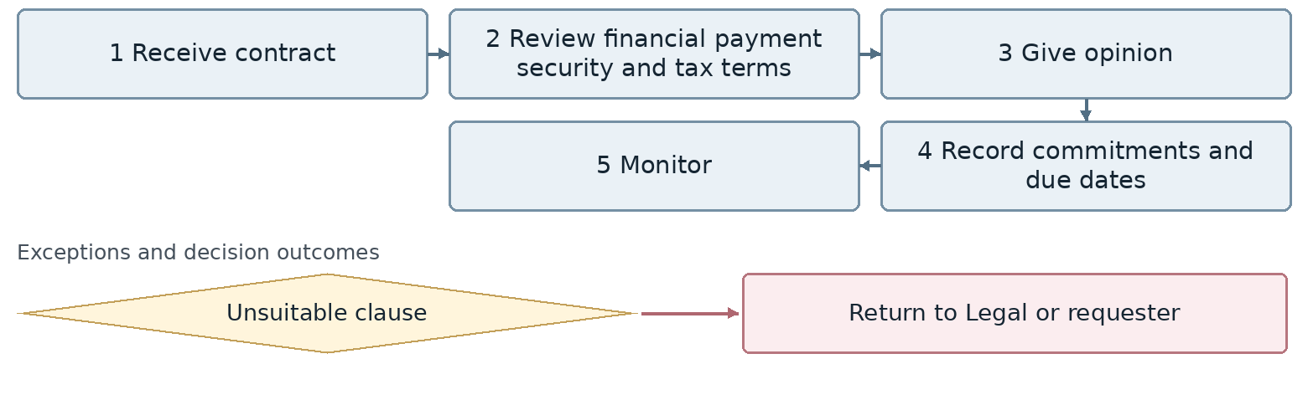
Confirm the connection point for any exception whose branch or return route is still undecided.
Outcome Contract with financial controls
Proposed owner Finance Manager. Interfaces: IT, Legal and auditors.
Target requirement Link financial commitments to payment dates, security and service acceptance. Version changes to financial clauses.
Required data Contract, counterparty, amount, tax, guarantee, due date, service acceptance. Common tracking: record identifier, owner, status, date and attachments.
Decision required Who resolves Finance and Legal disagreements? What authorizes payment before service delivery?
Reports and indicators Commitments, maturities and contractual payments.
Acceptance scenario Hold a service invoice without acceptance. A contract amendment has a traceable effect on the payment schedule.
Odoo review area Access, Documents and Activities. Delivery approach remains open.
□ Standard □ Configuration □ Studio □ Development □ Integration □ Alternative or gap
Limitations and evidence: __________________________________________________
Action owner: _____________________ Due date: _____________________

61 Financial document archiving and traceability
FIN-61 | Business approval pending
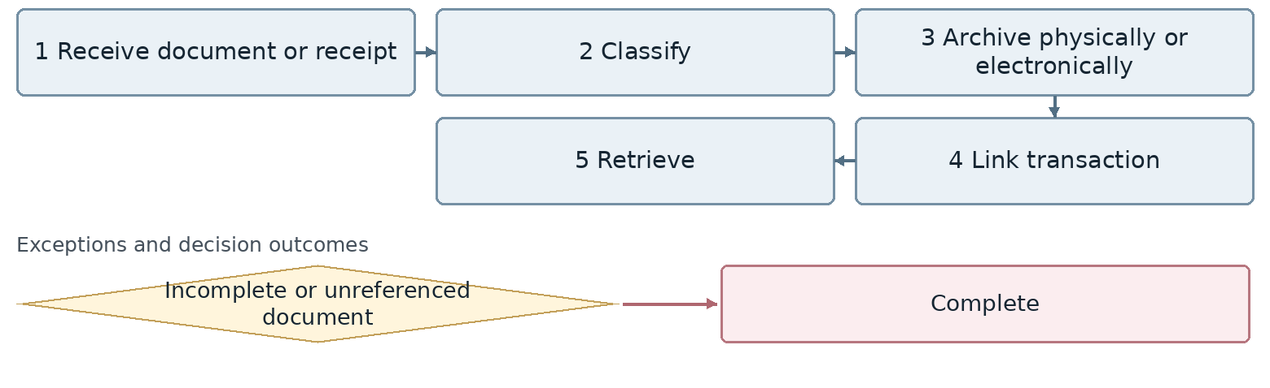
Confirm the connection point for any exception whose branch or return route is still undecided.
Outcome Traceable financial documents
Proposed owner Finance Manager. Interfaces: IT, Legal and auditors.
Target requirement Store documents with their transaction using event identifiers, classification, access levels and versions.
Required data Document identifier, type, period, owner, version, physical location, access. Common tracking: record identifier, owner, status, date and attachments.
Decision required What are the retention and access rules by document type? How are final versions distinguished from drafts?
Reports and indicators Incomplete documents and retrieval time.
Acceptance scenario Trace a payment to its receipt, authorization and journal entry. An unauthorized user cannot see confidential details.
Odoo review area Access, Documents and Activities. Delivery approach remains open.
□ Standard □ Configuration □ Studio □ Development □ Integration □ Alternative or gap
Limitations and evidence: __________________________________________________
Action owner: _____________________ Due date: _____________________

Solution decisions and acceptance evidence
The implementation team should state the delivery approach, scope, limitations, effort and cost for each requirement. Finance should approve the business rule and acceptance evidence before the design is closed.
Approach | Evidence to record
Standard | Demonstrate the complete scenario using the installed version and required permissions.
Configuration | Identify and test the required settings, rules and limits.
Studio | Specify field, form and workflow changes, licensing constraints and maintenance responsibilities.
Development | Record scope, tests, maintenance owner and upgrade cost.
Integration | Define the authoritative data, exchange method, schedule, errors, retries and reconciliation.
Alternative or gap | Document the alternative, remaining manual work and impact on the project decision.

Shared acceptance scenarios
Credit sale, check receipt, dishonor and order hold or release using one authoritative customer balance.
Foreign purchase with advance and final payment, partial goods receipt, late freight and import case settlement.
Test sample issue, return or consumption and conversion to an actual sale without premature revenue recognition.
Payroll with advance deductions, failed payment and employee exit settlement with an outstanding asset.
Interrupted integration and resubmission of the same transaction without duplicate posting or payment.
Attempted period close with a discrepancy, and unauthorized posting or reopening with a recorded control outcome.
Workshop decision: ___________________________________________________
Finance Manager approval: __________________ Odoo team: __________________

