Integrated Technical, Engineering, Quality & R&D Workflow Map
From technical request and customer application support through testing, product master data, quality, claims, technical content, R&D, and product release
Unified English working document — aligned with the Sales/CRM and Purchase/Inventory requirement packages

Scope: 26 technical, engineering, quality, R&D, and technical-content workflows for the Iran Odoo ERP workshop. Current-state facts, target requirements, exceptions, open decisions, reports, and demo evidence are kept inside each workflow.

Important boundary: items documented as current process facts are not assumed to be available in Odoo. Every target item must be classified and evidenced as Standard Odoo, Configuration, Odoo Studio, Custom Development, Integration, or Alternative / Not Supported.

Prepared for: Odoo implementation team and Karan Sa Industrial Group Technical, Engineering, Quality, Commercial, Sales/CRM, Warehouse, Finance, and Management owners
Document version: Unified technical package v4.0 | Review date: September 2026 | Workshop use: requirements validation and fit-gap decision
1. Architecture and cross-functional boundaries
The Technical unit is the Technical Solution Owner across the customer and product lifecycle. Technical records must not become a parallel database: requests, visits, offers, tests, drawings, product data, complaints, NCRs, claims, content, R&D, and release decisions must link to the same parent references used by Sales/CRM, Purchase, Inventory, Finance, and Quality.
Recommended parent-record chain
Customer 360 / Opportunity → Technical Request / Visit / Offer / Test → Sales Quotation / Sales Order → Purchase / Receipt / QC → Inventory / Delivery / Return → Invoice / Settlement → Complaint / Claim / Closure

Ownership and system boundaries
Record or activity | Primary owner | Required links / boundary
Customer request, Opportunity, follow-up, quotation, Sales Order | Sales / CRM / Call Center | Customer, Technical Request, Offer, test, purchase, delivery, collection, and closure
Technical specification, offer, visit, test, equivalency, drawing, product data | Technical / Engineering | Opportunity, Product Master, Sales Order, Purchase, Quality, and content
Foreign sourcing, supplier communication, import, commercial claim | Commercial / Purchase | Technical approval, supplier, Purchase Order, receipt, QC, claim, and landed-cost evidence
Receipt, quarantine, reservation, sample issue/return, delivery, stock movement | Warehouse / Inventory | Product, lot/serial, technical test, QC, Sales Order, Purchase, and branch/location
Invoice, payment, credit, valuation, financial recovery | Finance | Sales Order, Purchase, receipt, claim, settlement, and Odoo–Sepidar boundary

Common fit-gap rule
• No feature is treated as covered merely because a module name exists. The Odoo team must demonstrate the real scenario, confirm limitations, and record owner, due date, and acceptance evidence.
• Current system-of-record decisions remain open for Odoo versus Sepidar for invoices, stock vouchers, product coding, receivables, and financial postings; integration and reconciliation controls must be designed explicitly.
• External boundaries such as NTSW/customs, EPL, banks, carriers/forwarders, supplier portals, 3CX, and BI require status, document, reference, and failure-handling decisions.
• Access, audit trail, document versioning, restricted visibility, and approval evidence are mandatory controls across all workflows.
2. Process index
Phase A — Sales support, visits, and technical qualification
• 1. Technical Request and Priority / SLA
• 2. Customer Technical Visit Request
• 3. Technical Needs Assessment and Technical Offer
• 4. Production-line Visit and Solution Proposal
• 5. Customer Process Planning
Phase B — Tool testing and sample management
• 6. On-site Tool Test
• 7. Customer Test Report Receipt and Evaluation
• 8. Test Sample Request from ERP / Warehouse
Phase C — Order engineering and product master data
• 9. Technical Review of Standard Tool Order
• 10. Special Tool Engineering and Drawing Approval
• 11. Competitor Product Equivalency
• 12. Brand and Product Coding
• 13. Product Technical Master Data
Phase D — Incoming quality and after-sales technical service
• 14. Incoming Goods Quality Control
• 15. Incoming Goods Technical Nonconformity / NCR
• 16. Customer Complaint Technical Investigation
• 17. Product Failure and Supplier Claim
Phase E — Technical content and knowledge
• 18. Tech Sheet Preparation
• 19. Tech Guide Preparation
• 20. Technical Success Story
• 21. Technical Catalog Content
• 22. Website / Animation Technical Content
Phase F — New product R&D, feasibility, quality, and release
• 23. New Product R&D
• 24. New Product Manufacturing / Sourcing Feasibility
• 25. Initial Quality Test of New Product
• 26. Product Release to Sales
Phase A — Sales support, visits, and technical qualification
1. Technical Request and Priority / SLA
A shared technical case for requests originating from Sales, CRM, Commercial, Warehouse, or other processes, with visible priority, ownership, SLA, escalation, and closure.
Workflow route: Sales / CRM / Commercial / Warehouse request → topic and priority registration → assignment → technical action → response → closure or escalation

Process flowchart — translated English version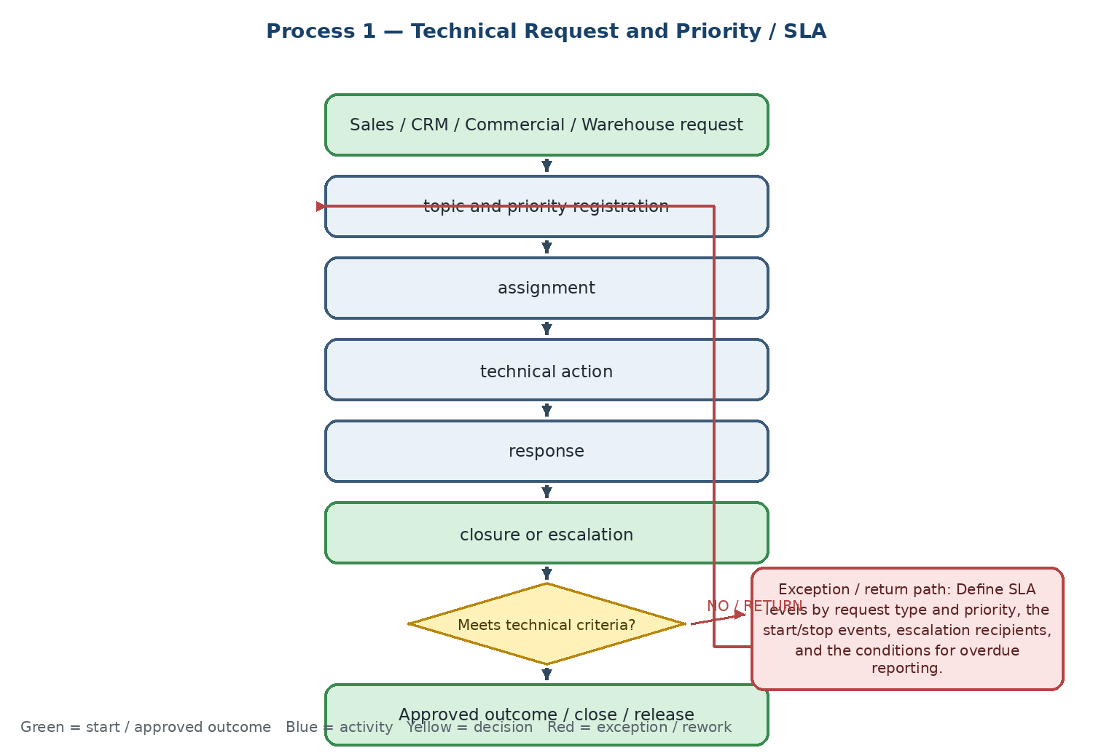

Current state and actual process facts
• Requests may originate from Sales, CRM, Commercial, Warehouse, or a linked Opportunity; the request must remain traceable to its source case.
• The current control is request registration, priority setting, assignment, action, response, and closure; incomplete requests are returned to the sender.
• Urgent or complex requests may require a senior engineer, a customer visit, or a tool test rather than a routine written response.
Target Odoo workflow and cross-functional integration
• Use Odoo Helpdesk or a controlled technical-request model embedded in the Opportunity and customer 360 record; configure request type, priority, owner, SLA, due date, files, and status history.
• The same case reference should connect the technical request to a visit, test, technical offer, quotation, purchase, delivery, complaint, or later claim without duplicate entry.
• Use activities, escalation notifications, and restricted visibility so Sales sees progress while technical detail remains controlled.
Exceptions, approvals, controls, and open decisions
• Define SLA levels by request type and priority, the start/stop events, escalation recipients, and the conditions for overdue reporting.
• Confirm the boundary between Call Center/CRM interaction tracking and the Technical Request record; one request must not create parallel ownership.
• Confirm which fields are mandatory before assignment and what evidence is required before closure.
Output, reports, KPIs, and workshop evidence
• Final output: answered and closed technical request linked to the parent Opportunity or service case
• KPIs: request volume by source and type, first-response time, average resolution time, overdue requests, and SLA deviation percentage
• Demo / evidence: create an incomplete request → return for completion → assign by priority → escalate an overdue request → attach the answer to the Opportunity
Workflow result — Coverage to confirm: □ Standard Odoo □ Configuration □ Odoo Studio □ Custom Development □ Integration □ Alternative / Not Supported | Gap: ........................................ | Action / Owner / Due: ........................................
2. Customer Technical Visit Request
A controlled decision process for deciding whether an on-site technical visit is required, then scheduling and recording the visit with Sales visibility.
Workflow route: Sales request → objective and information check → visit required? → Calendar / Field Service scheduling or remote technical response

Process flowchart — translated English version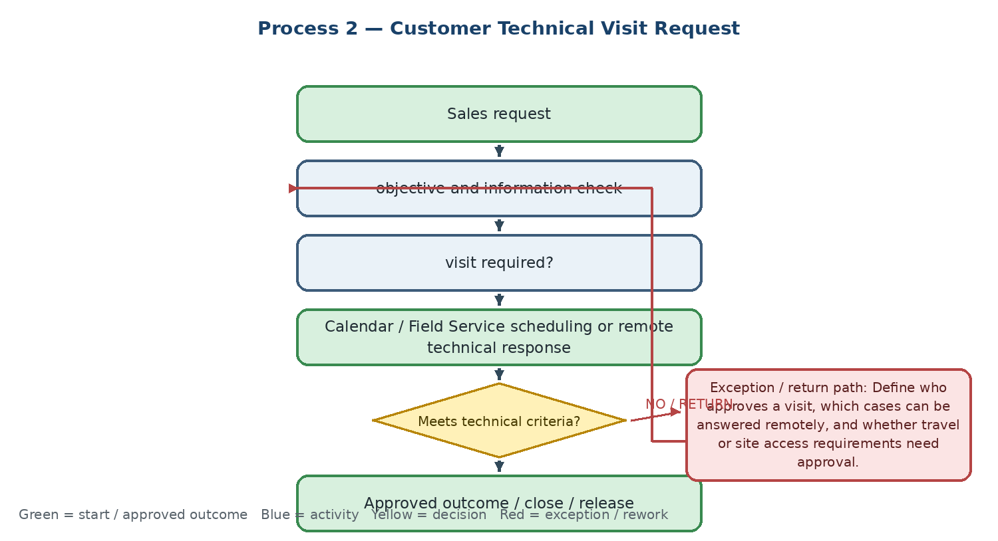

Current state and actual process facts
• Sales initiates a visit request and Technical checks the objective, customer information, location, and expected outcome.
• If information is insufficient, Sales completes the request; if a visit is unnecessary, Technical provides a remote response by phone or video conference.
• The final operational output is a scheduled visit in a shared calendar.
Target Odoo workflow and cross-functional integration
• Use Odoo Field Service and/or Calendar with a visit request linked to the customer, Opportunity, technical request, assigned engineer, location, expected duration, and visit objective.
• Record approval, rejection reason, rescheduling, cancellation, visit notes, photos, customer sign-off, and the follow-up activity in the same record.
• Return the visit result to Sales and preserve the link to any technical offer, test, quotation, or follow-up task.
Exceptions, approvals, controls, and open decisions
• Define who approves a visit, which cases can be answered remotely, and whether travel or site access requirements need approval.
• Confirm Field Service, Calendar, mobile, GPS, and electronic-signature requirements and the offline operating model.
• Define cancellation and rescheduling reasons and the SLA for communicating changes to Sales and the customer.
Output, reports, KPIs, and workshop evidence
• Final output: scheduled or completed Technical Visit record with result and follow-up action
• KPIs: visit requests, planning lead time, completed visits, cancellation/reschedule rate, and visit-to-solution conversion
• Demo / evidence: request a visit with missing data → return to Sales → approve and schedule → reschedule → complete the visit with a signed report
Workflow result — Coverage to confirm: □ Standard Odoo □ Configuration □ Odoo Studio □ Custom Development □ Integration □ Alternative / Not Supported | Gap: ........................................ | Action / Owner / Due: ........................................
3. Technical Needs Assessment and Technical Offer
Technical qualification of the customer application and preparation of a structured technical offer that can flow into Sales without re-entering data.
Workflow route: Machine / workpiece / current tool data → application analysis → product-basket match → technical solution → Technical Offer → Sales quotation

Process flowchart — translated English version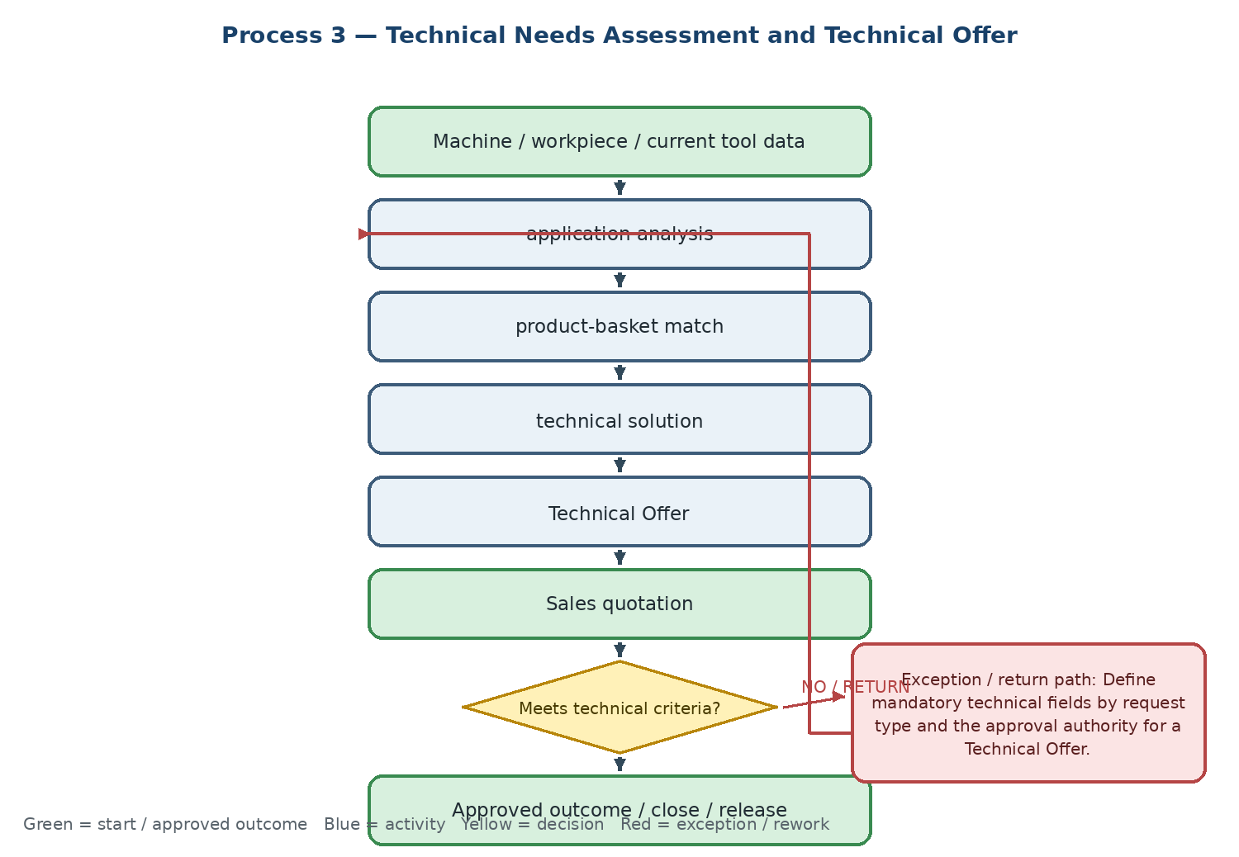

Current state and actual process facts
• The assessment captures the machine, workpiece, material, current tool, operating conditions, and the proposed product or solution.
• A standard solution is preferred; non-standard requirements are routed to equivalency, special-tool engineering, or a workshop test.
• The Technical Offer is the final technical output attached to the commercial Opportunity.
Target Odoo workflow and cross-functional integration
• Create structured technical fields on the Opportunity or a linked Technical Assessment model for machine, material, application, operating conditions, tool, and expected result.
• Store the Technical Offer as a controlled revision with technical approval and return the approved items, quantities, assumptions, and constraints to Sales for quotation.
• Do not duplicate customer or product data: the technical record must use the same customer, product master, and Opportunity references as Sales/CRM.
Exceptions, approvals, controls, and open decisions
• Define mandatory technical fields by request type and the approval authority for a Technical Offer.
• Confirm when the offer becomes part of the quotation and how revisions are handled after Sales or the customer changes the requirement.
• Define the rule for technical feasibility failure, alternative product proposal, test request, or special-tool route.
Output, reports, KPIs, and workshop evidence
• Final output: approved Technical Offer attached to the Opportunity and available for quotation
• KPIs: technical response time, offer-to-order conversion, offer revision count, and percentage of offers accepted on first submission
• Demo / evidence: complete a technical assessment → select a standard product → issue a revised offer → pass approved data to a Sales quotation without re-entry
Workflow result — Coverage to confirm: □ Standard Odoo □ Configuration □ Odoo Studio □ Custom Development □ Integration □ Alternative / Not Supported | Gap: ........................................ | Action / Owner / Due: ........................................
4. Production-line Visit and Solution Proposal
An on-site engineering activity for observing actual machining conditions, proposing a solution, and following the result until the customer problem is resolved.
Workflow route: Customer site visit → machine and process observation → problem and need capture → solution and parameters → visit report → technical follow-up

Process flowchart — translated English version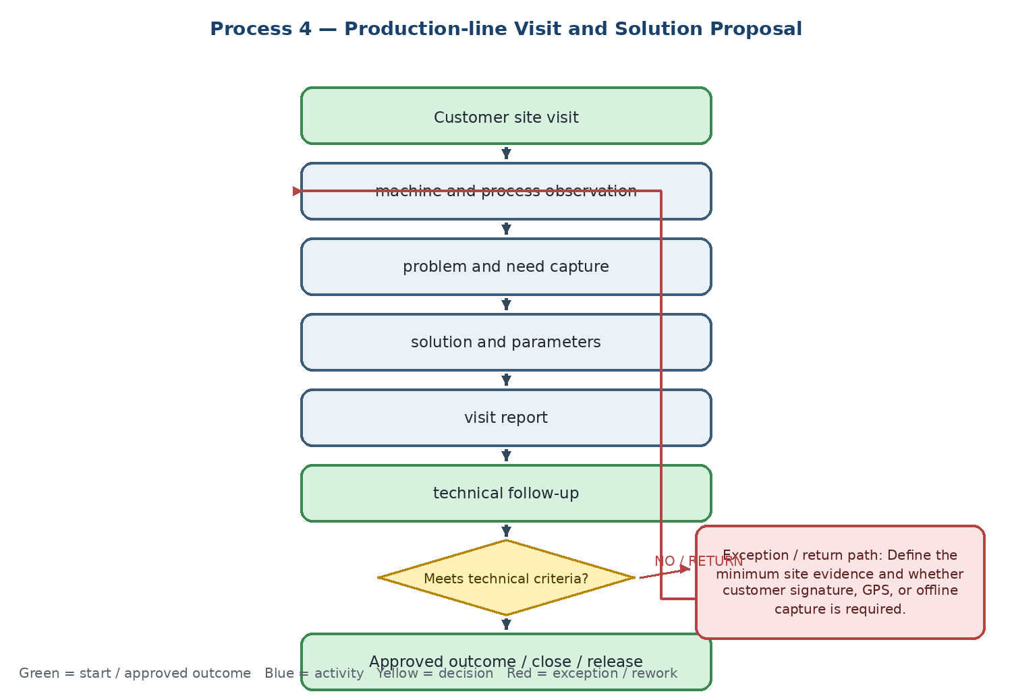

Current state and actual process facts
• Technical records machine conditions, the observed problem, workpiece and process information, and the proposed solution.
• If the solution is ineffective or low-performing, the case returns for data analysis, a senior-engineer review, a repeat visit, or a new tool test.
• The output is a formal Technical Visit Report linked to the customer record and the commercial case.
Target Odoo workflow and cross-functional integration
• Use Field Service/mobile forms for photos, operating conditions, measurements, tasks, customer acknowledgement, and follow-up actions.
• Link the report to the Customer, Opportunity, Technical Request, products, test, and later quotation or order; avoid storing the report as an isolated attachment.
• Create a follow-up task with owner and due date when the visit generates a test, a technical offer, a purchase request, or a customer action.
Exceptions, approvals, controls, and open decisions
• Define the minimum site evidence and whether customer signature, GPS, or offline capture is required.
• Set the acceptance criteria for an effective solution and the escalation path when the first solution fails.
• Confirm access permissions for customer confidential data, photos, and reports shared with Sales or the customer.
Output, reports, KPIs, and workshop evidence
• Final output: Technical Visit Report with proposed solution, evidence, owner, and follow-up status
• KPIs: visits completed, average time to resolve the customer issue, first-time solution effectiveness, and repeat-visit rate
• Demo / evidence: create a mobile visit → capture photos and parameters → issue a recommendation → mark ineffective → create a repeat visit and test action
Workflow result — Coverage to confirm: □ Standard Odoo □ Configuration □ Odoo Studio □ Custom Development □ Integration □ Alternative / Not Supported | Gap: ........................................ | Action / Owner / Due: ........................................
5. Customer Process Planning
Engineering design of the customer's machining process, including tools, fixtures, workpiece, material, and recommended cutting parameters, linked to the Opportunity.
Workflow route: Sales request → customer/site review → machine, fixture, workpiece, material and tooling analysis → Process Plan → sample test → technical approval → Sales quotation

Process flowchart — translated English version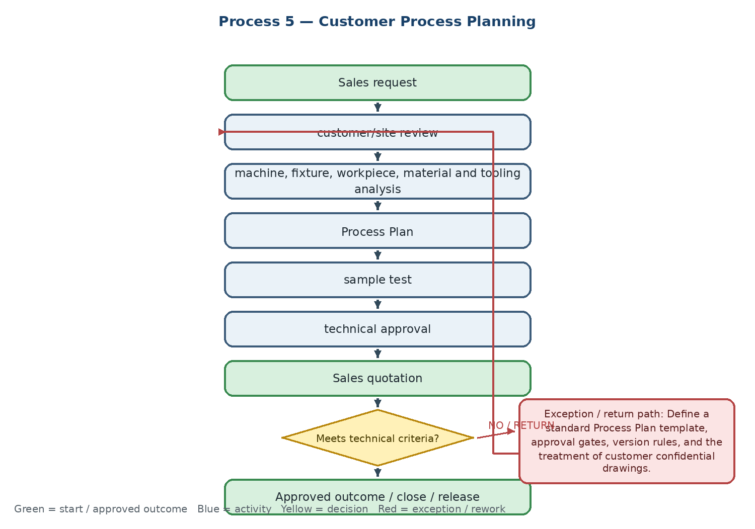

Current state and actual process facts
• The planning activity uses customer CNC machines, fixtures, workpiece, material, existing tools, and operating conditions as inputs.
• The engineer designs a process plan, recommended tool arrangement, fixtures, and cutting parameters, then prepares a document and sample for testing.
• Budget or machine limitations may require an alternative plan or temporary stop with Sales coordination.
Target Odoo workflow and cross-functional integration
• Create an Engineering Task or Project activity linked to the Opportunity and reuse the customer technical master data captured in CRM/Sales.
• Store the Process Plan, revisions, approvals, test result, and customer constraints in a controlled engineering document record.
• Make the approved plan available to Sales as a quotation attachment and to Technical, Warehouse, and Procurement for execution.
Exceptions, approvals, controls, and open decisions
• Define a standard Process Plan template, approval gates, version rules, and the treatment of customer confidential drawings.
• Confirm whether Process Planning is a CRM activity, Project task, or a dedicated Technical model in the target design.
• Define how a failed test, budget constraint, or alternative tool plan reopens the process.
Output, reports, KPIs, and workshop evidence
• Final output: approved Process Plan linked to the Opportunity and quotation
• KPIs: planning projects completed, average preparation time, test success rate against the plan, and revision count
• Demo / evidence: create a Process Plan from an Opportunity → assign engineering task → add drawing and parameters → approve → attach to quotation
Workflow result — Coverage to confirm: □ Standard Odoo □ Configuration □ Odoo Studio □ Custom Development □ Integration □ Alternative / Not Supported | Gap: ........................................ | Action / Owner / Due: ........................................
Phase B — Tool testing and sample management
6. On-site Tool Test
Execution and traceability of a tool test at the customer site or in a customer production environment, including sample availability and test result.
Workflow route: Test request → sample availability check → sample issue to engineer/customer → test execution → operating data and result capture

Process flowchart — translated English version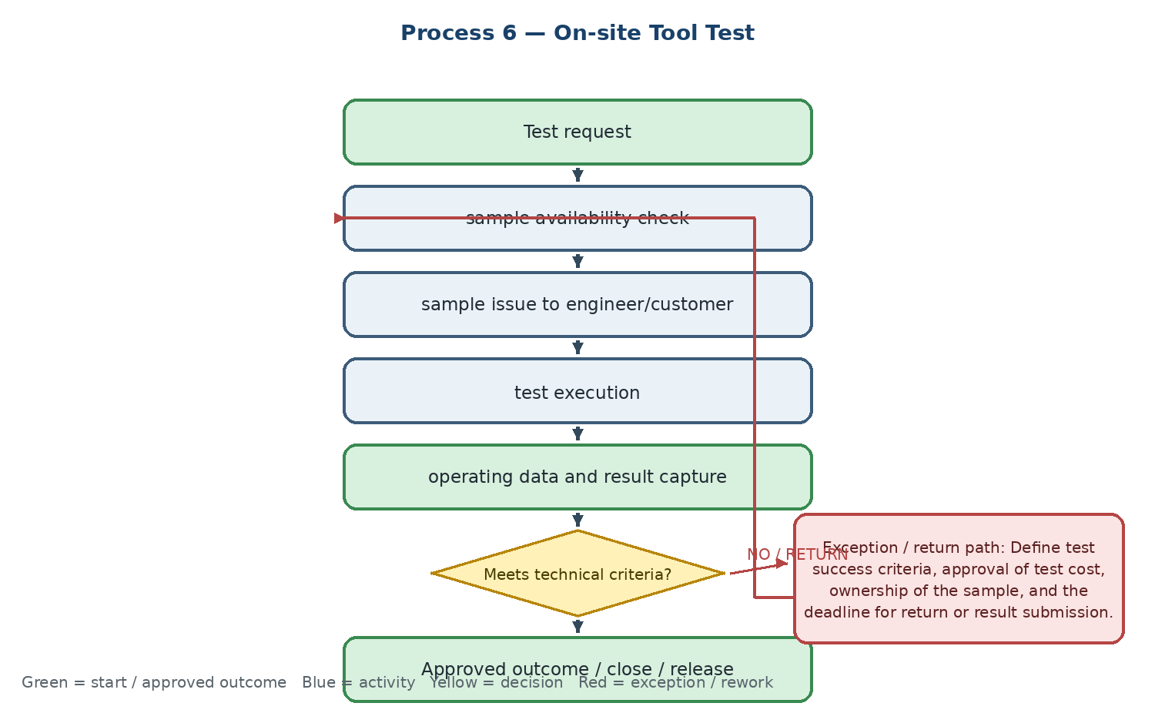

Current state and actual process facts
• The request is tied to a customer need and requires a decision on whether the test sample is available in the sample warehouse.
• If the tool is unavailable, a sample purchase or sourcing request is created; an unsuccessful test leads to changed parameters, another tool, or a repeat test.
• The final evidence is a formal Tool Test Report.
Target Odoo workflow and cross-functional integration
• Create a Test record from the Opportunity or Technical Request and link it to the sample product, stock reservation, issue/return, engineer, customer, and cost.
• Use Inventory operations for sample issue and return, and record test costs as a traceable marketing/engineering cost against the Opportunity or project.
• Store conditions, parameters, photos, result, customer acknowledgement, and next action in the test record.
Exceptions, approvals, controls, and open decisions
• Define test success criteria, approval of test cost, ownership of the sample, and the deadline for return or result submission.
• Confirm whether the test sample is reserved at quotation, Sales Order, or technical approval stage.
• Define the repeat-test route and when the case becomes a new purchase, a customer complaint, or a lost opportunity.
Output, reports, KPIs, and workshop evidence
• Final output: Tool Test Report with linked sample movement and commercial case
• KPIs: tests executed, success rate, test cycle time, repeat-test rate, and test-to-order conversion
• Demo / evidence: create a test request → reserve an available sample → issue/return the sample → record a failed result → create a repeat test
Workflow result — Coverage to confirm: □ Standard Odoo □ Configuration □ Odoo Studio □ Custom Development □ Integration □ Alternative / Not Supported | Gap: ........................................ | Action / Owner / Due: ........................................
7. Customer Test Report Receipt and Evaluation
A controlled review of a customer's test evidence so Technical can assess data sufficiency, issue a final opinion, and return the result to Sales.
Workflow route: Customer test → report received → completeness check → technical analysis → approved / rejected / more evidence requested → Sales update

Process flowchart — translated English version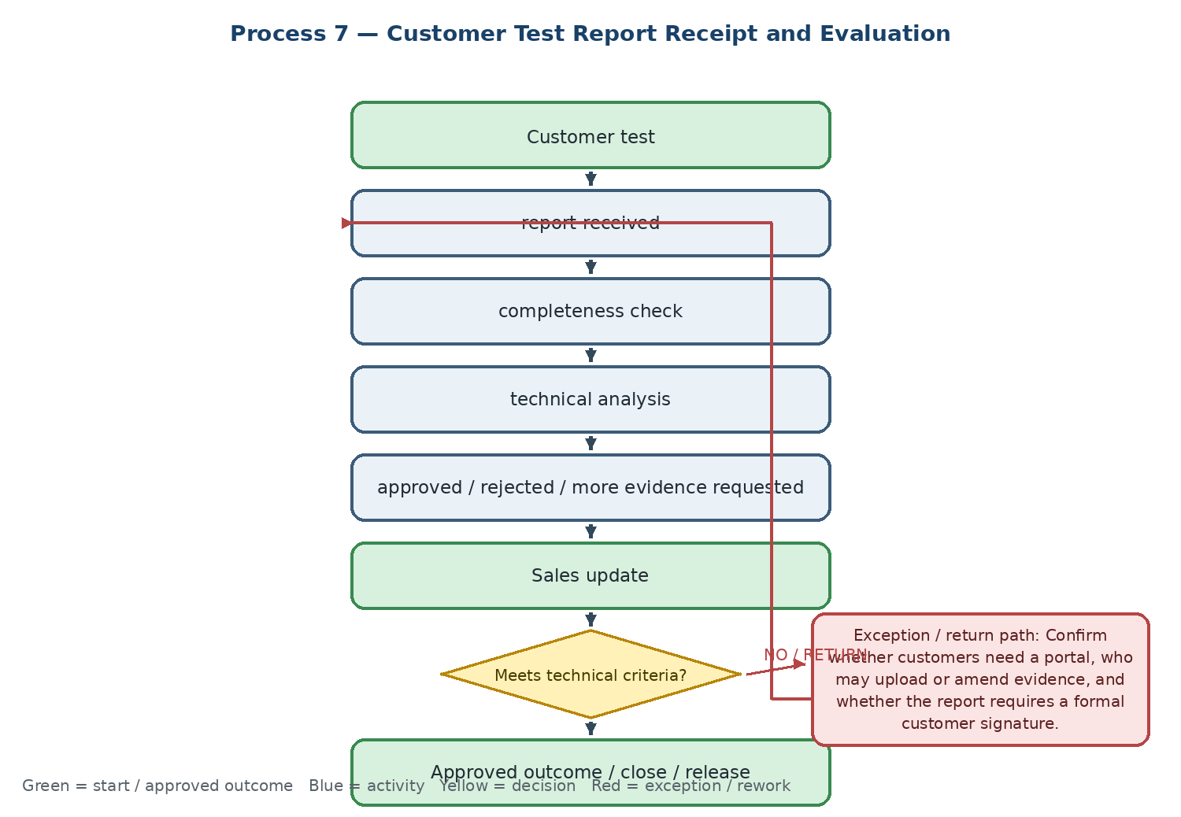

Current state and actual process facts
• The customer or technical contact submits the test result; Technical checks whether operating conditions, tool identity, result measures, and evidence are sufficient.
• Incomplete reports return to the customer for additional information or a supervised repeat test.
• The output is a technical opinion and confirmation of tool performance.
Target Odoo workflow and cross-functional integration
• Use a portal upload or controlled email-to-case route only if justified; otherwise create an internal Test Report activity linked to the customer and Opportunity.
• Configure a completeness checklist, reviewer assignment, decision status, comments, attachments, and a controlled return path.
• Publish the final technical decision to Sales while limiting customer-sensitive or engineering-only information.
Exceptions, approvals, controls, and open decisions
• Confirm whether customers need a portal, who may upload or amend evidence, and whether the report requires a formal customer signature.
• Define minimum evidence and the difference between rejected performance, incomplete evidence, and test not applicable.
• Set the SLA for Technical review after report receipt and escalation for overdue customer information.
Output, reports, KPIs, and workshop evidence
• Final output: approved or rejected customer Test Report with final technical opinion
• KPIs: incomplete-report rate, review time, test approval/rejection rate, and repeat-test rate
• Demo / evidence: upload an incomplete report → request missing data → receive the completed report → approve → show the status on the Sales case
Workflow result — Coverage to confirm: □ Standard Odoo □ Configuration □ Odoo Studio □ Custom Development □ Integration □ Alternative / Not Supported | Gap: ........................................ | Action / Owner / Due: ........................................
8. Test Sample Request from ERP / Warehouse
Supply, issue, return, and final-status tracking for test samples that are not currently available in stock, including consignment or customer-held samples.
Workflow route: Sample unavailable → sample request → purchase / foreign sourcing → receipt into sample location → issue to customer → return or final result

Process flowchart — translated English version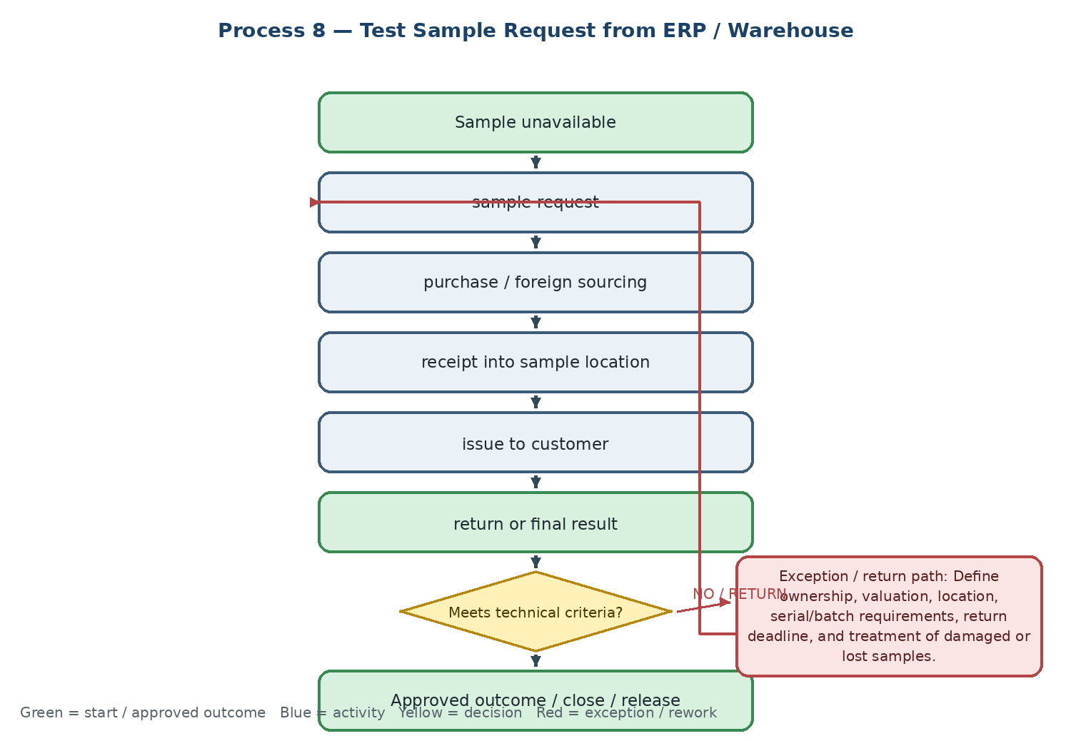

Current state and actual process facts
• The request starts from a Technical or Sales case and may require domestic purchase, foreign sourcing, or management approval before the test can start.
• The sample is received into a sample/consignment location, issued through a warehouse voucher, delivered to the customer, and later returned or converted into a final test result.
• The sample must remain traceable by product, quantity, serial/batch where applicable, owner, customer, and status.
Target Odoo workflow and cross-functional integration
• Use Purchase and Inventory with a dedicated Sample / Customer Consignment location or ownership model; retain ownership and valuation until the final disposition.
• Link the purchase, receipt, sample issue, return, damage/loss, and final outcome to the same Test and Opportunity reference.
• Use automated reminders for sample due date, return, overdue result, and unresolved customer-held stock.
Exceptions, approvals, controls, and open decisions
• Define ownership, valuation, location, serial/batch requirements, return deadline, and treatment of damaged or lost samples.
• Define who approves the sample purchase and how the sample cost is allocated to the Opportunity or campaign.
• Confirm whether consignment functionality is sufficient or a custom sample-status model is required.
Output, reports, KPIs, and workshop evidence
• Final output: physically issued test sample with complete stock, ownership, and test-case traceability
• KPIs: samples awaiting supply, issued sample vouchers, average supply time, overdue customer-held samples, and sample loss rate
• Demo / evidence: request an unavailable sample → create purchase → receive into sample location → issue to customer → return or mark final disposition
Workflow result — Coverage to confirm: □ Standard Odoo □ Configuration □ Odoo Studio □ Custom Development □ Integration □ Alternative / Not Supported | Gap: ........................................ | Action / Owner / Due: ........................................
Phase C — Order engineering and product master data
9. Technical Review of Standard Tool Order
A technical gate that validates product identity, code, and specification before a standard tool order is released to Commercial, Procurement, or the supplier.
Workflow route: Customer request / purchase order → product and specification check → technical approval → Commercial / Purchase release or correction

Process flowchart — translated English version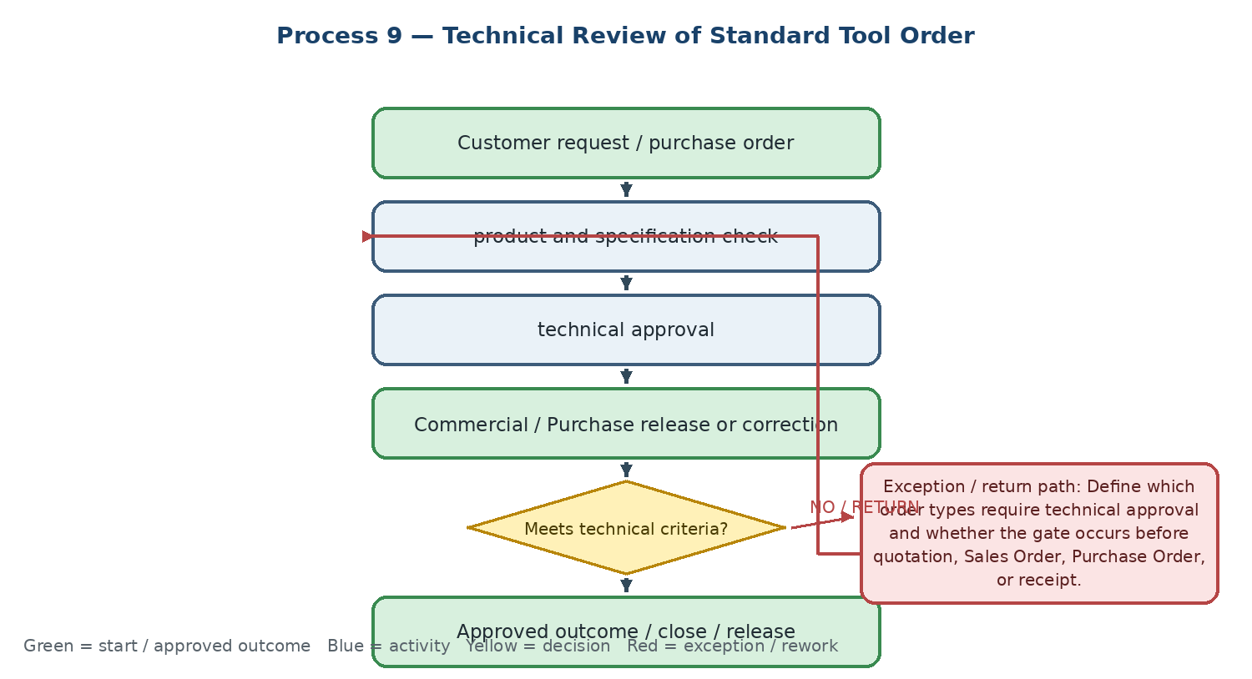

Current state and actual process facts
• Technical compares the requested item with the product basket, approved coding, dimensions, and specifications.
• Technical mismatch returns the request for correction or an alternative; invalid product codes route to the coding process.
• The final evidence is a technical approval in the purchase or order workbasket.
Target Odoo workflow and cross-functional integration
• Use the Product Technical Master as the controlled reference and expose the relevant specification fields in Sales, Purchase, and Inventory documents.
• Add a technical approval gate only where required by product class, customer application, foreign order, or risk; avoid blocking routine items without a defined business rule.
• Link approval, request revision, supplier order, receipt, and any later NCR to the same product and reference.
Exceptions, approvals, controls, and open decisions
• Define which order types require technical approval and whether the gate occurs before quotation, Sales Order, Purchase Order, or receipt.
• Define the release authority, approval evidence, and behavior when the product master is incomplete or obsolete.
• Confirm Odoo/Sepidar system-of-record boundaries for product code, order, invoice, and warehouse voucher.
Output, reports, KPIs, and workshop evidence
• Final output: technical approval or correction request for standard order items
• KPIs: first-pass approval rate, technical review cycle time, correction rate, and orders blocked by master-data issues
• Demo / evidence: submit an order with an invalid code → return for correction → approve a valid item → release the linked purchase/order
Workflow result — Coverage to confirm: □ Standard Odoo □ Configuration □ Odoo Studio □ Custom Development □ Integration □ Alternative / Not Supported | Gap: ........................................ | Action / Owner / Due: ........................................
10. Special Tool Engineering and Drawing Approval
Engineering control of special-tool requirements, supplier drawings, revisions, customer changes, and final approval before production or purchase release.
Workflow route: Special-tool request → Technical Sheet → Commercial / supplier request → supplier drawing → revision review → approved drawing → build / order release

Process flowchart — translated English version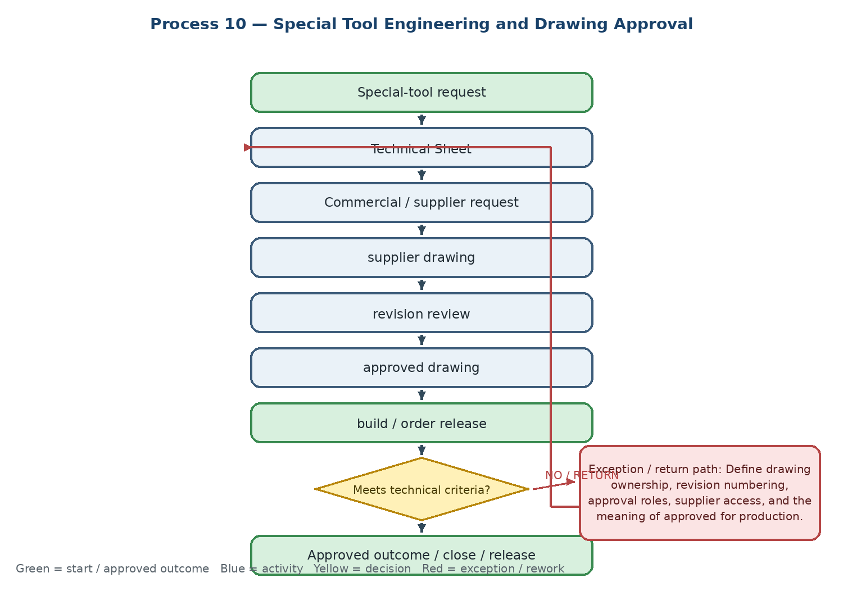

Current state and actual process facts
• The requirement is documented and sent through Commercial to the foreign or domestic supplier; supplier drawings and technical proposals are returned for review.
• Nonconforming drawings return to the supplier; a customer change creates a new revision and may reopen the full process.
• The final output is a stamped and approved engineering drawing and specification.
Target Odoo workflow and cross-functional integration
• Use Odoo Documents and/or PLM/ECO for controlled drawings, revision history, approval status, and linkage to the Opportunity, Purchase Order, project, and product.
• Store supplier communication and drawing evidence on the same case and prevent order release until the required revision is approved.
• Separate draft, under review, approved, rejected, obsolete, and superseded versions with restricted access.
Exceptions, approvals, controls, and open decisions
• Define drawing ownership, revision numbering, approval roles, supplier access, and the meaning of approved for production.
• Confirm whether PLM/ECO or Documents plus a controlled approval workflow is the target solution.
• Define how customer changes affect quotation, purchase, lead time, price, and prior revisions.
Output, reports, KPIs, and workshop evidence
• Final output: approved special-tool drawing and technical specification with revision history
• KPIs: open special-tool designs, revisions per drawing, approval cycle time, and supplier rework rate
• Demo / evidence: create a special-tool request → receive drawing V1 → reject with reason → receive V2 → approve → release the linked purchase
Workflow result — Coverage to confirm: □ Standard Odoo □ Configuration □ Odoo Studio □ Custom Development □ Integration □ Alternative / Not Supported | Gap: ........................................ | Action / Owner / Due: ........................................
11. Competitor Product Equivalency
Technical identification and approval of equivalent Karan Sa products for competitor codes, with test and qualification evidence where a direct match is not available.
Workflow route: Competitor code → technical attributes and dimensional extraction → product-basket comparison → equivalency level → optional test → approved equivalency record

Process flowchart — translated English version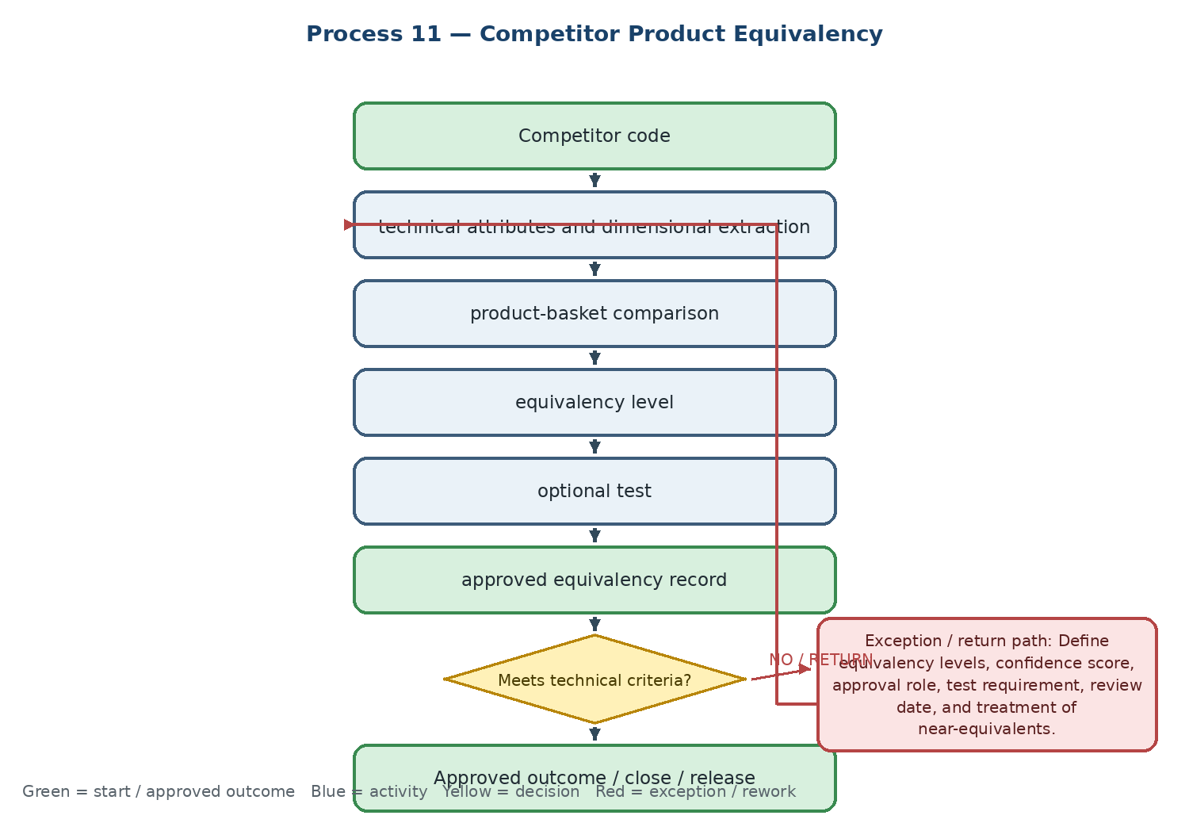

Current state and actual process facts
• Technical extracts the competitor product's technical and dimensional attributes and compares them with the company product basket.
• If no exact match exists, the closest alternative is proposed with differences, test requirements, or a special-tool route.
• The approved equivalency must be searchable by Sales and linked to the product master.
Target Odoo workflow and cross-functional integration
• Use Product Attributes or a dedicated equivalency model with competitor brand/code, internal code, equivalency level, technical differences, validity, approver, and evidence.
• Expose approved equivalencies in Sales search and quotation while preventing unapproved substitutions from being used as confirmed product matches.
• Link the equivalency to tests, technical offers, customer applications, and later complaints or claims.
Exceptions, approvals, controls, and open decisions
• Define equivalency levels, confidence score, approval role, test requirement, review date, and treatment of near-equivalents.
• Decide whether competitor codes are maintained as product aliases, attributes, or a separate controlled model.
• Define who can publish, edit, or retire an equivalency record.
Output, reports, KPIs, and workshop evidence
• Final output: approved and searchable competitor-to-internal equivalency record
• KPIs: equivalencies created, first-test success rate, response time, and equivalencies later rejected or revised
• Demo / evidence: search a competitor code in Sales → show approved internal alternatives → select a near-equivalent → trigger required test and approval
Workflow result — Coverage to confirm: □ Standard Odoo □ Configuration □ Odoo Studio □ Custom Development □ Integration □ Alternative / Not Supported | Gap: ........................................ | Action / Owner / Due: ........................................
12. Brand and Product Coding
Controlled creation of brand and product codes from technical parameters, including duplicate prevention, review, activation, and ownership of the master record.
Workflow route: New brand / tool → technical parameters → code-template check → coding proposal → senior technical approval → ERP activation

Process flowchart — translated English version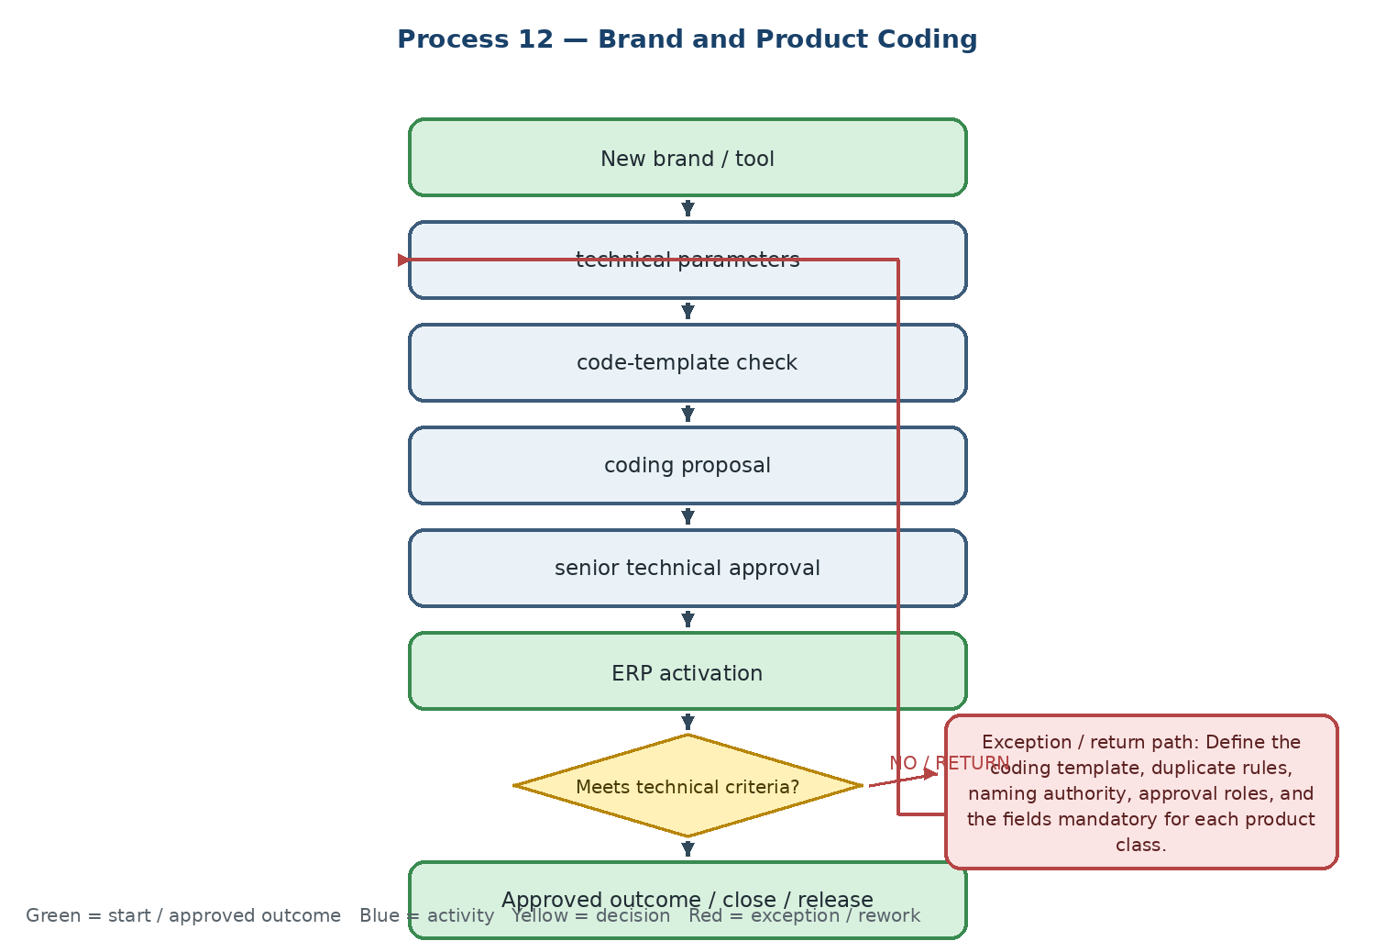

Current state and actual process facts
• Technical proposes a code using technical parameters, naming rules, and the approved product structure.
• Duplicate or rejected codes return to parameter review and revision before final registration.
• The output is an active ERP item with standardized code and technical identity.
Target Odoo workflow and cross-functional integration
• Use Product Templates, Variants, Attributes, Categories, and a controlled product-creation request with duplicate checks and approval status.
• Keep technical coding, commercial purchasing data, warehouse data, and financial valuation as related views of one product master rather than separate codes.
• Block Sales/Purchase activation until required technical, commercial, and warehouse fields are complete.
Exceptions, approvals, controls, and open decisions
• Define the coding template, duplicate rules, naming authority, approval roles, and the fields mandatory for each product class.
• Confirm how existing codes migrate from Sepidar and how legacy/obsolete codes are retained for history.
• Define whether product activation is a technical decision, a master-data decision, or a release gate.
Output, reports, KPIs, and workshop evidence
• Final output: active standardized product code and master record in the ERP
• KPIs: new codes created, coding error rate, duplicate attempts, and activation lead time
• Demo / evidence: submit a new-product coding request → detect duplicate → correct proposal → approve → activate the product for controlled use
Workflow result — Coverage to confirm: □ Standard Odoo □ Configuration □ Odoo Studio □ Custom Development □ Integration □ Alternative / Not Supported | Gap: ........................................ | Action / Owner / Due: ........................................
13. Product Technical Master Data
Creation and maintenance of the structured technical profile that supports Sales, Inventory, Website, Catalog, Equivalency, Quality, and customer service.
Workflow route: New product → technical and application data collection → structured field entry → review and approval → ongoing revision

Process flowchart — translated English version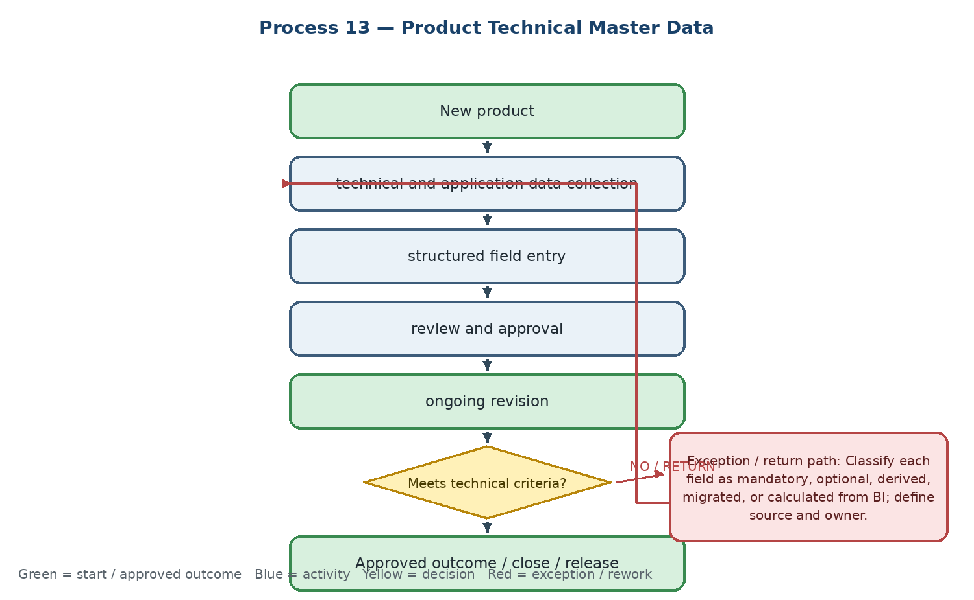

Current state and actual process facts
• The technical record includes specifications, application, machinable materials, operating conditions, dimensions, drawings, and other product evidence.
• Incomplete or conflicting information is researched in supplier catalogs or through supplier correspondence before approval.
• The technical master is the source for customer-facing content and warehouse/product identification.
Target Odoo workflow and cross-functional integration
• Use structured Product Attributes and controlled technical fields on the product master, with versioned documents, source references, reviewer, and last-review date.
• Expose only approved and role-appropriate fields to Sales, Website/eCommerce, Warehouse, Quality, and the customer portal.
• Use change history and document links so a technical revision can trigger review of catalog, Tech Sheet, web content, equivalency, and release status.
Exceptions, approvals, controls, and open decisions
• Classify each field as mandatory, optional, derived, migrated, or calculated from BI; define source and owner.
• Confirm the system of record for product attributes between Odoo, Sepidar, Website, and BI.
• Define periodic review, obsolete-data treatment, translation requirements, and approval evidence.
Output, reports, KPIs, and workshop evidence
• Final output: complete and approved Product Technical Master Record
• KPIs: technical-master completeness, stale or incomplete records, review compliance, and time to resolve data defects
• Demo / evidence: open a product with incomplete technical fields → route to owner → attach supplier evidence → approve → show controlled fields in Sales and Inventory
Workflow result — Coverage to confirm: □ Standard Odoo □ Configuration □ Odoo Studio □ Custom Development □ Integration □ Alternative / Not Supported | Gap: ........................................ | Action / Owner / Due: ........................................
Phase D — Incoming quality and after-sales technical service
14. Incoming Goods Quality Control
Inspection, disposition, quarantine, and release of incoming products in coordination with Warehouse and Commercial/Purchase.
Workflow route: Warehouse announces receipt → sampling by checklist and packing list → physical and specification inspection → accept / conditional accept / reject → notify Warehouse and Commercial

Process flowchart — translated English version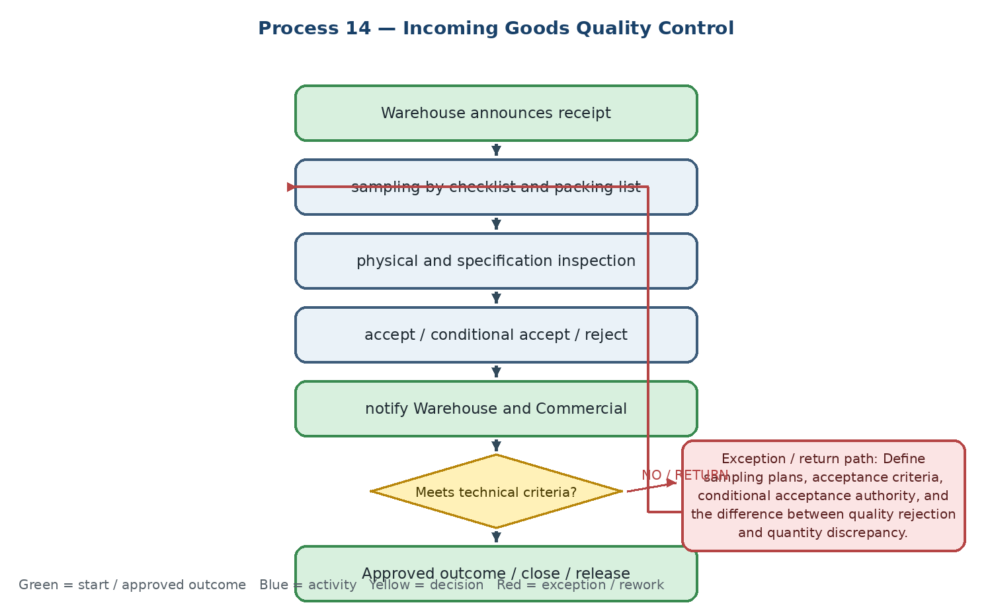

Current state and actual process facts
• Technical/QC checks brand, dimensions, quantity, packing list, and product specifications against the received shipment.
• Nonconforming goods move to quarantine and an NCR is raised; conditional acceptance requires defined management authorization.
• The final output is a QC Release or Rejection document that controls subsequent warehouse availability.
Target Odoo workflow and cross-functional integration
• Use Odoo Quality Control Points and Quality Checks on receiving operations, linked to Purchase Order, shipment, product, batch/lot/serial, and receipt.
• Use quarantine locations and controlled disposition statuses so Warehouse cannot release rejected stock without an approved decision.
• Return the QC result to Commercial/Purchase and preserve evidence for supplier claim, replacement, credit, or corrective action.
Exceptions, approvals, controls, and open decisions
• Define sampling plans, acceptance criteria, conditional acceptance authority, and the difference between quality rejection and quantity discrepancy.
• Confirm whether Quality Control is fully in Odoo or whether Sepidar remains the warehouse/invoice system of record during transition.
• Define hold propagation to other branches or stock lots when a systemic defect is found.
Output, reports, KPIs, and workshop evidence
• Final output: QC Release, Conditional Acceptance, or Rejection disposition linked to receipt
• KPIs: incoming-lot acceptance rate, inspection cycle time, NCR count, conditional-acceptance rate, and quarantine aging
• Demo / evidence: receive a shipment → trigger QC checklist → fail a dimension check → move to quarantine → approve disposition → release or reject stock
Workflow result — Coverage to confirm: □ Standard Odoo □ Configuration □ Odoo Studio □ Custom Development □ Integration □ Alternative / Not Supported | Gap: ........................................ | Action / Owner / Due: ........................................
15. Incoming Goods Technical Nonconformity / NCR
Formal recording, root-cause analysis, containment, and handoff of technical nonconformities to Commercial for supplier claim or replacement.
Workflow route: Defect detected → defect, quantity, evidence and photos recorded → technical root-cause analysis → NCR issued → Commercial supplier claim / corrective action

Process flowchart — translated English version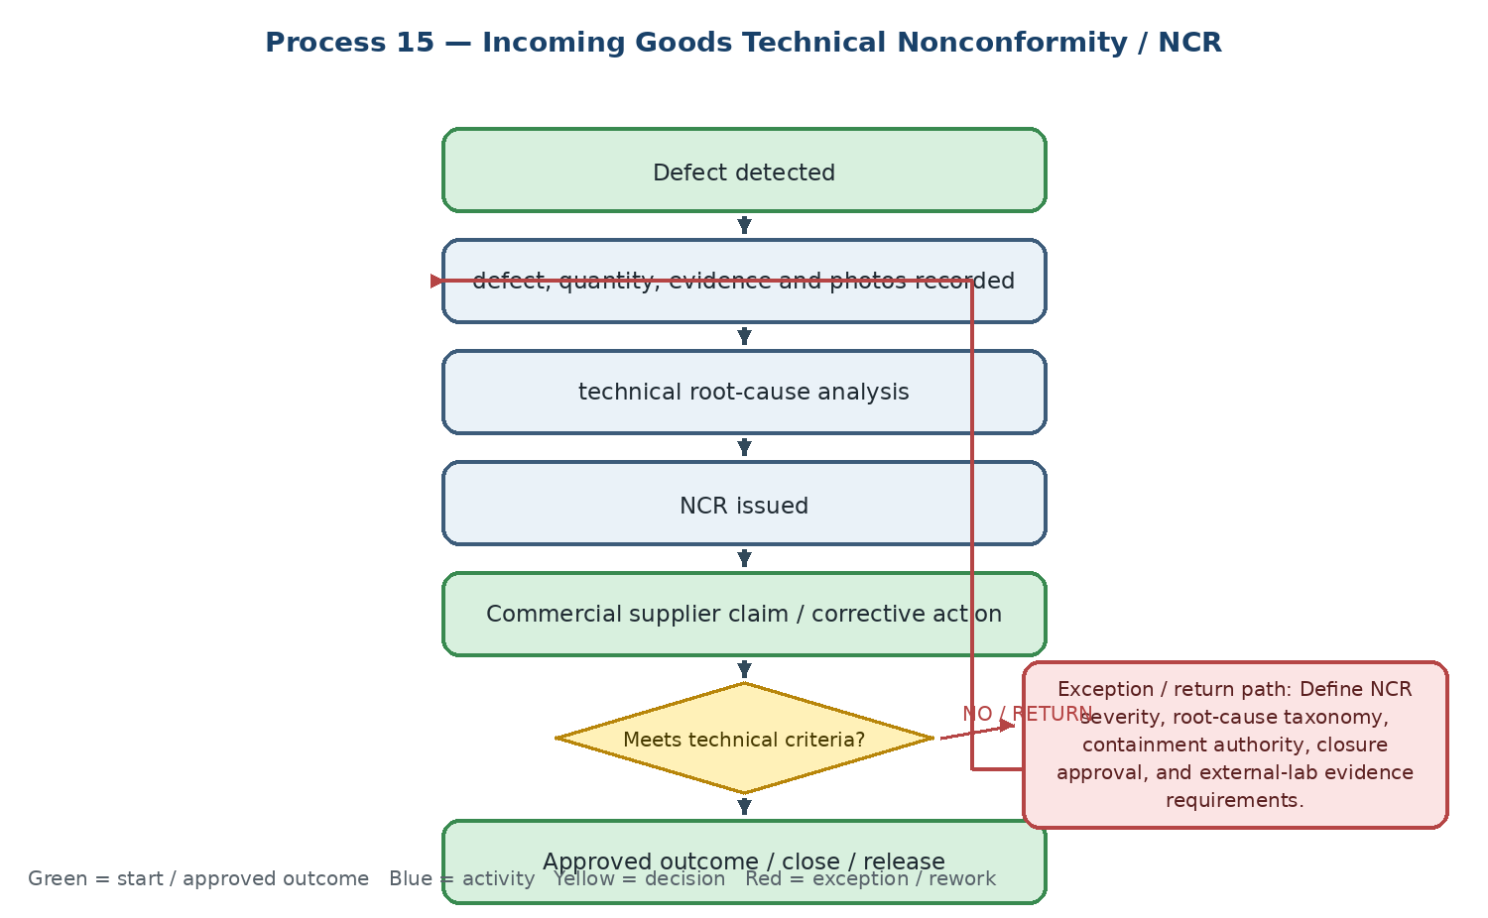

Current state and actual process facts
• NCR evidence includes defect type, quantity, affected product, photos, documents, and the receiving context.
• If the defect may affect other stock, similar items across warehouses are placed on hold; ambiguous defects may require external laboratory analysis.
• The technical NCR is sent to Commercial to pursue supplier claim, replacement, credit, or other disposition.
Target Odoo workflow and cross-functional integration
• Use Quality Alerts or a controlled NCR model linked to the receipt, Purchase Order, supplier, product, batch/serial, quarantine location, and supplier claim.
• Provide containment, root-cause category, corrective action, responsible owner, due date, evidence, and closure approval.
• Allow a systemic issue to trigger hold or review of related stock across branches, with restricted visibility and full audit trail.
Exceptions, approvals, controls, and open decisions
• Define NCR severity, root-cause taxonomy, containment authority, closure approval, and external-lab evidence requirements.
• Define the handoff and status link between Technical NCR and Commercial Supplier Claim; avoid duplicate cases.
• Confirm whether financial recovery, replacement, or debit/credit treatment is recorded in Odoo, Sepidar, or both.
Output, reports, KPIs, and workshop evidence
• Final output: closed NCR with root cause, containment, disposition, supplier action, and evidence
• KPIs: open NCRs, closure cycle time, root-cause distribution, repeat defects, and supplier response time
• Demo / evidence: raise NCR from a receipt → quarantine affected stock → create supplier claim → record corrective action → approve closure
Workflow result — Coverage to confirm: □ Standard Odoo □ Configuration □ Odoo Studio □ Custom Development □ Integration □ Alternative / Not Supported | Gap: ........................................ | Action / Owner / Due: ........................................
16. Customer Complaint Technical Investigation
Technical investigation of a complaint received through CRM, Sales, or Call Center, including information sufficiency, RCA, and the route to correction or supplier claim.
Workflow route: CRM complaint case → information and usage check → visit required? → technical analysis and RCA → corrective advice / supplier claim / closure

Process flowchart — translated English version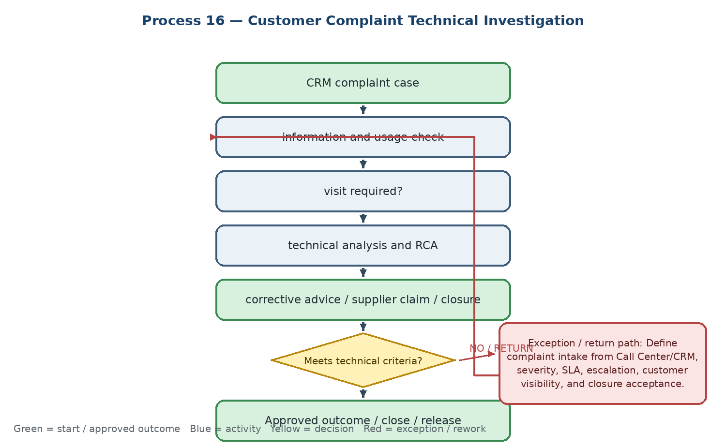

Current state and actual process facts
• The complaint must include customer, product, application, operating conditions, symptoms, evidence, and the original sale or delivery context.
• Incomplete information returns to the customer-facing owner; user error may result in corrective guidance, while inherent product failure routes to Supplier Claim.
• The output is an investigation report with diagnosis and recommended handling path.
Target Odoo workflow and cross-functional integration
• Use Helpdesk/Claims or a complaint model linked to Customer, Opportunity/Sales Order, delivery, product, batch/serial, test, NCR, and supplier claim.
• Record SLA, evidence, RCA, visit/test tasks, customer communication, corrective action, and final satisfaction or acceptance.
• Make status and next action visible to Sales/CRM while restricting internal RCA and supplier information by role.
Exceptions, approvals, controls, and open decisions
• Define complaint intake from Call Center/CRM, severity, SLA, escalation, customer visibility, and closure acceptance.
• Define standardized RCA categories and the handoff criteria to NCR, Supplier Claim, warranty, replacement, or user training.
• Confirm which customer, delivery, and financial fields are visible to Technical and which remain restricted.
Output, reports, KPIs, and workshop evidence
• Final output: Technical Complaint Investigation Report with diagnosis and disposition path
• KPIs: complaint volume, first response, resolution time, repeat complaint rate, RCA distribution, and customer satisfaction
• Demo / evidence: create complaint from a CRM case → request missing evidence → assign technical investigation → create supplier claim → close with customer-visible response
Workflow result — Coverage to confirm: □ Standard Odoo □ Configuration □ Odoo Studio □ Custom Development □ Integration □ Alternative / Not Supported | Gap: ........................................ | Action / Owner / Due: ........................................
17. Product Failure and Supplier Claim
Resolution of inherent product failure through evidence, supplier communication, replacement or financial recovery, and final customer validation.
Workflow route: Inherent defect confirmed → technical evidence → Commercial supplier claim → supplier decision → replacement / credit / compensation → functional retest → closure

Process flowchart — translated English version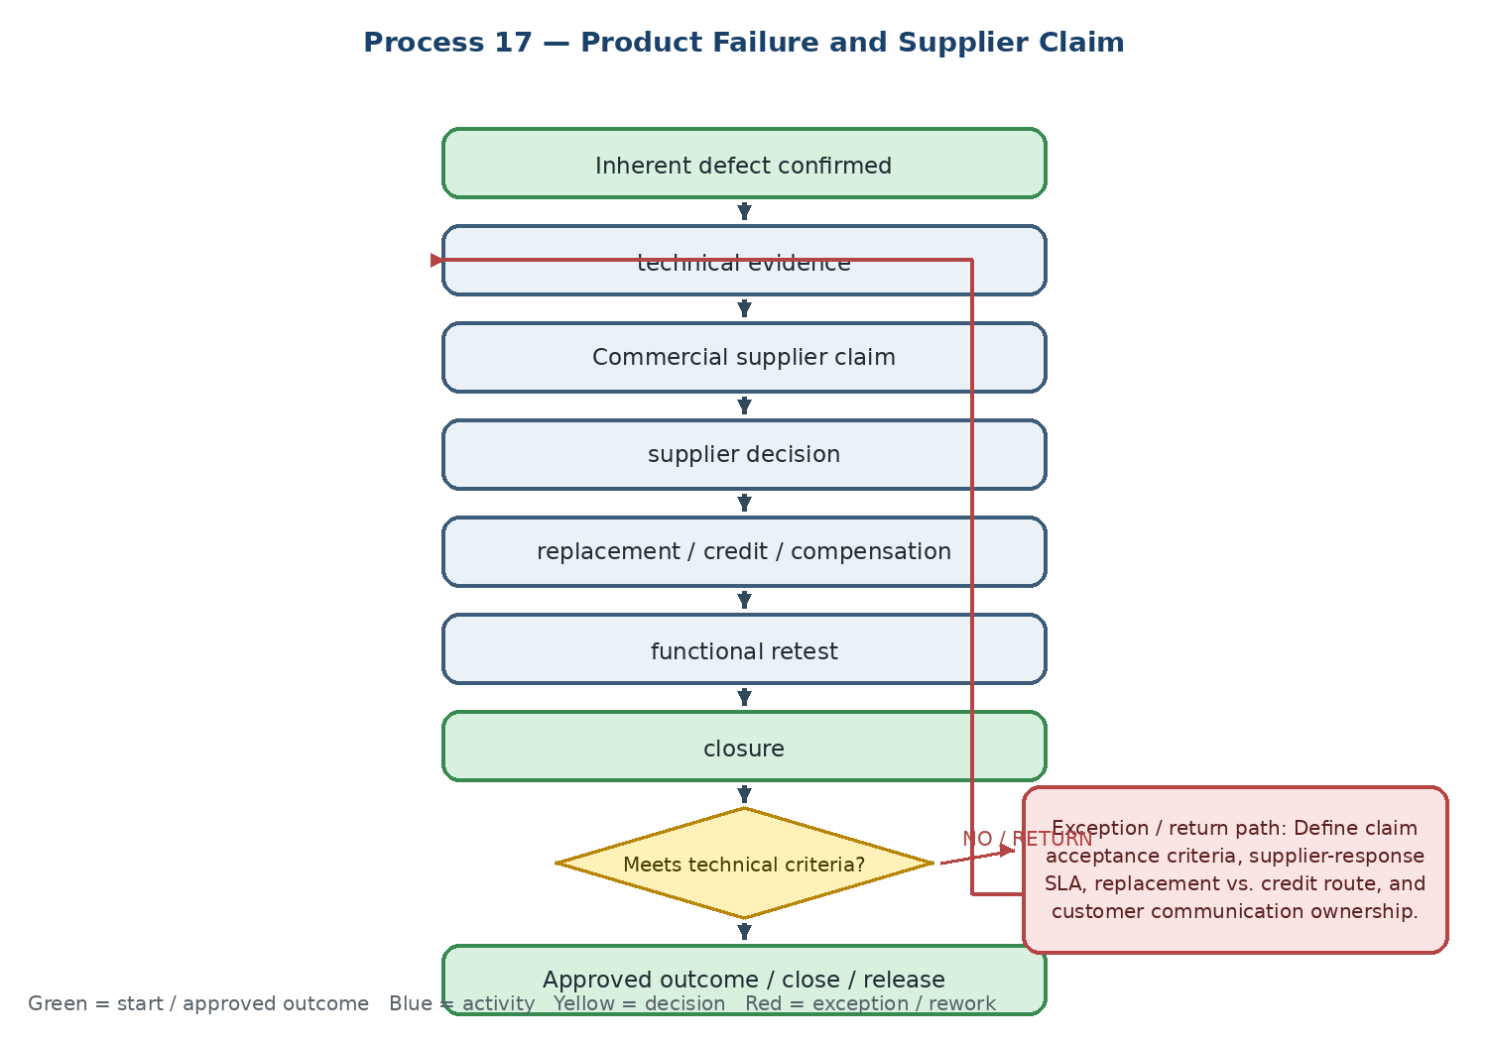

Current state and actual process facts
• Technical proves the defect, prepares supporting evidence, and communicates with the supplier through Commercial.
• The supplier may send a replacement, provide financial compensation, or reject the claim; an unsuccessful replacement reopens deeper investigation.
• The final case must connect the complaint, product, original purchase, replacement, financial treatment, and customer result.
Target Odoo workflow and cross-functional integration
• Link Helpdesk/Claims, Quality, Purchase, receipt, product, batch/serial, replacement delivery, and credit/financial adjustment to one claim reference.
• Track supplier response, commitment, due date, replacement logistics, retest, customer acceptance, and closure approval.
• Preserve the financial system-of-record decision and integrate or reconcile replacement value, credit, or debit with Sepidar/Odoo Finance.
Exceptions, approvals, controls, and open decisions
• Define claim acceptance criteria, supplier-response SLA, replacement vs. credit route, and customer communication ownership.
• Define how a second failure reopens the claim and when laboratory or engineering analysis is required.
• Decide how the financial value of replacement or compensation is posted and reconciled.
Output, reports, KPIs, and workshop evidence
• Final output: closed Supplier Claim with evidence, supplier disposition, customer validation, and financial treatment
• KPIs: open claims, claim cycle time, recovered value, repeat failure rate, and supplier response time
• Demo / evidence: confirm inherent defect → open supplier claim from complaint → record replacement → retest → close after customer acceptance
Workflow result — Coverage to confirm: □ Standard Odoo □ Configuration □ Odoo Studio □ Custom Development □ Integration □ Alternative / Not Supported | Gap: ........................................ | Action / Owner / Due: ........................................
Phase E — Technical content and knowledge
18. Tech Sheet Preparation
Controlled preparation, review, approval, revision, and publication of a product Tech Sheet from approved technical master data.
Workflow route: Technical data collection → dimensional and cutting tables → drawings and graphics → draft Tech Sheet → senior review → approved PDF

Process flowchart — translated English version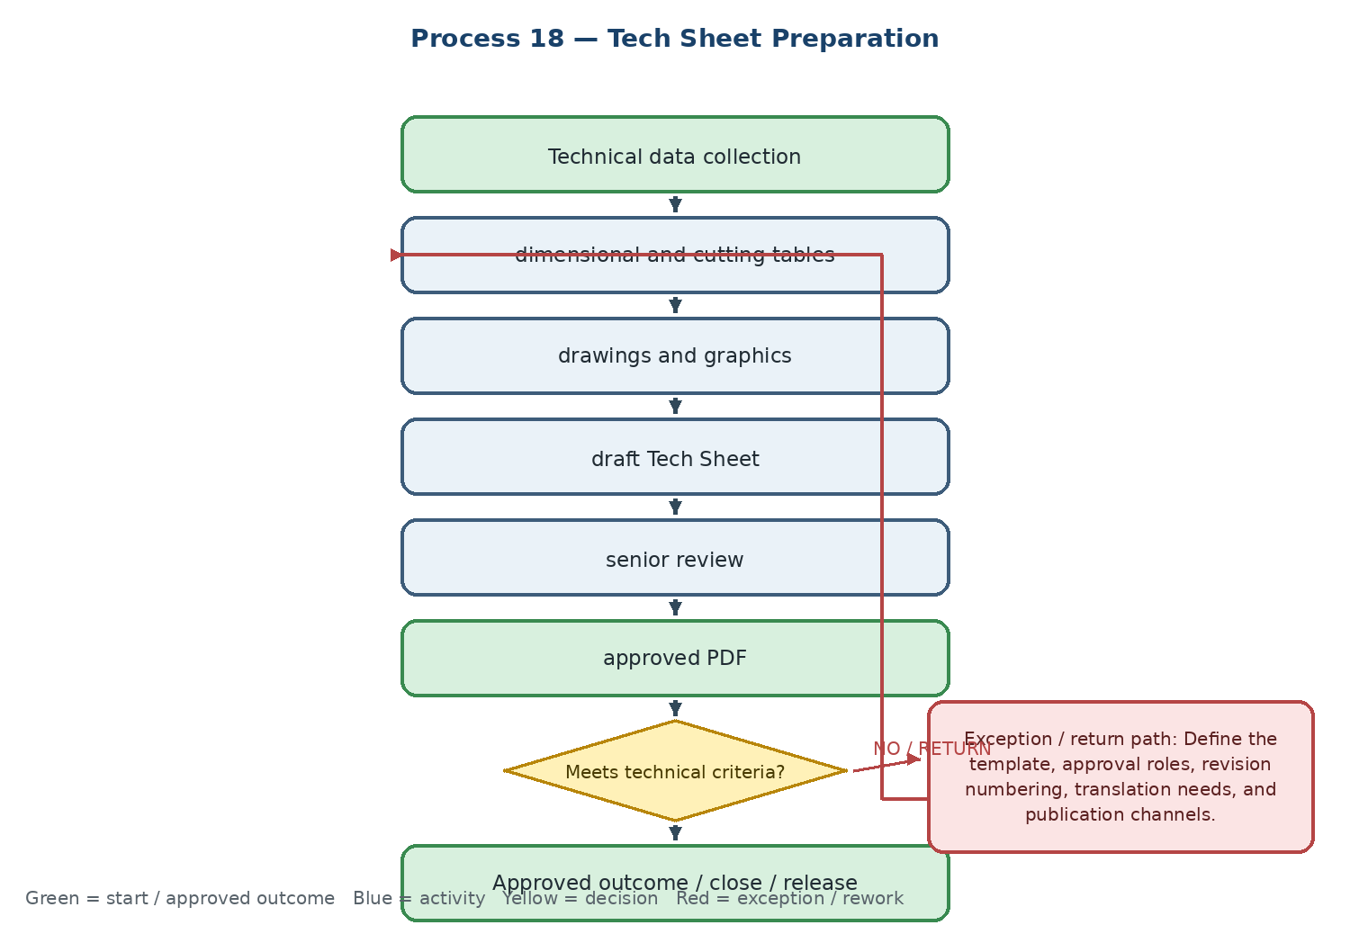

Current state and actual process facts
• The document is prepared from technical and application data, drawings, dimensions, cutting parameters, and product evidence.
• Technical or design errors return the draft to the preparer for correction and a new revision.
• The final output is an approved PDF under the organization's document standard.
Target Odoo workflow and cross-functional integration
• Use Documents, Knowledge, and product attachments with versioning, approval status, reviewer, source data, effective date, and publication status.
• Link the Tech Sheet to the Product Technical Master, product code, catalog, Website/eCommerce, and Sales so approved content is reused.
• Prevent publication of a draft and preserve superseded versions for audit and customer-history purposes.
Exceptions, approvals, controls, and open decisions
• Define the template, approval roles, revision numbering, translation needs, and publication channels.
• Define which changes to product attributes force Tech Sheet review or withdrawal.
• Confirm whether PDF generation is native, template-based, or requires a custom report.
Output, reports, KPIs, and workshop evidence
• Final output: approved version-controlled Tech Sheet PDF linked to the product
• KPIs: Tech Sheets approved, average preparation time, revision count, and overdue document reviews
• Demo / evidence: generate a draft from product data → submit for review → return with correction → approve → publish only the approved version
Workflow result — Coverage to confirm: □ Standard Odoo □ Configuration □ Odoo Studio □ Custom Development □ Integration □ Alternative / Not Supported | Gap: ........................................ | Action / Owner / Due: ........................................
19. Tech Guide Preparation
Creation and maintenance of a practical technical guide that converts product knowledge and recommended use into an approved internal and customer reference.
Workflow route: Application research → recommended methods and cutting parameters → guide drafting → senior technical approval → controlled publication

Process flowchart — translated English version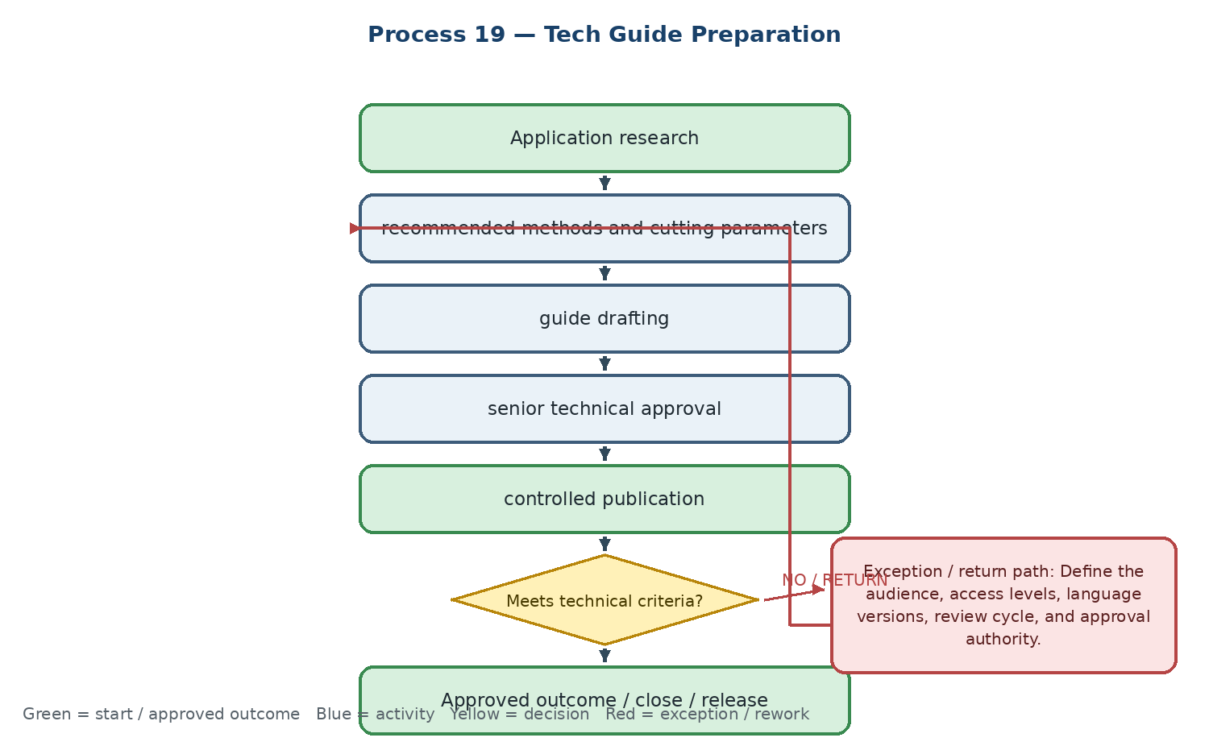

Current state and actual process facts
• Technical research covers product applications, recommended use, operating methods, and cutting parameters.
• A knowledge gap or major product-design change triggers immediate review and a new version.
• The output is a trusted Technical Guide Book for employees, Sales, and selected customers.
Target Odoo workflow and cross-functional integration
• Use Knowledge, eLearning, or Documents with role-based access, version, owner, review date, product links, and publication state.
• Connect the guide to product cards, Tech Sheets, training, and Sales resources without duplicating the technical master data.
• Use review reminders and change links so product or parameter revisions trigger content review.
Exceptions, approvals, controls, and open decisions
• Define the audience, access levels, language versions, review cycle, and approval authority.
• Decide whether guides are internal knowledge, customer-facing portal content, or separate controlled versions.
• Define content retirement when a product is obsolete or its specifications change.
Output, reports, KPIs, and workshop evidence
• Final output: approved and current Technical Guide linked to relevant products and training
• KPIs: active guides, review compliance, usage/downloads, and time from change to guide update
• Demo / evidence: create a guide from approved product data → restrict draft access → approve → publish to the intended audience → trigger review after a product change
Workflow result — Coverage to confirm: □ Standard Odoo □ Configuration □ Odoo Studio □ Custom Development □ Integration □ Alternative / Not Supported | Gap: ........................................ | Action / Owner / Due: ........................................
20. Technical Success Story
Conversion of a validated customer technical result into a controlled success story for Sales enablement, marketing, and customer communication.
Workflow route: Successful customer case → evidence and before/after results → story drafting → Technical and Branding approval → publication

Process flowchart — translated English version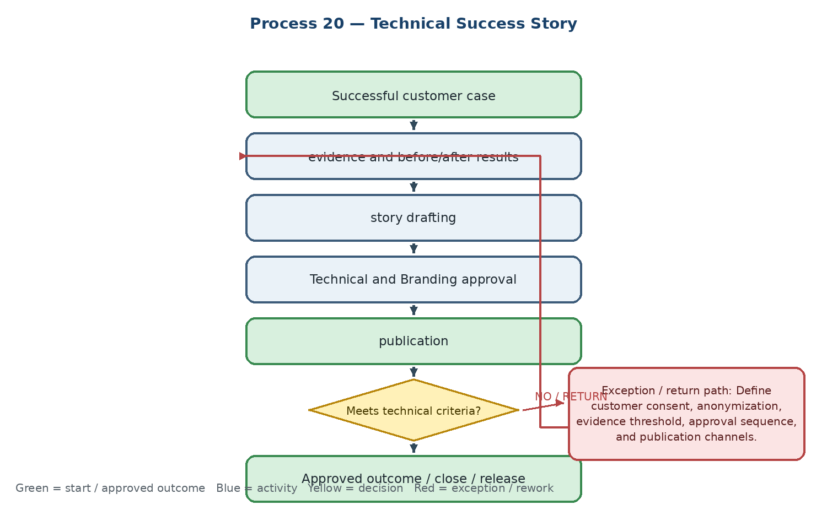

Current state and actual process facts
• The case is selected from a customer problem solved through technical support, test, or process planning.
• Evidence includes test results, photos, before/after data, application context, and measurable improvement.
• Insufficient evidence returns to the owner; the story may be cancelled if results cannot be substantiated.
Target Odoo workflow and cross-functional integration
• Link the story to Customer, Opportunity, products, test, complaint, and approved evidence in Documents or a controlled marketing/content model.
• Use separate technical approval, customer consent/anonymization, Brand approval, and publication status.
• Tag the story to equivalent products or applications so Sales can reuse it in the right context.
Exceptions, approvals, controls, and open decisions
• Define customer consent, anonymization, evidence threshold, approval sequence, and publication channels.
• Define whether the story is an internal Sales asset, public content, or both with separate versions.
• Set review and withdrawal rules when the product, customer, or evidence changes.
Output, reports, KPIs, and workshop evidence
• Final output: approved Technical Success Story with evidence, permissions, and product/application tags
• KPIs: stories completed, publication cycle time, Sales reuse, views/feedback, and conversion of story-supported opportunities
• Demo / evidence: select a successful case → attach evidence → request customer permission → obtain Technical and Brand approvals → publish an approved version
Workflow result — Coverage to confirm: □ Standard Odoo □ Configuration □ Odoo Studio □ Custom Development □ Integration □ Alternative / Not Supported | Gap: ........................................ | Action / Owner / Due: ........................................
21. Technical Catalog Content
Preparation and approval of technical catalog content from the product master, drawings, dimensions, and application data.
Workflow route: Catalog product set → technical chapter structure → attributes, drawings and 3D data → design → technical review → print / digital approval

Process flowchart — translated English version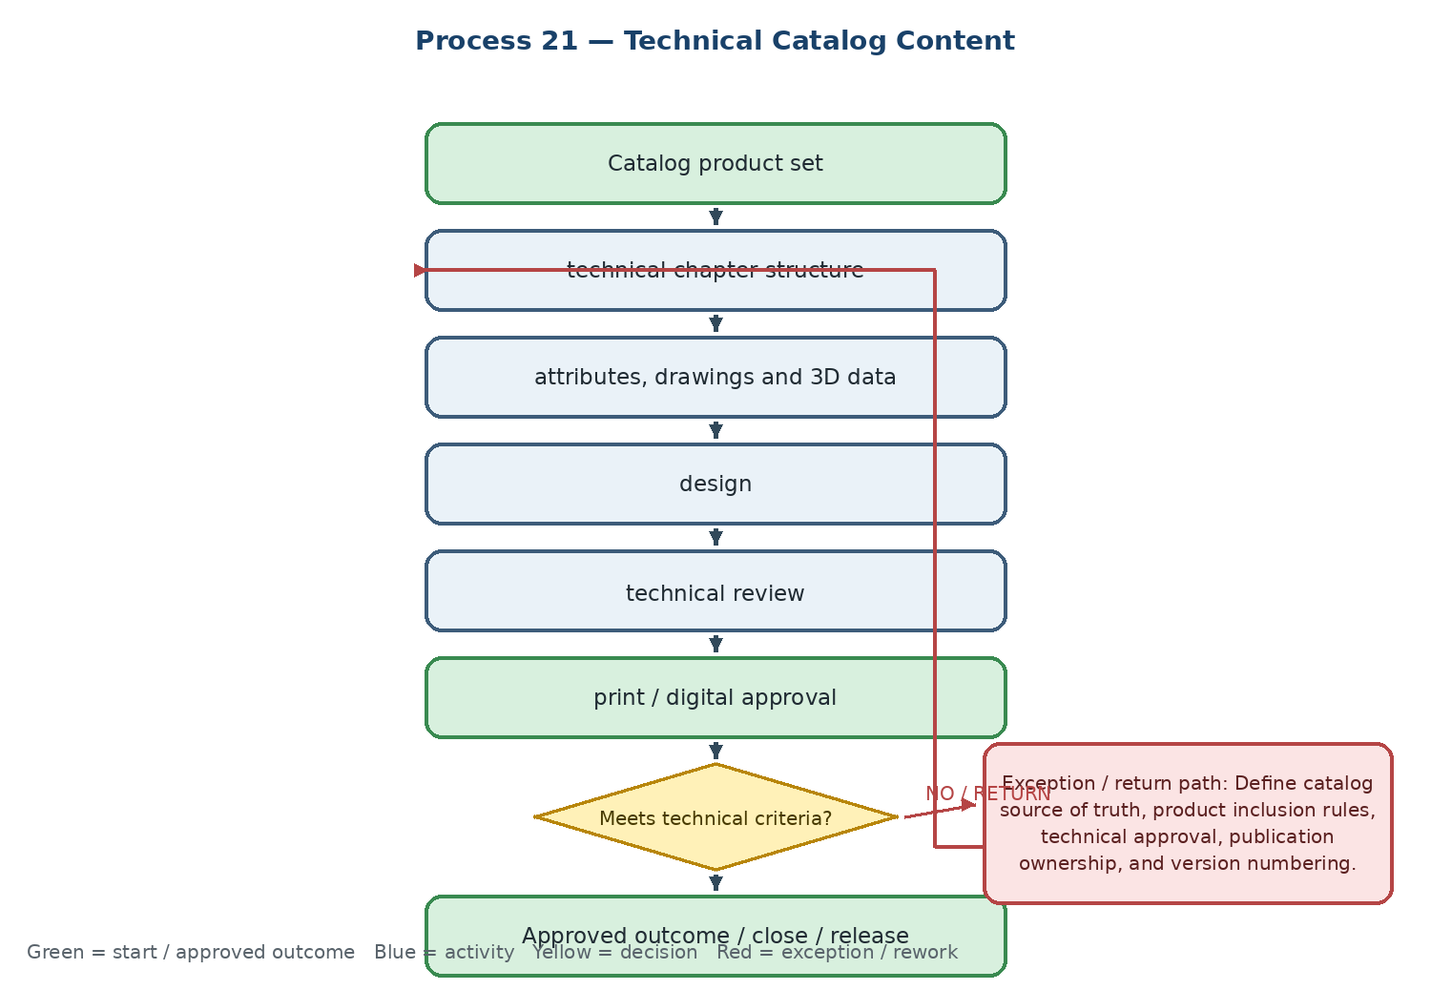

Current state and actual process facts
• Technical identifies the product set, chapter structure, dimensions, machining information, drawings, and 3D models required for the catalog.
• A dimensional or product change can stop publication and require immediate correction and a new version.
• The output is a technically approved catalog ready for print or digital publication.
Target Odoo workflow and cross-functional integration
• Use the Product Technical Master as the source and link approved documents, images, drawings, and catalog sections to products and revisions.
• Use PLM/Documents change signals to create a catalog-review task when a technical attribute or product status changes.
• Keep design/Branding work separate from technical approval while retaining one publication reference and version history.
Exceptions, approvals, controls, and open decisions
• Define catalog source of truth, product inclusion rules, technical approval, publication ownership, and version numbering.
• Define the effect of obsolete, suspended, or changed products on an active catalog.
• Confirm whether catalog generation is a report, external design workflow, or integration requirement.
Output, reports, KPIs, and workshop evidence
• Final output: approved technical catalog version ready for print or digital distribution
• KPIs: chapters completed, products with missing content, post-review corrections, and time from product change to catalog update
• Demo / evidence: select catalog products → pull approved technical attributes → detect changed dimension → open review task → approve new catalog version
Workflow result — Coverage to confirm: □ Standard Odoo □ Configuration □ Odoo Studio □ Custom Development □ Integration □ Alternative / Not Supported | Gap: ........................................ | Action / Owner / Due: ........................................
22. Website / Animation Technical Content
Technical creation, review, approval, and publication of product web content, videos, and animations linked to the active product master.
Workflow route: Priority product selection → technical data and media collection → content scenario → production → senior technical review → final approval and upload

Process flowchart — translated English version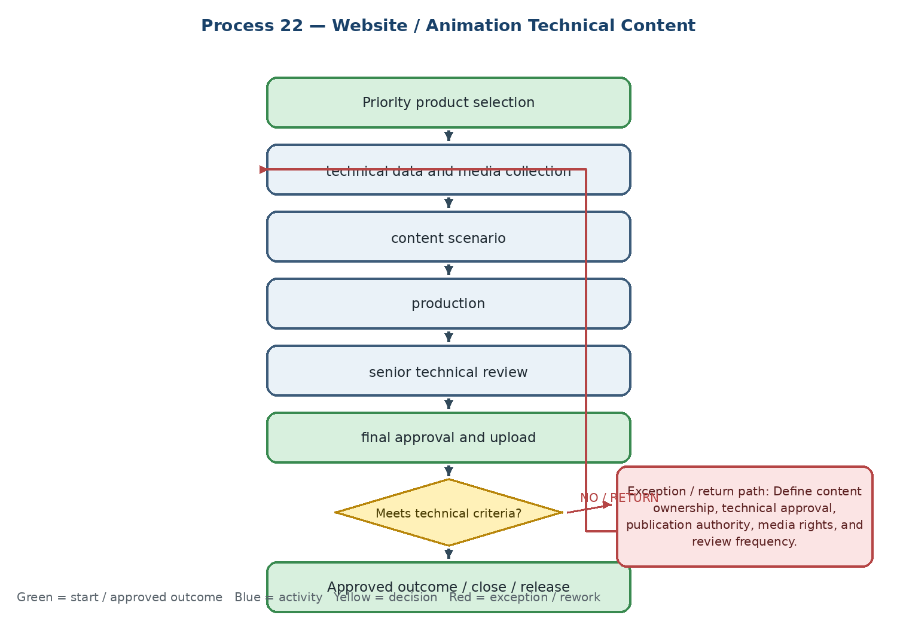

Current state and actual process facts
• Technical provides specifications, application videos, training scenarios, and product information to Branding and Website teams.
• Outdated technical data or a product removed from the portfolio requires immediate edit or removal from the content queue.
• The output is digital content ready for publication and linked to the relevant product.
Target Odoo workflow and cross-functional integration
• Link approved media and technical content to the Product record and Website/eCommerce product page, with draft, review, approved, published, and withdrawn states.
• Use product status and revision signals to prevent obsolete content from remaining public without review.
• Preserve Technical approval separately from Branding production and website publishing permissions.
Exceptions, approvals, controls, and open decisions
• Define content ownership, technical approval, publication authority, media rights, and review frequency.
• Define what happens when a product is suspended, obsolete, or technically revised after publication.
• Confirm whether Odoo Website is the publication system or whether a separate CMS remains in scope.
Output, reports, KPIs, and workshop evidence
• Final output: approved and product-linked digital technical content ready for publication
• KPIs: approved videos/animations, products with complete digital content, production-to-approval cycle time, and withdrawn-content count
• Demo / evidence: create content task → attach technical source → submit animation for review → reject outdated data → revise → approve and publish
Workflow result — Coverage to confirm: □ Standard Odoo □ Configuration □ Odoo Studio □ Custom Development □ Integration □ Alternative / Not Supported | Gap: ........................................ | Action / Owner / Due: ........................................
Phase F — New product R&D, feasibility, quality, and release
23. New Product R&D
Stage-gated research and development of a new product from market or competitor insight through initial prototype testing and go/no-go decision.
Workflow route: Market / competitor insight → new-product idea → value and portfolio assessment → prototype sourcing or production → R&D test → go / stop decision

Process flowchart — translated English version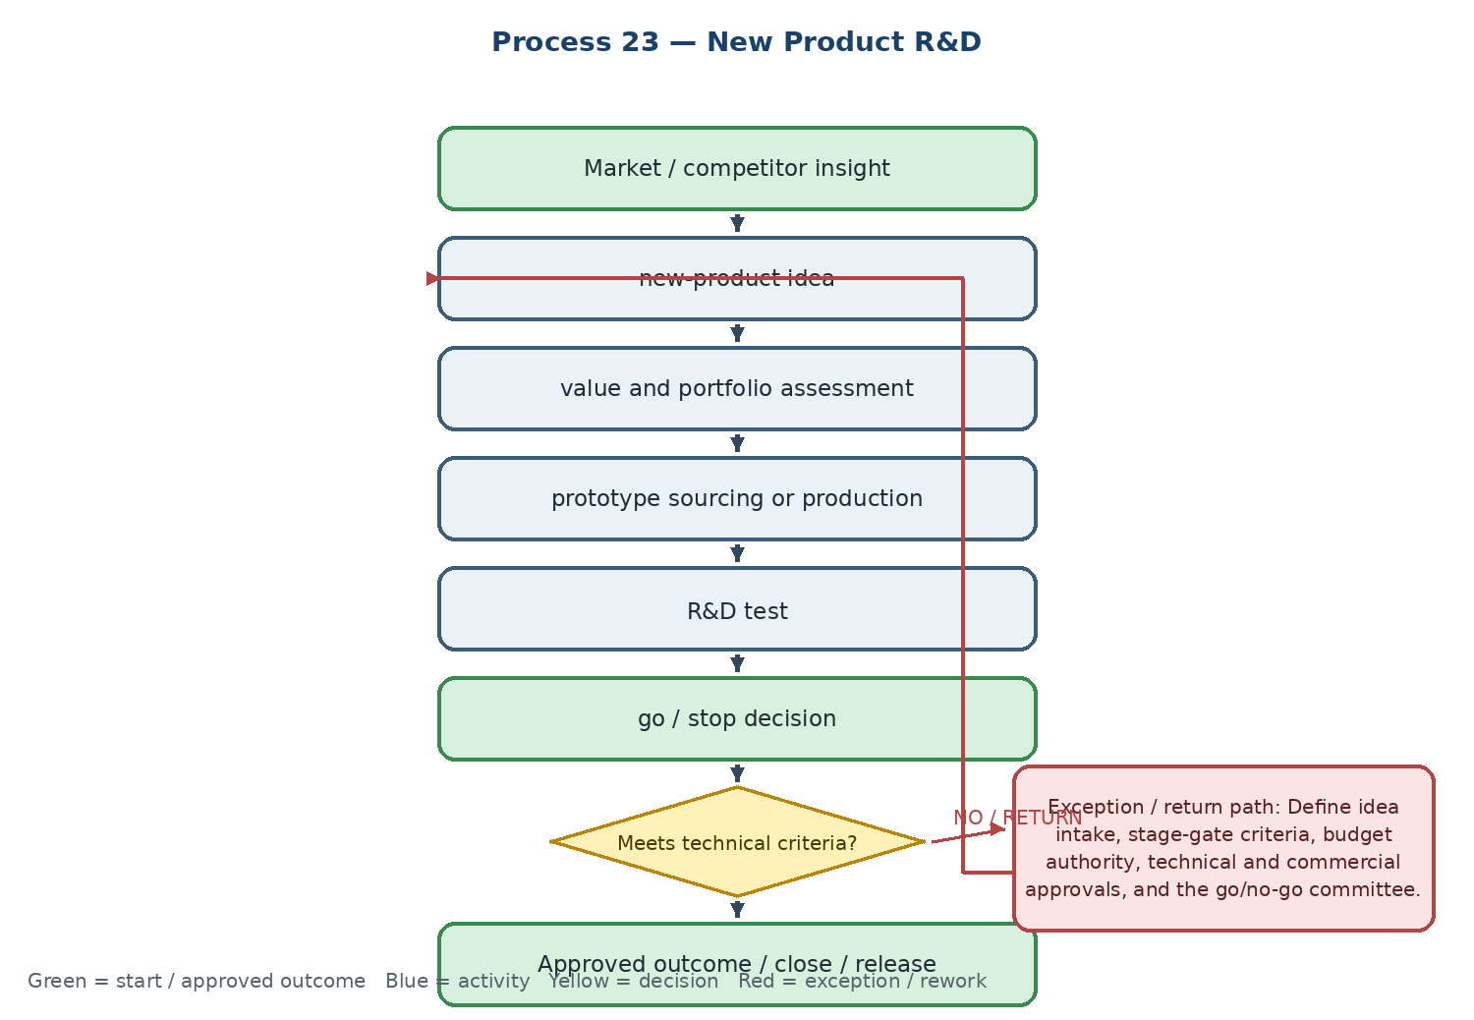

Current state and actual process facts
• Ideas originate from market visits, competitor monitoring, customer need, or emerging technology.
• The concept is assessed for value, product-basket fit, technical feasibility, and commercial potential before a prototype is tested.
• Weak market demand, uncompetitive cost, or failed initial testing stops the process and archives the reason.
Target Odoo workflow and cross-functional integration
• Use PLM/ECO and/or Projects with stage gates, business case, competitor benchmark, technical proposal, prototype, test results, approvals, and budget/owner fields.
• Link the R&D case to the future product, supplier/manufacturing feasibility, initial quality test, and eventual release decision.
• Keep rejected ideas searchable with reason and evidence so the organization does not repeat failed research.
Exceptions, approvals, controls, and open decisions
• Define idea intake, stage-gate criteria, budget authority, technical and commercial approvals, and the go/no-go committee.
• Decide whether PLM/ECO or Projects is the parent record and how R&D tasks and documents are governed.
• Define the link between R&D success, sourcing feasibility, product coding, and market introduction.
Output, reports, KPIs, and workshop evidence
• Final output: approved New Product Proposal or documented stop decision
• KPIs: active R&D projects, idea-to-commercial-product conversion, time-to-market, and stopped-project reasons
• Demo / evidence: submit an idea → approve concept → create prototype task → record failed test → archive with reason, or progress to feasibility
Workflow result — Coverage to confirm: □ Standard Odoo □ Configuration □ Odoo Studio □ Custom Development □ Integration □ Alternative / Not Supported | Gap: ........................................ | Action / Owner / Due: ........................................
24. New Product Manufacturing / Sourcing Feasibility
Technical and commercial feasibility assessment of whether a new product can be produced internally or sourced from a qualified supplier at an acceptable cost and lead time.
Workflow route: Approved product proposal → internal production capability or supplier search → capacity and quality review → estimated cost and lead time → management and Commercial decision

Process flowchart — translated English version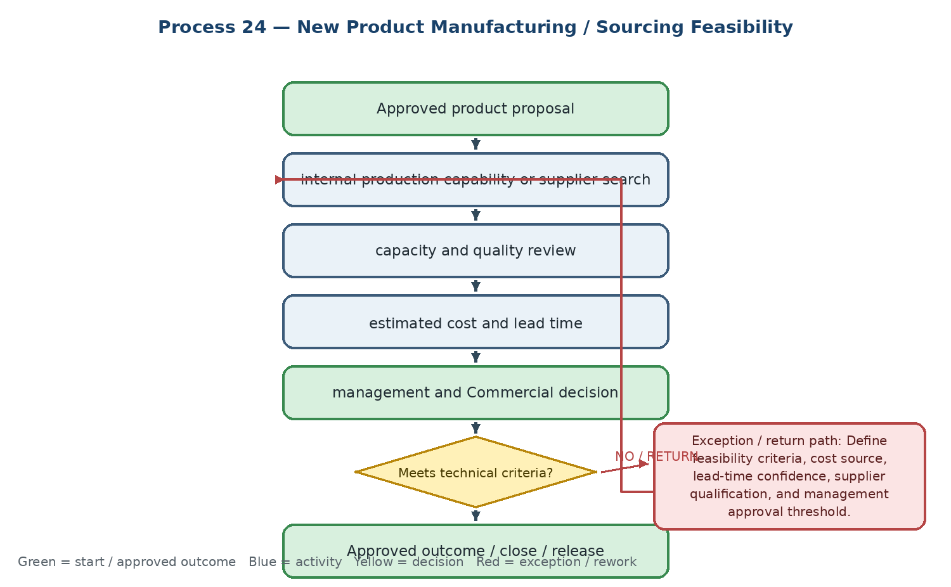

Current state and actual process facts
• Technical assesses internal manufacturing capability or identifies potential foreign/domestic suppliers and reviews equipment, engineering capacity, and quality standards.
• Cost and lead time are estimated and documented for Management and Commercial.
• If the product is not technically possible or economically viable, the case is redirected to alternatives or suspended.
Target Odoo workflow and cross-functional integration
• Link PLM/ECO, Projects, Purchase, supplier evaluation, product, cost estimate, lead-time evidence, and management approval.
• Store vendor evaluation on the supplier record and preserve quotations, capacity evidence, technical requirements, and feasibility report revisions.
• Return the decision to the R&D parent case and create the next action: prototype, sourcing, alternative supplier, or suspension.
Exceptions, approvals, controls, and open decisions
• Define feasibility criteria, cost source, lead-time confidence, supplier qualification, and management approval threshold.
• Confirm whether supplier evaluation is a Purchase process, PLM stage, or dedicated technical-commercial record.
• Define how an infeasible case is closed, redirected, or reopened after a new supplier or design change.
Output, reports, KPIs, and workshop evidence
• Final output: approved Feasibility Report with technical, supplier, cost, and lead-time conclusion
• KPIs: feasibility cases closed, average assessment time, new suppliers evaluated/qualified, and feasibility-to-prototype conversion
• Demo / evidence: open feasibility from R&D → evaluate supplier → capture cost and lead time → approve viable option or stop with reason
Workflow result — Coverage to confirm: □ Standard Odoo □ Configuration □ Odoo Studio □ Custom Development □ Integration □ Alternative / Not Supported | Gap: ........................................ | Action / Owner / Due: ........................................
25. Initial Quality Test of New Product
Controlled first-quality testing of a new product or supplier sample before commercial release, including operating conditions, tool life, wear, and workpiece quality.
Workflow route: New product data and physical sample → test selection → internal/customer CNC test → performance and tool-life report → technical quality decision

Process flowchart — translated English version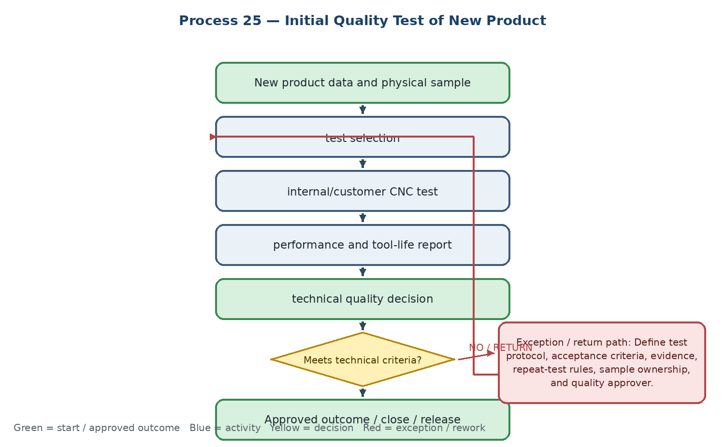

Current state and actual process facts
• Technical receives the product information and physical sample, selects test conditions, and records tool life, wear, and workpiece quality.
• A failed or nonconforming result returns to the manufacturer/supplier for correction or a new sample.
• The output is an Initial Quality Test Report that supports pricing, feasibility, and release.
Target Odoo workflow and cross-functional integration
• Use Odoo Quality and Inventory with a dedicated Quality Control Point for new-product samples, linked to receipt, lot/serial, R&D/PLM case, supplier, and test record.
• Capture test conditions, acceptance criteria, measurements, photos, tool life, wear, workpiece result, reviewer, and approval status.
• Link failure to NCR, supplier corrective action, repeat sample, feasibility, and the eventual Product Release decision.
Exceptions, approvals, controls, and open decisions
• Define test protocol, acceptance criteria, evidence, repeat-test rules, sample ownership, and quality approver.
• Define the connection between internal test, customer pilot, pricing input, and product release.
• Confirm batch/serial traceability and whether external laboratory data must be stored or integrated.
Output, reports, KPIs, and workshop evidence
• Final output: approved or rejected Initial Quality Test Report linked to the new-product case
• KPIs: new samples tested, first-pass acceptance rate, test cycle time, repeat-test count, and supplier correction time
• Demo / evidence: receive new-product sample → trigger quality point → record test measurements → fail and create supplier action, or approve for release stage
Workflow result — Coverage to confirm: □ Standard Odoo □ Configuration □ Odoo Studio □ Custom Development □ Integration □ Alternative / Not Supported | Gap: ........................................ | Action / Owner / Due: ........................................
26. Product Release to Sales
Final controlled release of a new product to the commercial organization after technical, quality, coding, documentation, packaging, and supply requirements are complete.
Workflow route: Quality approval + product coding + Tech Sheet/Guide completion → Sales/Commercial committee decision → ERP activation as sellable → Sales training → commercial distribution

Process flowchart — translated English version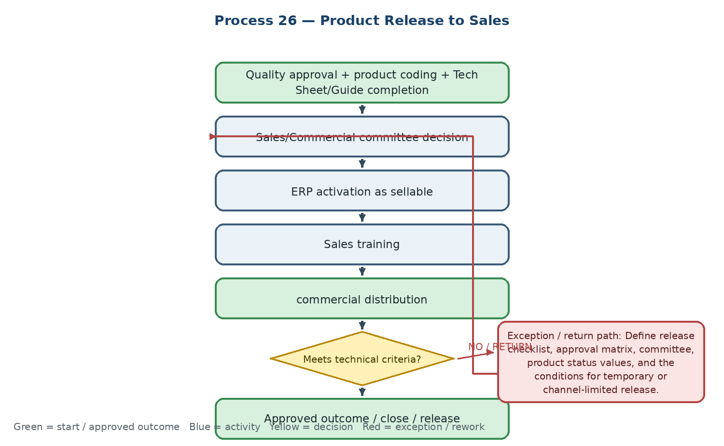

Current state and actual process facts
• Release requires successful quality tests, completed product coding, approved technical documents, packaging conformity, and a commercial decision.
• Incomplete documents or supply-chain nonconformity suspend the release and prevent commercial activation.
• The output is a Product Release Document and an active sellable status in the ERP.
Target Odoo workflow and cross-functional integration
• Use PLM/ECO or a controlled release workflow to require technical, quality, master-data, Commercial, and Management approvals before activating Can be Sold.
• Link the release to the Product Technical Master, Tech Sheet, Tech Guide, catalog, website content, supplier/warehouse readiness, and Sales training.
• Record release version, effective date, channels, restrictions, training completion, and later withdrawal or change history.
Exceptions, approvals, controls, and open decisions
• Define release checklist, approval matrix, committee, product status values, and the conditions for temporary or channel-limited release.
• Confirm whether Can be Sold, product availability, price-list inclusion, and website visibility are separate gates.
• Define post-release monitoring and the withdrawal/re-release route for quality or technical changes.
Output, reports, KPIs, and workshop evidence
• Final output: approved Product Release Document with controlled commercial activation
• KPIs: products released, release queue aging, release cycle time, training completion, and post-release corrections/withdrawals
• Demo / evidence: attempt release with missing document → return to owner → complete checklist and approvals → activate sellable status → show Sales access and release evidence
Workflow result — Coverage to confirm: □ Standard Odoo □ Configuration □ Odoo Studio □ Custom Development □ Integration □ Alternative / Not Supported | Gap: ........................................ | Action / Owner / Due: ........................................
3. Consolidated workshop decisions
The following decisions should be closed across Technical, Sales/CRM, Commercial, Warehouse, Finance, Quality, and the Odoo team before configuration or development estimates are finalized.
• One parent reference from Customer/Opportunity through Technical, Purchase, Receipt/QC, Inventory, Delivery, Settlement, Complaint/Claim, and closure.
• Owner and boundary for Technical Request, CRM case, Helpdesk ticket, Project task, Quality Alert/NCR, Supplier Claim, and PLM/ECO.
• System of record and integration behavior for product master, coding, invoice, warehouse voucher, customer balance, cheque, payment, and supplier claim recovery.
• SLA, priority, approval, escalation, status, return, and closure rules for technical requests, visits, tests, NCRs, complaints, claims, and release.
• Mandatory, derived, migrated, and optional fields for Customer, Opportunity, Product Technical Master, Test, Quality, Supplier, and content records.
• Classification and evidence for each requirement: Standard Odoo, Configuration, Odoo Studio, Custom Development, Integration, or Alternative / Not Supported.
Workshop acceptance rule: an item remains Open until the process owner, Odoo team, and relevant cross-functional owner agree on the scenario, solution class, limitation, evidence, action owner, due date, and acceptance test.

