Integrated Purchase, Foreign Procurement, and Inventory Process Map
Detailed English Requirements Document for the Odoo Fit-Gap Workshops
Final redesigned version — explicit start and end points, decision gates, Yes/No paths, corrective returns, operational documents, financial roles, and Odoo requirements
Scope: from demand creation and stock checking through domestic or foreign sourcing, import, receipt, incoming quality control, reservation, delivery, returns, payment, inventory valuation, and case closure.
Document structure
- Twenty-one end-to-end process areas are presented in a consistent two-page format.
- A transaction matrix identifies each key warehouse voucher, posting owner, stock effect, and financial follow-up.
- The first page of each area shows the workflow, an area-specific decision gate, corrective return path, operational record, and explicit role-to-role handoffs.
- The second page records the current-state scope, target Odoo requirements, controls, exceptions, reports, and decisions required during the workshop.
Workshop rule: each requirement must be classified as Standard Odoo, Configuration, Odoo Studio, Custom Development, Integration, or Alternative Solution, with its limitation and action owner recorded.
Karan Industrial Group

How to Use This Document
Review the workflow first, confirm every role handoff and decision, and then complete the corresponding requirement page with the Odoo team.
Page element | Meaning | Workshop use
Workflow node | An activity owned by the role shown in the node | Confirm the responsible role, required data, and output
Arrow / handoff | Transfer of responsibility or information | Confirm trigger, recipient, expected timing, and notification
Decision diamond and branches | A controlled question with Yes and No/correction paths | Confirm the decision rule, corrective owner, and exact return point
Requirement blocks | Target behavior, controls, reports, and open decisions | Classify the Odoo coverage and record limitations
Required Fit-Gap result
- Demonstrate the actual Odoo document, status, role, mandatory fields, approvals, access rights, and report for each requirement.
- Do not close a requirement with a verbal answer only; record the limitation, design choice, or estimation action when a demonstration is not available.
- Assign an owner and due date to each open item, then confirm it in the meeting minutes.
Process areas
Areas 1–7 | Areas 8–14 | Areas 15–21
1. Operating model and target architecture | 8. Supplier, freight, and international payment workflow | 15. Test items, technical samples, consignment, sale conversion, and expense treatment
2. Demand planning, Purchase Request, and sourcing-route decision | 9. Supplier preparation, inspection, packing list, shipment, and ETA | 16. Customer return, supplier return, rejection, claim, rework, and scrap
3. Supplier, product, coding, and warehouse master data | 10. Customs clearance, legal charges, landed cost, and import-file closure | 17. Inventory counts, adjustments, barcode, lot/serial, and stock integrity
4. Foreign supplier Inquiry/RFQ, quotation comparison, and commercial offer | 11. Warehouse receiving, Incoming QC, coding, traceability, and putaway | 18. Inventory aging, storage conditions, kits, internal consumption, and period close
5. Domestic sourcing by Sales for a customer order | 12. Stock visibility, inventory states, reservation, and shortage handling | 19. Roles, access, approvals, audit trail, notifications, and document control
6. Foreign purchase pre-order, PI/contract, approval, and Purchase Order | 13. Monthly replenishment, reorder rules, and internal transfers | 20. Reports, KPIs, supplier performance, and risk management
7. Import registration, foreign exchange allocation, and banking milestones | 14. Picking, packing, delivery, partial delivery, and proof of delivery | 21. Systems, integration, migration, cutover, and workshop runbook

Master Process Map: Demand to Supply, Inventory, Delivery, and Settlement
This map shows the main relationship between departments. Every detailed workflow in the following sections remains connected through the same demand, purchase, inventory, or delivery case.
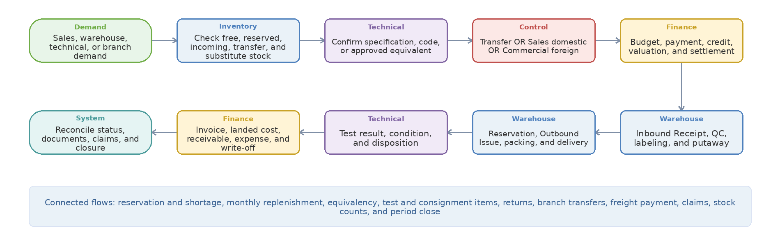
Non-negotiable design principles
- Register each demand once and check free stock, reservations, confirmed incoming supply, internal transfers, and technical substitutes before buying.
- Keep the demand identifier connected from RFQ and Purchase Order through shipment, receipt, quality control, delivery, payment, claim, and closure.
- Allow Sales to see supply status and committed date while restricting supplier prices, bank information, and payment details to authorized roles.
Ownership: Sales = domestic sourcing and local purchase | Commercial = foreign procurement and import | Technical = specification and quality decision | Warehouse = physical vouchers and stock | Finance = invoices, payment, valuation, expense, and receivables

Operational Document Matrix — When Each Voucher Is Created and Who Posts It
This matrix separates the physical warehouse event from its financial consequence. Each document must retain its source transaction, posting user, date/time, quantity, value status, approval history, and reversal or correction trail.
Business event | Required document | Posting owner | Stock effect and operational rule | Finance action
Purchase receipt | Inbound Receipt / Goods Receipt | Warehouse | Increase stock or move it to receipt/QC/quarantine; record partial, excess, shortage, damage, lot, and serial. | Match supplier invoice, tax, payable, valuation, and landed cost after the required controls.
Customer return | Return Inbound Voucher | Warehouse | Move returned stock to quarantine/returns; release to available stock only after Technical disposition. | Post Credit Note, refund, receivable correction, or write-off only after the approved decision.
Inter-warehouse dispatch | Transfer Outbound Voucher | Source Warehouse | Move quantity from the source location to an in-transit location; retain transfer and carrier reference. | No revenue or expense; monitor value and reconcile in-transit differences.
Inter-warehouse arrival | Transfer Inbound Voucher | Destination Warehouse | Move received quantity from in-transit to destination/QC and record shortages, damage, or excess. | Reconcile any quantity/value variance and investigate unresolved in-transit balance.
Customer delivery | Outbound Issue / Delivery Order | Warehouse | Reduce or move reserved stock after Sales release and any required Finance credit/payment release. | Post or validate sales invoice, receivable, tax, and cost according to the approved invoice policy.
Test, sample, or consignment issue | Test/Consignment Outbound Voucher | Warehouse | Move stock to a controlled customer, test, display, employee, or third-party location; this is not automatically a sale or expense. | Track item value, responsibility, deposit/credit condition, due date, and release rule; do not invoice or expense yet.
Test/sample return | Test/Consignment Return Inbound Voucher | Warehouse | Return the item to QC, quarantine, or available stock based on Technical condition assessment. | Post only the approved financial effect of damage, consumption, repair, or loss, if any.
Test converted to sale | Sales Order + linked delivery conversion + Sales Invoice | Sales creates the order; Warehouse links/reclassifies; Finance posts invoice | Keep stock at the customer; link the original test movement to the sale without a fictitious physical return. | Recognize sales invoice, receivable, tax, and cost once; retain the conversion approval and audit trail.
Test consumed, damaged, or lost | Consumption/Scrap Movement + approved Expense/Write-off | Technical decision + Management approval + Warehouse movement + Finance entry | Remove the approved quantity from usable stock and retain reason, condition, custodian, and evidence. | Post the approved expense or write-off to the correct cost center/project and account.
Internal consumption | Internal Issue Voucher | Warehouse | Issue stock to the approved department, employee, project, machine, or cost center. | Post inventory consumption to the correct cost center/project/account; no customer invoice.
Supplier return | Supplier Return Outbound Voucher | Warehouse | Move rejected or approved-return stock out against the original receipt and supplier claim. | Post supplier Credit/Debit Note, payable settlement, refund, replacement value, or write-off as approved.
Control boundary: Warehouse owns physical quantities and warehouse vouchers. Finance owns invoices, payments, receivables, tax, valuation, landed cost, expense, and write-off; Finance does not edit physical quantities.

Process 1 — Operating model and target architecture
Start: Register Sales, Warehouse, Technical, or branch demand with a unique case ID | End: Supply, receipt, delivery, and settlement completed with the case closed. The diagram moves left to right and continues right to left on the second row; the lower diamond shows the Yes, No, correction, and return paths.
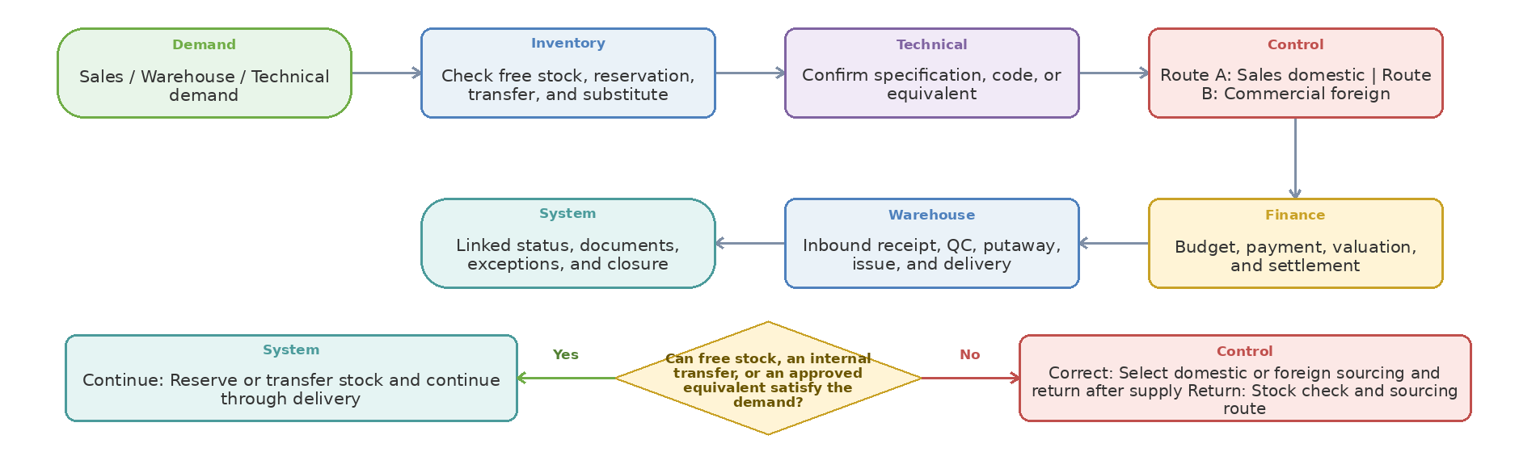
Step owner | Action or control | Operational document or system record | Handoff to
Demand | Sales / Warehouse / Technical demand | Identified Request with Attachments | Inventory
Inventory | Check free stock, reservation, transfer, and substitute | Stock, Reservation, and Allocation Record | Technical
Technical | Confirm specification, code, or equivalent | Technical Evaluation and Approval Form | Control
Control | Route A: Sales domestic | Route B: Commercial foreign | Activity, Status, and Attachment Record in the Odoo Case | Finance
Finance | Budget, payment, valuation, and settlement | Related Financial Document, Approval, or Invoice | Warehouse
Warehouse | Inbound receipt, QC, putaway, issue, and delivery | Inbound Receipt / Goods Receipt | System
System | Linked status, documents, exceptions, and closure | Activity, Status, and Attachment Record in the Odoo Case | Case closure / downstream stakeholder

Process 1 Requirements — Operating model and target architecture
One connected demand-to-supply-to-stock lifecycle should replace disconnected BPMS, spreadsheet, Sepidar, and manual follow-up while retaining the approved controls and return paths.
Decision Logic and Return Path
Decision gate | Yes path | No or exception path | Return to
Can free stock, an internal transfer, or an approved equivalent satisfy the demand? | Reserve or transfer stock and continue through delivery | Select domestic or foreign sourcing and return after supply | Stock check and sourcing route
Operating model requirements
- Use one connected lifecycle across demand, sourcing, purchase, import, inventory, delivery, settlement, and closure.
- Keep one case identifier, a clear owner, mandatory data, approvals, return paths, and status history throughout the lifecycle.
- Use standard connected Odoo transactions where they provide the required control and traceability instead of creating parallel cases.
- Keep role boundaries clear while allowing each department to see the operational status required for its work.
Target architecture principle
- A demand record should retain one reference from request through RFQ, supplier quotation, approval, Purchase Order, shipment, receipt, QC, inventory movement, delivery, supplier payment, landed cost, claim, and closure.
- Sales should see supply status, expected date, available/reserved/incoming quantity, QC result, and customer-delivery status without seeing restricted supplier pricing, payment, or banking information.
- Sales owns domestic supplier inquiry and local purchasing; Commercial owns foreign supplier sourcing, foreign purchasing, import registration, shipment, customs coordination, and foreign supplier follow-up.
- Warehouse owns all physical stock movements and warehouse vouchers; Technical owns specifications and QC decisions; Finance owns invoices, payments, valuation, expense, receivables, and accounting; Management owns defined exception approvals.
Core boundary decisions
- Decide the system of record for product/vendor masters, receipts/issues, invoices, payments, inventory valuation, and financial documents between Odoo and Sepidar.
- Decide which Iran-specific external steps remain status/document tracking in Odoo and which require integration, including NTSW, banking, EPL/customs, carriers, and BI.
- Every reviewed requirement must be classified as Standard, Configuration, Odoo Studio, Development, Integration, or Not Supported/Alternative, with the limitation and demo evidence recorded.
Workshop result
Coverage: Standard Odoo ☐ Configuration ☐ Odoo Studio ☐ Custom Development ☐ Integration ☐ Alternative Solution ☐ | Limitation and decision: ................................................

Process 2 — Demand planning, Purchase Request, and sourcing-route decision
Start: Demand contains quantity, required date, priority, and requester | End: Approved sourcing route and traceable commitment date. The diagram moves left to right and continues right to left on the second row; the lower diamond shows the Yes, No, correction, and return paths.
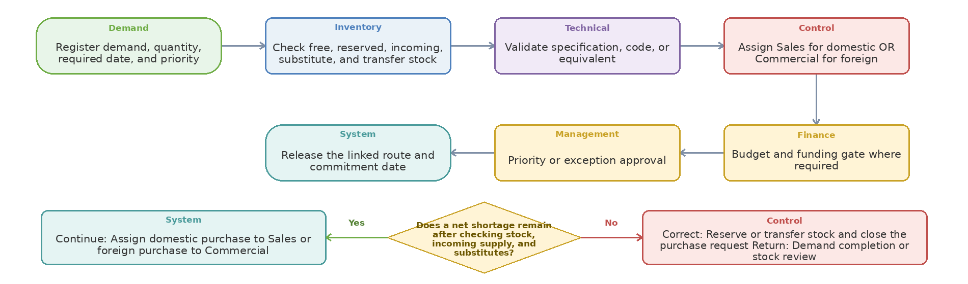
Step owner | Action or control | Operational document or system record | Handoff to
Demand | Register demand, quantity, required date, and priority | Identified Request with Attachments | Inventory
Inventory | Check free, reserved, incoming, substitute, and transfer stock | Stock, Reservation, and Allocation Record | Technical
Technical | Validate specification, code, or equivalent | Technical Evaluation and Approval Form | Control
Control | Assign Sales for domestic OR Commercial for foreign | Activity, Status, and Attachment Record in the Odoo Case | Finance
Finance | Budget and funding gate where required | Related Financial Document, Approval, or Invoice | Management
Management | Priority or exception approval | Activity, Status, and Attachment Record in the Odoo Case | System
System | Release the linked route and commitment date | Activity, Status, and Attachment Record in the Odoo Case | Case closure / downstream stakeholder

Process 2 Requirements — Demand planning, Purchase Request, and sourcing-route decision
Demand may originate from a Sales Order, warehouse replenishment, Technical sample/test, internal consumption, branch transfer, production requirement, or management decision.
Decision Logic and Return Path
Decision gate | Yes path | No or exception path | Return to
Does a net shortage remain after checking stock, incoming supply, and substitutes? | Assign domestic purchase to Sales or foreign purchase to Commercial | Reserve or transfer stock and close the purchase request | Demand completion or stock review
Confirmed current-state coverage
- Commercial planning considers Sales forecast, physical stock, reservations, stock in transit, open supply, MOQ, lead time, cash constraints, and priority before creating a supply plan.
- The approved flows include request intake from Sales, Warehouse, Technical, or another unit; duplicate/open-order check; urgency and source decision; correction, rejection, or routing to local/foreign purchase.
- Periodic/monthly warehouse ordering is a real process and includes Management, Technical equivalency, pricing, freight/clearance estimate, Finance/budget, ordering, coding, shipment, and warehouse receipt.
Required Purchase Request data and controls
- Request type, requesting unit/person, customer or project, product/code/specification, quantity/UoM, required date, priority, reason, available/reserved/incoming quantity, preferred source, attachments, and linked Sales Order/Technical Request should be structured fields.
- The system should identify duplicate demand, open Purchase Orders, transferable branch stock, substitutes, and partial availability before a new purchase is approved.
- A Purchase Request is not a supplier RFQ or Purchase Order. Statuses and responsibilities must remain distinct and reportable.
- Changes to quantity, specification, required date, source route, or cancellation after approval should trigger a controlled re-review and preserve an audit trail.
Planning policy and open decisions
- Define which products use make-to-order, minimum/maximum, reorder point, safety stock, forecast-driven replenishment, or manual request only.
- Define approval thresholds by request type, amount/value, branch, urgency, product category, budget status, and single-source exception.
- Clarify whether replenishment recommendations are automatic proposals or automatically generated draft RFQs/POs; the system should not create confirmed purchases without the required controls.
Workshop demonstration and acceptance
- Demo one demand with partial stock, branch stock, an open PO, and a remaining shortage; show how Odoo proposes reservation, transfer, and purchase without double-buying.
- Bring one monthly warehouse request and one customer-driven purchase request, including the approval path and required-date rule.
Workshop result
Coverage: Standard Odoo ☐ Configuration ☐ Odoo Studio ☐ Custom Development ☐ Integration ☐ Alternative Solution ☐ | Limitation and decision: ................................................

Process 3 — Supplier, product, coding, and warehouse master data
Start: Request to create or amend an item, supplier, or warehouse location | End: Approved, unique, active master record with an effective date. The diagram moves left to right and continues right to left on the second row; the lower diamond shows the Yes, No, correction, and return paths.
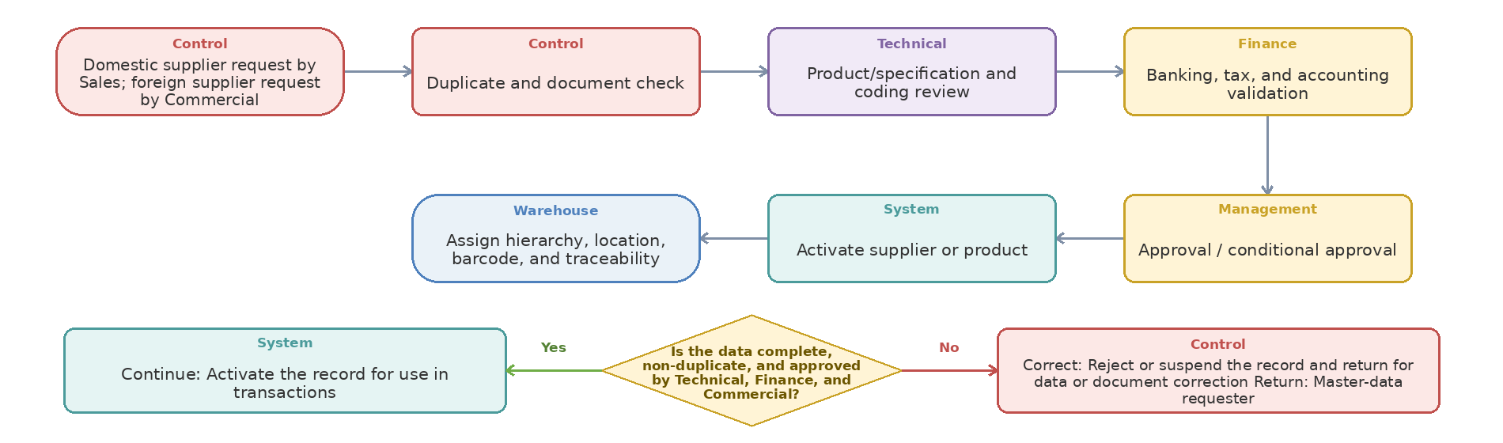
Step owner | Action or control | Operational document or system record | Handoff to
Control | Domestic supplier request by Sales; foreign supplier request by Commercial | Identified Request with Attachments | Control
Control | Duplicate and document check | Activity, Status, and Attachment Record in the Odoo Case | Technical
Technical | Product/specification and coding review | Technical Evaluation and Approval Form | Finance
Finance | Banking, tax, and accounting validation | Related Financial Document, Approval, or Invoice | Management
Management | Approval / conditional approval | Activity, Status, and Attachment Record in the Odoo Case | System
System | Activate supplier or product | Activity, Status, and Attachment Record in the Odoo Case | Warehouse
Warehouse | Assign hierarchy, location, barcode, and traceability | Item Card, Barcode, Serial/Lot, or Location Record | Case closure / downstream stakeholder

Process 3 Requirements — Supplier, product, coding, and warehouse master data
Procurement and inventory accuracy depend on controlled masters, duplicate prevention, ownership, activation gates, and a traceable relationship between Odoo and current Sepidar codes.
Decision Logic and Return Path
Decision gate | Yes path | No or exception path | Return to
Is the data complete, non-duplicate, and approved by Technical, Finance, and Commercial? | Activate the record for use in transactions | Reject or suspend the record and return for data or document correction | Master-data requester
Supplier master and qualification
- Supplier creation should capture legal name, country, company identifiers, contacts, products/brands, currencies, Incoterms, payment terms, banking information, documents, sanctions/risk notes, and responsible Commercial owner.
- Prequalification and classification should support commercial, technical, quality, country, documentation, delivery, claim, and risk criteria with Approved, Conditional, Suspended, and Rejected states.
- Duplicate supplier checks, maker-checker control for sensitive fields, document expiry alerts, and traceable reactivation/suspension are required.
Product and technical coding
- A requested item may be new/custom and may not yet have a company sales or Sepidar code. It should be created in a Pending Approval state with specification, brand, drawing/photo, application, UoM, purchase/sales description, and duplicate check.
- Technical owns the technical description/equivalency and required QC characteristics; Finance owns accounting/valuation fields; Commercial owns supplier purchase data; Warehouse owns storage, packaging, barcode, lot/serial, and handling attributes.
- Unapproved products should not be used in confirmed purchase, receipt, reservation, or delivery transactions unless an explicitly approved temporary-item policy exists.
Warehouse and location hierarchy
- Model company/branch, warehouse, receiving, quarantine, inspection, storage zone, aisle, rack, shelf/bin, packing, dispatch, returns, damaged/scrap, test, consignment, and in-transit locations as required.
- Each physical location needs a unique address, responsible owner, capacity/allowed-product rules where applicable, and a controlled change history.
- The final warehouse, branch, and location list is TBC and must be provided by the process owner before configuration and migration.
Required demo and decision
- Demo creation of a new supplier and new custom product from a sourcing request, technical/finance approvals, duplicate warning, activation, barcode/location assignment, and linkage to the final PO.
- Decide the master-data system of record and code mapping between Odoo, Sepidar, legacy BPMS, and BI before migration.
Workshop result
Coverage: Standard Odoo ☐ Configuration ☐ Odoo Studio ☐ Custom Development ☐ Integration ☐ Alternative Solution ☐ | Limitation and decision: ................................................

Process 4 — Foreign supplier Inquiry/RFQ, quotation comparison, and commercial offer
Start: Approved foreign-purchase demand with clear technical specifications | End: Selected offer with selection rationale and archived revisions. The diagram moves left to right and continues right to left on the second row; the lower diamond shows the Yes, No, correction, and return paths.
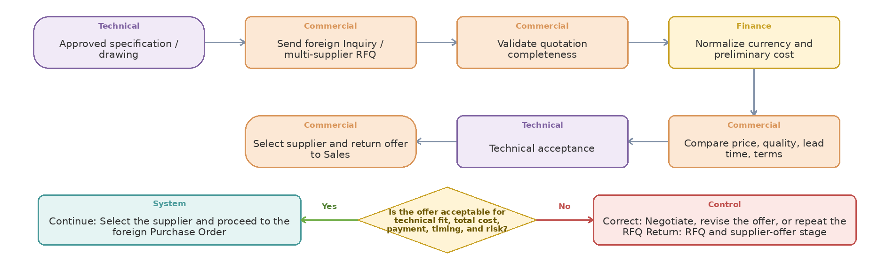
Step owner | Action or control | Operational document or system record | Handoff to
Technical | Approved specification / drawing | Technical Evaluation and Approval Form | Commercial
Commercial | Send foreign Inquiry / multi-supplier RFQ | RFQ and Comparison Record | Commercial
Commercial | Validate quotation completeness | Offer / PI / Contract Revision | Finance
Finance | Normalize currency and preliminary cost | Activity, Status, and Attachment Record in the Odoo Case | Commercial
Commercial | Compare price, quality, lead time, terms | Technical Evaluation and Approval Form | Technical
Technical | Technical acceptance | Test Scenario and Acceptance Approval | Commercial
Commercial | Select supplier and return offer to Sales | Return Request / Claim File | Case closure / downstream stakeholder

Process 4 Requirements — Foreign supplier Inquiry/RFQ, quotation comparison, and commercial offer
Technical requirements, supplier responses, preliminary import cost, comparison, negotiation, and the offer returned to Sales should remain connected and revision-controlled.
Decision Logic and Return Path
Decision gate | Yes path | No or exception path | Return to
Is the offer acceptable for technical fit, total cost, payment, timing, and risk? | Select the supplier and proceed to the foreign Purchase Order | Negotiate, revise the offer, or repeat the RFQ | RFQ and supplier-offer stage
Confirmed current state
- The approved process covers supplier search, Inquiry/RFQ, missing-response follow-up, quotation control, preliminary freight/clearance estimate, supplier comparison, negotiation, and a technical/financially controlled Offer to Sales.
- Quotation checks include item/code/specification, quantity/UoM, price, currency, validity, lead time, payment, Incoterm, packing, shipping, documentation, warranty/claim terms, and technical compliance.
- Foreign Procurement currently prepares offers from price lists or quotations using the Finance formula and requests freight/clearance estimates when needed.
Odoo requirements and data rules
- One sourcing request should support multiple RFQs and supplier quotations with a comparable line-level view and retained original documents.
- Comparison should normalize currency, UoM, tax/duty assumptions, freight, insurance, clearance, and payment timing while preserving the original supplier offer.
- Technical acceptability, approved supplier status, lead time, total expected cost, supplier risk, and deviation from requested specification must be visible before selection.
- Negotiation revisions, selected/rejected supplier reason, approval, and the final commercial offer to Sales must be traceable.
Approval and exception rules
- Single-source purchase, non-approved supplier, specification deviation, price variance, expired quotation, high-risk country/route, unusual payment terms, or Incoterm exception should require defined approval.
- When price, currency, lead time, payment terms, Incoterm, quantity, or specification changes after approval, the relevant approval should reset according to the final matrix.
Workshop demonstration and acceptance
- Demo three supplier RFQs, one incomplete response, currency/UoM normalization, landed estimate, technical rejection of one option, commercial selection, approval, and an offer returned to the linked Sales opportunity.
- Bring one anonymized supplier quotation set and the actual comparison/offer calculation used today.
Workshop result
Coverage: Standard Odoo ☐ Configuration ☐ Odoo Studio ☐ Custom Development ☐ Integration ☐ Alternative Solution ☐ | Limitation and decision: ................................................

Process 5 — Domestic sourcing by Sales for a customer order
Start: Customer-order shortage that can be sourced inside the country | End: Receipt, financial posting, outbound issue, and customer delivery completed. The diagram moves left to right and continues right to left on the second row; the lower diamond shows the Yes, No, correction, and return paths.
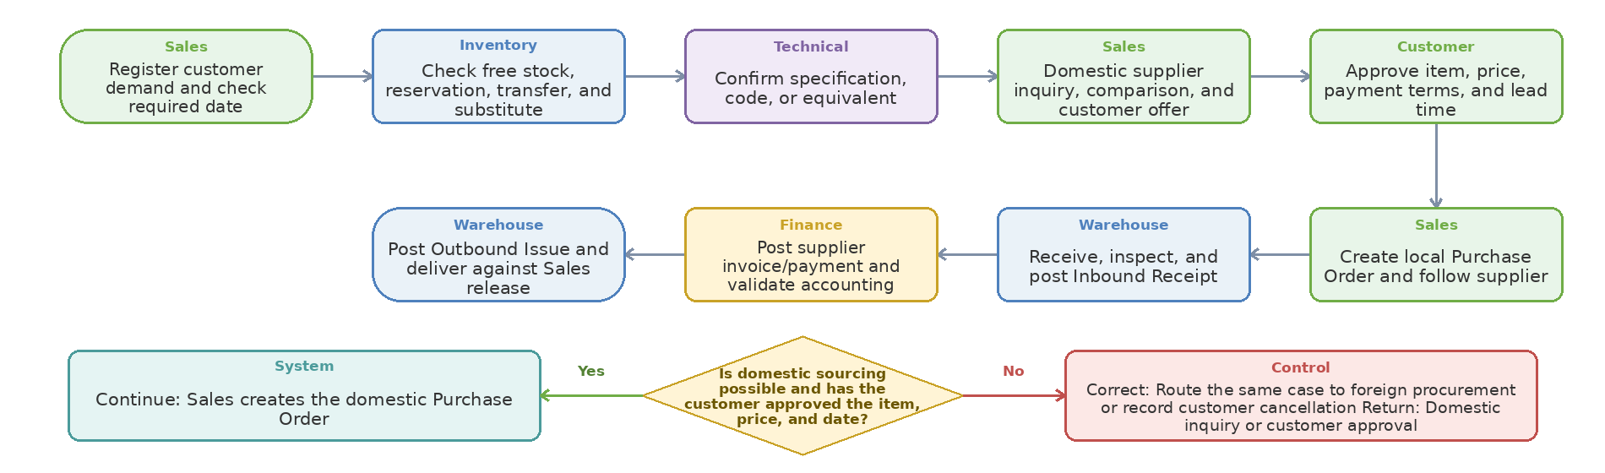
Step owner | Action or control | Operational document or system record | Handoff to
Sales | Register customer demand and check required date | Identified Request with Attachments | Inventory
Inventory | Check free stock, reservation, transfer, and substitute | Stock, Reservation, and Allocation Record | Technical
Technical | Confirm specification, code, or equivalent | Technical Evaluation and Approval Form | Sales
Sales | Domestic supplier inquiry, comparison, and customer offer | RFQ and Comparison Record | Customer
Customer | Approve item, price, payment terms, and lead time | Related Financial Document, Approval, or Invoice | Sales
Sales | Create local Purchase Order and follow supplier | Domestic Purchase Order | Warehouse
Warehouse | Receive, inspect, and post Inbound Receipt | Inbound Receipt / Goods Receipt | Finance
Finance | Post supplier invoice/payment and validate accounting | Related Financial Document, Approval, or Invoice | Warehouse
Warehouse | Post Outbound Issue and deliver against Sales release | Outbound Issue / Delivery Order | Case closure / downstream stakeholder

Process 5 Requirements — Domestic sourcing by Sales for a customer order
Domestic sourcing is owned by Sales. It applies when the requested item is unavailable in free stock but can be sourced inside the country; Commercial is not the owner of this route.
Decision Logic and Return Path
Decision gate | Yes path | No or exception path | Return to
Is domestic sourcing possible and has the customer approved the item, price, and date? | Sales creates the domestic Purchase Order | Route the same case to foreign procurement or record customer cancellation | Domestic inquiry or customer approval
Domestic sourcing ownership and trigger
- Sales owns the domestic supplier inquiry, comparison, negotiation, local Purchase Order, supplier follow-up, and customer commitment.
- The route begins only after Inventory confirms a net shortage and Technical confirms the required item, code, or approved equivalent.
- If the item cannot be sourced inside the country, Sales hands the same case to Commercial for foreign procurement without creating a duplicate demand.
Warehouse and financial documents
- Warehouse posts the Inbound Receipt against the local Purchase Order, received quantity, condition, location, lot/serial where required, and any shortage or rejection.
- Finance posts or validates the supplier invoice, payment, taxes, payable, and accounting entries; Finance must not edit the physical received quantity.
- After Sales and Finance release, Warehouse posts the Outbound Issue/Delivery Order and delivers the item against the customer Sales Order.
- Sales creates the customer Sales Order and invoicing request; Finance posts or validates the sales invoice and receivable according to the approved access matrix.
Control and exceptions
- Partial stock must be reserved first and only the net shortage purchased; partial receipt and backorder remain linked to the same customer order.
- Wrong item, quantity variance, damage, or failed QC moves to quarantine and cannot be issued until disposition is approved.
- Cancellation after local ordering must release reservations, stop delivery, and trigger supplier, warehouse, and financial correction steps.
Workshop demonstration and reports
- Demo: customer shortage -> domestic inquiry by Sales -> customer approval -> local PO -> Inbound Receipt -> supplier invoice/payment -> Outbound Issue -> sales invoice -> customer delivery.
- Reports: open domestic requests, supplier response time, local PO status, pending receipts, pending supplier invoices, orders waiting for stock, and cancellation reason.
Workshop result
Coverage: Standard Odoo ☐ Configuration ☐ Odoo Studio ☐ Custom Development ☐ Integration ☐ Alternative Solution ☐ | Limitation and decision: ................................................

Process 6 — Foreign purchase pre-order, PI/contract, approval, and Purchase Order
Start: Confirmed foreign-purchase need with specification and quantity | End: Approved foreign Purchase Order with active milestones. The diagram moves left to right and continues right to left on the second row; the lower diamond shows the Yes, No, correction, and return paths.
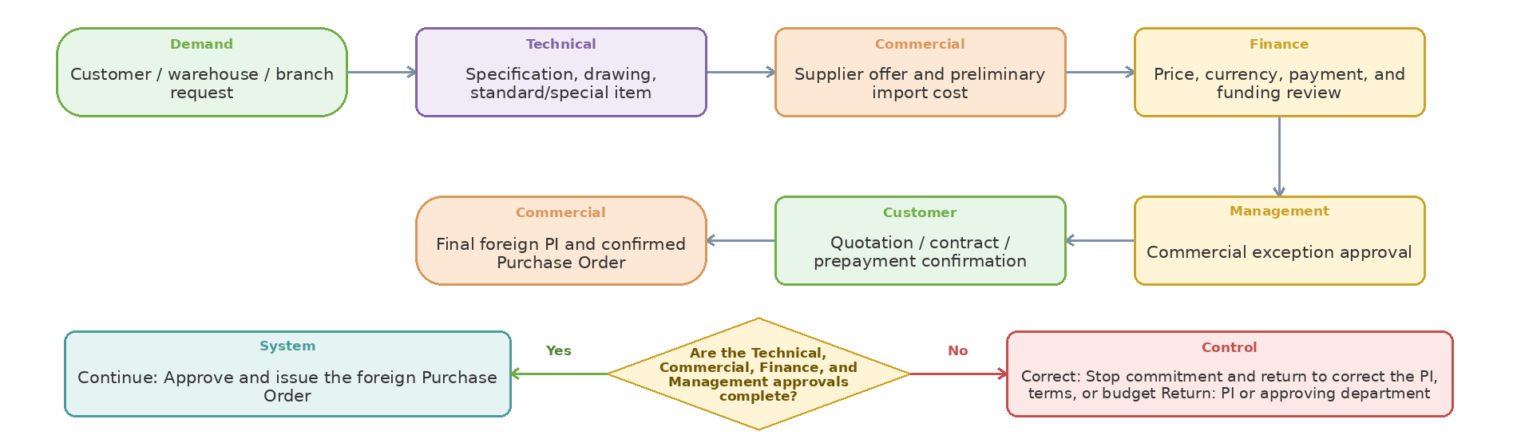
Step owner | Action or control | Operational document or system record | Handoff to
Demand | Customer / warehouse / branch request | Identified Request with Attachments | Technical
Technical | Specification, drawing, standard/special item | Technical Evaluation and Approval Form | Commercial
Commercial | Supplier offer and preliminary import cost | Offer / PI / Contract Revision | Finance
Finance | Price, currency, payment, and funding review | Related Financial Document, Approval, or Invoice | Management
Management | Commercial exception approval | Activity, Status, and Attachment Record in the Odoo Case | Customer
Customer | Quotation / contract / prepayment confirmation | Offer / PI / Contract Revision | Commercial
Commercial | Final foreign PI and confirmed Purchase Order | Offer / PI / Contract Revision | Case closure / downstream stakeholder

Process 6 Requirements — Foreign purchase pre-order, PI/contract, approval, and Purchase Order
Foreign purchasing begins with an approved technical/commercial need and must make every financial, managerial, customer, and supplier gate explicit before the final order is released.
Decision Logic and Return Path
Decision gate | Yes path | No or exception path | Return to
Are the Technical, Commercial, Finance, and Management approvals complete? | Approve and issue the foreign Purchase Order | Stop commitment and return to correct the PI, terms, or budget | PI or approving department
Confirmed foreign-procurement scope
- The workflow covers internal and external sourcing, commercial correspondence, Inquiry, supplier offer/quotation, PI, PO, packing list, documents, payment, shipment, import registration, customs clearance, delivery to Warehouse, and cost close.
- Current foreign-request data includes standard/special item, customer, technical owner, drawing availability, Inquiry Form, Incoterm such as CPT or DDP, offer, Finance/Management approvals, contract/proforma, payment/prepayment, supplier drawing/invoice, final Technical review, ordering, and coding.
- The Key Account route adds pricing, Finance, Management, and Technical controls but should be a rule on the standard process unless a genuine separate lifecycle is required.
PO and agreement requirements
- A Purchase Agreement/contract should retain validity, committed quantity/value, call-off usage, revision, renewal, attachments, and change approval where applicable.
- The final PI and PO must reference the request, Sales Order/customer or stock purpose, supplier quotation, selected Incoterm, currency/rate basis, items, lead time, payment schedule, packaging, inspection, shipping, and required documents.
- Draft PO, Approved PO, Sent/Confirmed PO, Amended PO, Partially Received, Fully Received, Closed, and Cancelled states must be distinct and auditable.
- Partial delivery, supplier substitution, order amendment, quantity/price/Incoterm change, and cancellation must preserve revisions and reset approvals when required.
Purchase-start gate and controls
- TBC: define the exact purchase-start gate as customer confirmation, signed contract, prepayment, Finance approval, Management approval, or a rule-based combination.
- No final supplier order should be released when the required technical specification, supplier status, budget/funding, customer commitment, or approval is incomplete.
- For stock replenishment, customer confirmation may not apply; the request type should select the correct approval path without creating a separate disconnected workflow.
Workshop demonstration and acceptance
- Demo customer-driven foreign purchase and warehouse replenishment using the same core model but different approval triggers, including PI revision and PO amendment.
- Bring one real anonymized Inquiry, quotation/PI, contract or approval, final PO, and supplier confirmation.
Workshop result
Coverage: Standard Odoo ☐ Configuration ☐ Odoo Studio ☐ Custom Development ☐ Integration ☐ Alternative Solution ☐ | Limitation and decision: ................................................

Process 7 — Import registration, foreign exchange allocation, and banking milestones
Start: Foreign Purchase Order and import-registration file | End: Approved import registration and FX allocation with commitments recorded. The diagram moves left to right and continues right to left on the second row; the lower diamond shows the Yes, No, correction, and return paths.
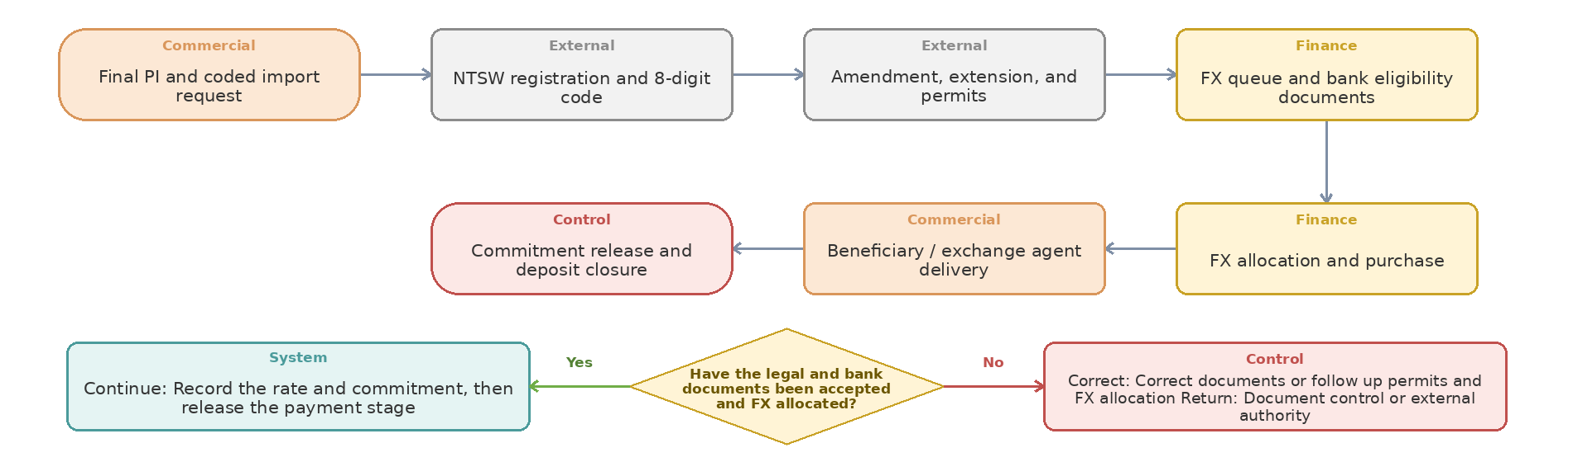
Step owner | Action or control | Operational document or system record | Handoff to
Commercial | Final PI and coded import request | Offer / PI / Contract Revision | External
External | NTSW registration and 8-digit code | Activity, Status, and Attachment Record in the Odoo Case | External
External | Amendment, extension, and permits | Import Registration and Permit File | Finance
Finance | FX queue and bank eligibility documents | Related Financial Document, Approval, or Invoice | Finance
Finance | FX allocation and purchase | Related Financial Document, Approval, or Invoice | Commercial
Commercial | Beneficiary / exchange agent delivery | Outbound Issue / Delivery Order | Control
Control | Commitment release and deposit closure | Activity, Status, and Attachment Record in the Odoo Case | Case closure / downstream stakeholder

Process 7 Requirements — Import registration, foreign exchange allocation, and banking milestones
Iran-specific registration and banking steps should be controlled as one import case with documents, milestone dates, owners, blockers, and audit history even where direct external integration is unavailable.
Decision Logic and Return Path
Decision gate | Yes path | No or exception path | Return to
Have the legal and bank documents been accepted and FX allocated? | Record the rate and commitment, then release the payment stage | Correct documents or follow up permits and FX allocation | Document control or external authority
Confirmed current-state milestones
- The workflow includes NTSW registration, 8-digit registration code, amendments/extensions, Ministry/bank/system permits, FX-allocation queue, bank documentation, eligibility decision, FX purchase, beneficiary/exchange-agent information, and receipt of payment confirmation.
- After shipment and clearance, customs documents are submitted to the bank for foreign-exchange commitment release and deposit release; the file cannot close while an obligation remains open.
- Tracked risks include permit refusal, FX non-allocation, expiry, policy changes, document errors, liquidity delay, and failure to release the FX commitment.
Odoo case and data requirements
- One Import Registration record should link PI/PO, registration number, HS/customs code, currency/value, bank, queue date/status, permits, expiry/extension dates, FX allocation, purchased amount/rate, beneficiary, exchange agent, documents, owner, and next action.
- Milestones need due dates, reminders, aging, blocker reasons, escalation, and revision history; uploading a document alone is not sufficient workflow control.
- Registration amount, PO amount, paid amount, shipped amount, customs value, and received amount should reconcile with explained variances.
Integration boundary and open decisions
- TBC: determine whether NTSW, bank, and external permit statuses are entered manually, imported from files, or integrated. Each method requires an owner and reconciliation control.
- The system should prevent closure when a permit, payment evidence, customs document, commitment release, or financial reconciliation remains open.
Required demo and reports
- Demo one import case from PI through registration, expiry alert, amendment, FX queue, allocation, purchase, beneficiary payment, clearance, and FX-commitment closure.
- Reports: registrations by status/expiry, queue aging, allocation time, permit delays, FX purchased vs. paid, open commitments, and documents missing for closure.
Workshop result
Coverage: Standard Odoo ☐ Configuration ☐ Odoo Studio ☐ Custom Development ☐ Integration ☐ Alternative Solution ☐ | Limitation and decision: ................................................

Process 8 — Supplier, freight, and international payment workflow
Start: Payment request linked to an order, contract, and due date | End: Reconciled payment and updated supplier balance. The diagram moves left to right and continues right to left on the second row; the lower diamond shows the Yes, No, correction, and return paths.
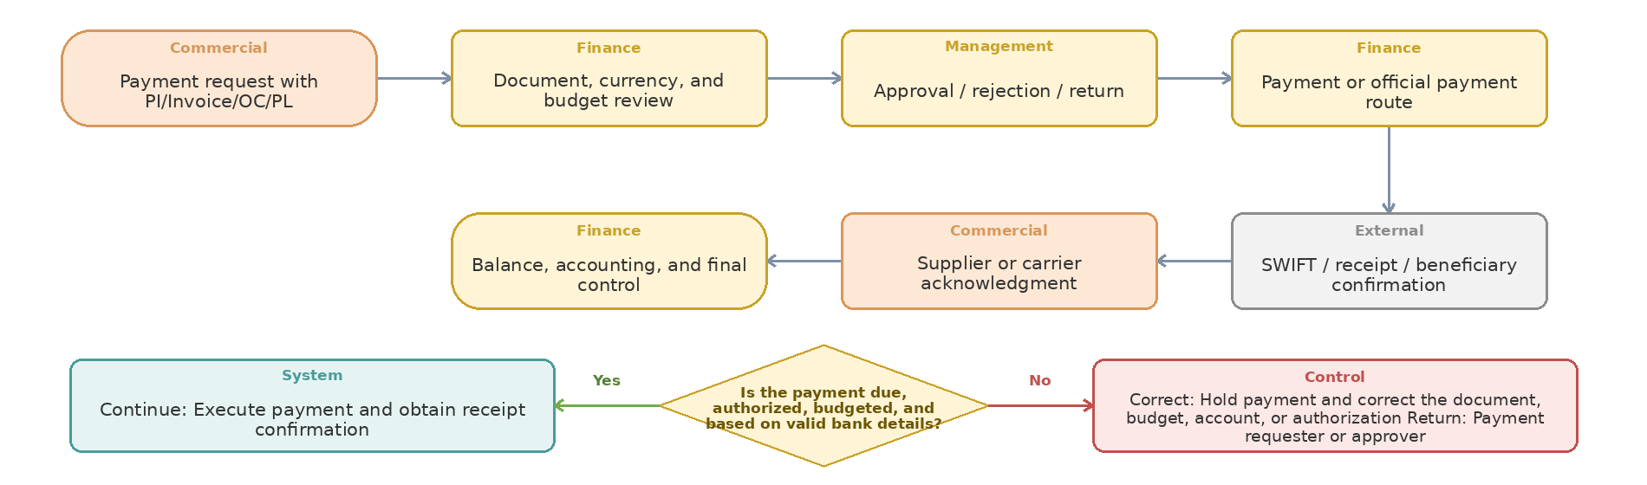
Step owner | Action or control | Operational document or system record | Handoff to
Commercial | Payment request with PI/Invoice/OC/PL | Offer / PI / Contract Revision | Finance
Finance | Document, currency, and budget review | Related Financial Document, Approval, or Invoice | Management
Management | Approval / rejection / return | Return Request / Claim File | Finance
Finance | Payment or official payment route | Related Financial Document, Approval, or Invoice | External
External | SWIFT / receipt / beneficiary confirmation | Activity, Status, and Attachment Record in the Odoo Case | Commercial
Commercial | Supplier or carrier acknowledgment | Shipment File, Packing List, and Tracking Record | Finance
Finance | Balance, accounting, and final control | Activity, Status, and Attachment Record in the Odoo Case | Case closure / downstream stakeholder

Process 8 Requirements — Supplier, freight, and international payment workflow
Supplier and logistics payments require controlled requests, supporting evidence, budget and management approval, SWIFT/receipt, balance tracking, and final reconciliation without exposing sensitive data to unrelated users.
Decision Logic and Return Path
Decision gate | Yes path | No or exception path | Return to
Is the payment due, authorized, budgeted, and based on valid bank details? | Execute payment and obtain receipt confirmation | Hold payment and correct the document, budget, account, or authorization | Payment requester or approver
Payment request inputs and milestones
- International funds requests capture request text, amount, beneficiary, detailed Excel, and related proforma/invoice; they pass Finance, budget, CEO approval, payment, completion of payment documents, and final control.
- Transport-payment workflows include freight data, supervisor and Finance review, invoice, official/non-official payment paths, accounting documents, final financial control, and archive.
- Foreign-purchase payments include initial and remaining-balance requests, receipts/SWIFT, partial payment, supplier/foreign-office follow-up, and open balance.
Required data and controls
- Payment request should link PO, supplier/carrier, invoice/PI/OC, installment, amount/currency, due date, beneficiary/bank, budget/cost center, shipment, attachments, and requester.
- Track requested, approved, paid, rejected/returned, partially paid, remaining, due/overdue, and reconciled states; the Commercial view may expose status and amount only according to access policy.
- Duplicate invoice/payment detection, maker-checker control for bank changes, payment-term validation, and audit of approval/payment evidence are required.
Open decisions and reports
- Define approval thresholds and who may change beneficiary, bank, currency, installment, or amount after approval.
- Decide whether payments are created/posted in Odoo Accounting, Sepidar, or through controlled integration; one accounting source of truth is required.
- Reports: payment requests by status/age, due supplier balances, advance balances, freight payments, SWIFT missing, payment cycle time, and PO-to-payment reconciliation.
Required demo
- Demo an advance plus balance payment with returned documentation, corrected request, approval, partial payment, SWIFT upload, supplier acknowledgment, and final reconciliation.
Workshop result
Coverage: Standard Odoo ☐ Configuration ☐ Odoo Studio ☐ Custom Development ☐ Integration ☐ Alternative Solution ☐ | Limitation and decision: ................................................

Process 9 — Supplier preparation, inspection, packing list, shipment, and ETA
Start: Approved foreign order and supplier readiness notice | End: Tracked shipment pre-advised to Customs and Warehouse. The diagram moves left to right and continues right to left on the second row; the lower diamond shows the Yes, No, correction, and return paths.
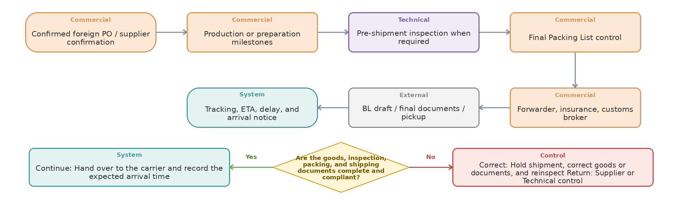
Step owner | Action or control | Operational document or system record | Handoff to
Commercial | Confirmed foreign PO / supplier confirmation | Foreign Purchase Order | Commercial
Commercial | Production or preparation milestones | Activity, Status, and Attachment Record in the Odoo Case | Technical
Technical | Pre-shipment inspection when required | Technical Evaluation and Approval Form | Commercial
Commercial | Final Packing List control | Shipment File, Packing List, and Tracking Record | Commercial
Commercial | Forwarder, insurance, customs broker | Customs Clearance File | External
External | BL draft / final documents / pickup | Offer / PI / Contract Revision | System
System | Tracking, ETA, delay, and arrival notice | Inbound Receipt / Goods Receipt | Case closure / downstream stakeholder

Process 9 Requirements — Supplier preparation, inspection, packing list, shipment, and ETA
After PO confirmation, supplier milestones and logistics events should be visible as a controlled shipment lifecycle rather than scattered emails and manual follow-up.
Decision Logic and Return Path
Decision gate | Yes path | No or exception path | Return to
Are the goods, inspection, packing, and shipping documents complete and compliant? | Hand over to the carrier and record the expected arrival time | Hold shipment, correct goods or documents, and reinspect | Supplier or Technical control
Confirmed current-state activities
- Commercial follows supplier confirmation, production/preparation milestones, revised ETA, partial readiness, and corrective action until Ready for Shipment.
- Final Packing List is checked against PO for item, quantity, weight, packaging, and discrepancies before shipment; BL draft, invoice, Packing List, COO, and registration data are reconciled before final approval.
- The approved process includes pre-shipment inspection, forwarder selection, customs-broker selection, cargo insurance, rate/route/method comparison, pickup, flight/route information, final BL, tracking, ETA, and delay/damage handling.
Odoo shipment requirements
- A shipment may consolidate multiple POs or split one PO; maintain shipment-to-PO-line allocation, packages, weights/volumes, carrier/forwarder, route, Incoterm, owner, planned/actual dates, and documents.
- Milestones should include supplier confirmed, in production, inspection planned/passed/failed, ready, picked up, departed, in transit, arrived, documents received, customs started, cleared, delivered to Warehouse, and closed.
- Delays, partial shipment, route change, damaged/missing packages, inspection failure, and missing/incorrect documents require reason, impact, next action, revised ETA, and notification to relevant followers.
Visibility and confidentiality
- Sales should see customer-relevant status and ETA; Warehouse should see expected items/packages and planned arrival; Finance should see cost/payment milestones; sensitive supplier/banking data should remain restricted.
- Notifications should go to record followers or defined roles, not every user, and material status changes should be logged.
Required demo and reports
- Demo one PO split into two shipments and one consolidated shipment with multiple POs; show PL control, document revision, ETA change, partial arrival, and role-based visibility.
- Reports: open/late POs, supplier milestone aging, shipments by status, revised ETA, freight mode/route, document errors, inspection outcome, and on-time shipment/delivery.
Workshop result
Coverage: Standard Odoo ☐ Configuration ☐ Odoo Studio ☐ Custom Development ☐ Integration ☐ Alternative Solution ☐ | Limitation and decision: ................................................

Process 10 — Customs clearance, legal charges, landed cost, and import-file closure
Start: Shipment arrival with clearance documents complete | End: Warehouse delivery, landed cost, and import file closed. The diagram moves left to right and continues right to left on the second row; the lower diamond shows the Yes, No, correction, and return paths.
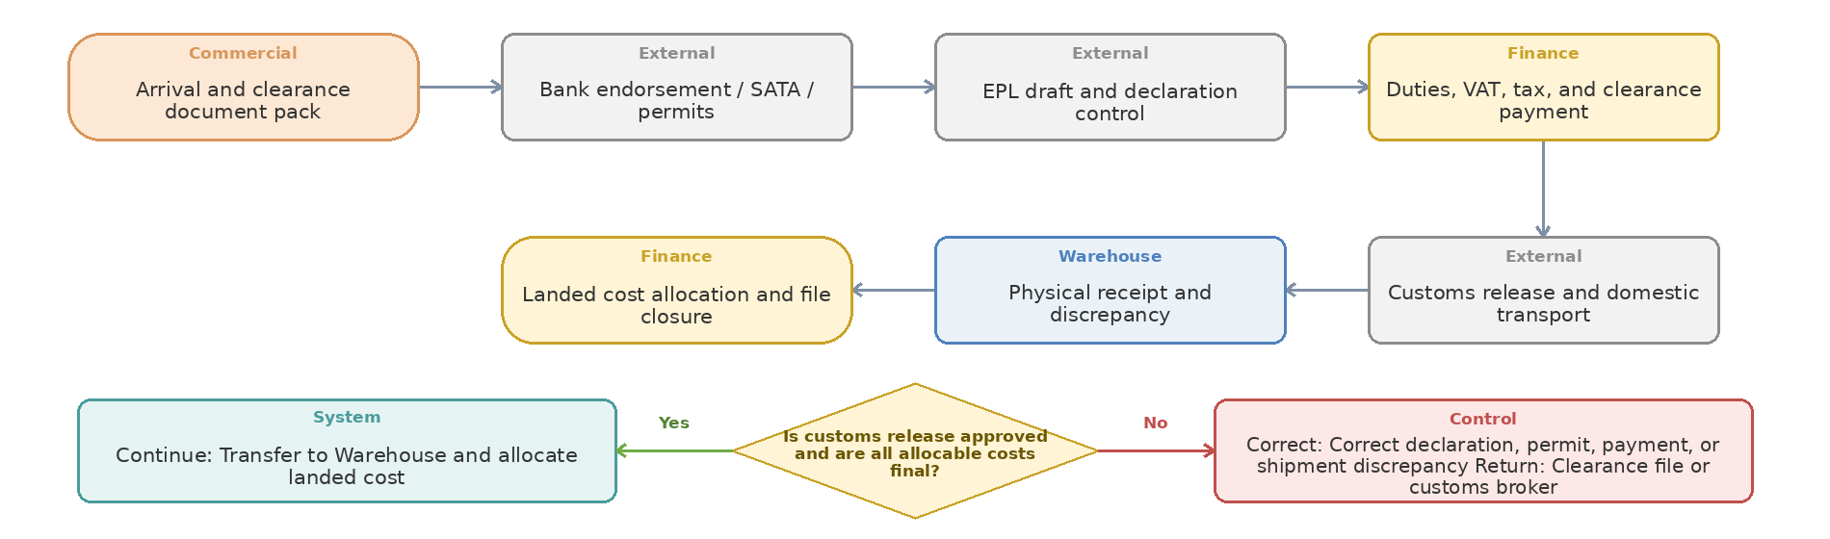
Step owner | Action or control | Operational document or system record | Handoff to
Commercial | Arrival and clearance document pack | Inbound Receipt / Goods Receipt | External
External | Bank endorsement / SATA / permits | Import Registration and Permit File | External
External | EPL draft and declaration control | Customs Clearance File | Finance
Finance | Duties, VAT, tax, and clearance payment | Related Financial Document, Approval, or Invoice | External
External | Customs release and domestic transport | Customs Clearance File | Warehouse
Warehouse | Physical receipt and discrepancy | Activity, Status, and Attachment Record in the Odoo Case | Finance
Finance | Landed cost allocation and file closure | Related Financial Document, Approval, or Invoice | Case closure / downstream stakeholder

Process 10 Requirements — Customs clearance, legal charges, landed cost, and import-file closure
Clearance and landed cost should connect legal documents and actual costs to the shipment, receipt, inventory value, Finance, and final import-file closure.
Decision Logic and Return Path
Decision gate | Yes path | No or exception path | Return to
Is customs release approved and are all allocable costs final? | Transfer to Warehouse and allocate landed cost | Correct declaration, permit, payment, or shipment discrepancy | Clearance file or customs broker
Confirmed current-state clearance route
- The process includes BL, warehouse receipt, release order, Packing List, invoice, road permit, bank endorsement, inspection certificate where applicable, NTSW clearance permission, SATA code, EPL draft, declaration control, final declaration, duties/taxes, customs reference, release, and delivery to Warehouse.
- Documents and values are checked against import registration and purchase documents; discrepancy in HS code, value, quantity, origin, or document content returns for correction.
- High risks include document errors, sudden customs-law change, permit delay, valuation dispute, EPL interruption, demurrage, and capital tied up at customs.
Landed-cost requirements
- Collect estimated and actual purchase price, FX effects, bank/transfer fees, freight, insurance, inspection, customs duty, VAT/tax where capitalized, clearance, demurrage/storage, domestic transport, and other attributable charges by shipment.
- Allocation method must be configurable by value, quantity, weight, volume, or a defined product/category rule and should retain calculation evidence and adjustments.
- TBC: Finance must approve which cost elements are capitalized, expensed, recoverable, or excluded, and how provisional cost is adjusted after late invoices.
- Actual landed cost should reconcile to PO/receipt/inventory valuation and support estimated-vs-actual variance reporting.
Closure controls
- Do not close the import file until receipt quantities, QC/claims, supplier payment, freight/clearance invoices, customs documents, landed cost, financial posting, and FX-commitment obligations are reconciled.
- Open-item checklist, owner, due date, aging, and closure approval are required; reopening must preserve reason and audit trail.
Required demo and reports
- Demo one shipment with two products, multiple cost invoices, provisional then actual cost, allocation by weight/value, partial receipt, claim, and final cost/closure reconciliation.
- Reports: clearance cycle time, customs delays/reasons, estimated-vs-actual landed cost, logistics cost per unit, duty/tax, demurrage, open import files, and unreleased FX commitments.
Workshop result
Coverage: Standard Odoo ☐ Configuration ☐ Odoo Studio ☐ Custom Development ☐ Integration ☐ Alternative Solution ☐ | Limitation and decision: ................................................

Process 11 — Warehouse receiving, Incoming QC, coding, traceability, and putaway
Start: Physical arrival notice linked to an order, transfer, or return reference | End: Stock put away or rejected stock dispositioned, with value recorded. The diagram moves left to right and continues right to left on the second row; the lower diamond shows the Yes, No, correction, and return paths.
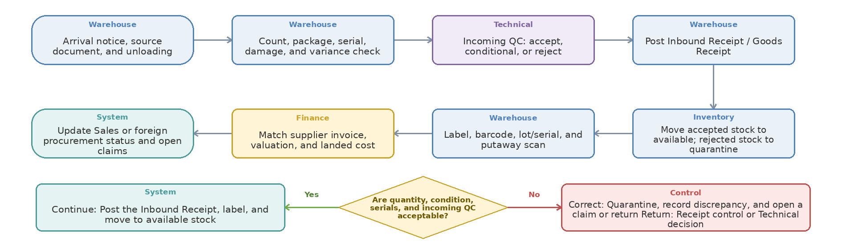
Step owner | Action or control | Operational document or system record | Handoff to
Warehouse | Arrival notice, source document, and unloading | Inbound Receipt / Goods Receipt | Warehouse
Warehouse | Count, package, serial, damage, and variance check | Consumption, Expense, or Write-off Approval | Technical
Technical | Incoming QC: accept, conditional, or reject | Access Matrix and Approval History | Warehouse
Warehouse | Post Inbound Receipt / Goods Receipt | Inbound Receipt / Goods Receipt | Inventory
Inventory | Move accepted stock to available; rejected stock to quarantine | Access Matrix and Approval History | Warehouse
Warehouse | Label, barcode, lot/serial, and putaway scan | Item Card, Barcode, Serial/Lot, or Location Record | Finance
Finance | Match supplier invoice, valuation, and landed cost | Related Financial Document, Approval, or Invoice | System
System | Update Sales or foreign procurement status and open claims | Return Request / Claim File | Case closure / downstream stakeholder

Process 11 Requirements — Warehouse receiving, Incoming QC, coding, traceability, and putaway
Physical receipt must distinguish arrival, counting, quarantine, Technical QC, accepted/rejected quantity, system receipt, coding/labeling, and final putaway.
Decision Logic and Return Path
Decision gate | Yes path | No or exception path | Return to
Are quantity, condition, serials, and incoming QC acceptable? | Post the Inbound Receipt, label, and move to available stock | Quarantine, record discrepancy, and open a claim or return | Receipt control or Technical decision
Inbound receipt triggers
- Create an expected receipt from a foreign Purchase Order, Sales-owned local Purchase Order, inter-warehouse transfer, customer return, supplier replacement, or test/consignment return.
- Warehouse checks packages, quantity, serial/lot, visible damage, and source document before posting any physical receipt.
- Technical records the QC decision; Technical does not post the warehouse receipt and Finance does not change the physical received quantity.
Inbound Receipt / Goods Receipt ownership
- Warehouse creates and validates the Inbound Receipt with source document, received and rejected quantity, receipt date, warehouse/location, lot/serial, package, and discrepancy reason.
- Accepted quantity moves to an available or putaway location; uncertain or rejected quantity moves to quarantine and never appears as free-to-sell.
- Partial receipt leaves the remaining Purchase Order or transfer quantity open as a backorder; over-receipt requires an explicit tolerance and approval rule.
- Correction must use return, reversal, or controlled adjustment with history; a posted receipt must not be silently overwritten.
Finance, valuation, and follow-up
- Finance matches the supplier invoice to the Purchase Order and Inbound Receipt, posts payable/tax, and applies landed cost where relevant.
- Quantity or quality variance creates a supplier or carrier claim owned by Sales for domestic suppliers and Commercial for foreign suppliers.
- Inventory value is posted only after the required receipt, invoice, cost, and approval conditions are met; unresolved value differences remain visible.
Workshop demonstration and reports
- Demo: partial receipt with damage -> Inbound Receipt -> quarantine -> split QC result -> accepted putaway -> rejected return/claim -> invoice matching and remaining backorder.
- Reports: expected receipts, unposted receipts, QC waiting, quarantine, receipt variance, PO balance, invoice mismatch, and receipt-to-availability cycle time.
Workshop result
Coverage: Standard Odoo ☐ Configuration ☐ Odoo Studio ☐ Custom Development ☐ Integration ☐ Alternative Solution ☐ | Limitation and decision: ................................................

Process 12 — Stock visibility, inventory states, reservation, and shortage handling
Start: Sales or reservation demand with item, quantity, and required date | End: Valid reservation, shortage-recovery route, or release recorded. The diagram moves left to right and continues right to left on the second row; the lower diamond shows the Yes, No, correction, and return paths.
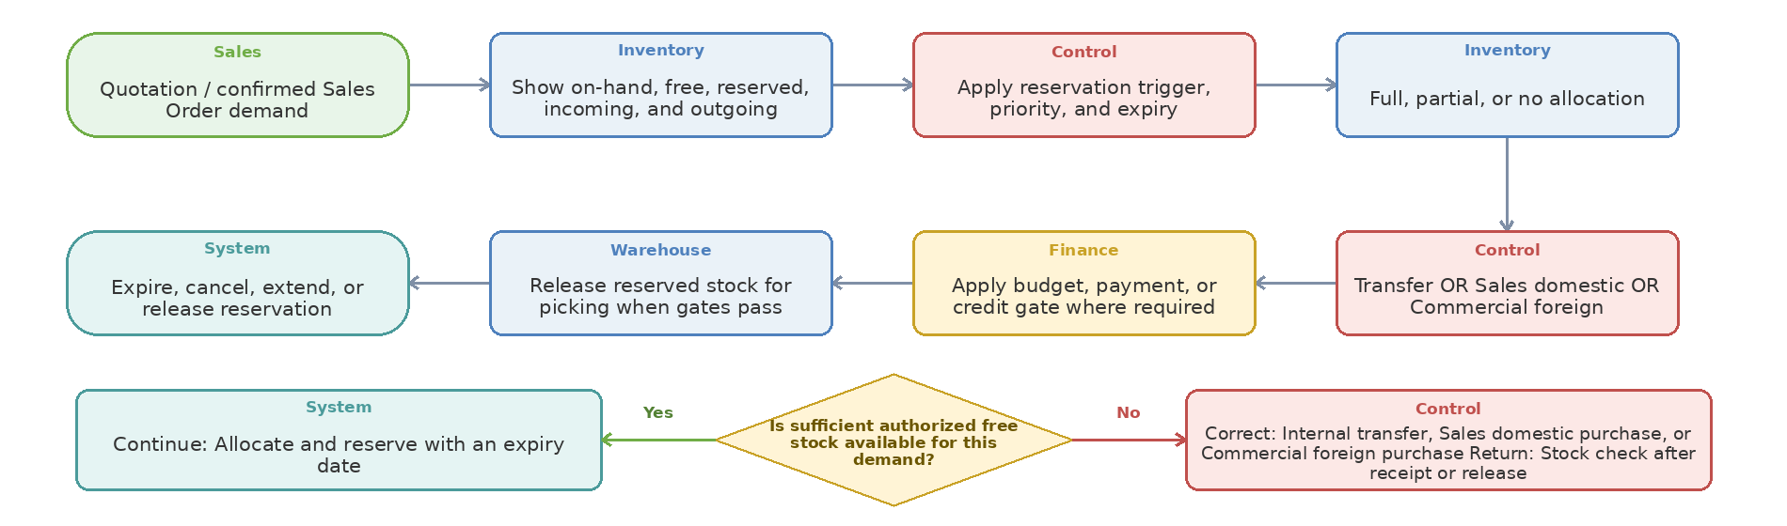
Step owner | Action or control | Operational document or system record | Handoff to
Sales | Quotation / confirmed Sales Order demand | Offer / PI / Contract Revision | Inventory
Inventory | Show on-hand, free, reserved, incoming, and outgoing | Stock, Reservation, and Allocation Record | Control
Control | Apply reservation trigger, priority, and expiry | Offer / PI / Contract Revision | Inventory
Inventory | Full, partial, or no allocation | Stock, Reservation, and Allocation Record | Control
Control | Transfer OR Sales domestic OR Commercial foreign | Activity, Status, and Attachment Record in the Odoo Case | Finance
Finance | Apply budget, payment, or credit gate where required | Related Financial Document, Approval, or Invoice | Warehouse
Warehouse | Release reserved stock for picking when gates pass | Offer / PI / Contract Revision | System
System | Expire, cancel, extend, or release reservation | Offer / PI / Contract Revision | Case closure / downstream stakeholder

Process 12 Requirements — Stock visibility, inventory states, reservation, and shortage handling
Users need one reliable availability picture: physical on-hand, free, reserved, blocked/QC, test/consignment, incoming, outgoing, in transit, and forecasted quantity.
Decision Logic and Return Path
Decision gate | Yes path | No or exception path | Return to
Is sufficient authorized free stock available for this demand? | Allocate and reserve with an expiry date | Internal transfer, Sales domestic purchase, or Commercial foreign purchase | Stock check after receipt or release
Documented reservation current state
- The BPMS reservation request captures item, brand, quantity, customer, start date, and end date; it passes final approval and Warehouse approval to issue, or rejection to archive.
- Target stock management requires free/reserved/blocked/QC/test/consignment/return/in-transit states, partial reservation, shortage notification, conflict priority, expiry, and release after cancellation or financial rejection.
Odoo requirements
- Availability displayed from Sales and Purchase must separate on-hand from free-to-promise and show incoming/outgoing/forecasted dates without users switching to an external spreadsheet.
- TBC: reservation trigger at quotation, approved quotation, Sales Order, payment/credit release, or another milestone; define expiry, extension, priority, and manager override.
- Cancellation, quotation expiry, credit block, quantity reduction, customer change, or delivery-date change should update reservations and linked sourcing according to explicit rules.
- If only part is available, reserve the available quantity and route the net shortage to transfer or purchase while preserving one customer-order view.
- A net shortage routes to Sales for domestic sourcing when available in-country; only items unavailable in-country route to Commercial for foreign procurement.
Access and confidentiality
- A salesperson restricted to own quotations may see that quantity is reserved without access to another salesperson's customer, quotation value, price, or commercial details.
- Managers and authorized Inventory users may see reservation source and priority to resolve conflicts. Field/record access must be demonstrated, not assumed.
Required demo and reports
- Demo 50 units on hand with 25 already reserved: a second salesperson sees usable availability, restricted reservation details, partial allocation, shortage sourcing, expiry, cancellation, and automatic release.
- Reports: on-hand/free/reserved/blocked/incoming/outgoing/forecast, reservation aging/expiry, shortage, orders waiting for stock, and over-reservation exceptions.
Workshop result
Coverage: Standard Odoo ☐ Configuration ☐ Odoo Studio ☐ Custom Development ☐ Integration ☐ Alternative Solution ☐ | Limitation and decision: ................................................

Process 13 — Monthly replenishment, reorder rules, and internal transfers
Start: Reorder alert, demand forecast, or branch request | End: Transfer or purchase received and target stock reconciled. The diagram moves left to right and continues right to left on the second row; the lower diamond shows the Yes, No, correction, and return paths.
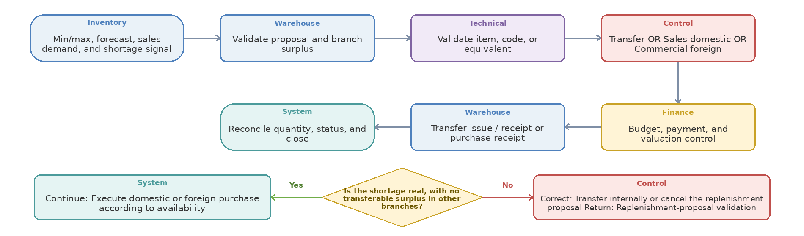
Step owner | Action or control | Operational document or system record | Handoff to
Inventory | Min/max, forecast, sales demand, and shortage signal | Identified Request with Attachments | Warehouse
Warehouse | Validate proposal and branch surplus | Activity, Status, and Attachment Record in the Odoo Case | Technical
Technical | Validate item, code, or equivalent | Technical Evaluation and Approval Form | Control
Control | Transfer OR Sales domestic OR Commercial foreign | Activity, Status, and Attachment Record in the Odoo Case | Finance
Finance | Budget, payment, and valuation control | Related Financial Document, Approval, or Invoice | Warehouse
Warehouse | Transfer issue / receipt or purchase receipt | Activity, Status, and Attachment Record in the Odoo Case | System
System | Reconcile quantity, status, and close | Reconciliation and Case-Closure Checklist | Case closure / downstream stakeholder

Process 13 Requirements — Monthly replenishment, reorder rules, and internal transfers
Warehouse replenishment and branch transfers should use demand, stock, reservations, incoming supply, lead time, and priority while keeping stock in transit and destination confirmation visible.
Decision Logic and Return Path
Decision gate | Yes path | No or exception path | Return to
Is the shortage real, with no transferable surplus in other branches? | Execute domestic or foreign purchase according to availability | Transfer internally or cancel the replenishment proposal | Replenishment-proposal validation
Documented monthly-order flow
- BPMS route: request -> Management approval -> Technical review -> pricing -> freight/clearance pricing -> Finance/budget -> Management -> ordering -> technical equivalency/Sepidar coding -> shipment/clearance -> warehouse receipt -> archive.
- The approved Warehouse process also supports shortage/overstock analysis, purchase or transfer proposal, same-warehouse location moves, inter-warehouse/branch transfer, stock in transit, destination receipt, and unresolved discrepancy.
Replenishment and transfer requirements
- Reorder proposals should consider free stock, reservations, confirmed demand, incoming POs/transfers, lead time, MOQ, pack size, safety stock, seasonality/forecast, and branch surplus.
- TBC: define min/max/reorder parameters and whether they are global, warehouse-specific, branch-specific, or product/category-specific.
- Inter-warehouse transfer requires request, source availability, approval, reservation, pick/pack, issue, in-transit state, destination receipt, quantity/condition discrepancy, and close.
- Destination confirmation must be independent from source dispatch; a transfer remains open until receiving discrepancy is resolved.
- Ownership rule: Sales executes domestic purchase; Commercial executes foreign purchase only; source Warehouse posts transfer issue and destination Warehouse posts transfer receipt.
Optional/scope boundary
- B2B backup, international-branch requests, Turkey/Dubai supply, direct production-material purchasing, outsourced production, and supplier rebate are documented supporting processes; decide which belong to the Iran implementation phase.
- If branches share one legal entity/database, access and warehouse rules should separate operational responsibility while supporting consolidated visibility.
Required demo and reports
- Demo a monthly proposal that chooses transfer for one item, local purchase for another, foreign purchase for a third, and no action where an open PO covers demand.
- Reports: below-minimum/above-maximum, safety-stock breach, open replenishment, transfer in transit, branch shortage/surplus, replenishment lead time, and proposal-to-action conversion.
Workshop result
Coverage: Standard Odoo ☐ Configuration ☐ Odoo Studio ☐ Custom Development ☐ Integration ☐ Alternative Solution ☐ | Limitation and decision: ................................................

Process 14 — Picking, packing, delivery, partial delivery, and proof of delivery
Start: Released Sales Order or specialist outbound request | End: Full or partial delivery, proof of receipt, and traceable balance. The diagram moves left to right and continues right to left on the second row; the lower diamond shows the Yes, No, correction, and return paths.
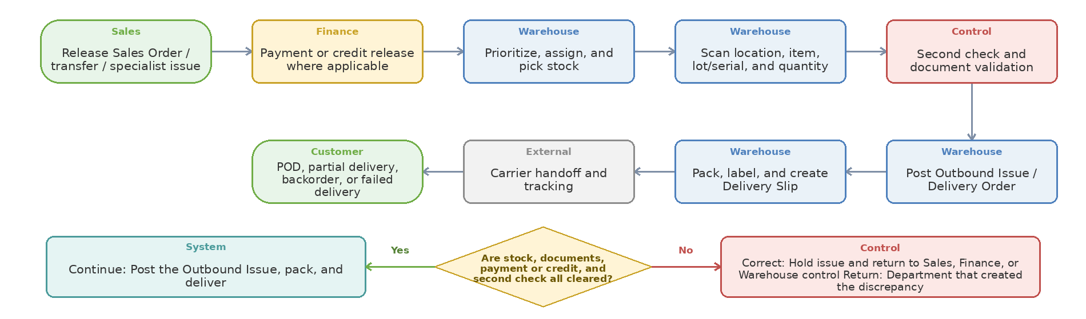
Step owner | Action or control | Operational document or system record | Handoff to
Sales | Release Sales Order / transfer / specialist issue | Activity, Status, and Attachment Record in the Odoo Case | Finance
Finance | Payment or credit release where applicable | Related Financial Document, Approval, or Invoice | Warehouse
Warehouse | Prioritize, assign, and pick stock | Offer / PI / Contract Revision | Warehouse
Warehouse | Scan location, item, lot/serial, and quantity | Item Card, Barcode, Serial/Lot, or Location Record | Control
Control | Second check and document validation | Activity, Status, and Attachment Record in the Odoo Case | Warehouse
Warehouse | Post Outbound Issue / Delivery Order | Outbound Issue / Delivery Order | Warehouse
Warehouse | Pack, label, and create Delivery Slip | Outbound Issue / Delivery Order | External
External | Carrier handoff and tracking | Shipment File, Packing List, and Tracking Record | Customer
Customer | POD, partial delivery, backorder, or failed delivery | Outbound Issue / Delivery Order | Case closure / downstream stakeholder

Process 14 Requirements — Picking, packing, delivery, partial delivery, and proof of delivery
Warehouse fulfillment should begin only after the required Sales/Finance/Technical release and should preserve item, quantity, serial/lot, package, carrier, delivery, and customer receipt evidence.
Decision Logic and Return Path
Decision gate | Yes path | No or exception path | Return to
Are stock, documents, payment or credit, and second check all cleared? | Post the Outbound Issue, pack, and deliver | Hold issue and return to Sales, Finance, or Warehouse control | Department that created the discrepancy
Outbound Issue / Delivery Order ownership
- Warehouse creates and validates the Outbound Issue/Delivery Order; Sales requests release and Finance provides payment/credit status where applicable but neither changes physical issued quantity.
- The outbound document must reference its trigger: Sales Order, inter-warehouse transfer, test/sample/consignment request, internal consumption, or supplier return.
- Stock is reduced or moved to an in-transit/third-party location only when the warehouse movement is validated; printing a document alone must not change stock.
Picking, checking, and packing
- Picking shows source location, reserved quantity, item, lot/serial, package, and destination; barcode scanning validates each controlled field where adopted.
- A second check is required for defined high-risk orders; wrong item, shortage, damaged packaging, missing release, or blocked stock prevents posting the outbound document.
- Delivery Slip and formal Packing List remain separate templates unless one approved template contains every required field.
Finance and delivery follow-up
- Sales creates the Sales Order and invoice request; Finance posts or validates the sales invoice, receivable, tax, and credit status according to the access matrix.
- Partial delivery leaves a backorder against the same Sales Order; delivered, remaining, cancelled, returned, invoiced, and paid quantities must reconcile.
- Carrier, tracking, dispatch date/time, delivery result, failed-delivery reason, and signed/digital POD remain linked to the outbound document.
Workshop demonstration and reports
- Demo: payment release -> picking -> second check -> Outbound Issue -> packing -> partial delivery -> POD -> backorder completion -> invoice reconciliation.
- Reports: unposted issues, picked-not-issued, issued-not-delivered, backorders, missing POD, delivery accuracy, and invoice/delivery mismatch.
Workshop result
Coverage: Standard Odoo ☐ Configuration ☐ Odoo Studio ☐ Custom Development ☐ Integration ☐ Alternative Solution ☐ | Limitation and decision: ................................................

Process 15 — Test items, technical samples, consignment, sale conversion, and expense treatment
Start: Test, sample, consignment, or display-item request | End: Approved return, extension, sale conversion, expense, or write-off. The diagram moves left to right and continues right to left on the second row; the lower diamond shows the Yes, No, correction, and return paths.
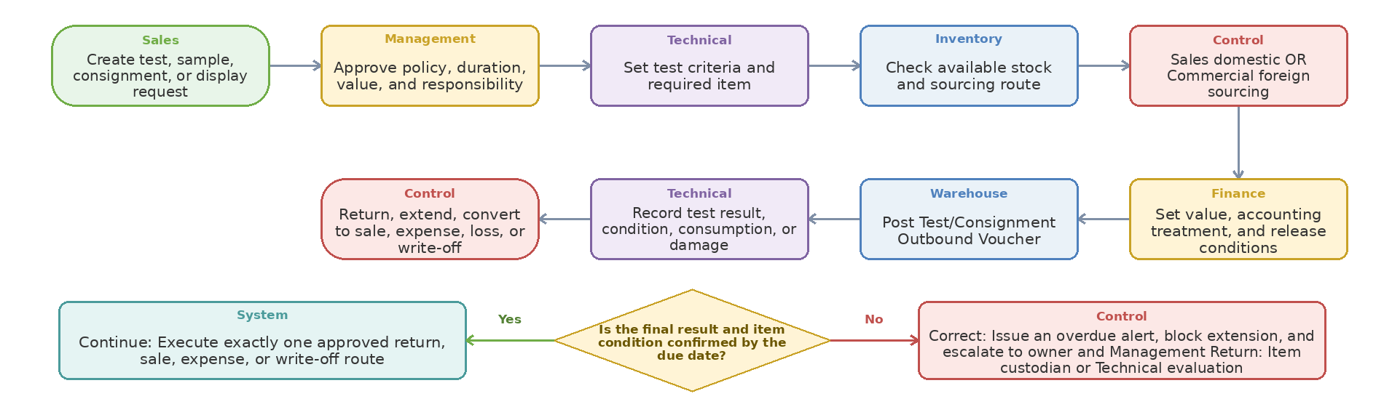
Step owner | Action or control | Operational document or system record | Handoff to
Sales | Create test, sample, consignment, or display request | Test Scenario and Acceptance Approval | Management
Management | Approve policy, duration, value, and responsibility | Access Matrix and Approval History | Technical
Technical | Set test criteria and required item | Test Scenario and Acceptance Approval | Inventory
Inventory | Check available stock and sourcing route | Activity, Status, and Attachment Record in the Odoo Case | Control
Control | Sales domestic OR Commercial foreign sourcing | Activity, Status, and Attachment Record in the Odoo Case | Finance
Finance | Set value, accounting treatment, and release conditions | Activity, Status, and Attachment Record in the Odoo Case | Warehouse
Warehouse | Post Test/Consignment Outbound Voucher | Test Scenario and Acceptance Approval | Technical
Technical | Record test result, condition, consumption, or damage | Consumption, Expense, or Write-off Approval | Control
Control | Return, extend, convert to sale, expense, loss, or write-off | Return Request / Claim File | Case closure / downstream stakeholder

Process 15 Requirements — Test items, technical samples, consignment, sale conversion, and expense treatment
Test, sample, and consignment goods need inventory ownership, issue/return movements, due dates, technical results, financial disposition, and conversion to sale without disappearing from stock visibility.
Decision Logic and Return Path
Decision gate | Yes path | No or exception path | Return to
Is the final result and item condition confirmed by the due date? | Execute exactly one approved return, sale, expense, or write-off route | Issue an overdue alert, block extension, and escalate to owner and Management | Item custodian or Technical evaluation
Request, sourcing, and issue documents
- Sales owns the request and domestic sourcing; Commercial becomes involved only when the required item is unavailable in-country and must be purchased abroad.
- Finance confirms value, customer/employee responsibility, deposit or credit condition, and expected accounting treatment before release where required.
- Warehouse posts a Test/Consignment Outbound Voucher that moves the item from sellable stock to a controlled test, consignment, display, employee, or customer location; the issue is not automatically an expense or sale.
- The outbound voucher records item, serial/lot, quantity, value, custodian, customer/location, issue date, due date, condition, and linked request.
Return and extension
- A physical return requires Warehouse to inspect the item and post a Test/Consignment Return Inbound Voucher to quarantine, QC, or available stock according to Technical decision.
- Technical records test result and condition; Warehouse records the physical movement; Finance records only the financial consequence.
- An extension changes the due date with approval and reminder history but does not create a new issue or duplicate item movement.
Conversion to sale, expense, loss, or write-off
- For conversion to sale, Sales creates or confirms the Sales Order and invoicing request; Finance posts or validates the sales invoice, receivable, tax, and cost according to the approved access matrix.
- The item does not need a fictitious physical return: Warehouse links or reclassifies the original test/consignment issue to the Sales delivery so stock remains at the customer while the sale and cost are recognized once.
- For consumed test material, failed test, damage, loss, or no-return, Technical confirms the condition, Management approves the disposition, Warehouse posts the required consumption/scrap movement, and Finance posts the expense or write-off.
- No test item may be expensed, invoiced, or written off without a linked request, movement, approval, and final disposition.
Workshop demonstration and reports
- Demo four outcomes from one controlled flow: good return, due-date extension, direct sale conversion with invoice, and approved expense/write-off after consumption or damage.
- Reports: open and overdue items, value at third parties, return status, test result, sale conversion, invoiced/not-invoiced items, expense/write-off, damage/loss, and custodian aging.
Workshop result
Coverage: Standard Odoo ☐ Configuration ☐ Odoo Studio ☐ Custom Development ☐ Integration ☐ Alternative Solution ☐ | Limitation and decision: ................................................

Process 16 — Customer return, supplier return, rejection, claim, rework, and scrap
Start: Return request linked to a sale, delivery, purchase, or receipt | End: Stock, claim, and financial effect dispositioned and case closed. The diagram moves left to right and continues right to left on the second row; the lower diamond shows the Yes, No, correction, and return paths.
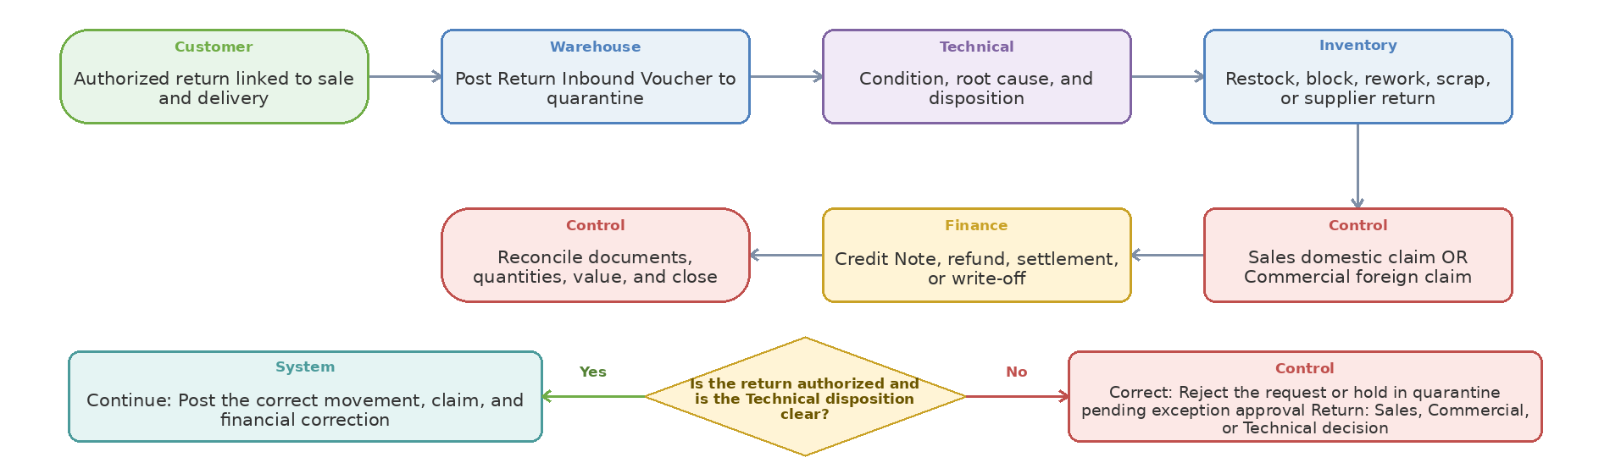
Step owner | Action or control | Operational document or system record | Handoff to
Customer | Authorized return linked to sale and delivery | Outbound Issue / Delivery Order | Warehouse
Warehouse | Post Return Inbound Voucher to quarantine | Return Request / Claim File | Technical
Technical | Condition, root cause, and disposition | Activity, Status, and Attachment Record in the Odoo Case | Inventory
Inventory | Restock, block, rework, scrap, or supplier return | Return Request / Claim File | Control
Control | Sales domestic claim OR Commercial foreign claim | Return Request / Claim File | Finance
Finance | Credit Note, refund, settlement, or write-off | Consumption, Expense, or Write-off Approval | Control
Control | Reconcile documents, quantities, value, and close | Reconciliation and Case-Closure Checklist | Case closure / downstream stakeholder

Process 16 Requirements — Customer return, supplier return, rejection, claim, rework, and scrap
All reverse flows should start from the original transaction and preserve quantity, condition, reason, technical decision, inventory state, supplier/customer settlement, and financial impact.
Decision Logic and Return Path
Decision gate | Yes path | No or exception path | Return to
Is the return authorized and is the Technical disposition clear? | Post the correct movement, claim, and financial correction | Reject the request or hold in quarantine pending exception approval | Sales, Commercial, or Technical decision
Documented current return flow
- BPMS customer return: register -> Sales specialist approval -> domestic-sourcing review -> receive from customer -> health/condition check -> restock, supplier return, or return to Sales assistant/archive; final warehouse and supplier-return controls exist.
- The approved Commercial process covers shortage/damage discrepancy, claim with supplier/carrier/insurance, replacement, refund/credit note, vendor return, and unresolved-claim escalation.
- The approved Warehouse process covers customer return authorization, quantity/serial/visual check, Technical review, returns/quarantine location, supplier return, damaged/scrap stock, repack/rework, and inventory adjustment.
Odoo requirements
- Return must reference original Sales Order/Delivery/Invoice or PO/Receipt/Shipment and retain requested, authorized, received, accepted, rejected, replaced, credited, and closed quantities.
- Capture reason, condition, serial/lot, photos/documents, root cause, responsibility, technical disposition, claim amount, carrier/insurance involvement, replacement/Credit Note/refund, and customer/supplier communication.
- Rejected or returned stock must move to a controlled location/status until the disposition is approved; no direct adjustment to free stock.
- Rework/repack, reduced value, scrap/destruction, supplier return, and saleable restock require role-appropriate approval and financial effect.
- Warehouse posts the customer Return Inbound Voucher and supplier Return Outbound Voucher; Sales owns domestic supplier claims and Commercial owns foreign supplier claims.
Control and reports
- A claim may close only after replacement, monetary settlement, Credit Note, accepted rejection, or approved write-off is reconciled.
- Reports: return rate/reason, claim aging/value, supplier/carrier/brand/product recurrence, rejected QC, replacement time, Credit Notes, rework/scrap value, and unresolved responsibility.
Workshop demonstration and acceptance
- Demo customer return -> quarantine -> Technical decision -> supplier claim/return -> replacement and Credit Note; also show partial quantity and commission/invoice impact where applicable.
- Bring one customer return, vendor claim, damaged-item record, Credit Note or replacement evidence, and expected approval path.
Workshop result
Coverage: Standard Odoo ☐ Configuration ☐ Odoo Studio ☐ Custom Development ☐ Integration ☐ Alternative Solution ☐ | Limitation and decision: ................................................

Process 17 — Inventory counts, adjustments, barcode, lot/serial, and stock integrity
Start: Approved stock-count plan with defined scope and timing | End: Stock reconciled and root cause of variances recorded. The diagram moves left to right and continues right to left on the second row; the lower diamond shows the Yes, No, correction, and return paths.
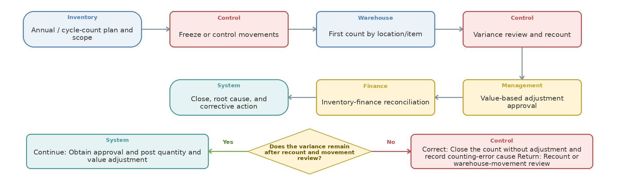
Step owner | Action or control | Operational document or system record | Handoff to
Inventory | Annual / cycle-count plan and scope | Stock Count and Recount Sheet | Control
Control | Freeze or control movements | Activity, Status, and Attachment Record in the Odoo Case | Warehouse
Warehouse | First count by location/item | Item Card, Barcode, Serial/Lot, or Location Record | Control
Control | Variance review and recount | Stock Count and Recount Sheet | Management
Management | Value-based adjustment approval | Activity, Status, and Attachment Record in the Odoo Case | Finance
Finance | Inventory-finance reconciliation | Activity, Status, and Attachment Record in the Odoo Case | System
System | Close, root cause, and corrective action | Report, Dashboard, or Corrective Action | Case closure / downstream stakeholder

Process 17 Requirements — Inventory counts, adjustments, barcode, lot/serial, and stock integrity
Inventory integrity requires controlled physical counts, movement control, recount, approved adjustment, financial reconciliation, location/barcode discipline, and root-cause analysis.
Decision Logic and Return Path
Decision gate | Yes path | No or exception path | Return to
Does the variance remain after recount and movement review? | Obtain approval and post quantity and value adjustment | Close the count without adjustment and record counting-error cause | Recount or warehouse-movement review
Confirmed warehouse control activities
- The Warehouse profile includes annual and seasonal counts, discrepancy notification to Finance, 5S, location mapping, rack numbering, location-data updates, temperature/humidity checks, and HSE controls.
- Target inventory integrity controls include cycle counts, high-value/high-variance scope, first/second counts, negative/no-location/wrong-location/open-document/expired-reservation/serial discrepancy investigation, adjustment approval, and period close.
- Inventory risks include theft/loss, wrong delivery, coding/location error, recording error, damage during movement, and inadequate training.
Count and adjustment requirements
- Count sheets/tasks should support blind count where required, location/item/lot/serial, counter/reviewer, first/recount quantity, system quantity, variance, reason, evidence, value, approval, and adjustment document.
- Direct adjustment without documented reason and approval is prohibited; approval threshold should depend on variance value, quantity, product risk, and period status.
- A closed period may only be reopened through controlled approval with reason and audit trail.
Barcode and traceability requirements
- TBC: identify which products/operations require barcode, QR, lot, serial, package, GS1/own code, or no scan; define label content, printer/scanner devices, and offline/exception procedure.
- Scanning should validate receiving, putaway, transfer, picking, packing, delivery, count, test/consignment issue/return, and supplier/customer return where adopted.
- Traceability should answer where the item is, its status/owner, how it entered, every movement, who handled it, and which customer/order received it.
Reports and demo
- Reports: inventory accuracy, variance quantity/value/cause/user/location, negative stock, no-location items, repeated variance, open movements, expired reservation, serial inconsistency, and period-close open items.
- Demo barcode receipt-to-delivery and a cycle count with movement control, recount, value-based approval, adjustment, financial reconciliation, and traceability search.
Workshop result
Coverage: Standard Odoo ☐ Configuration ☐ Odoo Studio ☐ Custom Development ☐ Integration ☐ Alternative Solution ☐ | Limitation and decision: ................................................

Process 18 — Inventory aging, storage conditions, kits, internal consumption, and period close
Start: Aging, storage-condition, consumption, or period-close alert | End: Item disposition completed and period quantity and value reconciled. The diagram moves left to right and continues right to left on the second row; the lower diamond shows the Yes, No, correction, and return paths.
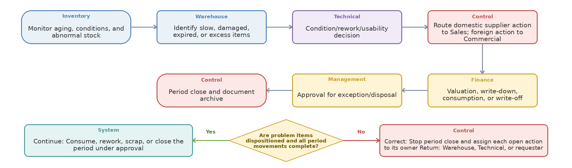
Step owner | Action or control | Operational document or system record | Handoff to
Inventory | Monitor aging, conditions, and abnormal stock | Activity, Status, and Attachment Record in the Odoo Case | Warehouse
Warehouse | Identify slow, damaged, expired, or excess items | Consumption, Expense, or Write-off Approval | Technical
Technical | Condition/rework/usability decision | Activity, Status, and Attachment Record in the Odoo Case | Control
Control | Route domestic supplier action to Sales; foreign action to Commercial | Activity, Status, and Attachment Record in the Odoo Case | Finance
Finance | Valuation, write-down, consumption, or write-off | Consumption, Expense, or Write-off Approval | Management
Management | Approval for exception/disposal | Activity, Status, and Attachment Record in the Odoo Case | Control
Control | Period close and document archive | Reconciliation and Case-Closure Checklist | Case closure / downstream stakeholder

Process 18 Requirements — Inventory aging, storage conditions, kits, internal consumption, and period close
Operational warehouse control also includes aging, shelf/condition monitoring, internal consumption, kits, damaged items, document completeness, and controlled closing.
Decision Logic and Return Path
Decision gate | Yes path | No or exception path | Return to
Are problem items dispositioned and all period movements complete? | Consume, rework, scrap, or close the period under approval | Stop period close and assign each open action to its owner | Warehouse, Technical, or requester
Aging and storage controls
- Slow/non-moving analysis should use last receipt, last sale/use, aging bands, quantity/value, location, reserved/open demand, and proposed transfer/promotion/return/write-down/disposal action.
- Where applicable, capture manufacturing/expiry dates, temperature/humidity, inspection, FEFO, near-expiry alerts, and quarantine for storage-condition deviation.
- Warehouse safety and environmental incidents, rack/equipment condition, and corrective actions remain process controls even if Odoo stores only selected records or attachments.
Kits, internal consumption, and rework
- Kits/sets/promotional packs should retain component consumption, finished pack, substitutions by approval, label/package, and unpacking back to components.
- Internal consumption requires requesting unit, cost center/project, quantity, approval, issue, recipient, and abnormal-consumption monitoring.
- Damaged goods, repack/relabel/rework, reduced value, scrap/destruction, and recovery should preserve original item, quantity, cost, reason, approver, and result.
Warehouse-finance reconciliation and close
- Before close, review open receipts/issues, in-transit transfers, negative stock, old reservations, quarantine/returns, count variances, unvalued documents, and inventory-finance differences.
- Warehouse owns physical/movement completeness; Finance owns valuation and accounting. Differences require document/date/quantity/value investigation rather than manual balancing without cause.
- Required warehouse documents should be attached to the transaction and searchable; missing/invalid versions should block closure where material.
Reports and demo
- Reports: slow/non-moving value, aging bands, near expiry, storage exceptions, internal consumption, kit build/unbuild, damage/rework/scrap value, inventory-finance variance, and close/reopen history.
- Demo one slow-stock action, damaged-item rework or write-off, internal consumption, and a month-end close with open-item blocking and controlled reopen.
Workshop result
Coverage: Standard Odoo ☐ Configuration ☐ Odoo Studio ☐ Custom Development ☐ Integration ☐ Alternative Solution ☐ | Limitation and decision: ................................................

Process 19 — Roles, access, approvals, audit trail, notifications, and document control
Start: Request for access, document creation, or record change | End: Authorized action with approval, notification, and evidence history. The diagram moves left to right and continues right to left on the second row; the lower diamond shows the Yes, No, correction, and return paths.
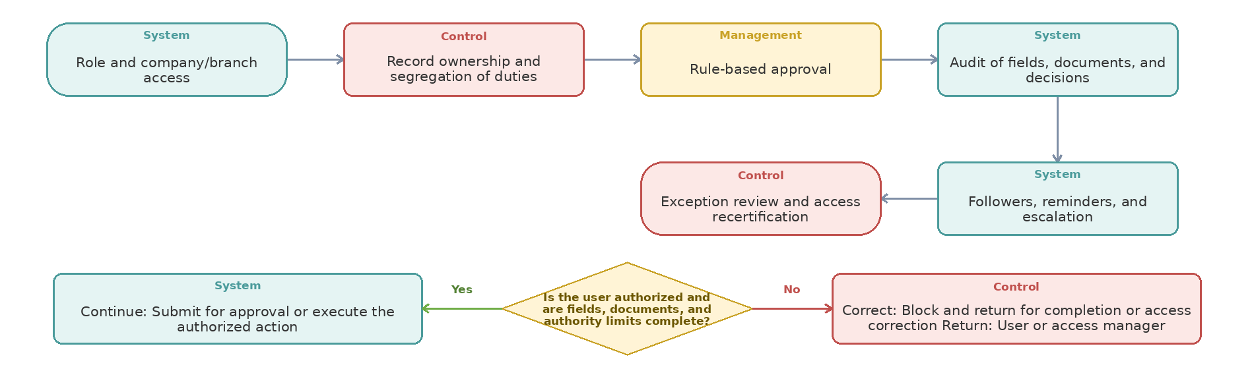
Step owner | Action or control | Operational document or system record | Handoff to
System | Role and company/branch access | Access Matrix and Approval History | Control
Control | Record ownership and segregation of duties | Activity, Status, and Attachment Record in the Odoo Case | Management
Management | Rule-based approval | Activity, Status, and Attachment Record in the Odoo Case | System
System | Audit of fields, documents, and decisions | Activity, Status, and Attachment Record in the Odoo Case | System
System | Followers, reminders, and escalation | Activity, Status, and Attachment Record in the Odoo Case | Control
Control | Exception review and access recertification | Access Matrix and Approval History | Case closure / downstream stakeholder

Process 19 Requirements — Roles, access, approvals, audit trail, notifications, and document control
The target design needs simple role ownership, separation of duties, restricted commercial/financial information, traceable approvals, and notifications to the right participants.
Decision Logic and Return Path
Decision gate | Yes path | No or exception path | Return to
Is the user authorized and are fields, documents, and authority limits complete? | Submit for approval or execute the authorized action | Block and return for completion or access correction | User or access manager
Role and access matrix
- Define access for Sales domestic-sourcing roles, Commercial foreign-procurement/import roles, Warehouse receiver/picker/controller/manager, Technical/QC, Finance, branch users, executive management, and system administrator.
- Sales must not change completed warehouse movements or posted financial documents; Commercial is restricted to foreign procurement/import; Warehouse must not change approved prices/payment terms; Finance must not change physical quantities.
- Record-level access may limit users to own branch/team/requests while managers see consolidated data. Field-level hiding or complex rules must be identified as Standard/configuration versus development.
Approvals and audit
- Approval rules may depend on amount/value, currency, supplier status, source, urgency, product category, payment terms, Incoterm, budget, risk, branch, variance, and exception type.
- Approval should log requester, approver, date/time, decision, comment, prior values, documents, and any reapproval after material change.
- Confirmed Inbound Receipts, Outbound Issues, transfer issues/receipts, returns, adjustments, and Purchase Orders must not be silently deleted or overwritten; correction, reversal, amendment, or cancellation must retain history.
Notifications and document control
- Followers should receive relevant record changes, messages, document requests, and due-date alerts; high-impact status changes may use role-based automatic followers.
- Documents need category, transaction link, version, owner, date, expiry where applicable, required/optional status, and missing-document report.
- Supplier quotation/PI/PO, BL/PL/COO, customs/bank, QC, claim, receipt/issue, count, test/consignment, and POD documents should be searchable from the related record.
Required demo
- Demo a user seeing own branch requests only, Sales seeing ETA but not supplier price, Technical seeing item/specification but restricted commercial fields, manager approval, approval reset after change, and full audit trail.
Workshop result
Coverage: Standard Odoo ☐ Configuration ☐ Odoo Studio ☐ Custom Development ☐ Integration ☐ Alternative Solution ☐ | Limitation and decision: ................................................

Process 20 — Reports, KPIs, supplier performance, and risk management
Start: Posted purchase, import, inventory, and Finance transactions | End: Reliable KPI, recorded risk, and closed corrective action. The diagram moves left to right and continues right to left on the second row; the lower diamond shows the Yes, No, correction, and return paths.
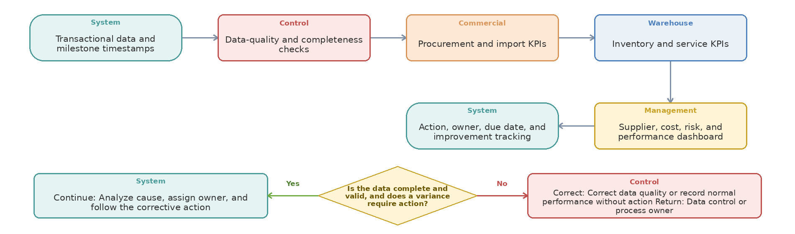
Step owner | Action or control | Operational document or system record | Handoff to
System | Transactional data and milestone timestamps | Activity, Status, and Attachment Record in the Odoo Case | Control
Control | Data-quality and completeness checks | Technical Evaluation and Approval Form | Commercial
Commercial | Procurement and import KPIs | Offer / PI / Contract Revision | Warehouse
Warehouse | Inventory and service KPIs | Offer / PI / Contract Revision | Management
Management | Supplier, cost, risk, and performance dashboard | Report, Dashboard, or Corrective Action | System
System | Action, owner, due date, and improvement tracking | Shipment File, Packing List, and Tracking Record | Case closure / downstream stakeholder

Process 20 Requirements — Reports, KPIs, supplier performance, and risk management
Operational lists, management KPIs, supplier scorecards, risk alerts, and BI boundaries must be agreed before implementation so reporting is not deferred until after go-live.
Decision Logic and Return Path
Decision gate | Yes path | No or exception path | Return to
Is the data complete and valid, and does a variance require action? | Analyze cause, assign owner, and follow the corrective action | Correct data quality or record normal performance without action | Data control or process owner
Required Commercial/Purchase reporting
- Purchase Requests by source/status/age/priority; RFQ response rate/time; quotation comparison; supplier selection; PO open/late/partial/cancelled; purchase lead time; price variance; agreement usage; payment/advance status.
- Import registration/permit/FX queue aging; shipments/ETA/delay; document completeness; customs cycle; landed cost estimate vs. actual; logistics cost per unit; claim/return/Credit Note; open import-file items.
- Supplier scorecard: response, price, quality, complete delivery, on-time delivery, document accuracy, claim rate/resolution, risk, and improvement/suspension status.
Required Inventory/Warehouse reporting
- Stock by company/branch/warehouse/location/product/status; on-hand/free/reserved/blocked/QC/test/consignment/in-transit/incoming/outgoing/forecast; shortages; replenishment; transfer in transit.
- Receipt cycle, QC aging/rejection, putaway time, picking/packing accuracy/time, delivery/backorder/POD, return, damage/scrap/rework, count variance, negative/no-location stock, slow/non-moving aging, and inventory-finance reconciliation.
- Workload/productivity may report operations and time per person/team where accepted, with care that speed alone does not represent quality.
Formal process KPIs and risk alerts
- Foreign Procurement profile KPIs include Offer time, Final Order time, payment-request time, shipment-request time, full and discrepancy-free delivery, registration code, FX milestones, SATA/commitment release, lead time, on-time delivery, logistics cost, damage/return, and capacity utilization.
- Warehouse profile KPIs include inventory accuracy, receipt cycle time, delivery accuracy/error, on-time dispatch, and internal-order-to-delivery time.
- Alerts should cover supplier/shipper delay, permit/registration expiry, FX/price exposure, missing documents, customs delay, stockout, expired reservation, QC aging, overdue test/consignment, negative stock, and repeated variance.
Reporting boundary and acceptance
- For each report decide Odoo list/pivot/dashboard, spreadsheet export, BI, or custom report. Define owner, audience, frequency, filters, drill-down, source fields, and acceptance example.
- Do not accept “reportable” without showing the fields and sample output or identifying the required development/BI work.
Workshop result
Coverage: Standard Odoo ☐ Configuration ☐ Odoo Studio ☐ Custom Development ☐ Integration ☐ Alternative Solution ☐ | Limitation and decision: ................................................

Process 21 — Systems, integration, migration, cutover, and workshop runbook
Start: Approved scope, owned data, and solution design | End: Stable live operation with reconciled balances and active support. The diagram moves left to right and continues right to left on the second row; the lower diamond shows the Yes, No, correction, and return paths.
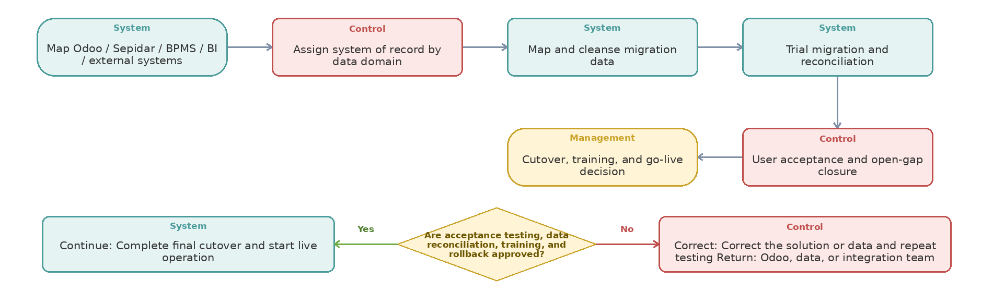
Step owner | Action or control | Operational document or system record | Handoff to
System | Map Odoo / Sepidar / BPMS / BI / external systems | Offer / PI / Contract Revision | Control
Control | Assign system of record by data domain | Activity, Status, and Attachment Record in the Odoo Case | System
System | Map and cleanse migration data | Data Mapping and Reconciliation File | System
System | Trial migration and reconciliation | Data Mapping and Reconciliation File | Control
Control | User acceptance and open-gap closure | Test Scenario and Acceptance Approval | Management
Management | Cutover, training, and go-live decision | Data Mapping and Reconciliation File | Case closure / downstream stakeholder

Process 21 Requirements — Systems, integration, migration, cutover, and workshop runbook
The workshop should close one canonical target flow, system-of-record decision, migration boundary, Fit-Gap classification, demonstration result, owner, and estimate for each major scenario.
Decision Logic and Return Path
Decision gate | Yes path | No or exception path | Return to
Are acceptance testing, data reconciliation, training, and rollback approved? | Complete final cutover and start live operation | Correct the solution or data and repeat testing | Odoo, data, or integration team
System roles and integrations
- Odoo target scope: demand/Purchase Request, RFQ/quotation comparison, Purchase, Inventory, approvals, activities, attachments, shipment/import status, QC, traceability, and reporting according to final Fit-Gap.
- Sepidar currently supports coding, receipt/issue, invoice, accounting documents, inventory/financial records, and payment. Decide replace, integrate, or controlled coexistence for each domain.
- Open legacy requests, IDs, and attachments require migrate/archive decisions, and parallel operational workflows should be retired where Odoo goes live.
- NTSW, EPL/customs, banks, carriers/forwarders, and BI require explicit manual/import/API boundaries and error/reconciliation ownership.
Migration and cutover
- Map suppliers, products/codes/UoM/categories, warehouses/locations, barcode/lot/serial, stock by status/location, open reservations/transfers, open PR/RFQ/PO, shipments, import files, payments/advances, test/consignment, returns/claims, and relevant documents.
- Run trial migration, duplicate/quality cleansing, opening-stock count, value reconciliation with Finance, open-document reconciliation, user acceptance, cutover freeze, and post-load verification.
- Keep legacy cross-reference on migrated open records so historical BPMS/Sepidar documents remain traceable.
Mandatory workshop demos
- 1) Customer shortage -> Sales-owned domestic purchase -> Inbound Receipt -> supplier invoice/payment -> Outbound Issue -> sales invoice -> delivery; 2) monthly replenishment -> route decision -> foreign RFQ comparison and PO; 3) PI/registration/FX/payment -> shipment/customs -> landed cost; 4) partial receipt/QC rejection/claim.
- 5) inter-warehouse transfer issue and destination receipt; 6) reservation/confidential availability; 7) barcode Inbound Receipt/Outbound Issue/count; 8) test/consignment -> return, sale, expense, or write-off; 9) customer/vendor return -> Credit Note/replacement; 10) period close and reconciliation.
Required Odoo response and estimation
- For each workflow record: module/feature, Standard/Configuration/Studio/Development/Integration/Alternative, limitation, actual demo, open design decision, action owner, due date, and acceptance evidence.
- For development or integration provide estimated hours/cost, dependencies, upgrade/maintenance impact, testing, migration, training, and the closest standard alternative.
- The final Fit-Gap must clearly separate reviewed/closed requirements from not-reviewed items and should not treat the four-session mini-gap as full validation of every exception.
Workshop preparation and remaining TBC items
- Bring sample PR/RFQ/PO, supplier quotation/invoice, one local and one foreign purchase, PI/contract/payment, import/shipping/customs documents, landed-cost example, warehouse/branch/location list, stock report, approval matrix, QC/receipt, transfer, test/consignment, return, count, delivery/POD, and required-report list.
- TBC by owners: legal entities/branches, exact warehouses/locations, approval thresholds, coding ownership, reservation/replenishment/QC/barcode rules, valuation/landed-cost policy, Odoo-Sepidar boundary, external integration method, migration volumes, report priorities, and optional-process scope.
Workshop result
Coverage: Standard Odoo ☐ Configuration ☐ Odoo Studio ☐ Custom Development ☐ Integration ☐ Alternative Solution ☐ | Limitation and decision: ................................................

