ODOO REQUIREMENTS & FIT-GAP WORKSHOP
Integrated Project Control & Systems / Methods Workflow Map
From project intake and portfolio governance through execution control, process design, QMS actions, ERP requirements, UAT, cutover, adoption, and value realization
Unified English working document - aligned with the Sales/CRM, Purchase/Inventory, and Technical/Engineering/Quality requirement packages.
Scope: 20 consolidated workflows for the Iran Odoo ERP workshop. Current-state facts, target requirements, exceptions, approvals, reports, evidence, and open decisions remain inside each workflow.
Important boundary: project-control mechanics not evidenced in the supplied sources are labeled as target requirements. No feature is accepted because a module exists; the Odoo team must demonstrate the real scenario and record limitations.
Prepared for: Odoo implementation team and Karan Sa Industrial Group Management, Systems & Methods, Project Control, Process Owners, Finance, HR, IT/System Support, and participating units
Document version: v1.0 | Review date: September 2026 | Workshop use: requirements validation, demonstration, Fit-Gap classification, and implementation decision

1. Architecture, ownership, and scope boundaries
Project Control governs the temporary delivery lifecycle; Systems & Methods governs end-to-end process architecture, controls, evidence, and improvement. The two domains share actions, risks, decisions, documents, KPIs, and change control but must not duplicate ownership.
Recommended traceability chain
Strategy / KPI / Audit / Risk / Requirement / Improvement Opportunity -> Project or Action -> Deliverable / Task / Milestone -> Evidence / Decision / Change / Issue -> Acceptance / Closure -> Lesson / Benefit / Process Update
Ownership and system boundaries
Record or responsibility | Primary business owner | Required link / boundary
Project request, charter, priority, milestone, task, status, closure | Sponsor / Project Manager / Project Control | Strategic objective, process, KPI, risk, issue, change, deliverable, evidence, and benefit
Process map/profile, As-Is/To-Be, RACI, SLA, rule, KPI design, QMS action | Systems & Methods / Process Owner | Operational Odoo record, controlled document, role, approval, audit/CAPA, and project
Functional support, UAT coordination, training, vendor follow-up | Functional System Support / Process Owner | Requirement, configuration, defect, ticket, release, user, and evidence
Infrastructure, API security, provisioning, technical monitoring | IT / System Admin / Odoo Admin | Approved role/integration specification, incident, access decision, and audit log
Cost, budget, accounting, settlement, financial evidence | Finance | Project/PO/contract and approved Odoo-Sepidar/accounting boundary
People capacity, competency, job/organization role | HR / Line Manager | Approved role/RACI, training need, resource plan, and Rahkaran/HR boundary
Explicit scope exclusions / ownership safeguards
- Product nonconformity, returned/rejected goods, technical testing, and supplier/product claims remain in the Technical, Warehouse, Purchase, and Sales packages; this file covers systemic/QMS findings and cross-process action governance.
- Calibration execution belongs to Technical/Quality and competency administration belongs to HR; Systems & Methods may define governance, links, evidence, and reporting only.
- If a specialist HSE owner exists, Systems & Methods owns governance/documentation/monitoring support, not operational HSE execution.
- Customer complaint operations remain CRM/Technical; Systems & Methods owns trend/systemic analysis and resulting CAPA/improvement where applicable.
- Daily system administration, infrastructure, vendor tickets, and technical release execution are not silently assigned to Systems & Methods; functional/process ownership and technical execution must be separated.

2. Process index
Phase A - Project intake, portfolio, and setup
- 1. Project / Improvement Request, Business Case, and Charter
- 2. Prioritization, Approval, and Portfolio Alignment
- 3. Project Setup, WBS, Milestones, Roles, and Baseline
Phase B - Project execution and control
- 4. Task, Dependency, Assignment, and Timesheet Control
- 5. Progress, Schedule, KPI, and Management Reporting
- 6. Project Risk, Issue, Decision, and Escalation
- 7. Scope and Change Control
- 8. Deliverable Acceptance, Project Closure, Lessons, and Benefits
Phase C - Systems & Methods process governance
- 9. Process Catalogue, As-Is / To-Be, and Standardization
- 10. Process Ownership, RACI, Handoff, SLA, and Approval Design
- 11. Business Rules, Forms, Data Capture, and Process Pilot
- 12. Controlled Documents, Records, and Organizational Knowledge
- 13. KPI Evidence, Process Performance, and Management Review
- 14. Internal Audit, Nonconformity, CAPA, and Improvement Action
Phase D - ERP lifecycle and operational enablement
- 15. ERP Requirements, Scope Catalogue, and Fit-Gap
- 16. Solution Blueprint, Functional Roles, Master Data, and Integration
- 17. Configuration Review, UAT, Defect, and Sign-Off
- 18. Data Migration, Cutover Readiness, and Go-Live Decision
- 19. Training, Adoption, Functional Support, and Stabilization
- 20. Release Impact, Compliance, Continuity, and Value Realization
How to use this document in the Odoo workshop
- Run the diagram and the real scenario first; use the bullets to close roles, data, approvals, exceptions, integrations, reports, limitations, and evidence.
- For every workflow, capture coverage as Standard Odoo, Configuration, Odoo Studio, Custom Development, Integration, or Alternative / Not Supported.
- Do not authorize the next gate until the current workflow output, decision owner, acceptance evidence, and unresolved gap/action are documented.
- For development/integration, record estimate, dependencies, upgrade/maintenance impact, testing, migration, security, training, standard alternative, owner, and due date.

PHASE A - PROJECT INTAKE, PORTFOLIO, AND SETUP
1. Project / Improvement Request, Business Case, and Charter
A single controlled intake for strategic initiatives, ERP work, improvement projects, and corrective-action projects before work begins.
Workflow route: Idea, KPI gap, audit finding, risk, requirement, or management request -> qualify need -> define outcome, sponsor, owner, scope, value, cost, and risk -> approve, return, reject, or defer -> create project charter.
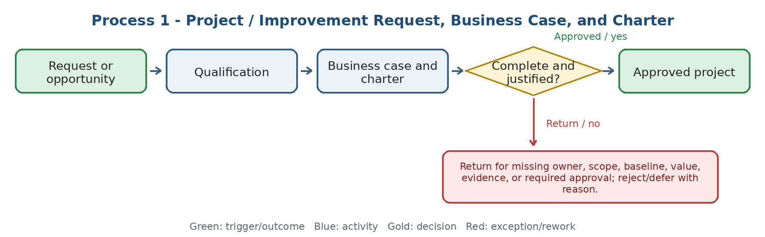
Current state and actual process facts
- The source workbook confirms that KPI gaps, audits, risks, staff proposals, benchmarking, and process problems can initiate corrective or improvement work.
- Strategic goals are expected to be translated into programs/projects with an owner and KPI; however, one current Project Control intake and charter method is not evidenced in the supplied sources.
- Treat detailed Project-module behavior in this chapter as a target requirement until the unit validates the real current route.
Target Odoo workflow and cross-functional integration
- Use one project-request record linked to the originating KPI, risk, audit finding, CAPA, ERP requirement, or management decision; avoid disconnected tasks and spreadsheets.
- Required data: request type, objective, baseline, expected benefit, sponsor, project manager, process owner, scope/in-scope/out-of-scope, priority, estimated time/cost, dependencies, risks, confidentiality, and acceptance criteria.
- Candidate Odoo touchpoints to demonstrate: Project, Approvals, Documents, Knowledge, and controlled custom fields/forms. Coverage is not assumed by module name.
Exceptions, approvals, controls, and open decisions
- No project becomes active without sponsor, accountable owner, measurable outcome, initial scope, and approval evidence.
- Duplicate or overlapping requests must be merged or linked; low-value requests may be rejected/deferred with a recorded reason.
- Open decision: project categories, approval thresholds, mandatory business-case fields, and who can bypass or fast-track urgent work.
Output, reports, KPIs, and workshop evidence
- Output: approved/rejected/deferred request and a version-controlled Project Charter.
- KPIs: request aging, approval lead time, percentage returned for incomplete data, approved portfolio value, and requests without owner/sponsor.
- Demo/evidence: create a real improvement request from a KPI or audit finding, return it for missing data, approve it, and generate the linked project.
Workflow result - Coverage to confirm: [ ] Standard Odoo [ ] Configuration [ ] Odoo Studio [ ] Custom Development [ ] Integration [ ] Alternative / Not Supported
Gap / limitation: ............................................................ Action / Owner / Due / acceptance evidence: ........................................................................
2. Prioritization, Approval, and Portfolio Alignment
Projects must compete transparently for resources and remain aligned with approved strategy, risk, and operational urgency.
Workflow route: Qualified request -> score strategic alignment, urgency, risk reduction, benefit, cost, and capacity -> rank portfolio -> management decision -> publish priority and funding/resource gate.
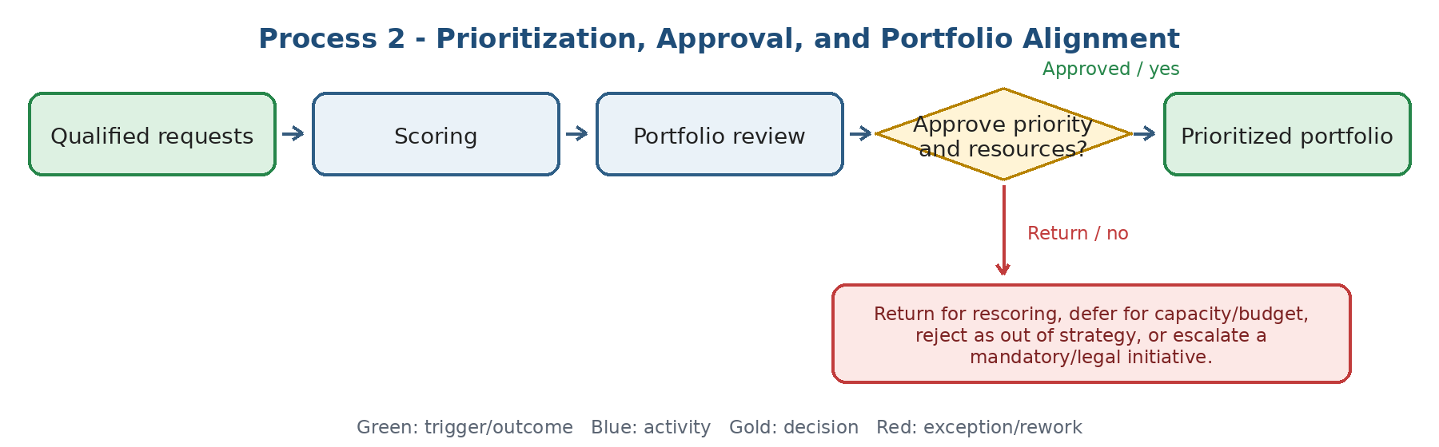
Current state and actual process facts
- The QMS source requires periodic strategy review, approved strategic goals, and measurement of project alignment with the organization strategy.
- The Systems & Methods workbook identifies insufficient resources, out-of-strategy projects, and high deviation as escalation triggers.
- A single current portfolio board, scoring model, and budget gate are not confirmed.
Target Odoo workflow and cross-functional integration
- Maintain one portfolio view with project category, sponsor, strategic objective, score, priority, status, planned start/finish, key milestone, budget/resource need, risk, and dependency.
- Support scenario-based prioritization and visible reasons for approval, deferral, or rejection; retain decision history.
- Finance provides cost/budget evidence; HR/line managers provide resource capacity; Management owns final priority and risk acceptance.
Exceptions, approvals, controls, and open decisions
- A project cannot consume committed budget or capacity before the applicable approval gate.
- Mandatory/legal/high-risk work may follow an expedited path but must still retain evidence, owner, due date, and post-approval review.
- Open decisions: scoring weights, approval committee, budget threshold, portfolio review frequency, and treatment of emergency projects.
Output, reports, KPIs, and workshop evidence
- Output: approved portfolio and transparent backlog of deferred/rejected proposals.
- KPIs: strategic alignment %, approved vs. capacity, deferred value, priority changes, and portfolio risk concentration.
- Demo/evidence: compare three requests, change resource capacity, approve one, defer one, and show the decision trail.
Workflow result - Coverage to confirm: [ ] Standard Odoo [ ] Configuration [ ] Odoo Studio [ ] Custom Development [ ] Integration [ ] Alternative / Not Supported
Gap / limitation: ............................................................ Action / Owner / Due / acceptance evidence: ........................................................................
3. Project Setup, WBS, Milestones, Roles, and Baseline
An approved charter becomes an executable baseline with deliverables, tasks, dependencies, roles, dates, and acceptance gates.
Workflow route: Approved charter -> select template -> define deliverables/WBS -> assign owner and RACI -> set milestones/dependencies/calendar -> baseline schedule and controls -> launch.
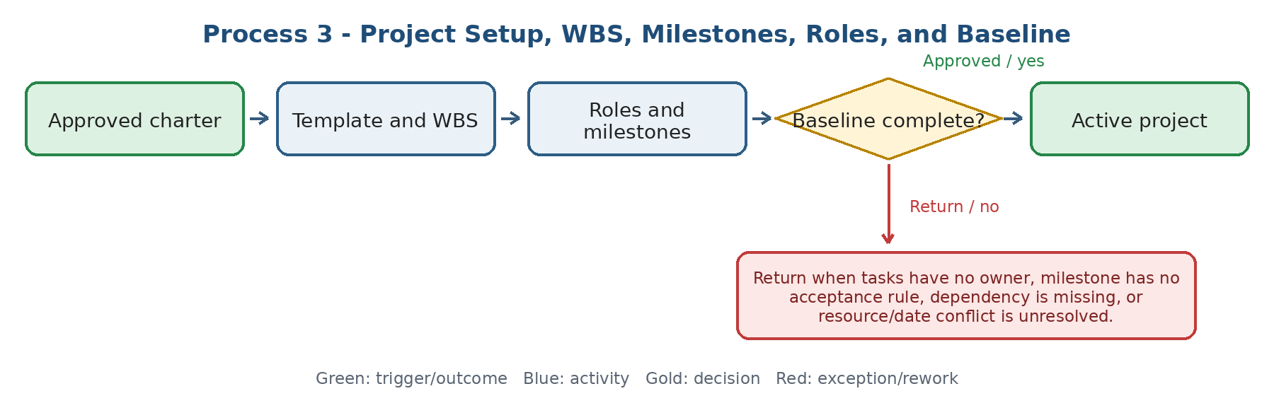
Current state and actual process facts
- The ERP blueprint source expects milestones, decision log, issue/risk tracking, security, testing, training, and governance responsibilities.
- The supplied sources do not confirm a standardized current WBS, project template, dependency method, or baseline approval mechanism.
- Process ownership/RACI and handoff design are established Systems & Methods responsibilities and must connect to project roles.
Target Odoo workflow and cross-functional integration
- Create project templates by type: ERP/IT implementation, process improvement, corrective action, organizational change, and strategic initiative.
- Represent deliverables, work packages, tasks, dependencies, milestone acceptance, planned effort, responsible/accountable roles, reviewers, and required documents.
- Freeze an approved baseline while allowing controlled forecast updates and change history.
Exceptions, approvals, controls, and open decisions
- No milestone is complete without acceptance evidence and authorized approver.
- No task should be ownerless; segregation-of-duties conflicts and cross-unit handoffs require explicit responsibility.
- Open decisions: template catalog, project numbering, baseline authority, calendar rules, and whether external parties access the project.
Output, reports, KPIs, and workshop evidence
- Output: active project with approved WBS, RACI, milestone plan, dependency map, and baseline.
- KPIs: projects launched without baseline, ownerless tasks, unresolved resource conflicts, and baseline approval lead time.
- Demo/evidence: build an ERP Fit-Gap project from a template and show milestones, dependencies, roles, documents, and baseline approval.
Workflow result - Coverage to confirm: [ ] Standard Odoo [ ] Configuration [ ] Odoo Studio [ ] Custom Development [ ] Integration [ ] Alternative / Not Supported
Gap / limitation: ............................................................ Action / Owner / Due / acceptance evidence: ........................................................................
PHASE B - PROJECT EXECUTION AND CONTROL
4. Task, Dependency, Assignment, and Timesheet Control
Execution must show who does what, by when, with what predecessor, effort, evidence, and exception path.
Workflow route: Baseline task -> assignment and due date -> predecessor/resource check -> work and time/evidence registration -> review -> complete, return, block, or escalate.
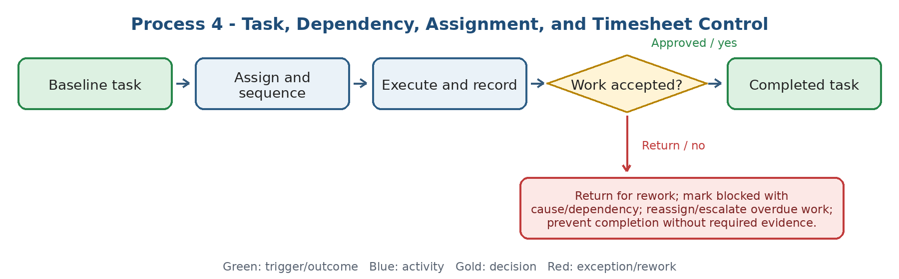
Current state and actual process facts
- The supplied sources require owner, due date, evidence, SLA, escalation, and effectiveness checks across actions, but do not confirm one current project-task/timesheet control process.
- Existing tools named in the process profile include Rahkaran, Mizito, Teamyar, and other current/future process systems; final system-of-record boundaries remain open.
- Timesheet detail should not be treated as verified current practice for Systems & Methods unless confirmed by the unit.
Target Odoo workflow and cross-functional integration
- Tasks require owner, planned start/finish, planned effort, priority, predecessor/dependency, status, blocker reason, deliverable/evidence, reviewer, and acceptance result.
- Time entry, if adopted, must distinguish project execution, meetings, support, rework, and training; approval and correction rules must be explicit.
- Show workload, overdue work, blocked tasks, dependency impact, planned vs. actual effort, and cross-unit queues.
Exceptions, approvals, controls, and open decisions
- A blocked task pauses or explains schedule impact; silent overdue work is not acceptable.
- Task completion cannot replace deliverable acceptance; time approval cannot itself prove project progress.
- Open decisions: mandatory timesheets, approval owner, minimum time unit, correction lock, billable/non-billable use, and task dependency behavior.
Output, reports, KPIs, and workshop evidence
- Output: accepted task, approved/corrected time evidence where applicable, and updated project forecast.
- KPIs: overdue tasks, blocked aging, rework rate, task acceptance lead time, planned vs. actual effort, and dependency-caused delay.
- Demo/evidence: block a task on another unit, escalate overdue work, return a deliverable, correct time, and show the effect on the project.
Workflow result - Coverage to confirm: [ ] Standard Odoo [ ] Configuration [ ] Odoo Studio [ ] Custom Development [ ] Integration [ ] Alternative / Not Supported
Gap / limitation: ............................................................ Action / Owner / Due / acceptance evidence: ........................................................................
5. Progress, Schedule, KPI, and Management Reporting
Management reporting must separate activity from measurable progress and highlight variance, forecast, decisions, and required action.
Workflow route: Task/milestone/evidence data -> validate update -> calculate progress and variance -> forecast finish/benefit -> management review -> corrective action or accepted status.
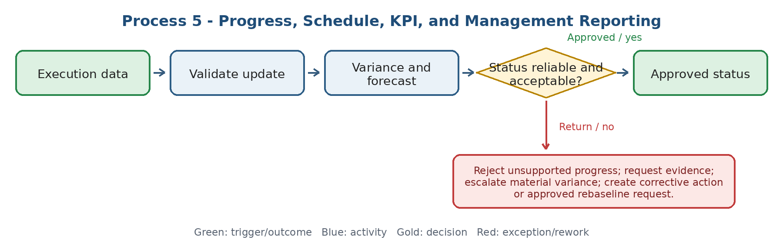
Current state and actual process facts
- The workbook requires baseline, target, actual, data source, owner, period, validation, variance analysis, and action when KPI is below target.
- Process-performance analysis currently may occur outside the system; the source notes that the system may provide data, target/actual comparison, trend, and variance while deeper analysis remains external.
- A unified current project dashboard and earned-progress rule are not confirmed.
Target Odoo workflow and cross-functional integration
- Progress must derive from accepted tasks/deliverables or a defined physical-progress rule, not only manual percentage entry.
- Dashboard: status, baseline/forecast dates, milestone variance, overdue/blocked work, planned/actual effort, scope changes, risk/issues, decision aging, and benefit KPI.
- Freeze reporting periods where needed and retain evidence/source for any manual status override.
Exceptions, approvals, controls, and open decisions
- Manual progress override requires reason, approver, and audit trail.
- Material schedule/cost/scope variance must trigger action or formal risk acceptance; green status without evidence is not allowed.
- Open decisions: progress formula, thresholds/RAG rules, reporting frequency, forecast ownership, and executive dashboard drill-down.
Output, reports, KPIs, and workshop evidence
- Output: validated project status, forecast, variance explanation, and management actions.
- KPIs: on-time milestones, schedule variance, overdue action aging, forecast accuracy, reporting timeliness, and evidence completeness.
- Demo/evidence: submit an unsupported 80% update, reject it, attach evidence, recalculate status, and trigger escalation for a delayed milestone.
Workflow result - Coverage to confirm: [ ] Standard Odoo [ ] Configuration [ ] Odoo Studio [ ] Custom Development [ ] Integration [ ] Alternative / Not Supported
Gap / limitation: ............................................................ Action / Owner / Due / acceptance evidence: ........................................................................
6. Project Risk, Issue, Decision, and Escalation
Risks, issues, decisions, and actions need different records but one traceable project context and escalation path.
Workflow route: Identify risk/issue/decision need -> assess severity/impact -> assign owner and action/decision due date -> execute or decide -> verify evidence/effectiveness -> close, accept, or re-escalate.
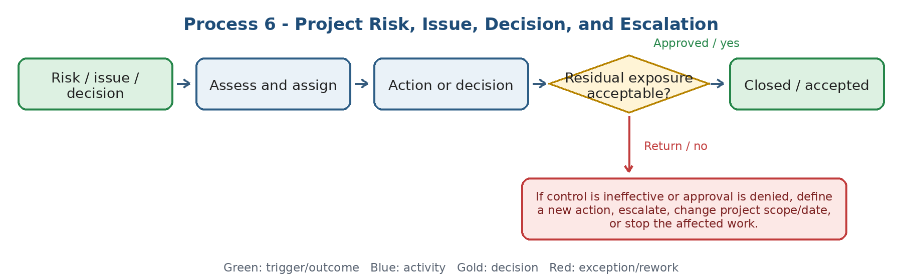
Current state and actual process facts
- QMS sources define risk identification, probability/consequence assessment, prioritization, control actions, periodic review, and residual-risk reassessment.
- The risk owner may identify and follow up an action while another unit executes it; execution responsibility must therefore be separate from risk ownership.
- High risk requires immediate action/escalation; accepted risk requires recorded authorization. Detailed project-issue and decision-log practice is not confirmed.
Target Odoo workflow and cross-functional integration
- Link each risk/issue/decision to project, milestone/task, process, originating event, owner, executor, due date, impact, probability/severity, response, evidence, and status.
- Effectiveness review and residual-risk assessment should be performed by an authorized reviewer independent enough from action execution; the process owner/management accepts residual risk within authority.
- Show aging, overdue decisions, high exposure, blocked work, related changes, and repeated root causes.
Exceptions, approvals, controls, and open decisions
- Do not close risk merely because an action was completed; verify effect and record residual risk.
- If CEO/management rejects a proposed response, record the reason and return to response design, resource/scope change, risk acceptance, or stop decision.
- Open decisions: scoring matrix, acceptance authority, independent effectiveness reviewer, escalation SLA, and issue-to-change conversion.
Output, reports, KPIs, and workshop evidence
- Output: controlled risk/issue, documented decision, verified action, and accepted residual exposure or renewed treatment.
- KPIs: high risks, overdue actions/decisions, issue aging, recurring causes, ineffective controls, and residual-risk trend.
- Demo/evidence: create a server-room risk owned by IT with an Administrative procurement action, reject the first control, reassess residual risk, and escalate.
Workflow result - Coverage to confirm: [ ] Standard Odoo [ ] Configuration [ ] Odoo Studio [ ] Custom Development [ ] Integration [ ] Alternative / Not Supported
Gap / limitation: ............................................................ Action / Owner / Due / acceptance evidence: ........................................................................
7. Scope and Change Control
No project scope, baseline, configuration, process, or deliverable changes without impact assessment and an explicit approval path.
Workflow route: Change request -> classify and assess scope/time/cost/risk/data/training/document impact -> review options -> approve, reject, or defer -> update baseline and execute -> verify effect.
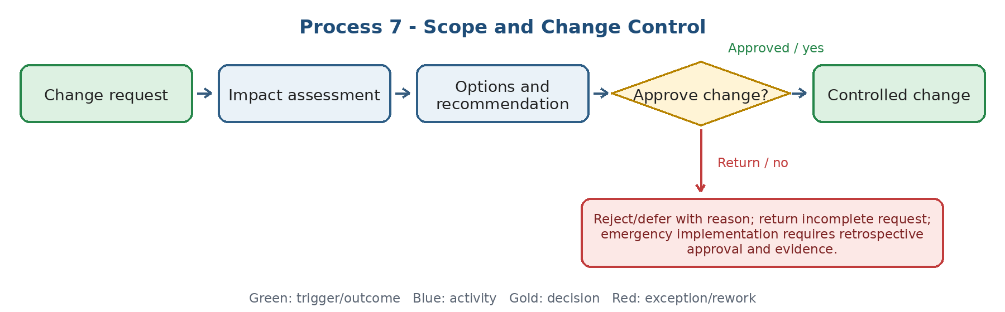
Current state and actual process facts
- QMS defines change nature, potential results, risks, resources, training, document updates, communication, execution monitoring, and effectiveness review.
- The ERP workbook requires scope change control, backlog priority, cross-owner approval, release planning, and audit trail.
- Numeric change thresholds and the final Change Control Board are not confirmed.
Target Odoo workflow and cross-functional integration
- One change request links to the affected project baseline, process, requirement, configuration, integration, report, role, document, test, training, and release.
- Store alternatives, impact estimate, affected owners, approval threshold, decision, effective release/date, implementation evidence, and outcome review.
- Prevent unapproved scope creep and personal low-value changes from entering the active build.
Exceptions, approvals, controls, and open decisions
- A change affecting another process owner cannot be approved by the requester alone.
- Approved change must update relevant baseline, documents, tests, training, and communications before closure.
- Open decisions: change categories, emergency path, approval levels, cost/time tolerance, and connection between Helpdesk tickets and project change backlog.
Output, reports, KPIs, and workshop evidence
- Output: approved/rejected/deferred change, updated baseline/release, and verified implementation result.
- KPIs: change lead time, scope creep, emergency changes, rework caused by change, changes without updated documents/tests, and benefit achieved.
- Demo/evidence: convert a user request into a change, assess cross-unit impact, reject a personal request, approve a justified one, and update the baseline.
Workflow result - Coverage to confirm: [ ] Standard Odoo [ ] Configuration [ ] Odoo Studio [ ] Custom Development [ ] Integration [ ] Alternative / Not Supported
Gap / limitation: ............................................................ Action / Owner / Due / acceptance evidence: ........................................................................
8. Deliverable Acceptance, Project Closure, Lessons, and Benefits
A project is not closed because tasks are complete; deliverables, acceptance, open obligations, knowledge, and realized benefits must be addressed.
Workflow route: Deliverables ready -> acceptance against criteria -> resolve punch list/open risk -> handover and support owner -> close financial/contract records -> capture lessons -> measure benefits -> close or extend.
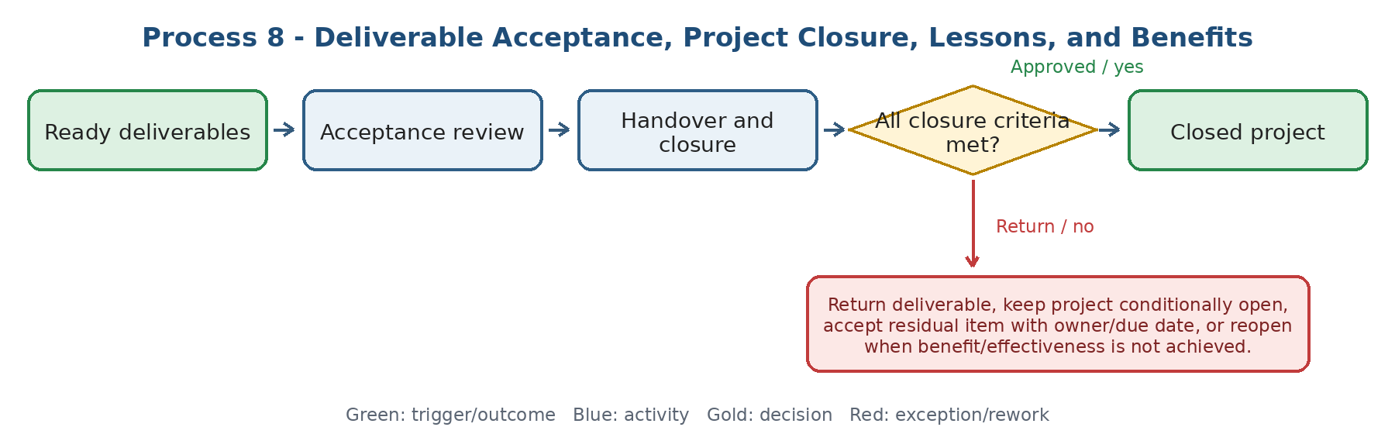
Current state and actual process facts
- The workbook requires evidence-based closure, effectiveness checks, lessons learned, knowledge capture, and benefits realization against the To-Be baseline.
- Improvement projects should compare before/after results and standardize successful change.
- One current closure checklist, warranty/hypercare handover, and benefit-review calendar are not confirmed.
Target Odoo workflow and cross-functional integration
- Closure checklist: accepted deliverables, signed criteria, open issue/risk disposition, documents, training, handover owner, support/warranty, financial/contract status, data access/archive, and lessons.
- Schedule benefit reviews after go-live/implementation; link baseline and target to actual time, error, cost, transparency, adoption, quality, or revenue outcome.
- Create follow-up actions where benefits are not realized; do not hide them by closing the project.
Exceptions, approvals, controls, and open decisions
- Only the authorized sponsor/process owner accepts the deliverable; project manager cannot self-accept.
- Open critical defects or missing mandatory training/data prevent closure unless formally risk-accepted.
- Open decisions: closure authority, conditional acceptance, benefit-review period, document retention, and reopen criteria.
Output, reports, KPIs, and workshop evidence
- Output: accepted handover, closure report, lesson/knowledge record, and benefit-realization plan/results.
- KPIs: first-pass acceptance, punch-list aging, projects closed with open items, benefit realization %, lesson reuse, and post-closure reopen rate.
- Demo/evidence: reject a deliverable, accept after rework, hand over to support, capture a lesson, schedule benefit review, and reopen an ineffective improvement.
Workflow result - Coverage to confirm: [ ] Standard Odoo [ ] Configuration [ ] Odoo Studio [ ] Custom Development [ ] Integration [ ] Alternative / Not Supported
Gap / limitation: ............................................................ Action / Owner / Due / acceptance evidence: ........................................................................
PHASE C - SYSTEMS & METHODS PROCESS GOVERNANCE
9. Process Catalogue, As-Is / To-Be, and Standardization
A governed process catalogue connects enterprise process architecture to real workflows, variants, systems, controls, and improvement priorities.
Workflow route: Organization structure/objectives and unit activities -> identify end-to-end process -> assign boundary and owner -> document As-Is -> design To-Be/standard variants -> approve, publish, and review.
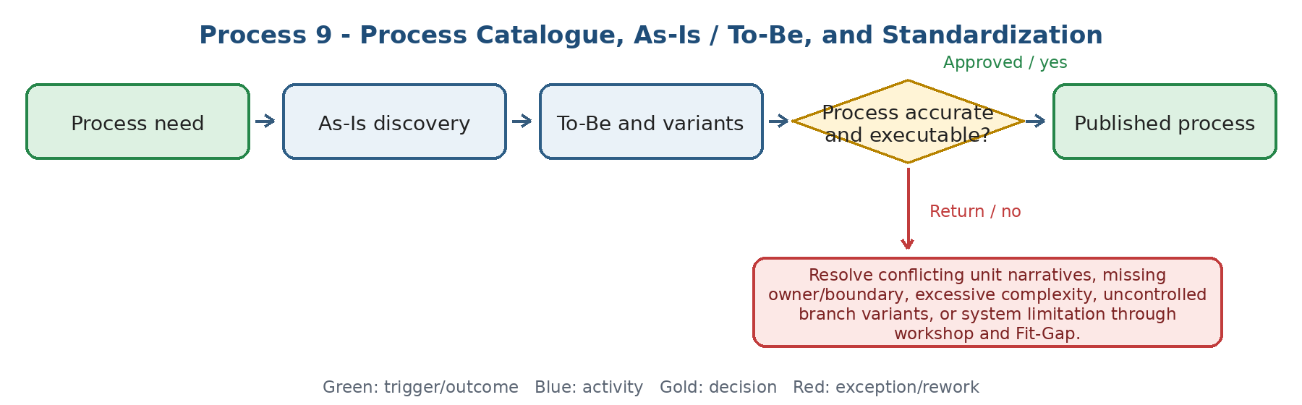
Current state and actual process facts
- The source confirms enterprise process mapping, process profiles, As-Is interviews/observation, To-Be design, standardization, controlled variants, and periodic revision.
- Process facts include goals, scope, stakeholders, inputs/outputs, activities, KPIs, risks, documents, owner approval, publication, and revision.
- Many architecture/documentation activities are marked as not requiring transaction-system mechanization; Odoo should not be forced to replace specialist modeling tools.
Target Odoo workflow and cross-functional integration
- Maintain a searchable process catalogue with process ID, type, owner, scope, version, status, linked SOP/forms/KPIs/risks/roles/systems, review date, and implementation scope.
- Odoo should execute and evidence operational workflows where appropriate; process maps and detailed models may remain in a controlled document/modeling repository linked to Odoo records.
- Support branch/process variants without uncontrolled duplication.
Exceptions, approvals, controls, and open decisions
- No process is published without accountable owner and validated user evidence.
- A process that exists but is intentionally not mechanized is Out of Scope, not Not Applicable; an activity not performed is Not Applicable.
- Open decisions: process repository, version numbering, review frequency, branch variant rule, and integration/linking with external modeling documents.
Output, reports, KPIs, and workshop evidence
- Output: approved process map/profile, As-Is/To-Be, controlled variants, and ERP scope classification.
- KPIs: processes without owner, expired profiles, processes analyzed, manual steps, rework/bottlenecks, and open To-Be gaps.
- Demo/evidence: link a process profile to its SOP, owner, KPI, risk, Odoo workflow, and revision approval without duplicating the operational transaction.
Workflow result - Coverage to confirm: [ ] Standard Odoo [ ] Configuration [ ] Odoo Studio [ ] Custom Development [ ] Integration [ ] Alternative / Not Supported
Gap / limitation: ............................................................ Action / Owner / Due / acceptance evidence: ........................................................................
10. Process Ownership, RACI, Handoff, SLA, and Approval Design
Every end-to-end process needs explicit decision ownership, execution roles, cross-unit handoffs, service levels, approval limits, substitutes, and escalation.
Workflow route: Approved To-Be -> identify owner and roles -> define handoffs/input completeness -> set SLA/start-stop/hold -> define approval matrix and substitute -> test exceptions -> approve and publish.
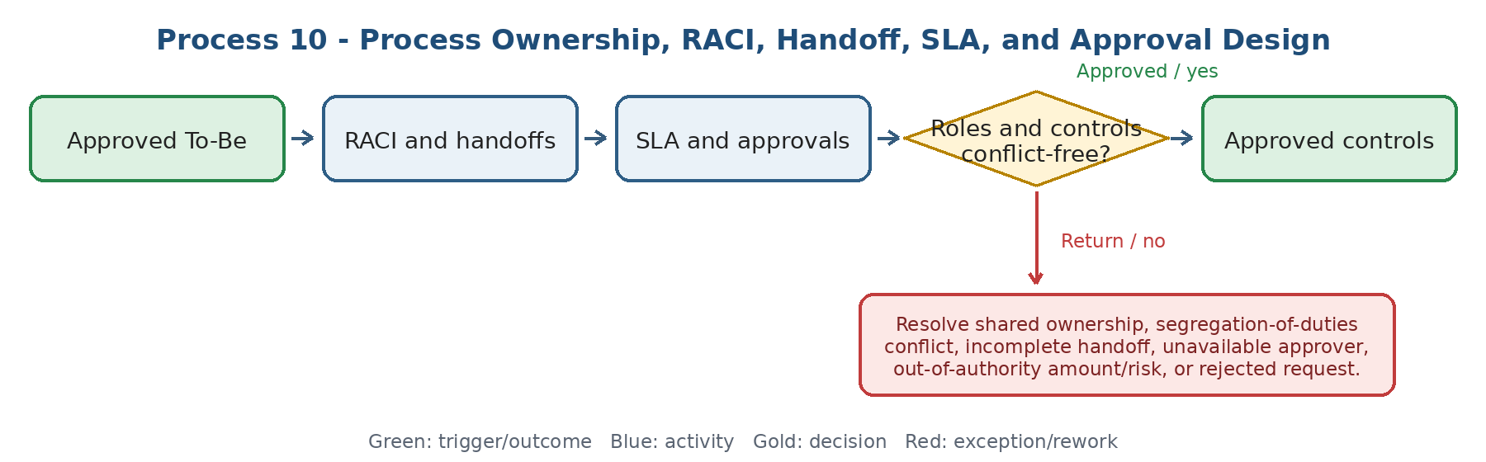
Current state and actual process facts
- The workbook explicitly defines Process Owner, executor, approver, consulted/informed roles, data owner, decision owner, handoff trigger, completeness, SLA, waiting state, escalation, and approval levels.
- Incomplete inputs return through a standard path; SLA breach triggers warning/escalation; out-of-authority requests go to a higher level; absent approvers need a substitute.
- Final ownership is shared with Systems & Methods management and HR where organization roles are affected.
Target Odoo workflow and cross-functional integration
- Translate approved business roles to Odoo groups/record rules/approval routes without confusing process ownership with technical user provisioning.
- Store SLA start/stop/pause rules, handoff evidence, return reasons, approval delegation, thresholds, and audit history.
- Connect role matrix to task/request types and sensitive data access; IT/Admin provisions access from approved functional roles.
Exceptions, approvals, controls, and open decisions
- No shared or ambiguous final ownership; one accountable owner per process/result.
- Override is only allowed with authority and audit trail; emergency access must be time-limited and reviewed.
- Open decisions: final RACI owner, SLA calendars, pause reasons, escalation recipients, approval thresholds, delegation duration, and SoD rules.
Output, reports, KPIs, and workshop evidence
- Output: approved RACI, handoff/SLA specification, approval matrix, and functional access requirement.
- KPIs: ownerless activities, unclear handoffs, incomplete-input returns, SLA breach, approval lead time, rejections, overrides, and access exceptions.
- Demo/evidence: incomplete cross-unit request -> return -> corrected handoff -> overdue escalation -> substitute approval -> audit trail.
Workflow result - Coverage to confirm: [ ] Standard Odoo [ ] Configuration [ ] Odoo Studio [ ] Custom Development [ ] Integration [ ] Alternative / Not Supported
Gap / limitation: ............................................................ Action / Owner / Due / acceptance evidence: ........................................................................
11. Business Rules, Forms, Data Capture, and Process Pilot
Rules and forms must enforce only valuable controls, capture data once, protect sensitive fields, and survive realistic pilot scenarios.
Workflow route: To-Be and risk -> identify decisions/data -> define rules, mandatory fields, attachments, duplicate controls, and exceptions -> configure prototype -> pilot real scenarios -> revise and approve.
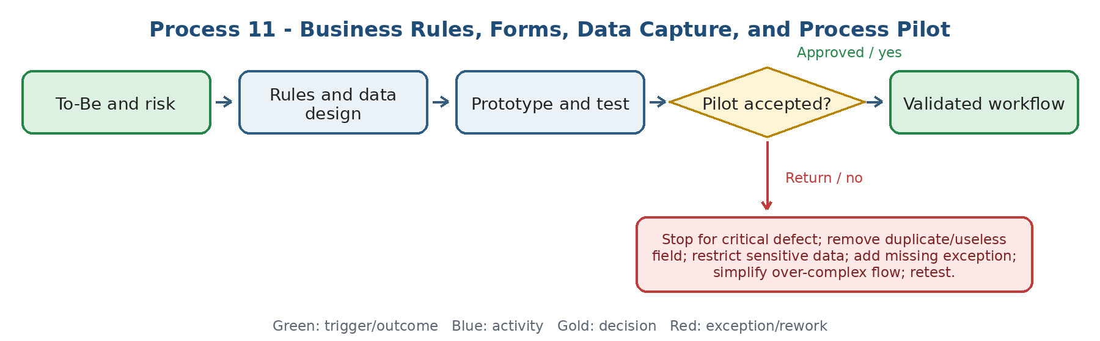
Current state and actual process facts
- The workbook confirms design of business rules, mandatory controls/warnings, authorized override, forms, fields, attachments, checklists, duplicate prevention, sensitive access, and real-user pilot/revision.
- Critical error or user rejection stops the pilot; an uncovered exception becomes a new test; process owner approves after re-execution.
- Process requirements should be business requirements, not vague requests for a preferred screen or solution.
Target Odoo workflow and cross-functional integration
- Create a field/data dictionary with purpose, source, owner, mandatory condition, sensitivity, default/derived rule, duplicate logic, validation, and reporting use.
- Demonstrate Standard, Configuration, Studio, Custom Development, Integration, or Alternative for every rule/form need.
- Keep test scenarios linked to requirement and expected result; retain pilot evidence and revisions.
Exceptions, approvals, controls, and open decisions
- A field with no decision, control, operational, legal, or reporting use should be removed.
- Pilot approval cannot be based on a generic demo; real normal, rejection, return, exception, and escalation cases must pass.
- Open decisions: who owns data definitions, which fields are mandatory by condition, and the threshold for Studio vs. custom development.
Output, reports, KPIs, and workshop evidence
- Output: approved rule/form/data specification, validated prototype, pilot log, and process-owner sign-off.
- KPIs: missing data, duplicate fields/records, validation errors, pilot defects, revision count, exception coverage, and user acceptance.
- Demo/evidence: show a duplicate, sensitive field restriction, authorized override, normal path, rejection, exception, and corrected retest.
Workflow result - Coverage to confirm: [ ] Standard Odoo [ ] Configuration [ ] Odoo Studio [ ] Custom Development [ ] Integration [ ] Alternative / Not Supported
Gap / limitation: ............................................................ Action / Owner / Due / acceptance evidence: ........................................................................
12. Controlled Documents, Records, and Organizational Knowledge
Policies, procedures, instructions, forms, records, guides, lessons, and knowledge require distinct lifecycle, access, retention, and evidence rules.
Workflow route: Need or experience -> draft/capture -> code, owner, classify, and review -> approve/publish -> use and retrieve -> revise/retire/archive -> retain or dispose by rule.
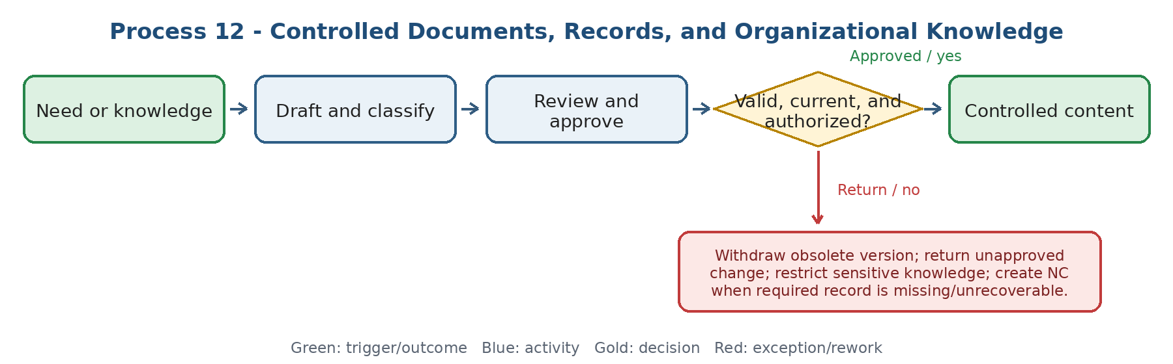
Current state and actual process facts
- Sources confirm controlled procedures, instructions, forms, checklists, process documents, coding, ownership, revision, controlled publication, retirement, records retention/access/retrieval/disposal, and knowledge capture/share/review.
- Knowledge sources include project/process experience, success/failure lessons, reports, standards, videos, and training content.
- Old versions must be removed from use; closing without approval or losing required evidence is not acceptable.
Target Odoo workflow and cross-functional integration
- Separate document master from transactional record/evidence while linking them to processes, projects, tasks, risks, audits, CAPA, UAT, and support tickets.
- Metadata: type, code, owner, version, status, approver, effective date, review date, confidentiality, related process/project, retention, and obsolete/archive state.
- Candidate touchpoints: Documents, Knowledge, Project, Helpdesk, and approval workflow; demonstrate version/access/retention limitations.
Exceptions, approvals, controls, and open decisions
- Only approved effective version is visible for execution; obsolete content remains archived but not operationally selectable.
- Required record cannot be deleted before retention end; access and disposal must be authorized and auditable.
- Open decisions: master repository, numbering/version rule, e-signature need, retention matrix, external sharing, and migration of current content.
Output, reports, KPIs, and workshop evidence
- Output: controlled document/knowledge item, retrievable record, revision trail, and valid evidence archive.
- KPIs: active/expired documents, overdue reviews, missing owner, retrieval time, obsolete use, knowledge coverage, and lesson reuse.
- Demo/evidence: revise an SOP, approve and publish it, block old version, link a project lesson, retrieve audit evidence, and apply access/retention rules.
Workflow result - Coverage to confirm: [ ] Standard Odoo [ ] Configuration [ ] Odoo Studio [ ] Custom Development [ ] Integration [ ] Alternative / Not Supported
Gap / limitation: ............................................................ Action / Owner / Due / acceptance evidence: ........................................................................
13. KPI Evidence, Process Performance, and Management Review
Performance control connects strategy, process KPIs, evidence quality, target/actual/baseline, variance, risk, actions, and management decisions.
Workflow route: Goal/process outcome -> KPI definition and source -> period evidence -> validate/reconcile -> calculate target/actual/variance -> analyze -> action/management review -> effectiveness follow-up.
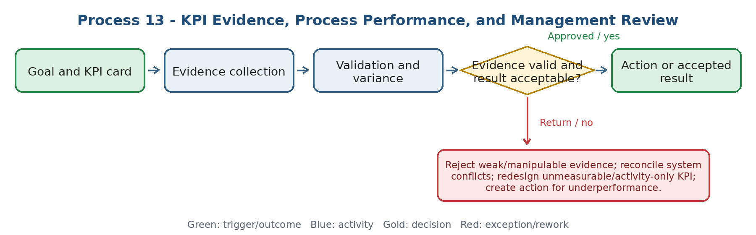
Current state and actual process facts
- The workbook defines KPI outcome, formula, source, owner, period, baseline, target, actual, validation, evidence, variance, and corrective action when below target.
- Evidence from system data is preferred; manual evidence is only for metrics outside systems. Conflicting systems require a declared System of Record.
- Management review combines KPI, audit, risk, complaints/satisfaction, change, and resources into decisions/actions with owner and due date.
Target Odoo workflow and cross-functional integration
- Maintain KPI cards linked to process, strategic goal, project, data source, calculation, owner, target, evidence, result, status, and action.
- System may provide validated data, trend, target/actual, and variance; complex causal analysis may remain outside but its action/decision must be recorded.
- Management review package and minutes should create traceable decisions/actions, not a disconnected document only.
Exceptions, approvals, controls, and open decisions
- No KPI result is accepted without definition, period, source, formula, and evidence; manual override requires reason and approval.
- Below-baseline/high-risk performance triggers redesign; near baseline triggers correction; above target may trigger benchmarking/target uplift.
- Open decisions: calculation in Odoo vs. BI, evidence approval, period lock, threshold colors, review cadence, and action escalation.
Output, reports, KPIs, and workshop evidence
- Output: reliable KPI result, process-performance report, management decision, and tracked improvement action.
- KPIs: missing evidence, data conflicts, on-time evaluation, target achievement, action closure, repeated underperformance, and review action aging.
- Demo/evidence: load system and manual evidence, reject an invalid source, reconcile two values, calculate variance, create action, and follow it through review.
Workflow result - Coverage to confirm: [ ] Standard Odoo [ ] Configuration [ ] Odoo Studio [ ] Custom Development [ ] Integration [ ] Alternative / Not Supported
Gap / limitation: ............................................................ Action / Owner / Due / acceptance evidence: ........................................................................

14. Internal Audit, Nonconformity, CAPA, and Improvement Action
Audits, KPI failures, complaints, risks, incidents, errors, and staff suggestions should enter one governed action lifecycle without losing their origin.
Workflow route: Risk-based audit/issue/opportunity -> finding or action need -> classify and assign -> containment/RCA/action -> evidence -> effectiveness check -> close, reopen, or improvement project.
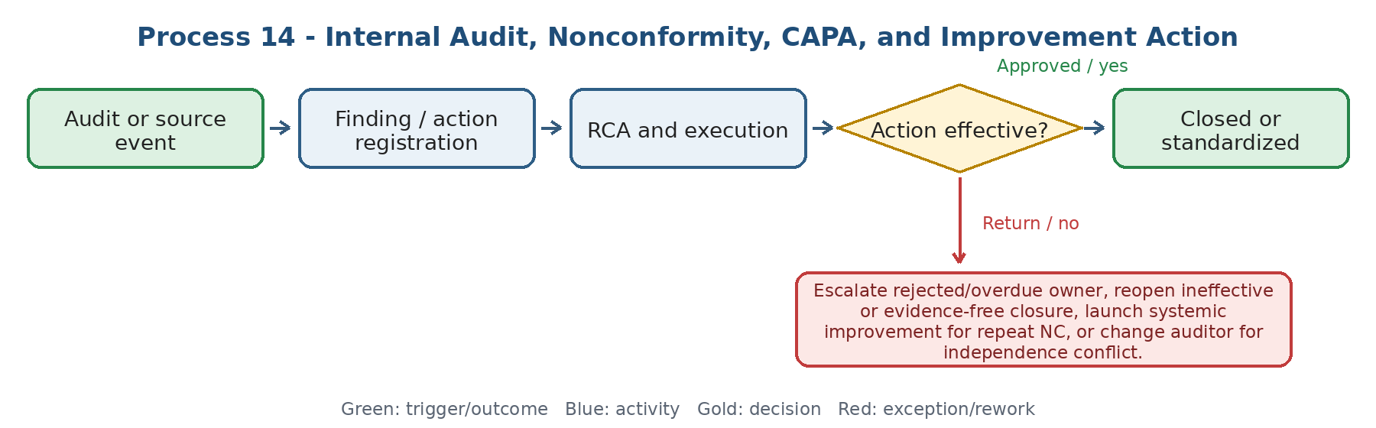
Current state and actual process facts
- The workbook merges audit planning/execution and links findings to Conformity, Observation/OFI, or Nonconformity; NC follows containment, RCA, CAPA, evidence, effectiveness, and closure/reopen.
- Action Management should accept audit findings, KPI gaps, complaints, nonconformity, risk, improvement opportunity, incident/error, and employee suggestion.
- Product nonconformity/returns remain in Technical, Inventory, and Sales packages; Systems & Methods owns systemic/QMS nonconformity and cross-process improvement.
Target Odoo workflow and cross-functional integration
- One Action record preserves source, category, severity, process/project, owner, executor, due date/SLA, containment, root cause, plan, evidence, effectiveness reviewer, outcome, and recurrence link.
- Risk-based audit plan must prevent auditor independence conflicts and allow out-of-plan audit for new risk/complaint.
- High-value OFI can become an improvement project; successful results must update process/document/standard.
Exceptions, approvals, controls, and open decisions
- Owner rejection triggers evidence review and escalation; closure without evidence/effectiveness is prohibited.
- Repeat NC requires systemic analysis and possibly a higher-level project/change, not another isolated action.
- Open decisions: finding taxonomy, severity/SLA, audit independence, CAPA approver, effectiveness reviewer, and criteria for converting action to project.
Output, reports, KPIs, and workshop evidence
- Output: audit report/finding, closed effective CAPA or improvement project, and updated control/document where required.
- KPIs: audit coverage, report lead time, open/aging NC, repeat NC, CAPA closure time, overdue actions, effectiveness %, and benefit realized.
- Demo/evidence: create finding -> disputed evidence -> confirm NC -> containment/RCA/action -> late escalation -> ineffective review -> reopen -> close with evidence.
Workflow result - Coverage to confirm: [ ] Standard Odoo [ ] Configuration [ ] Odoo Studio [ ] Custom Development [ ] Integration [ ] Alternative / Not Supported
Gap / limitation: ............................................................ Action / Owner / Due / acceptance evidence: ........................................................................
PHASE D - ERP LIFECYCLE AND OPERATIONAL ENABLEMENT
15. ERP Requirements, Scope Catalogue, and Fit-Gap
ERP requirements must be scenario-based, owned, prioritized, and classified by demonstrated coverage before budget or implementation commitment.
Workflow route: Process problem/goal -> workshop real scenario -> define role/data/approval/exception/report -> prioritize Must/Should -> in/out-of-scope decision -> demo and Fit-Gap -> approve decision.
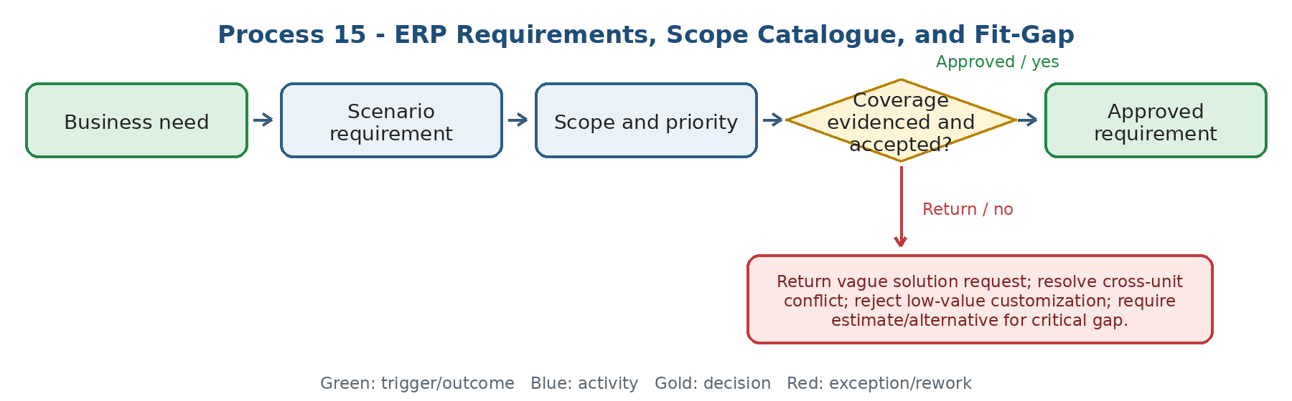
Current state and actual process facts
- The workbook explicitly requires workshops based on real scenarios, not generic demos; it captures roles, data, approval, exceptions, reports, priority, and manager confirmation.
- Scope distinguishes In Scope, Out of Scope, and Not Applicable. Fit-Gap distinguishes Standard, Configuration, Gap, workaround/extension, cost/risk, and governance decision.
- Ownership is shared with the functional system support role; process owners confirm business requirements.
Target Odoo workflow and cross-functional integration
- Requirement record: process/scenario, current problem, target outcome, owner, users, trigger, data, rules, approval, exception/return, report/KPI, priority, acceptance criteria, evidence, and linked decision.
- For every requirement classify Standard Odoo, Configuration, Odoo Studio, Custom Development, Integration, or Alternative / Not Supported.
- For custom/integration: estimate hours/cost, dependencies, upgrade impact, security, testing, data migration, training, maintenance, and standard alternative.
Exceptions, approvals, controls, and open decisions
- A statement that a module exists or it can be done is not Fit; Odoo team must run the actual scenario or provide a precise limitation/flow.
- No development for a low-value gap without business value, owner, acceptance test, lifecycle cost, and governance approval.
- Open decisions: scope governance, Must/Should method, evidence standard, sign-off owner, and which gaps block vendor/implementation selection.
Output, reports, KPIs, and workshop evidence
- Output: approved scope catalogue, requirement register, Fit-Gap decision, estimate/action, owner, due date, and acceptance evidence.
- KPIs: requirements open/approved, coverage by category, critical gaps, unresolved ownership, change in scope, estimate aging, and evidence completeness.
- Demo/evidence: take one cross-unit process and show normal, return, approval, exception, report, access, and audit trail; record coverage and limitation in place.
Workflow result - Coverage to confirm: [ ] Standard Odoo [ ] Configuration [ ] Odoo Studio [ ] Custom Development [ ] Integration [ ] Alternative / Not Supported
Gap / limitation: ............................................................ Action / Owner / Due / acceptance evidence: ........................................................................
16. Solution Blueprint, Functional Roles, Master Data, and Integration
The approved Fit-Gap becomes a controlled design across process, data, security, interfaces, reports, tests, training, decisions, and milestones.
Workflow route: Scope/Fit-Gap -> process/data/security/integration/report design -> role and System-of-Record decisions -> blueprint review -> approve baseline -> configuration/build backlog.
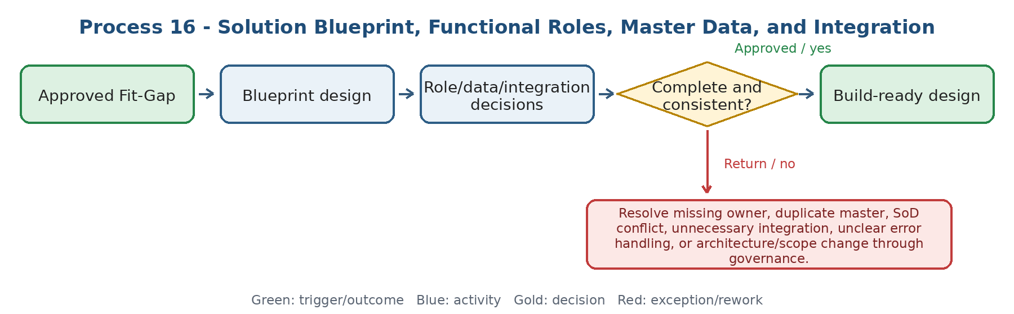
Current state and actual process facts
- The workbook defines Solution Blueprint, decision log, milestones, issues/risks, functional role matrix, Master Data governance, integration requirements, report catalogue, alerts, and security/audit controls.
- Master examples include Customer, Product, Vendor, Employee, Chart, and Location; each needs Data Owner, fields, duplicate rule, approval, and System of Record.
- Integration definition includes source, target, trigger, data, frequency, error handling, owner, testing, and monitoring; API/security design remains IT/Admin responsibility.
Target Odoo workflow and cross-functional integration
- Blueprint sections: scope, end-to-end process, object/data model, roles/access/SoD, master ownership, integration/error queue, reports/KPIs, notifications, migration, testing, training, cutover, support, and release governance.
- Declare system of record for each domain across Odoo, Sepidar, Rahkaran, Teamyar/Mizito/BPMS, BI, and other retained tools; avoid parallel duplicate databases.
- Alerts need trigger, recipient, channel, reminder, escalation, and anti-noise rule.
Exceptions, approvals, controls, and open decisions
- Blueprint cannot be approved with unresolved critical process/data/security/integration decisions.
- Integration is not accepted without failure handling, reconciliation, monitoring, and ownership.
- Open decisions: retained systems, finance/accounting boundary, HR boundary, document repository, BI read/write boundary, and admin vs. functional ownership.
Output, reports, KPIs, and workshop evidence
- Output: approved Solution Blueprint, RACI/access matrix, data dictionary, integration specification, report/alert catalogue, and build backlog.
- KPIs: unresolved decisions, duplicate masters, interface failures, SoD conflicts, blueprint changes, and build items without acceptance test.
- Demo/evidence: update a master record, run approval/access rule, trigger integration, show failed sync/retry/reconciliation, and trace report data to source.
Workflow result - Coverage to confirm: [ ] Standard Odoo [ ] Configuration [ ] Odoo Studio [ ] Custom Development [ ] Integration [ ] Alternative / Not Supported
Gap / limitation: ............................................................ Action / Owner / Due / acceptance evidence: ........................................................................
17. Configuration Review, UAT, Defect, and Sign-Off
Configuration is accepted only when requirement-linked normal and exception scenarios pass with real roles, data, controls, and expected evidence.
Workflow route: To-Be/Fit-Gap -> configure sandbox -> process-owner review -> test case and data -> UAT execute -> log defect -> fix/retest -> sign-off or no-go.
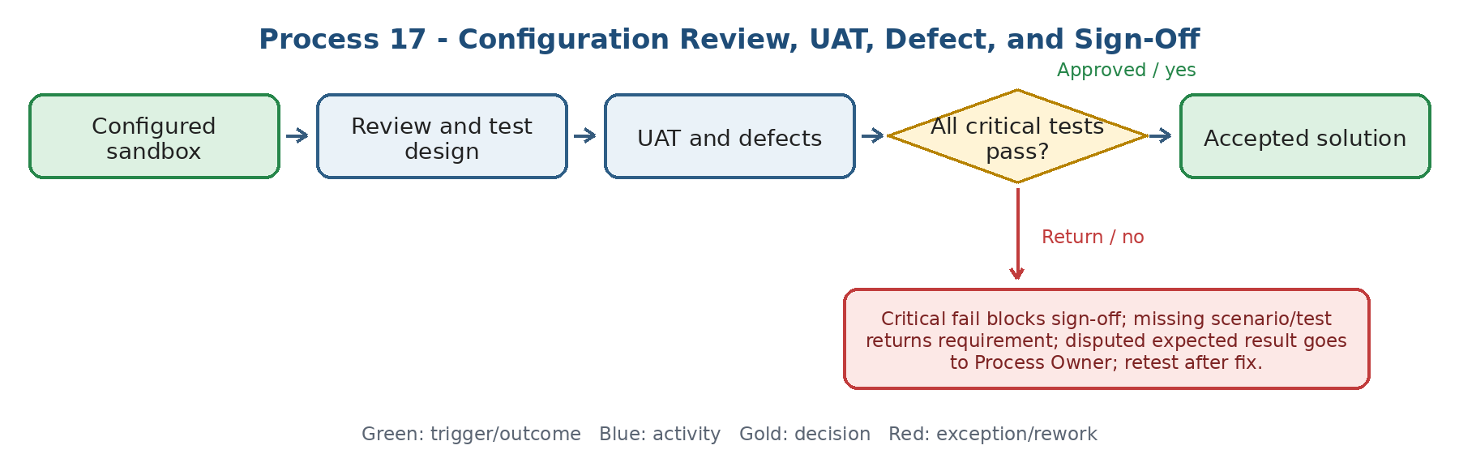
Current state and actual process facts
- The workbook requires workflow/status/rule/approval/form review in sandbox, process-owner baseline, test scenarios, expected result, test data, user role, defect, retest, and sign-off.
- A critical failure means no Go-Live; a requirement without a test cannot be signed off.
- The source assigns UAT operational ownership to functional system support with Process Owner/business-user approval.
Target Odoo workflow and cross-functional integration
- Link every test to requirement, process step, role, data precondition, expected result, evidence, actual result, defect, severity, fix release, retest, and approver.
- Cover normal path, reject/return, approval, access denial, duplicate/data validation, integration failure, report, notification, and audit trail.
- Maintain defect aging, critical/open defects, test pass rate, and conditional acceptance/risk decision.
Exceptions, approvals, controls, and open decisions
- Builder/developer cannot self-approve UAT; authorized business owner signs off.
- A workaround must be documented, tested, trained, and accepted with risk/expiry where temporary.
- Open decisions: severity model, exit criteria, evidence type, conditional sign-off, test environment refresh, and regression scope after update.
Output, reports, KPIs, and workshop evidence
- Output: approved configuration baseline, complete test evidence, defect register, retest, and process-owner sign-off/no-go decision.
- KPIs: test pass rate, critical/open defects, defect aging, reopen rate, requirements without test, and sign-off cycle time.
- Demo/evidence: fail a return/approval/integration scenario, log defect, block sign-off, retest, and show traceability from requirement to evidence.
Workflow result - Coverage to confirm: [ ] Standard Odoo [ ] Configuration [ ] Odoo Studio [ ] Custom Development [ ] Integration [ ] Alternative / Not Supported
Gap / limitation: ............................................................ Action / Owner / Due / acceptance evidence: ........................................................................
18. Data Migration, Cutover Readiness, and Go-Live Decision
Go-Live is a gated management decision based on reconciled data, passed UAT, access, training, support, open risks/issues, and a tested cutover/rollback plan.
Workflow route: Source data -> map, cleanse, deduplicate, and trial load -> reconcile and sign off -> cutover checklist/freeze/final load -> validate -> Go/No-Go -> launch or rollback.
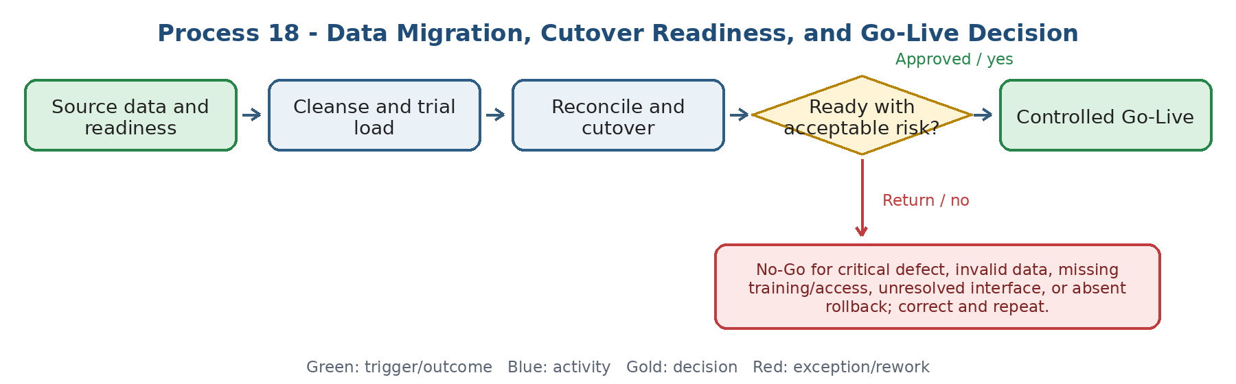
Current state and actual process facts
- The workbook assigns data cleansing/validation to business Data Owners, structure coordination/reconciliation to Systems & Methods/functional support, and loading to Admin/implementation team.
- Required sequence includes mapping, deduplication, migration template, trial load, reconciliation, unit sign-off, final load, and validation.
- Readiness includes UAT, data, training, access, open issues, cutover tasks, freeze/load/validation, Go/No-Go, and rollback/risk acceptance.
Target Odoo workflow and cross-functional integration
- Migration objects and cutover tasks need owner, source, mapping, cleansing rule, trial result, reconciliation total, exception, evidence, sign-off, final sequence, duration, and rollback dependency.
- Open legacy workflow records require a migrate/archive/close decision and cross-reference between legacy ID and Odoo record.
- Go-Live dashboard should show readiness by workstream and blocking vs. accepted residual items.
Exceptions, approvals, controls, and open decisions
- No ownerless data; Admin loading does not replace business validation/sign-off.
- Critical readiness failure results in No-Go unless authorized risk acceptance explicitly covers impact, mitigation, owner, and expiry.
- Open decisions: migration history depth, freeze window, reconciliation thresholds, open-record treatment, rollback trigger, and Go-Live authority.
Output, reports, KPIs, and workshop evidence
- Output: reconciled migration, signed readiness checklist, cutover plan, Go/No-Go decision, launch/rollback record, and open-item handover.
- KPIs: valid records %, duplicates, reconciliation errors, sign-off status, readiness %, cutover completion, data defects after launch, and rollback incidents.
- Demo/evidence: trial-load duplicate data, fail reconciliation, correct/reload, block Go-Live for missing training, approve after evidence, and execute rollback simulation.
Workflow result - Coverage to confirm: [ ] Standard Odoo [ ] Configuration [ ] Odoo Studio [ ] Custom Development [ ] Integration [ ] Alternative / Not Supported
Gap / limitation: ............................................................ Action / Owner / Due / acceptance evidence: ........................................................................
19. Training, Adoption, Functional Support, and Stabilization
Role-based training, support, adoption monitoring, and post-launch stabilization are part of implementation control, not optional aftercare.
Workflow route: Role/process and release -> training need and scenario -> train/practice/assess -> Go-Live support ticket -> classify/respond/escalate -> user confirms resolution -> adoption review and improvement.
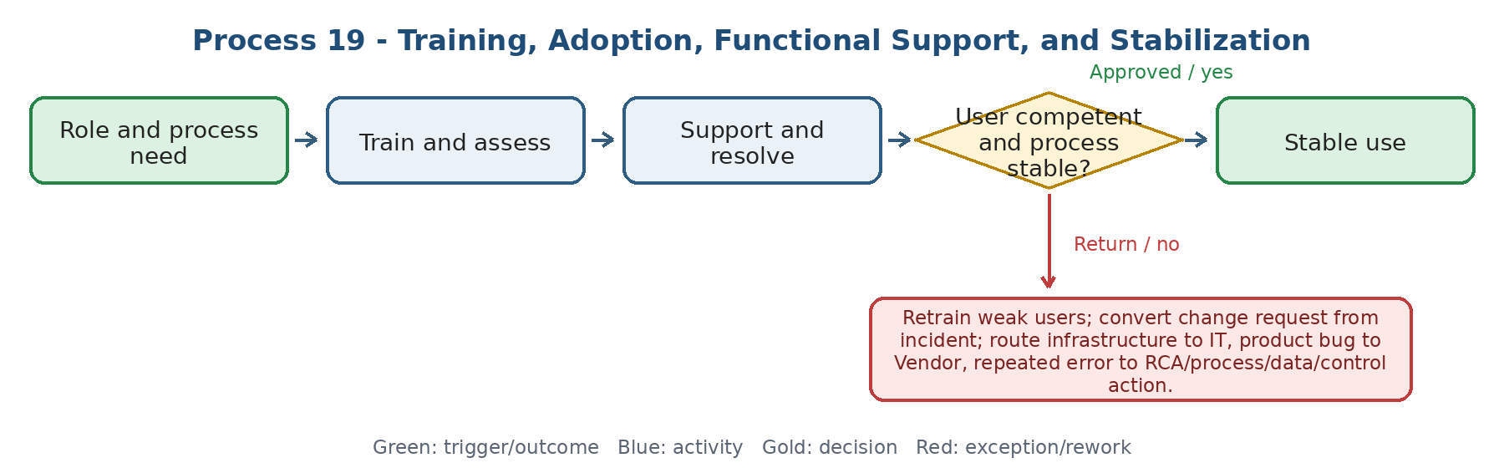
Current state and actual process facts
- Sources define role-based real-scenario training, practice, evaluation, quick guides/FAQ/video, coaching, support request categories, SLA, resolution confirmation, vendor escalation, root-cause analysis, and adoption maturity.
- The Systems & Methods role is process/adoption/governance; functional system support owns many daily tickets, UAT, training, vendor follow-up, backlog, and release tasks; IT owns infrastructure/security/API execution.
- Bypassing the system or returning to the old method is a stabilization failure requiring root-cause and action.
Target Odoo workflow and cross-functional integration
- Training record links user/role/process/scenario, attendance, practice, assessment, result, retraining, guide/version, and release.
- Ticket categories: Incident, How-to, Access, Change, Data, Integration, Infrastructure, Vendor Bug; route each to owner/SLA and connect repeated cases to Problem/RCA or change backlog.
- Adoption uses login/transaction/error/support plus observation to distinguish true correct use from superficial use and process bypass.
Exceptions, approvals, controls, and open decisions
- Do not close a ticket until the user confirms resolution or objective evidence exists; Change is not hidden as Incident.
- Obsolete guidance is retired after release; urgent workaround has owner, limitation, expiry, and follow-up.
- Open decisions: support tiers, SLA, ticket channels, champion network, adoption score, training pass level, vendor escalation, and hypercare exit criteria.
Output, reports, KPIs, and workshop evidence
- Output: competent users, current guides, resolved/accepted tickets, stabilized process, RCA/change actions, and adoption plan.
- KPIs: training pass/coverage, user errors, first response/resolution, SLA %, backlog, repeat incident, vendor aging, bypass rate, and correct-use/adoption maturity.
- Demo/evidence: role-based training failure/retest, incident triage, access vs. change routing, vendor escalation, user confirmation, repeated-error RCA, and adoption dashboard.
Workflow result - Coverage to confirm: [ ] Standard Odoo [ ] Configuration [ ] Odoo Studio [ ] Custom Development [ ] Integration [ ] Alternative / Not Supported
Gap / limitation: ............................................................ Action / Owner / Due / acceptance evidence: ........................................................................
20. Release Impact, Compliance, Continuity, and Value Realization
Every system release or change must be assessed for process, integration, reports, control, training, continuity, and realized business value.
Workflow route: Vendor release/change -> impact assessment -> sandbox/regression and continuity check -> enable/defer decision -> communicate/train/deploy -> monitor compliance/performance/value -> improve or rollback.
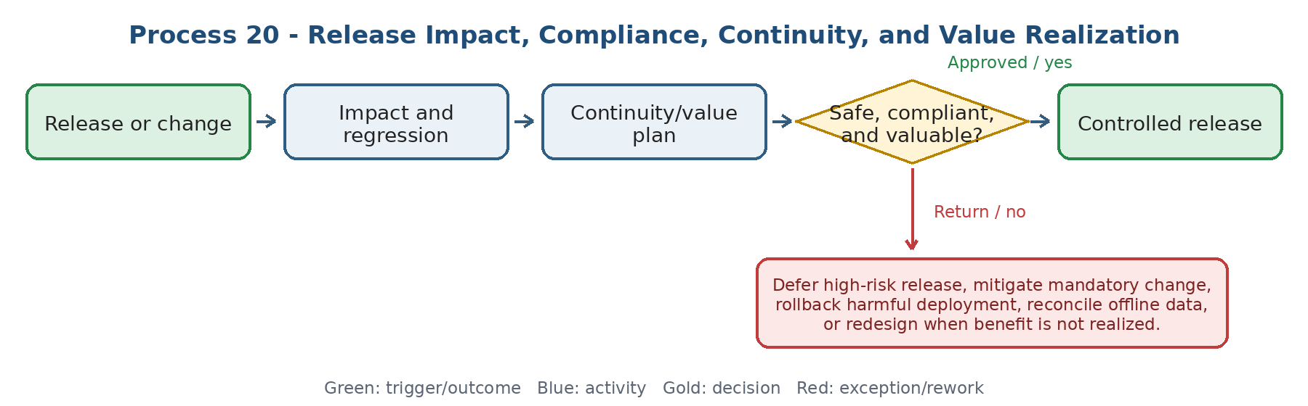
Current state and actual process facts
- The workbook includes release-note impact on process/integration/report, sandbox testing, enable/defer, training/announcement, audit trail, compliance controls, business continuity workaround/re-entry, process analytics, and benefit realization.
- IT owns infrastructure/disaster recovery; Systems & Methods owns controlled manual process, re-entry/reconciliation rule, operational impact, and process/value monitoring.
- Benefit measures include time, error, manual work, cost, transparency, satisfaction, and correct use against baseline/business case.
Target Odoo workflow and cross-functional integration
- Release record links affected processes, configurations, roles, integrations, reports, documents, tests, training, incidents, continuity plan, decision, deployment, and post-release result.
- Compliance monitoring includes sensitive change/approval/override logs and conversion of control failure into Incident/NC/CAPA.
- Process analytics should expose cycle time, waiting, return/rework, error, bottleneck, SLA breach, and transaction failure; benefits compare baseline to actual.
Exceptions, approvals, controls, and open decisions
- No release enablement without impact owner, regression evidence, communication/training, rollback/continuity decision, and audit trail.
- Offline/manual workaround must be controlled and reconciled when the system returns; it must not become a permanent parallel process.
- Open decisions: release authority/calendar, mandatory upgrade rule, regression pack, BCP test frequency, audit-log retention, analytics ownership, and benefit-review cadence.
Output, reports, KPIs, and workshop evidence
- Output: approved/deferred release, updated process/tests/guides, continuity evidence, compliance report, process insight, and benefit result/action.
- KPIs: release defects, change failure, audit exceptions, continuity test result, recovery/reconciliation issues, cycle time/rework/SLA, and benefit realization.
- Demo/evidence: assess a release, detect broken integration, defer, retest, train/deploy, simulate outage/re-entry, review audit trail, and measure benefit.
Workflow result - Coverage to confirm: [ ] Standard Odoo [ ] Configuration [ ] Odoo Studio [ ] Custom Development [ ] Integration [ ] Alternative / Not Supported
Gap / limitation: ............................................................ Action / Owner / Due / acceptance evidence: ........................................................................
Appendix A - Mandatory end-to-end demonstrations
Project intake to benefits
- KPI/audit/improvement need -> charter -> priority/approval -> WBS/milestones -> blocked task/timesheet -> status variance -> deliverable acceptance -> lesson and benefit review.
Risk action across units
- Risk owned by one unit -> action executed by another -> overdue escalation -> evidence -> independent effectiveness check -> residual-risk acceptance or new action.
Controlled process change
- Change request -> impact on process/data/role/document/test/training -> approval/rejection -> implementation -> audit trail -> effectiveness and rollback/rework.
Audit/KPI to Action Management
- Finding or KPI gap -> containment/RCA -> corrective/improvement action -> owner/SLA -> evidence -> ineffective review/reopen -> effective closure and process update.
ERP requirement to Go-Live
- Real scenario -> requirement/scope -> Fit-Gap -> blueprint -> configuration -> UAT failure/defect/retest -> migration reconciliation -> No-Go/Go-Live -> support/adoption.
Appendix B - Workshop decision matrix
# | Workflow | Coverage | Gap / limitation | Action / owner / due | Evidence / acceptance
1 | Project / Improvement Request, Business Case, and Charter | Std / Config / Studio / Custom / Integration / Alt
2 | Prioritization, Approval, and Portfolio Alignment | Std / Config / Studio / Custom / Integration / Alt
3 | Project Setup, WBS, Milestones, Roles, and Baseline | Std / Config / Studio / Custom / Integration / Alt
4 | Task, Dependency, Assignment, and Timesheet Control | Std / Config / Studio / Custom / Integration / Alt
5 | Progress, Schedule, KPI, and Management Reporting | Std / Config / Studio / Custom / Integration / Alt
6 | Project Risk, Issue, Decision, and Escalation | Std / Config / Studio / Custom / Integration / Alt
7 | Scope and Change Control | Std / Config / Studio / Custom / Integration / Alt
8 | Deliverable Acceptance, Project Closure, Lessons, and Benefits | Std / Config / Studio / Custom / Integration / Alt
9 | Process Catalogue, As-Is / To-Be, and Standardization | Std / Config / Studio / Custom / Integration / Alt
10 | Process Ownership, RACI, Handoff, SLA, and Approval Design | Std / Config / Studio / Custom / Integration / Alt
11 | Business Rules, Forms, Data Capture, and Process Pilot | Std / Config / Studio / Custom / Integration / Alt
12 | Controlled Documents, Records, and Organizational Knowledge | Std / Config / Studio / Custom / Integration / Alt
13 | KPI Evidence, Process Performance, and Management Review | Std / Config / Studio / Custom / Integration / Alt
14 | Internal Audit, Nonconformity, CAPA, and Improvement Action | Std / Config / Studio / Custom / Integration / Alt
15 | ERP Requirements, Scope Catalogue, and Fit-Gap | Std / Config / Studio / Custom / Integration / Alt
16 | Solution Blueprint, Functional Roles, Master Data, and Integration | Std / Config / Studio / Custom / Integration / Alt
17 | Configuration Review, UAT, Defect, and Sign-Off | Std / Config / Studio / Custom / Integration / Alt
18 | Data Migration, Cutover Readiness, and Go-Live Decision | Std / Config / Studio / Custom / Integration / Alt
19 | Training, Adoption, Functional Support, and Stabilization | Std / Config / Studio / Custom / Integration / Alt
20 | Release Impact, Compliance, Continuity, and Value Realization | Std / Config / Studio / Custom / Integration / Alt
Appendix C - Source basis and evidence status
This document separates source-backed current-state facts from target requirements and open design decisions. Project Control details that were not explicit in the supplied sources are intentionally not presented as current practice.
- Systems & Methods Activities and Workflow Workbook (supplied XLSX) - 65 reviewed activities/processes with execution route, decision/exception/return, outputs, records/KPIs, and unit comments.
- POE Process ID(4).pdf - Process Operations Enablement profile: process systemization, user enablement, functional support, current/future process systems, KPIs, risks, and improvement evaluation.
- QMS Process ID(4).pdf - QMS/strategy/risk/quality/stakeholder/change/knowledge/HSE process profile, indicators, risks, and improvement evaluation.
- Odoo_Sales_CRM_ENGLISH_FINAL.docx, Odoo_Purchase_Foreign_Procurement_Inventory_Requirements_FINAL.docx, and Odoo_Technical_Engineering_Quality_RnD_FULL_ENGLISH.docx - prior workshop package structure, cross-functional boundaries, demo/evidence method, and classification rule.
- Official Odoo 18 documentation index for feature confirmation during the workshop: https://www.odoo.com/documentation/18.0/applications.html
Evidence rule: Current-state fact = explicitly supported by the supplied workbook/process profiles or earlier approved unit packages. Target requirement = desired control or design to validate. Open decision = unresolved owner, threshold, rule, system boundary, or acceptance criterion.

