Integrated Sales & CRM Workflow Map
From lead and customer master through technical review, pricing, sourcing, credit, order, delivery, collection, and post-sales CRM
Full English edition — detailed requirements, exceptions, approvals, gaps, reports, tools, and demo scenarios embedded in each workflow
How to read this document: each chapter represents a real or target workflow. Directly below the diagram are the current state, data, roles, exceptions, Odoo requirements, open decisions, reports/KPIs, and meeting evidence/demo items. Requirements are therefore kept inside the workflow rather than in disconnected checklists.
Important boundary: items documented in the BPMS workflow exports are treated as current-state facts. Items labeled as “Odoo requirement” or “open decision” are desired-state requirements or design choices and must not be assumed to exist today.

1. Customer model: separate customer dimensions before the sales workflow
A customer can simultaneously be B2B, a legal entity, a key account, and part of a value segment; these are customer attributes, not sales routes.
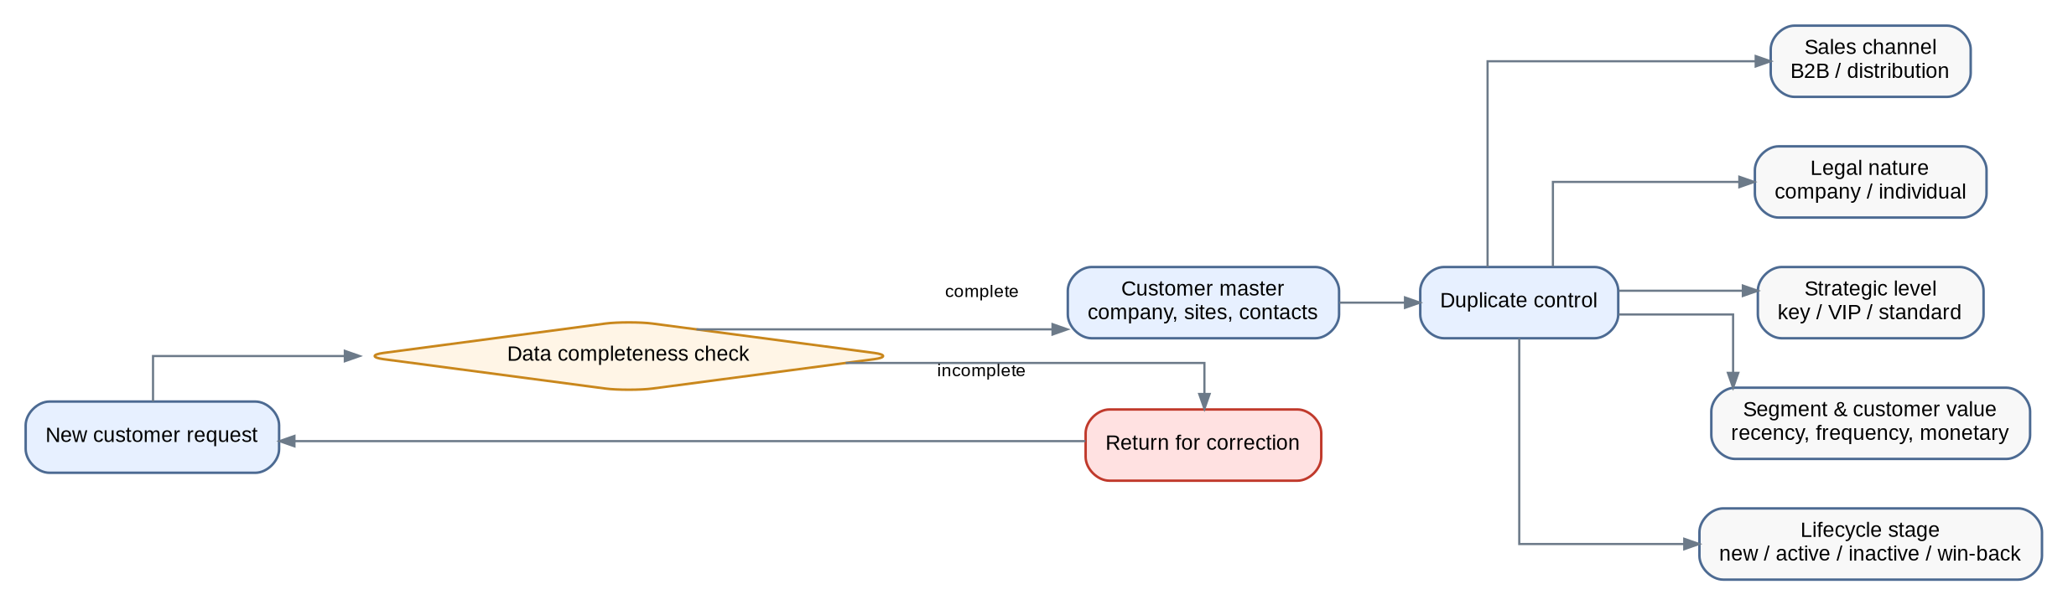
Current state and actual customer-master data
• The current new-customer form includes company name, mobile, company/individual type, business field and activity type, primary and secondary geography, address, email, customer grade, sales status, acquisition source, contact person with position and mobile, workpiece material, number of shifts, and counts of special-purpose, manual, and CNC machines.
• The “New Customer” process includes a control gate: request registration, review, return for correction if incomplete, and completion/archive if approved.
• The CRM team also requires one customer record that supports multiple branches/sites and multiple contacts with purchasing, technical, production, and finance roles.
Odoo requirements and data rules
• Sales channel (B2B/distribution), legal nature (company/individual), strategic level (key/VIP/standard), value segmentation, and lifecycle stage should be independent fields or tags; one single-select customer type is not enough.
• Duplicate leads, contacts, and customers should be checked using name, phone, email, and company identifier, with traceable merge or reassignment.
• Mandatory fields, record ownership, data quality controls, access levels, and change history must be configurable.
• A decision is required on whether grades A/B/C/D and Working/Done/Freeze statuses are migrated as-is or derived from BI and the sales pipeline.
Open decisions and meeting evidence
• Define customer ownership and transfer rules across region, team, and branch, including conflict resolution for shared customers.
• Decide whether new-customer creation requires CRM validation/approval or whether data-quality rules are sufficient.
• Bring to the meeting: one anonymized multi-branch customer example, the current field list, and a Mandatory/Derived/Migration decision for each field.
Workflow result — Coverage: □ Standard □ Configuration □ Odoo Studio □ Development □ Integration | Gap: .................................... | Action / Owner / Due: ....................................
2. Pre-sales CRM workflow — lead, qualification, ownership, and handoff to Sales
Multi-channel intake through opportunity creation, with hold/lost states and Sales acceptance in the same lifecycle.
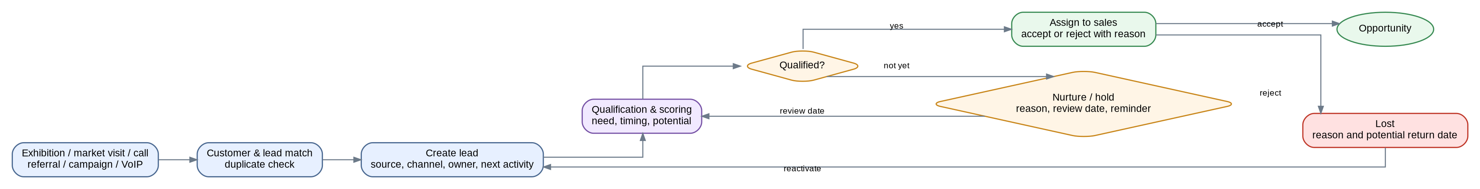
Current state and CRM-team requirements
• Leads arrive from exhibitions, market visits/customer tours, calls, referrals, campaigns, and other channels; source and channel must be reportable.
• CRM requires a 360-degree record, duplicate control, enrichment, qualification/scoring, customer potential including CNC and other machine counts, next activity, and lead nurturing.
• After qualification, Sales should accept or reject the lead with a reason. CRM should monitor the handoff without creating parallel ownership.
Tools and service-level timing
• 3CX/VoIP: caller recognition, inbound/outbound call logging, recording, missed calls, and callbacks on the customer, lead, or case timeline.
• SMS/email: approved templates, consent/opt-out, delivery/failure status, replies, and follow-up on the interaction timeline.
• Every open lead/opportunity must have a next activity and due date; first-action SLA, aging, and supervisor escalation must be configurable and reportable.
Pipeline, open decisions, and KPIs
• Operational stages should be explicit: lead/qualification, introduction/need, visit/technical/test when applicable, negotiation/quotation, hold, lost, and won.
• Hold must not be treated as Lost; it should have a reason, review date, reminder, and defined forecasting behavior.
• Lost reason should be mandatory, capturing competitor, price, budget, lead time, no need, and potential return date.
• The “Won” definition still needs closure: quotation acceptance, sales order, invoice, delivery, or another milestone?
• KPIs: lead source, lead-to-opportunity conversion, opportunity aging, overdue activities, visits, pipeline value, forecast, new/active/inactive customers, acquisition/retention/win-back rates, and first-response time.
• Demo: duplicate 3CX call → match/merge → qualification → assignment → Sales acceptance → opportunity → hold → reactivate. Bring: sample lead/customer, ownership/access rules, and a sample call log.
Workflow result — Coverage: □ Standard □ Configuration □ Odoo Studio □ Development □ Integration | Gap: .................................... | Action / Owner / Due: ....................................
3. Parent sales workflow — one opportunity, multiple operating routes
After an opportunity is created, the route is selected by customer need and supply method, not merely by customer type.
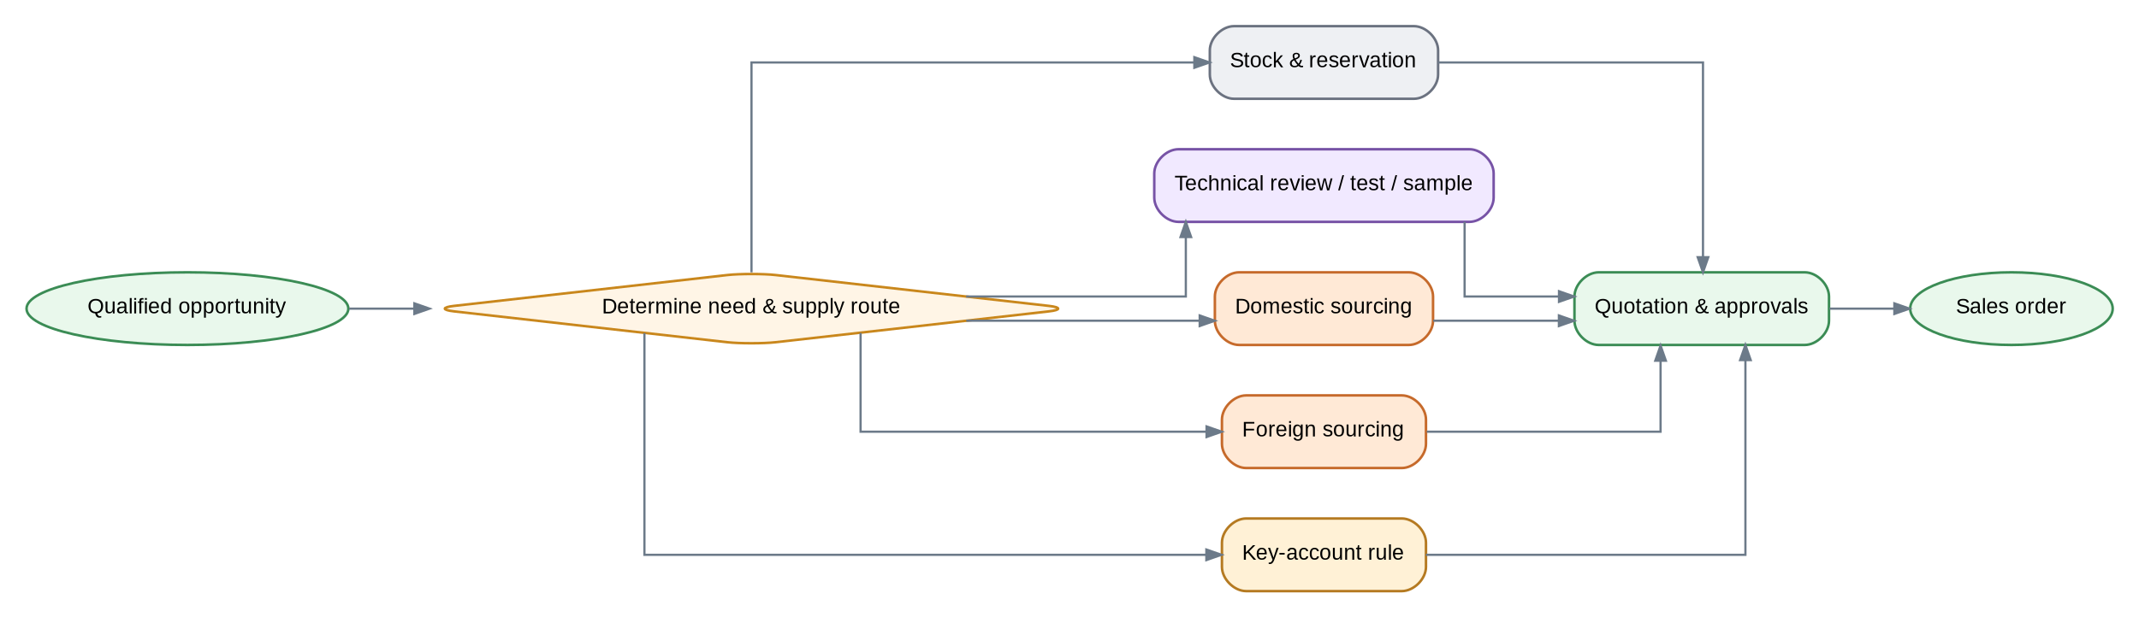
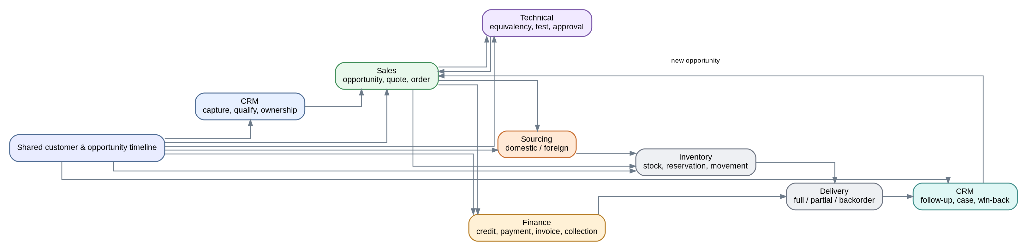
Target architecture principle
• Customer and opportunity should be the parent records; technical requests, tests, reservations, domestic/foreign sourcing, consignment, and returns should link back to them.
• Technical, Finance, Inventory, and Procurement own their specialist activities; Sales owns opportunity, quotation, and sales order; CRM owns interactions, handoffs, and cases before/after the sale and during the sales lifecycle.
• The current BPMS workflows should not be reproduced one-for-one as separate Odoo cases. Necessary controls and approvals should be retained while parallel workflows are eliminated.
Boundary decisions
• CRM vs. Sales boundary: should a case track only interactions/handoffs, or also quotations? Recommended target: quotation remains the commercial record in Sales; the case retains interaction and handoff tracking.
• The current BPMS does not use one standard Sales Order across all routes. Odoo should introduce a single order reference and link specialist requests to it.
Workflow result — Coverage: □ Standard □ Configuration □ Odoo Studio □ Development □ Integration | Gap: .................................... | Action / Owner / Due: ....................................
4. Standard commercial workflow — opportunity to quotation, credit, order, delivery, and collection
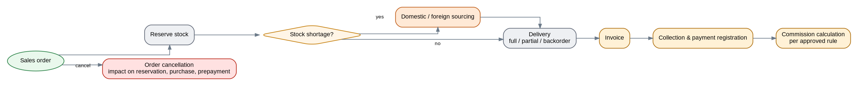
Quotation data and controls
• Quotation must link to the customer, opportunity, and technical proposal and contain item/quantity, base price, currency and FX rate, discount, freight, final price, payment terms, delivery time, validity, supply source, notes, owner, and revision.
• Multiple quotations for one opportunity, version/revision history, expiry, and renewal must be traceable.
• Changes to price, discount, payment terms, delivery date, and approvals must have an audit trail.
Approvals, exceptions, and credit
• Approval is not limited to discount; it may depend on margin, sales amount, payment terms, key-account status, supply route, freight, or foreign-order conditions.
• Credit control should block orders based on credit limit, overdue debt, returned cheques, or a combination, with reasoned/approved exception release.
• Resolve the CRM feedback conflict: CRM said purchase-credit data exchange is not needed, while Sales needs credit status for blocking. Decide whether CRM sees no amounts or only a restricted flag/limit/overdue status.
• Define when a contract becomes mandatory by order value, order type, payment terms, or foreign sourcing, and link the contract to the Sales Order.
Delivery, invoice, cancellation, collection, and commission
• Full delivery, partial delivery, and backorders should be managed against the same Sales Order.
• Invoice timing must be finalized for stock sales, domestic sourcing, and foreign sourcing, and the official invoice system of record must be decided between Odoo, Sepidar, or an integration model.
• Sales Order cancellation must have a defined impact on reservation, linked purchases, prepayments, and customer commitments.
• Commission basis must be decided: confirmed sale, invoice, or collection, including the effect of returns and non-collection.
Reports, KPIs, demo, and evidence
• Sales reporting by salesperson, team, branch, B2B/distribution channel, customer, region, industry, brand, product group, product, and cash/credit.
• Quotation value, sales-order value, invoice value, collection value, margin, target achievement, promotion/focus-product sales, unattended quotations, blocked orders, and sales cycle time.
• Demo: quotation V1 → V2 with discount/margin approval → customer confirmation → credit block → exception release → Sales Order → partial delivery/backorder → invoice → collection → commission.
• Bring: sample quotation/proforma, approval matrix, price list/FX rule, contract, customer aging/balance/cheques, and commission policy.
Workflow result — Coverage: □ Standard □ Configuration □ Odoo Studio □ Development □ Integration | Gap: .................................... | Action / Owner / Due: ....................................
5. Stock-sale and reservation workflow
The current reservation process records item, brand, quantity, customer, start/end dates, then moves through approval to warehouse release or archive.
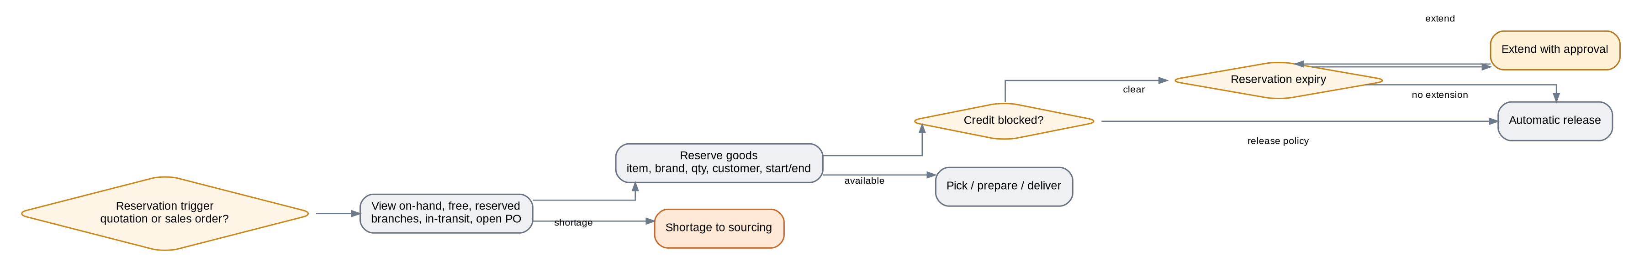
Documented current state
• Reservation fields include item name, brand, quantity, customer name, start date, and end date.
• Current route: reservation request → final approval → warehouse approval → goods issue when approved; rejected requests are archived.
• The presence of start/end dates confirms that reservation expiry and release are real process requirements.
Odoo requirements and open decisions
• Sales should see on-hand, free, reserved, branch stock, in-transit stock, and open purchase orders.
• The reservation trigger must be finalized: at quotation or only after confirmation/Sales Order? The previous checklist mentioned three days, but this is not a final policy.
• Expired reservations should release automatically, with approval-based extension if required.
• If credit is blocked, define whether reservation is temporarily kept, released, or retained through exception approval.
Reports, demo, and evidence
• Report on on-hand/free/reserved stock, expired/near-expiry reservations, orders waiting for stock, and inter-warehouse transfers.
• Demo: a Sales Order with part available and part unavailable → reserve available stock → send shortage to sourcing → reservation expiry and release.
• Bring: branch/warehouse stock screenshot or report and the current reservation/release policy.
Workflow result — Coverage: □ Standard □ Configuration □ Odoo Studio □ Development □ Integration | Gap: .................................... | Action / Owner / Due: ....................................
6. Technical equivalency, technical proposal, test, and sample workflow
Technical equivalency and test-item workflows are integrated into one sales scenario so Sales, Technical, Inventory, and Finance are visible in one route.
Technical data and current state
• Technical request starts from a sales need and should capture machine/equipment, workpiece, material, current tool, operating conditions, proposed product, item code, technical file/drawing, test requirement, result, owner, and response time.
• Current equivalency route: request registration → Sales Manager approval → technical review → if approved, issue from warehouse for label design → label/packaging preparation → receipt back into warehouse; rejection routes to return/archive.
• Technical sample request: sample request → pricing → Finance review → Management approval → ordering → warehouse receipt → archive.
Test route and exceptions
• The test workflow includes manager approval, technical approval, in-stock/out-of-stock sample branches, test pricing, Finance approval, order/shipping, warehouse receipt/issue, test report, and technical review.
• For an in-stock sample: issue document → test → report. For an unavailable sample: test pricing → Finance → order/shipping → receipt/issue → test.
• After the result, the route may convert an available item to sale, purchase and sell the ordered item, or archive/continue technical follow-up.
• Issue numbers, invoices, accounting documents, and test reports are recorded today and must remain traceable in the target state.
Odoo requirement, KPI, and demo
• Technical Request/Test should be created directly from the Opportunity, with result, files, drawings, product, and test report returned to Sales without re-entry.
• KPIs: technical response SLA, number of tests, successful-test-to-order conversion, test cycle time, and failed/returned cases.
• Demo: special tool → Technical Request → approval → in-stock/out-of-stock test → Inventory/Purchase → test result → successful sale or return.
• Bring: sample technical proposal, test report, drawing/catalog, and sample test issue document.
Workflow result — Coverage: □ Standard □ Configuration □ Odoo Studio □ Development □ Integration | Gap: .................................... | Action / Owner / Due: ....................................
7. Domestic sourcing workflow
The current flow runs from Sales request and inquiry through purchase, warehouse receipt, invoice, and customer delivery.
Documented current state
• Registration includes customer name and an Inquiry Form; incomplete requests are returned. The current form also uses a naming convention and requires the Sales supervisor to be informed.
• Route: register → Sales specialist approval → technical review → final inquiry review → customer review/approval → purchase and supply → warehouse receipt/payment check → coding → sales invoice → customer delivery.
• Accounting document number, warehouse receipt/issue number, and item code/specifications are captured at relevant stages.
Odoo requirements and gaps
• The Inquiry Form should be converted into structured Odoo data as far as practical, reducing dependency on Excel and manual naming conventions.
• Sourcing response (market price, lead time, supplier, status) should return to the same Opportunity/Sales Request with measurable response SLA. The previous checklist mentioned 24 hours and needs final confirmation.
• After customer approval, domestic purchase, receipt, and delivery should be traceable to the Sales Order.
• The system of record for coding, receipt/issue, and invoice between Odoo and Sepidar must be decided.
Reports, demo, and evidence
• Average domestic-inquiry response time, inquiry-to-sale conversion, orders waiting for domestic sourcing, and lead-time achievement.
• Demo: unavailable item → domestic request → technical check → supplier/price/lead time → quotation → confirmation → purchase → receipt → invoice/delivery.
• Bring: one anonymized real inquiry, price/lead-time response, and receipt/delivery document.
Workflow result — Coverage: □ Standard □ Configuration □ Odoo Studio □ Development □ Integration | Gap: .................................... | Action / Owner / Due: ....................................
8. Foreign sourcing workflow — customer request through order, CPT/DDP, and delivery
Pre-order and actual input data
• The foreign-request form captures standard/special item, CPT/DDP Incoterm, customer, technical-solution owner, drawing availability, and Inquiry Form.
• Current requirements include completing/numbering the inquiry, attaching clearly named drawings/photos, standardized request title, and selecting the customer from the customer bank; missing customers are added through CRM.
• Main route: customer profile → management → technical → supplier offer → sales pricing → Sales Finance review → final technical review → final quotation → Finance/Management control → customer approval → official proforma/contract → Commercial approval → payment/prepayment → supplier drawing/invoice → technical approval → final review → Purchase Order and coding.
Critical gates and open decisions
• Reject/return paths exist at customer profile/management, technical, sales pricing, Finance control, Management approval, customer approval, Commercial, and final drawing/order approval.
• The purchase-start gate must be clarified: customer confirmation, contract, prepayment, Finance/Management approval, or a defined combination? Current data shows payments/approvals before ordering, but the final rule should be simplified and explicit.
• Official proforma, contract, and Sepidar coding exist in the current state; replacement vs. integration is a critical design decision.
Fulfillment — two real CPT and DDP branches
• CPT branch: order tracking → customer negotiation/settlement → settlement and Management approval → virtual warehouse receipt → invoice and customs-document handoff → feedback.
• DDP branch: order tracking → warehouse receipt → incoming QC → settlement check for release → Management approval → invoice → goods issue → signed delivery → monitoring/feedback.
• Sales should see supplier/production status, shipment, customs, ETA, receipt, QC, and delivery without manual chasing; the visible information level must be defined.
Reports, demo, and evidence
• Inquiry-to-offer lead time, order-to-delivery lead time, open orders, shipment status, on-time delivery %, discrepancy/QC, and CPT/DDP time/cost performance.
• Mandatory demo: one complete foreign Opportunity through ordering, then both CPT and DDP branches, showing links among quotation, Sales Order, Purchase, shipment, receipt, invoice, and customer.
• Bring: sample inquiry, supplier quotation/proforma, Incoterm and lead time, contract, prepayment/payment receipt, and shipment/customs statuses.
Workflow result — Coverage: □ Standard □ Configuration □ Odoo Studio □ Development □ Integration | Gap: .................................... | Action / Owner / Due: ....................................
9. Key/VIP account workflow — commercial exception and approval, not a separate case
The current BPMS has a separate key-account workflow, but the target should model it as a tag plus pricing/credit/approval rules on the standard flow unless a real process difference requires otherwise.
Current state and target design
• Special sourcing/sales pricing, Finance control, manager approval, and technical review before ordering are prominent in the current key-account route.
• VIP service level, special discount, credit rule, contract requirement, and sourcing priority must be governed; numeric limits are not finalized in the source material.
• Demo: customer tagged Key Account → quotation with special rule → additional approval → credit/contract → order.
• Report: sales, margin, collection, repeat purchase, and service level for Key Accounts vs. standard customers.
Workflow result — Coverage: □ Standard □ Configuration □ Odoo Studio □ Development □ Integration | Gap: .................................... | Action / Owner / Due: ....................................
10. Consignment and display-item workflow
The item must remain company-owned and visible at the customer/partner location, with return due date and usage outcome tracked.
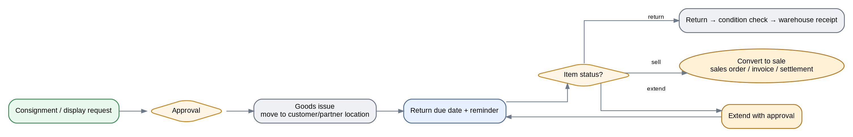
Current state and gaps
• The current form captures item code/name/quantity; goods issue has an issue number; return has a receipt number, and the Finance branch records an accounting document number.
• Return due date, extension, custodian, and direct conversion to sale are not explicitly modeled in the current workflow and are real gaps.
• Goods should remain visible in a customer/partner inventory location and must not disappear from company inventory visibility.
Roles, Odoo requirements, and reporting
• Sales/Call Center manages the request and follow-up; Inventory owns the movement; Technical checks condition/use when needed; Finance enters only for sale conversion or settlement.
• Return due date, reminder, approval-based extension, usage result, and conversion to Sales Order/Invoice should appear on the customer timeline.
• Demo: consignment → customer location issue → reminder → extension → good return or conversion to sale.
• Report: consignment stock at third parties, consignment aging, overdue returns, consignment inventory value, and conversion to sale. Bring: sample issue/return request.
Workflow result — Coverage: □ Standard □ Configuration □ Odoo Studio □ Development □ Integration | Gap: .................................... | Action / Owner / Due: ....................................
11. Post-sales return workflow — return, technical/inventory review, and financial impact
Returns should start from the original Sales Order, Delivery, and Invoice and preserve end-to-end traceability.
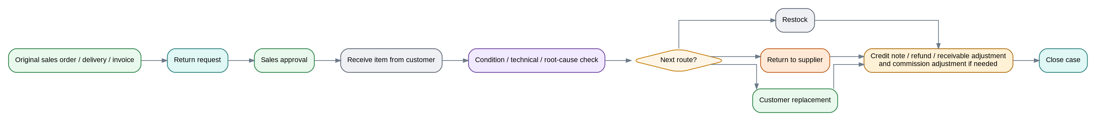
Documented current state
• Current route: return registration → Sales specialist approval → domestic-sourcing review → receive item from customer → condition check → three outputs: restock, return to supplier, or return to Sales assistant/archive.
• Final control of warehouse receipt and final control of supplier return exist as separate steps.
• The return request references the domestic-sourcing action ID and customer bank.
Gap and Odoo requirement
• The current workflow does not fully model financial impact; Return should link to credit note, refund, replacement, receivable adjustment, and commission adjustment when applicable.
• Technical/root-cause review, item condition, return to supplier, and replacement should link to the customer case and original Sales Order/Delivery/Invoice.
• Partial delivery, backorder, and return quantities must remain traceable against the original order quantities.
Reports, demo, and evidence
• Return rate, return reason by brand/product/customer, return closure time, credit-note value, and repeat issues.
• Demo: Invoice/Delivery → Return → Technical Check → Stock/Supplier/Replacement → Credit Note/Refund → close case.
• Bring: sample return, warehouse receipt/issue documents, and expected financial scenario.
Workflow result — Coverage: □ Standard □ Configuration □ Odoo Studio □ Development □ Integration | Gap: .................................... | Action / Owner / Due: ....................................
12. Post-sales CRM and win-back lifecycle
CRM has a role before, during, and after the sale; during the sale it owns interactions and SLA, not the quotation or Sales Order.
Case, complaint, knowledge, and Voice of Customer
• Case ID should link to customer, product, Opportunity/Sales Order/Invoice, and Technical/Inventory when needed.
• Complaints should have SLA, cross-functional collaboration, customer resolution confirmation, reopen logic, root cause, and corrective action.
• Knowledge/FAQ should have an expert owner, version, and periodic review and be usable during calls/cases.
• Survey/CSAT/VoC: low scores should create a follow-up activity/case and recurring themes should drive improvement actions.
Segmentation, loyalty, campaign, and growth
• RFM, customer value/potential, purchase behavior, churn, and dynamic segmentation; the calculation boundary between Odoo and BI must be decided.
• Customer loyalty: points based on customer behavior/value, collection behavior, and product mix; cash/credit rewards and the effect of returns/non-collection require clear Finance rules.
• Campaigns should be attributable to leads, opportunities, and sales; inactive/lost customers should support win-back.
• Cross-sell, up-sell, referral, and VIP use cases can be defined; confirm whether they are in the current phase scope.
Interaction quality, KPIs, and demo
• Call/case QA: sampling, scoring, feedback, coaching, and re-evaluation when needed.
• KPIs: CSAT/VoC, case SLA, root cause, Lost/Inactive win-back rate, retention, repeat purchase, churn, campaign conversion, cross-sell, and up-sell.
• Demo: Lost with reason → segment → campaign/SMS/call → reactivate → opportunity/sale with attribution; complaint case → Technical → resolution → survey.
Workflow result — Coverage: □ Standard □ Configuration □ Odoo Studio □ Development □ Integration | Gap: .................................... | Action / Owner / Due: ....................................
13. Systems embedded in the workflow — Odoo, Sepidar, BPMS, VoIP, Call Center, and BI
Each system should have a clear role and system-of-record responsibility; parallel databases without data ownership are not acceptable.
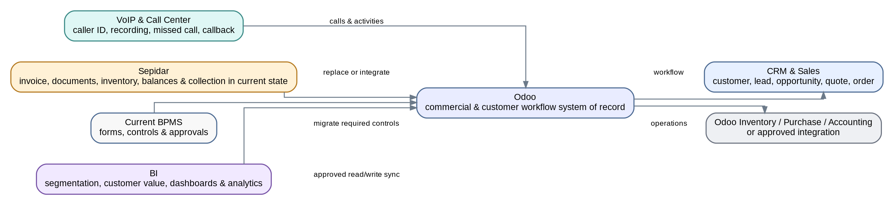
Expected role of each tool
• Odoo CRM/Sales: customer, lead, opportunity, quotation, Sales Order, activities, approvals, and commercial traceability.
• Odoo Inventory/Purchase/Accounting or approved integration: reservation/movement, sourcing, invoice, payment, and receivables according to final scope.
• 3CX/Call Center: caller recognition, recording, missed calls, callback, and activity/case on the customer timeline.
• Sepidar currently supports proforma/invoice, coding, financial documents, receipt/issue, balances, and collection; the exact replacement/integration model must be decided.
• BPMS is the current-state source for forms, controls, and approvals; after Odoo, parallel workflows should be removed as far as possible.
• BI supports segmentation/customer value, Sales/CRM dashboards, and complex analytics; read/write/sync boundaries must be defined.
Access, audit, and integration
• Role/access matrix for specialists, supervisors, Sales Manager, CRM, Technical, Finance, branches, and consolidated management.
• Audit trail for changes to owner, price, discount, payment terms, delivery date, approvals, and sensitive customer data.
• Integration/sync error monitoring and a system of record for each data domain; duplicate master data across Odoo/Sepidar/BI is not acceptable.
• Usage/adoption reporting and user training are part of implementation governance.
Cutover and migration
• Contacts, customers, products, and specialized customer fields require mapping; Mandatory/Derived status and customer grade/sales status treatment must be decided.
• Open BPMS requests—reservation, test, consignment, domestic/foreign sourcing, returns, IDs, and attachments—must be reviewed and either migrated or archived by decision.
• Open records should retain cross-reference between the legacy ID and the Odoo record so history is not broken.
Workflow result — Coverage: □ Standard □ Configuration □ Odoo Studio □ Development □ Integration | Gap: .................................... | Action / Owner / Due: ....................................
14. Supporting/out-of-core workflows and scope boundary
Not every current workflow export belongs in the Sales & CRM core; each must be assigned to the correct implementation scope.
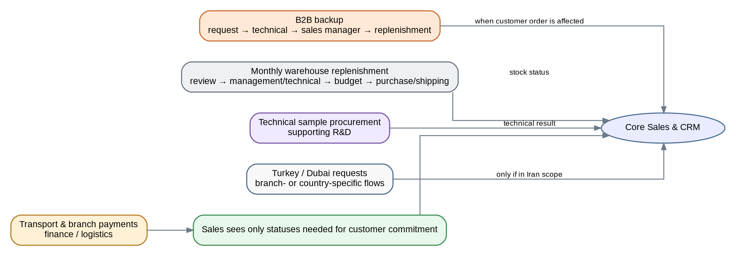
Supporting processes
• B2B backup: item request → Technical → Sales Manager approval → sales-trend review → item receipt/sale notification → archive; this is primarily replenishment/sourcing support.
• Monthly warehouse ordering: request/review → Management/Technical → pricing/budget/shipping → order/shipping/receipt/coding; this belongs to Inventory Replenishment/Purchase.
• Technical sample request is a sample-procurement process supporting Technical/R&D.
International and financial processes
• Turkey and Dubai request workflows are branch/country specific; decide whether they are in Iran scope or only reference processes.
• Transport payments and international-branch funds/payment requests belong to Finance/Logistics; only gates/statuses needed by Sales should be exposed.
• Design principle: Sales should not own payments or logistics; it should only see statuses required to make customer commitments.
Workflow result — Coverage: □ Standard □ Configuration □ Odoo Studio □ Development □ Integration | Gap: .................................... | Action / Owner / Due: ....................................
15. Run the workshop through these workflows — demo-driven, not checklist-driven
The workshop should close a canonical workflow, owner, data model, approval rule, integration boundary, reports/KPIs, gaps, and next actions for each branch.
Recommended workshop sequence
• 1) Customer/Lead/Ownership and 3CX handoff; 2) Quotation/Credit/Sales Order core; 3) Inventory/Reservation; 4) Technical/Test; 5) Domestic sourcing; 6) Foreign CPT/DDP; 7) Consignment/Return; 8) Post-sales CRM/BI/Integration.
• For each workflow, record Fit/Gap, module/feature, coverage type (Standard/Configuration/Odoo Studio/Development/Integration), limitations, demo, action owner, and due date in place.
• Whenever the Odoo team says “it can be done,” request the actual scenario in the system or a precise flow. For custom development, record estimated hours, upgrade impact, and the standard alternative.
Three non-negotiable demos
• Stock sale: Lead/Opportunity → Quotation → Approval/Credit → Sales Order → Reservation/Expiry → Partial Delivery → Invoice/Payment.
• Technical/test: Opportunity → Technical Request → Approval → in-stock/out-of-stock Test → Inventory/Purchase → Result → Sale/Return.
• Foreign sourcing: Opportunity → Technical/Supplier Offer/Pricing/Finance/Contract/Prepayment → Purchase → CPT and DDP → Delivery/Invoice/Feedback.
Evidence by workflow and desired output
• Customer/Lead: multi-branch customer example, ownership/access rules, and call log.
• Commercial: quotation/proforma, pricing/FX, approvals, contract, aging/cheques, and commission.
• Inventory/Technical: stock/reservation, technical proposal/test report, consignment/return.
• Sourcing: domestic/foreign inquiry, Incoterm/lead time, prepayment/receipt, and shipment status.
• CRM/BI: dashboard, customer segmentation/value, campaign/inactive customers, and completed CRM-team workbook.
• Desired output: for every branch, agree the canonical workflow, owner, data model, approval rule, integration boundary, reports/KPIs, gaps, and next actions.
Basis of preparation: the complete final Sales & CRM workflow document, BPMS workflow exports, the completed CRM-team workbook, and the related process profiles.

