**Free Instagram Marketing Tip #2: Use Instagram Stories to Introduce Your Business**

Your followers are savvy and inquisitive, and they want to know more about your brand!

So simply introducing your products with photos on your feed isn’t enough these days — you need to take the time to introduce your brand and business too.

Your followers are curious about how your products are made, the people behind the business, and what you have planned for the future — so take the time to share this info with them.

Not only does this open up great opportunities to create engaging content your followers will love, but it gives you another way to introduce your products and services without dipping into the marketing budget.

Instagram Stories is one of the best platforms for this — it’s short video clips allow for quick and easy insights into your day-to-day business life. Jewelry brand [@mejuri](https://www.instagram.com/mejuri/?hl=en) is a great example of how they incorporate behind-the-scenes content of their business and product-based content.

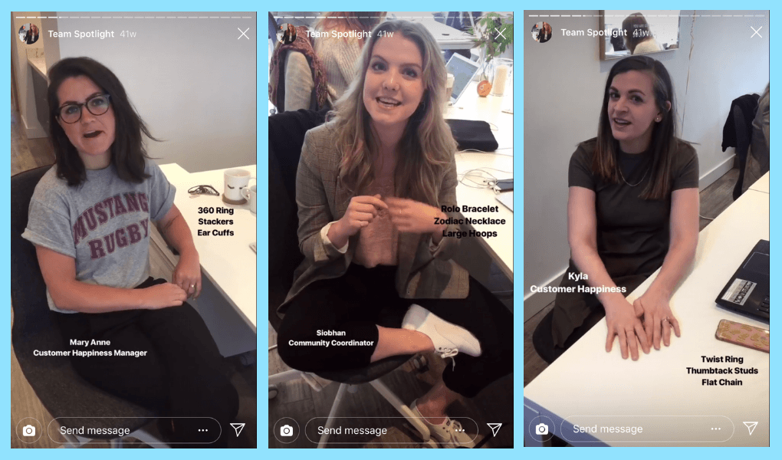

Think about creating some of these Instagram Stories next time you want you’re planning a content calendar:

**#1: Tell Your Brand Story**

Don’t be afraid to share with your followers how, when, and why you wanted to create your business. Let them know about your struggles as a startup and some of your proudest moments to date.

**#2: Take Your Audience Behind the Scenes**

Think about bringing your followers along to your warehouse or introducing them to the manufacturing team or where you source your materials from.

If you’re selling a service  rather than a physical product, you could share a ‘day in the life of…’ post on Instagram Stories that shows glimpses of the inner workings of your business and who is involved in running the business each day.

**If you’re already on a Later Business plan, you can**[**schedule Instagram Stories**](https://later.com/blog/schedule-instagram-stories/)**! Just like your feed posts, you can now plan, schedule, and publish your Instagram Stories!**